Helpful hints:

Styles
I recommend using the Styles editor under the Home tab while editing this document. Look at the Styles section now. This paragraph uses the ‘single space’ style, different from the ‘paragraph’ style used throughout the manuscript. Put your cursor on any word in this paragraph and change the style to ‘paragraph’. See that? It’s magic.

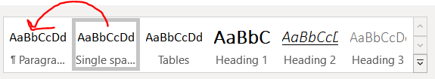

You can quickly change the formatting of the entire manuscript by right-clicking the style name and modifying the style. Say one journal requires Times New Roman 12 but another requires Arial 11. You can right-click and change the style and apply to formatting change to the entire document. This will only work if you consistently use MS Word’s Styles.

Page Breaks
Get used to inserting ‘page breaks’ rather than hitting ‘enter’ a bunch of times when trying to move text to a new page. ‘Basic’ page breaks are inserted with ctrl+enter, or under layout breaks page. Formatting (e.g., rotating a page from portrait to landscape) will extend across ‘basic’ page breaks. Inserting a ‘section break next page' will allow you to modify the formatting of the following group of pages. For example, if you wanted to rotate a single page with a wide table from portrait to landscape without affecting the rest of the manuscript, you’d put a ‘section break next page’ before and after that table then rotate that one page.

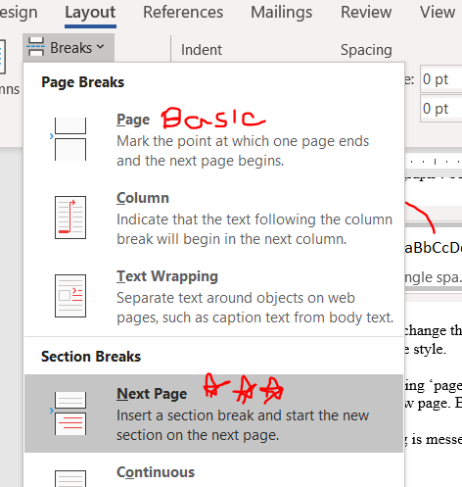

Formatting Reveal
If your formatting is messed up and you can’t otherwise figure out why, hit this button under home:

New Window
Embrace the “New Window” button, it opens up the current document in a second window and applies ongoing edits across both. Super helpful when looking at tables/figures in one window while describing them in a results section in a separate window.
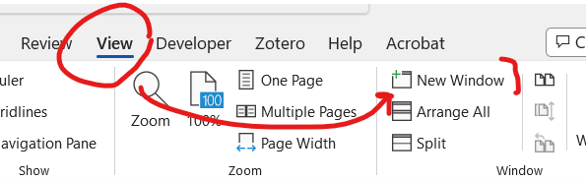

Suggested steps to publication:
[ ] Install a reference manager. I strongly recommend Zotero, which is free, if you don’t already have one. It has an excellent browser plugin. (Zotero is to EndNote as Google Docs is to MS Word.)
[ ] when using your reference manager, be really particular about keeping the sources organized into subfolders. E.g., have one subfolder for all papers describing your outcome+exposure, one describing your study design if a cohort, etc
[ ] identify coauthors
[ ] discuss the order of authors with everyone before writing the first word
[ ] write the last paragraph of the introduction: “The purpose of this analysis is to a) do the first goal and b) do the second goal”. You have now identified the only things that will be in your paper. Don’t include other stuff.
[ ] write the first 2 sections of the introduction literature (“background” and “importance”) and the 2nd section of the discussion (“How it extends what we already know” except for the last bit where it talks about the “present findings”.)
[ ] make blank tables that are as detailed as possible without data yet. This will help you identify the data to include
[ ] identify the types of figures that you want to include and make placeholders for them
[ ] write methods prior to doing the analysis
[ ] do the analysis, fill in tables, make figures
[ ] revise methods with any tweaks that you made while doing the analysis
[ ] write results section
[ ] flesh out the rest of the discussion
[ ] write abstract. Make sure to include the “The purpose of this analysis is to a) do the first goal and b) do the second goal” in your abstract. Write out key findings.
[ ] send what you have so far to your group. Set up a meeting with everyone to discuss the analysis, results, and main conclusions.
[ ] revise analysis, methods, results, abstract based upon this meeting
[ ] write cover letter
[ ] Finish the most complete draft possible. Turn on review track changes then save. Send this to your closest collaborator. The completeness of this draft will directly affect how quickly they read and provide suggestions. If you send unfinished work, you’ll receive slow or incomplete or unhelpful feedback.
[ ] revise with suggestions, then re-circulate to co-authors.
[ ] make sure everything is in past tense and that the word “data” is always plural

Research resources:
- Keeping your digital work organized: https://blog.uvm.edu/tbplante/2017/08/10/keeping-your-digital-work-organized/
- Using the Pomodoro method to stay focused: https://blog.uvm.edu/tbplante/2017/08/08/tomighty-the-java-powered-pomodoro-app/
- Lots of Stata code on my UVM blog: https://blog.uvm.edu/tbplante

July 13, 2023

Dear Dr. [EDITOR IN CHIEF],

We wish to submit the enclosed manuscript, [TITLE OF THE MANUSCRIPT], for consideration as a [type of submission like ‘research letter’] in [NAME OF THE JOURNAL].

The second paragraph gives a 3-4 sentence background of the urgency or lack of knowledge that this manuscript is trying to address. This should be snappy because the top tier editors need to know why they should spend time reading your manuscript.

The third paragraph says what you found, like the following sentences.
In our cohort study, we compared patients with a myocardial infarction prescribed high-dose aspirin to those prescribed low-dose aspirin. Those prescribed high-dose aspirin had a significantly greater odds of heads spontaneously combusting than those prescribed low-dose aspirin. Further, this association persisted when adjusting for really important things of interest.

The fourth paragraph paints the overall significance of this in society and how it advances the field, like in the following sentences.
Our study has important public health and clinical implications. First, it suggests that a commonly prescribed medication may be doing more harm than good by inducing more spontaneous head fires. Second, it informs the future of clinical practice as these findings may be a driver for updating best practice guidelines. Finally, it is really important because of other stuff that you don’t even know yet.

This manuscript is not under consideration elsewhere and none of its contents have been previously published. All authors approved the manuscript and meet authorship criteria. All disclosures are included in our submission.

Many thanks for your time and consideration.

Sincerely

[signature]
Your name

This is the descriptive title of the manuscript
Running title: [Running title <50-60 characters]

Author A
Affiliation, city, state
Email:
Disclosures:

Author B
Affiliation, city, state
Email:
Disclosures:

Author C
Affiliation, city, state
Email:
Disclosures:

Author D
Affiliation, city, state
Email:
Disclosures:

Corresponding author:
[name, address, phone, fax, email as a paragraph]

Word count:
### abstract
### manuscript

Figures: #
Tables: #

Key words:

Suggested tweet:

Abstract

Background
This is the background section. It tells you why people should care about your project. It should be relatively succinct and set up the reason for this study.

Methods
We used [source of data], including [big group you are targeting like men and women age ≥18] excluding [reasons for excluding people]. [brief overview of analysis plan.]

Results
Of the [number of participants or datapoints] in [dataset], we excluded [##], leaving [##] in this analysis. [exposure variable] was [mean and sd] for all participants [or by group].
[Primary outcome showed…] (HR ##; 95% CI [## to ##]) overall. The effect of [exposure variables like high dose aspirin] did not vary significantly [subgroups] any of the outcomes considered [or say which ones it varied for].

Conclusions
Among [population of interest], the [primary outcome was different or was not different]. This final sentence or two should set up your follow up study and how these findings advance knowledge.

Introduction

Background
The first paragraph should start with a big bang, like the following sentence. Spontaneous head explosions are the third leading cause of death and disability in the US, accounting for $500 trillion per second of healthcare costs. Then briefly explain prior literature as it is relevant to this study. For the love of Pete, please keep this section to only 1 paragraph. The last sentence should tie into the importance paragraph. The final sentence could be something like what follows. Although we know that regular aspirin intake is associated with fewer cardiovascular disease events, its association with head explosions is less well known, there is no current way to empirically identify whose head will ultimately explode.

Importance
This second paragraph should start with a sentence that links with the previous paragraph’s final sentence, like what follows. Recent observational analyses have found adults who eat propane lighters to have lower likelihood of also taking aspirin on a regular basis. Then build up the paragraph to link to the goals of your paper, and for the love of Pete keep this section to 1 paragraph only.

Goals of this investigation
The last paragraph of the background should make it clear as day why you did this study by literally counting out the objectives and their matching hypotheses. Each of these objectives should make sense to someone who knows nothing about your field but has read the beginning of your background. These objectives should essentially be your primary and main secondary outcomes. Say something like the following sentences. The objective of this study was to 1. Evaluate the effects of two levels of aspirin on spontaneous head combustion among at-risk adults, 2. To assess the likelihood of adherence to aspirin therapy by level of propane lighter consumption. We hypothesized [include a list of hypotheses that match these objectives like] that 1. lower doses of aspirin would reduce head explosions and 2. Adults in the highest quartile of propane lighter consumption would have the lowest consumption of aspirin by end-of-study pill count.

Methods

Name of the study or overall population from which your data are derived
The EPONYMOUS study is a national cohort study of whatever. [details about the study design. This is different from the subgroup that you’re focusing on.]

Exposure of interest
Describe how the exposure of interest was calculated for each individual. It’s always great idea to go into way more detail than you think you need.

Covariates of interest
Describe how covariates of interest was calculated for each individual.

Outcome of interest
Describe how the outcome of interest was determined for each individual.

Study population
This paragraph should line up with the first paragraph of the results section. I do not like to actually list the numbers in the overall population here, because those are more akin to results. This should describe the overall population, inclusion criteria, and exclusion criteria, with something like the next sentence. We included participants from the EPONYMOUS study who attended visit 1 and 2. We excluded those missing any variables required to define the exposure or outcome, including [list].

Statistical analysis
This section should line up in order with the results section so that each few sentences describes the methods for each table, figure, and text-based results. They should be introduced in order that they show up in the results section. Sociodemographics, [medical comorbidities relevant to your outcome like BP and cholesterol if stroke were the outcome] and [other covariates of interest above] were tabulated by the [exposure of interest], using [whatever statistics] to compare the groups. [The preceding sentence describes your table 1. Note: don’t compare baseline characteristics with statistics in RCTs unless it’s a secondary analysis. In mega cohort studies it doesn’t make much sense to include P-values also because the groups will likely have P<0.05 because of the size and ‘overpowering’ between groups.] We [tabulated or visualized] the exposure of interest in the entire population using [chart/graphic if you did it]. We [tabulated or visualized] the outcome of interest in the entire population using [chart/graphic if you did it].
We calculated [statistic] for the primary outcome using [logistic regression or whatever]. We repeated this for [whatever].
We performed a sensitivity analysis for [whatever].
Analyses used [statistical program of choice and where it’s from and please don’t use excel. It seems to be convention when using R or Python to also list out any fancy statistical packages used]. Analyses were performed on an [intention-to-treat or per protocol] basis (if RCT; delete this sentence if an observational study). [name of institution] Institutional Review Board deemed this research [approved this or said it was exempt or non-human subjects research]. We considered a two-tailed P<0.05 to be statistically significant.

Results

Study population
This starts with a summary of the number of participants, like: Of the ## participants with follow-up data, ## were excluded for [reason] leaving [final number] in this analysis. [can include a flow diagram here. Example for a cohort study follows. If this is an RCT, please use a CONSORT flow diagram.]
Figure 1 – Flow diagram
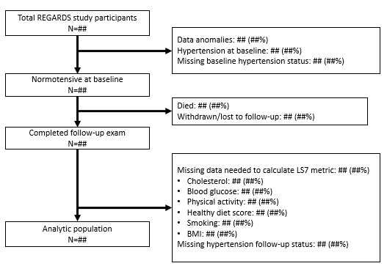
This paragraph walks readers through your Table 1. I find this to be a very difficult paragraph to write. It might be easiest if you record yourself describing the table 1 to a friend or colleague, then write down what you said. Of you can follow this structure. Of the ### participants, ### (##%) had the exposure and ### (##%) did not have the exposure. The mean (SD) age of entire population was ## (##) years old, ##% were female, and ##% were Black participants. Now describe if there are any big differences between the exposed and not exposed group for each of the rows.
Table 1 – Demographics and covariates of interest for the study population by exposure status*
 | Total | Exposed | Not exposed | P-value
N
Age (y)
Female (%)
Additional demographics
Start a list of covariates here
More covariates
More covariates
More covariates
*Continuous variables are presented as mean (SD). Proportions are presented as N (%)

Distribution or frequency of the outcome
Describe the distribution or frequency of the outcome. You might consider using histograms, violin plots, or just tabulate the outcome overall or by demographic group.
Figure 2 – My excellent figure*
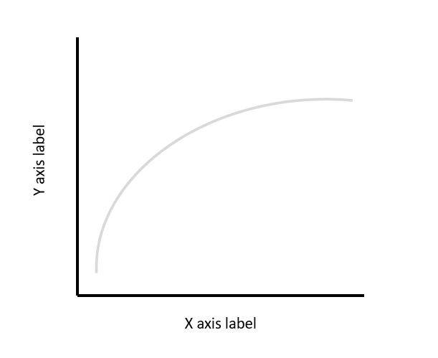
*Here is the footer description.

Distribution of the exposure
This is where you describe the exposure of interest, and probably also tie it to a figure or table. This is a histogram of trunk space using the “sysuse auto” dataset in stata.. You could describe this as a bimodal distribution, with peaks around 10 and 15 cubic feet.
Figure 3 – Histogram of trunk space.
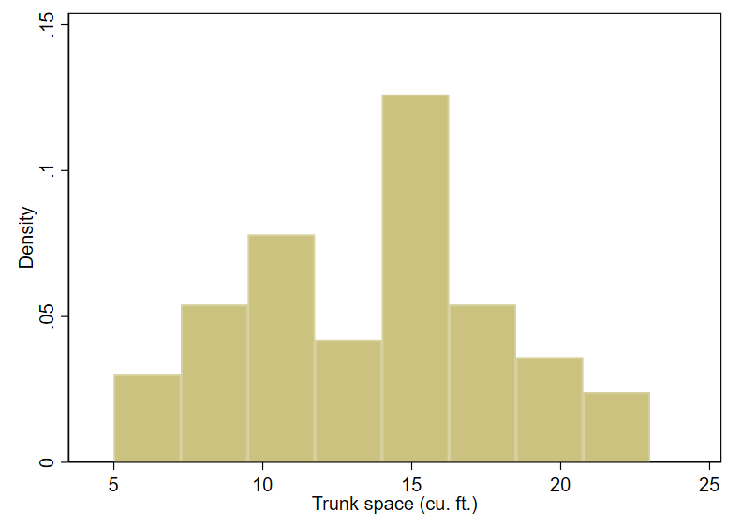

Primary analysis
This is where you do your fancy stats that tie the exposure to the outcome.
Table 2 – Relative risk (RR) of [outcome] by each model*
 | RR (95% CI) | P-value
Model 1
Model 2
Model 3
*Model 1 included [list]. Model 2 included [list]. Model 3 included [list].

Discussion

Main findings
This starts with a description of the findings without including numbers, like: Based on a [type of study like case control study or whatever], we found that [main points of this paper that should directly tie into the objectives listed in the last bit of the background]. This is a sentence saying why this is important and how it should be tied to the follow-up. It is probably a good idea to keep a bullet list of the biggest findings of importance while you are going through this manuscript

How it extends what we already know
Prior literature showed [whatever it showed and literally pull out the RR, OR, or HR and 95% CI from the paper and put it here, something like this] a 20% greater risk of head explosion with low dose relative to high dose aspirin in the NAMED cohort (RR 1.21; 95% CI 1.04 to 1.33) that included men in the Southwestern US. Similar patterns were seen among confirmed in the OTHERNAME cohort (RR 1.19; 1.05, 1.25), which included men and women. [Next bit is how it fits in with prior literature like what follows.] The prior studies did not address [whatever issue is novel, if any, in your study.]. The present findings are generally consistent with these findings as we found [whatever we found] and extend upon prior literature in [detailed ways].

How is it different from any prior data? Why might it differ?
Inconsistencies with prior literature (if any) are possibly because of [reasons].

Why is it important/how does it advance the field, what are the implications, what is future thinking or what hypothesis can be made?
These findings extend on primary literature in several ways. [ways that it’s a new discovery] Describe potential mechanisms for any association that may be observed. Future studies should focus on…

Strengths and limitations
I like to come up with a bulleted list at first then switch it to a paragraph

Wrap up/conclusions
In conclusion, this is a sentence or two about the main findings of this study. Best to understate here.

Acknowledgments
We would like to thank [person] for [what they did].

Funding
This work was supported by [grant or contract number] from [organization].

References
Use a reference manager!! I recommend Zotero. It’s free and has an excellent browser plugin.

