STAT 288: Filename (e.g., Chapter 1 Problems)
Richard Single (your name here)
Wednesday, January 23, 2020
This is an R Markdown document. Markdown is a simple formatting syntax for authoring HTML, PDF, and MS Word documents. For more details on using R Markdown see http://rmarkdown.rstudio.com.
When you click the Knit button a document will be generated that includes both content as well as the output of any embedded R code chunks within the document. You can embed an R code chunk like this:
summary(cars)
## speed dist
## Min. : 4.0 Min. : 2.00
## 1st Qu.:12.0 1st Qu.: 26.00
## Median :15.0 Median : 36.00
## Mean :15.4 Mean : 42.98
## 3rd Qu.:19.0 3rd Qu.: 56.00
## Max. :25.0 Max. :120.00
You can also embed plots, for example:
plot(cars)
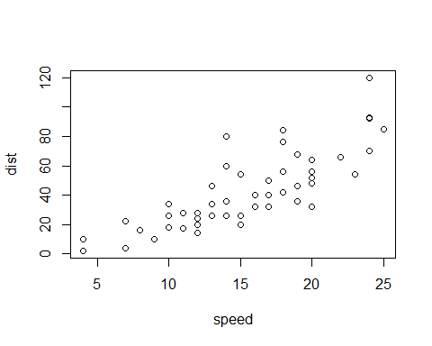
Note that the figure width and figure height can be modified using fig.width= and fig.height= as below:
plot(cars) #```{r, fig.width=4, fig.height=4}
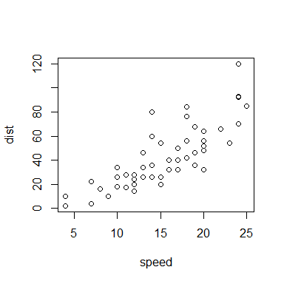
Note that the echo = FALSE parameter was added to the next code chunk to prevent printing the R code that generated the plot.
You can use results="hide" to hide the results/output (but the code would still be displayed) as below.
summary(cars) #```{r, results="hide"}

