Student WD
- Registration holds were divided into 3 tiers to accommodate various administrative needs.
Tier 1 – no registration processing permitted.
Tier 2 – cannot add, but drop/withdraw is permitted. Current holds in this tier are: any hold in STVHLDD where the ar_hold_ind = ‘Y’, FH, LN, AR, KH, SH.
Tier 3 – special case for Advisor (AA) hold. Term is compared to GWVGLOB RegTerm. If term < RegTerm, any registration action valid for the time period is permitted. If term >= RegTerm, no registration processing is permitted.
Tier 3 processing was created so students with AA holds, put in place to require advising for a future term registration, do not prevent current term registration processing. So, for example, a student with an AA hold in March cannot do anything for Fall until they see their advisor. However, the student can withdraw from Spring classes and can add/drop/withdraw from summer classes. The code specifically uses RegTerm to allow for summer processing.

- If WD is not an option for the section, text displays in the Request Withdrawal column noting this, either that it is not yet time:
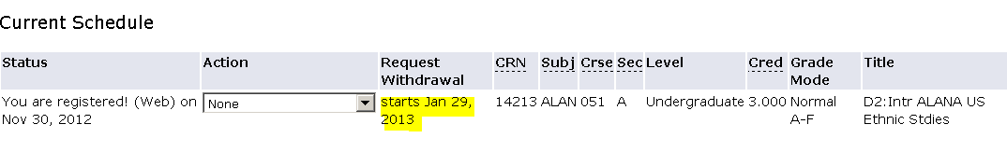
Or that the time has passed. (Note, we considered changing the text to some terse comment about needing Dean’s approval but could not come up w/ language that was terse enough and still clear that the dean would not automatically approve the request.
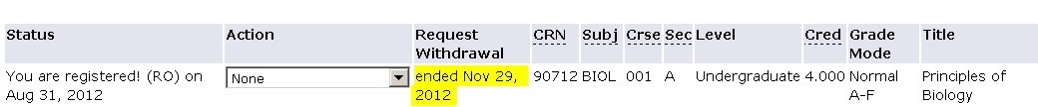

Two conditions can result in an ‘empty’ drop down box displaying in the Action column but no information in the Request Withdrawal column:
- If the student can no longer WD, but the dean’s office can still process a WD for the student.
- A condition that really should never occur: if a student is graded for the section.
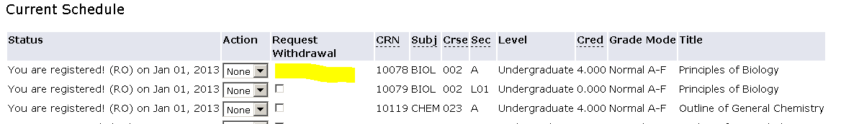
- If WD is an option, a checkbox will display next to the section:
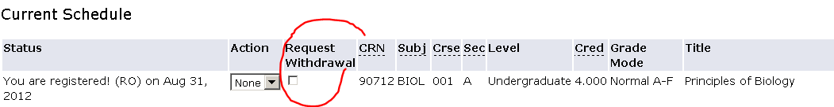

- To WD, check the box. The date the box was checked displays in the Request Withdrawal column. The date marking the end of the pending period displays as text under the section. If the course is linked and the student only checks 1 member of the link, a message displays asking the student to WD from the linked component also. The WD will not occur if both components of a link are not checked. 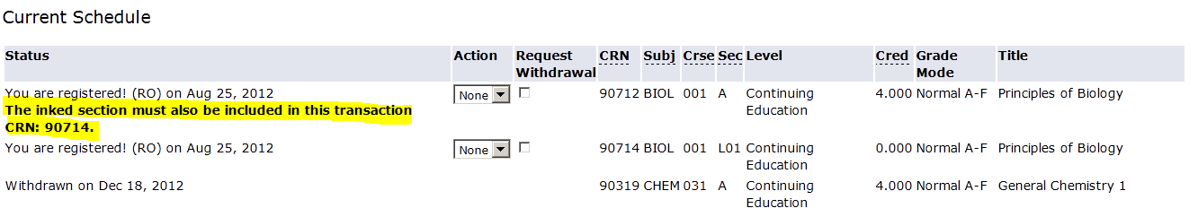

- The ‘Withdrawal is pending’ message indicates how long the student has to change his/her mind. 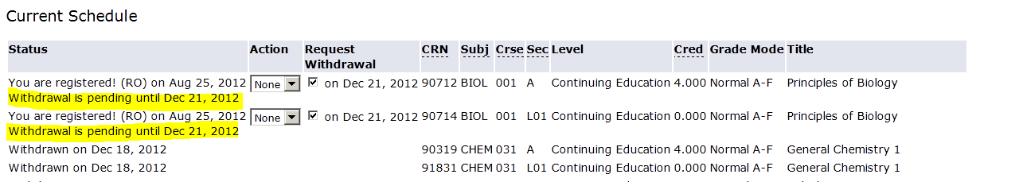 If the student decides s/he does not want to WD, s/he simply unchecks the box. The schedule redisplays and is again available for a WD request.
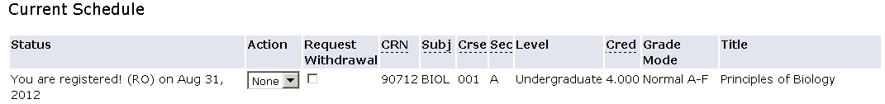

- When a student clicks ‘Request Withdrawal’, an email is sent to the student, all instructors of the course, all of the student’s advisees and the student’s dean’s office. The subject line is ‘Student Planned Withdrawal from Course Crn Term’. The email text notes the student plans to WD and suggests the email recipient contact the student to discuss the decision. The email notes the request will be pending until the pending date unless the request is subsequently cancelled.

- If the student unchecks the Withdrawal Request box, an email is sent to all instructors, advisors, student’s dean’s office and the student with subject line ‘Cancellation of Withdrawal from Course Crn Term’. The message text indicated the Student id has cancelled the pending WD from course title term.

- The length of the pending period is controlled by the following infotext value. The norm is 2 business days. It can be changed to something longer if desired to accommodate 3-day holiday weekends, Spring Break, etc. It cannot go beyond swbsect_wd_end_date for the crn. This means we do not have to manually adjust the value as the WD period is coming to an end. The code will take care of it automatically. Example: Last WD date is 30 Oct. Business day value is 2. WD through 28 Oct are pending for 2 business days. WD on 29 Oct are pending for 1 business day (expire on 30 Oct) and WD on 30 Oct are pending only until the end of the day 30 Oct.

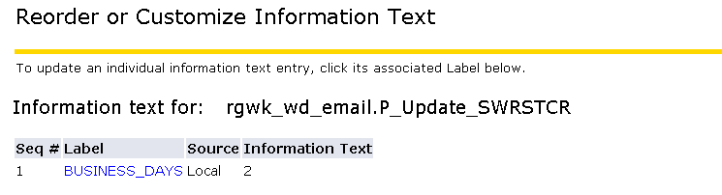

- A batch process runs nightly and examines all WD requests.
  - If sysdate> the expire date, the section status is changed to WD. The student will no longer be able to cancel the WD him/herself. Nothing displays in the Action or Request Withdrawal columns. 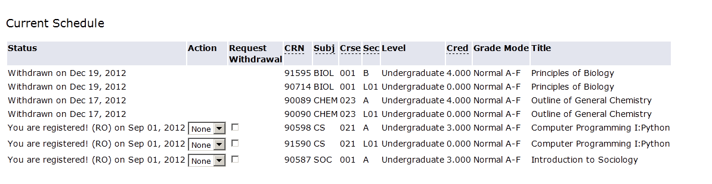 (Note: if it is during the WD period, and the student wants to undo the WD, the process is: student asks the instructor to use the ‘Add a Student to my class’ feature, RO has to process (starting w/ deleting from academic history). We do not plan to automate this as part of this project).
  - The grade of W is written to sfrstcr_grde_code and user = OPS$RGBATCH. There is only a BASE record in SFASTCA. Details of the WD are in swrstcr, not sfrstca.
  - The W will show up on the grade list and also on the student transcript (the roll runs after the process that expires WDs).
  - ‘Withdrawn’ displays in the Registration Status column of the class roster.
  - ‘Graded’ displays on the class roster of the gradable section in the Enrollment Change column. The column is blank in the non-gradable section. This is based on rsts_code = WD rather than on grade = W (so it will work for non-graded linked courses).
  - The academic alert column is blank for both the graded and non-graded sections. This is based on rsts_code = WD rather than on grade = W (so it will work for non-graded linked courses).
  - If a student WD from only one component of a linked course, the batch process will enter a WD for the other linked component. This should never occur, as the online process requires all link components be selected. It is a ‘safety net’. Note: because online processing is supposed to trap all conditions, the batch process does not identify students who have all WD values and generate emails about total WD. That only occurs in the online process.
  - If a student has a pending WD, and a faculty member sends a Never Attended before the WD is completed, the pending WD will just sit in swrstcr. The batch process will not be able to resolve it because there will not be a row in sfrstcr (because RO staff will delete it when processing the Never Attended). Nothing will show up on the batch report because there is nothing to do, no action to take. This is ok.

- The date the student requests the WD is the effective date of the WD. It is the date that will be used for refund purposes.

- Parts of term overlap, so student/dean withdrawal periods may overlap. If a student wants to go into the add/drop page, and a dean’s office staff member is on the student’s record to do an online WD, the student will get this message: no longer true? 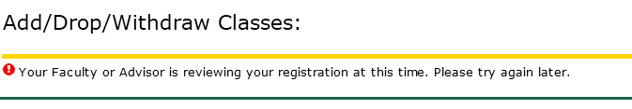

- If the student WDs from all their courses, they get this message:
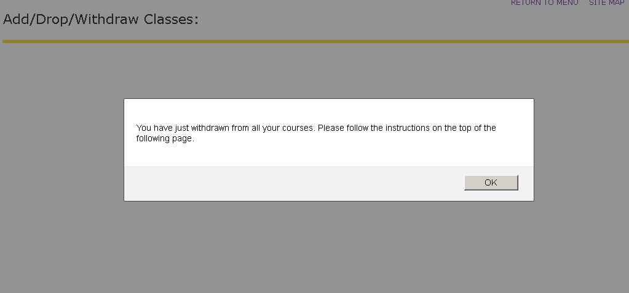
And then this will display on the screen when OK is clicked:
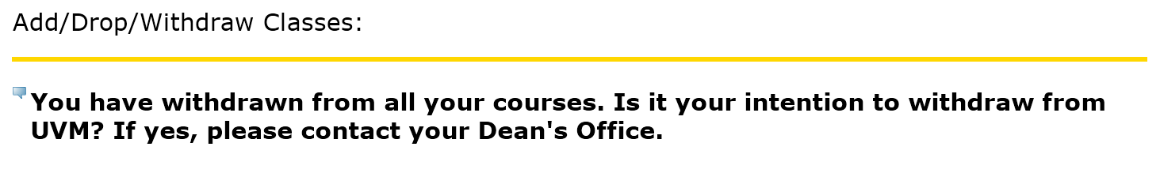
  - These messages are not given for summer session.
  - Emails are sent to advisor(s) and dean’s office(s). The subject line is ‘Student Withdrawal from all courses for TERM’.
  - CE students do not get the message. Only non-CE students get them for spring and fall (no one gets them for summer).

Student WD after WD period but before the end of the term
- WD does not display in the drop down. Infotext explains the student must contact her/his dean’s office to request permission to withdraw. If no rsts codes are valid any more for any part of term in the term, the student gets this:
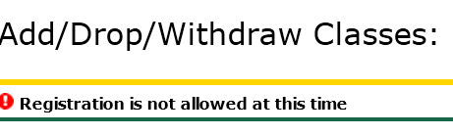

- Dean’s office uses ID selection to choose student, then selects ‘Approve Late Course Withdrawal’.
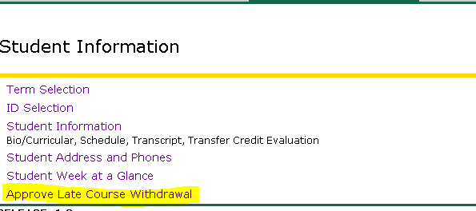

- Dean’s office staff choose ‘Withdraw’ from the drop down menu and click ‘Submit Changes’.
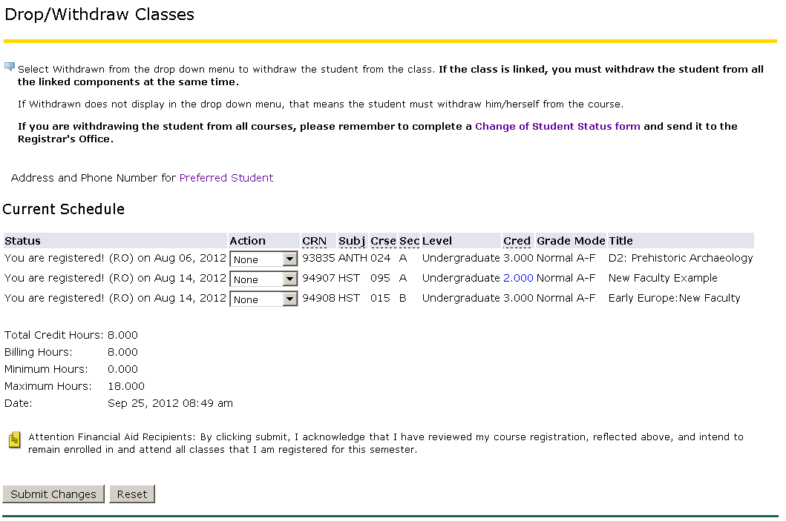

- An email is sent to the student, all instructors, all advisors, all appropriate student dean’s offices with subject line: Dean’s Office Withdrew Student from Section – Term.

- TEMP and BASE records are in SFRSTCA w/ dean netid as user w/ ‘Final grade updated to W’.

- Withdrawn displays on the class roster.

- W displays on the grade list, with Withdrawn status, date of WD and dean’s netid as user.

- If the course is linked, and there are no overrides, both components must have the WD code. If WD is only placed on one member of the link, the following message will display. The solution is to enter WD for all linked components before pressing SUBMIT: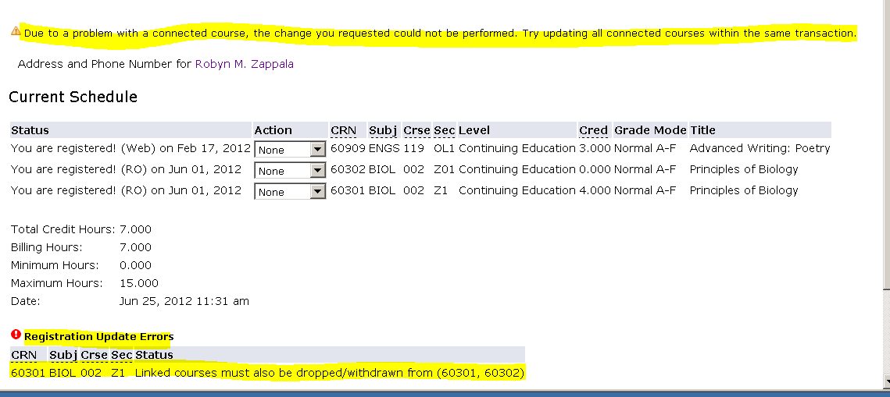

- If the dean’s office withdrawal(s) result(s) in the student having WD/DD for all their courses (i.e. it appears the student is withdrawing from UVM), an email is sent to the advisor(s) and dean(s) office(s) with subject line ‘Dean’s Office Withdrawal STUDENT from all courses for TERM”.
  - This email is only sent in fall/spring. As noted earlier, WD from all summer courses is not considered WD from UVM.
  - For fall/spring, a 2nd email is sent to the dean’s office noting they need to complete a Change of Student Status form and send it to the RO. We are not automating the Change of Student Status process.
  - For summer, then, only the ‘WD from this course’ email is sent. If a student is in 3 courses, and the dean does a WD for all 3, only 3 ‘Dean’s Office Withdrew Student from Section – Term’ emails are generated. We are NOT automating a complete WD. This is too complex (need to change etrm to WD, stdn to WD, create a comment, delete reg for next term, DD if in add/drop vs WD if in WD period, etc).

- If the dean’s office tries to use the WD application during the student WD period, they get this message (note, swbsect_wd_end is referenced to give the end date):
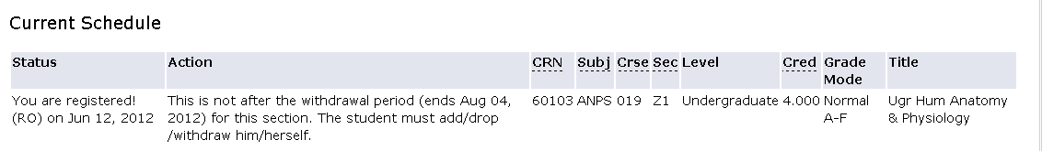

- If the student was enrolled in a modular course and it is graded before the term ends, this is what the dean’s office will see:

- If the modular course is over but not graded, the dean’s office will still not be able to do a withdrawal. This is what the dean’s office will see: 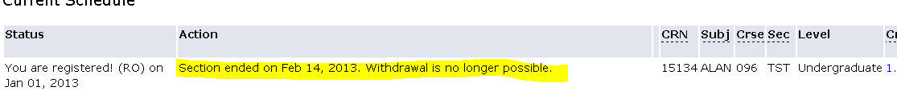

- If a dean’s office staff member tries to enter a student record while the student or RO staff are in it, this message will display:
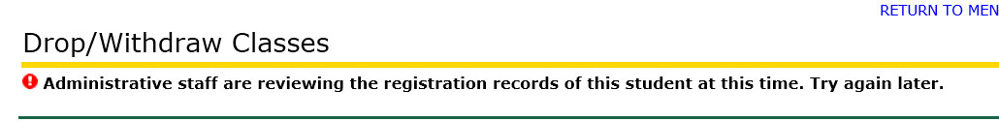

- If a dean’s office staff member tries to do a student WD, but while thinking about it the student enters his/her registration record, this message will display when the dean’s office staff member hits submit:
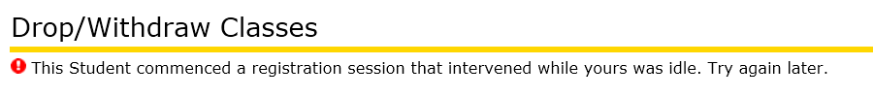

Technical items:
- Setup items
  - There must be an SFARGTC rule that encompass the WD period (currently the last day of class for the term).
  - The Web Reg end date on SOATERM must encompass the WD period (currently the last day of class for the term).
  - The end date for WD on SFARSTS must encompass the WD period (currently the last day of class for the term).

- Begin date for WD is determined by comparing sysdate to ssbsect_census_2_date. If sysdate >, the WD displays.

- End date for WD is determined by comparing sysdate to swbsect_wd_end_date. If sysdate >, WD does not display.
  - In addition to end dates, swbsect has fields for the 50% and 25% refund dates. These dates are calculated by procedure sfs_calc_wd_refund_dates.sql
  - Package hwwkaddp calls the sfs procedure and also an RO-written procedure (which calculates the add/drop/wd_end dates).
  - Any time a section is created or modified via SSASECT or SWCSCHD, package hwwkaddp is invoked causing all the dates to be recalculated.
  - Job rg2053up also calls hwwkaddp when it is run.

- The pending period ‘telescopes’ as follows. Set expire_date = SYSDATE. Add the number of business days. Compare that result to the swbsect_wd_end_date. If wd_end_date > result, then set expire_date = result and display the expire_date as the ‘pending until’ date. If result > wd_end_date, then subtract days as is needed so result will not exceed wd_end_date. Example: Business days = 2, last day to wd for the section is 14-Apr. Student chooses WD on 13 Apr. 13 Apr+2 = 15 Apr. 15 Apr > 14 Apr. So 14-Apr is set as the expire_date and the student is presented with the message ‘pending until 14-April’.

- WD details are in table swrstcr:
SWRSTCR_TERM_CODE
SWRSTCR_PIDM
SWRSTCR_CRN
SWRSTCR_TRIGGER_STATUS P if pending, else null
SWRSTCR_WITHDRAW_STATUS WP if pending, CA if cancelled, WD when pending expires
SWRSTCR_WITH_STATUS_DATE date of withdraw_status, changes whenever withdraw status changes
SWRSTCR_WITH_EXPIRE_DATE date request will expire
SWRSTCR_WITH_CANCEL_DATE date student canceled, may be null, if student cancels multiple times, most recent cancel request (i.e. it is updated, there is not a separate record for each cancel request)
SWRSTCR_LINK_CRN if section is linked, crn of the linked section
SWRSTCR_ERROR_CODE
SWRSTCR_PROVISIONAL_STATUS
SWRSTCR_INSERT_USER netid of person who requested the WD
SWRSTCR_INSERT_DATE never changes
SWRSTCR_UPDATE_USER OPS$BATCH when rg2070up expires the WD
SWRSTCR_UPDATE_DATE updated whenever an update occurs

A WD request inserts a row with an insert Date ( which is never changed) = sysdate, trigger status = P, Withdrawal Status = WP, Status_date = sysdate and Expire Date = calculated date value, update date = sysdate.
A Cancel request updates the same row, changing trigger status to null, changing wd status to CA and setting Cancel Date = sysdate
Changing Cancel back to WD updates the same row, trigger back to P, Withdrawal Status back to WP and Status Code Date and update_dates both = sysdate. Cancel date remains, showing at one time the student did request the cancel.
The completion batch program checks the Expire Date. If passed, it updates the same row with the Update Date = sysdate and a Withdrawal Status of WD and Status Code Date = sysdate.
- RG1203UP – This process finds students with sfrstcr_link_over = Y and sets it to null. This is necessary because if the value of this field is Y, it will allow only one component of a linked course to be WD. The process uses CurrTerm.

- Infotext for this process
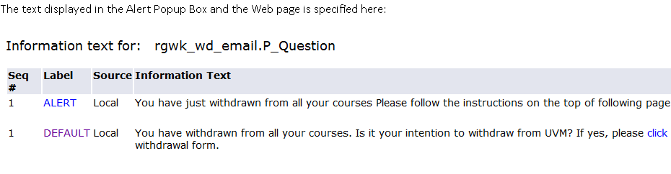
Also: P_AddDrop, P_FacAdd, P_Regs, P_SelDefTerm

- Check ‘Web ind’ on STVRSTS

- Note: if already graded, WD does not display as an option

- Whether or not a drop down box displays in the Action column (which may or may not have features when clicked) is determined by the status of the individual section.

  - If the section is already Withdrawn or graded, nothing displays in the Action column or the Request Withdrawal column. See BIOL 002 in the example below.

  - If the student cannot WD, but the dean’s office can process a WD, a drop down box displays in the Action column (with no choices when clicked) and the WD end date displays in the Request Withdrawal column (swbsect_wd_end_date). See CHEM 023 and SOC 001 below.

  - If the section is completely over (such as a winter session section or a modular section) such that neither the student nor the dean’s office may request a WD, nothing displays in the Action field and the section end date displays in the Request Withdrawal column (ssbsect_ptrm_end_date). See FOR 185 and RUSS 095 below.

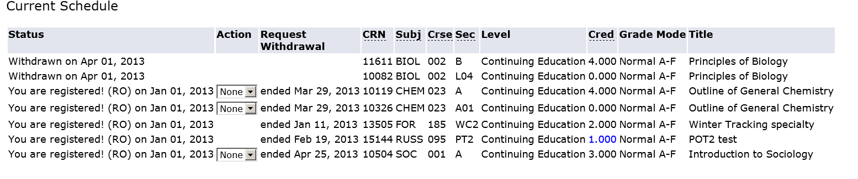
- SFS had a need for 25% and 50% WD dates to be calculated.
  - A database procedure was written to do this. It is fired ON INSERT and ON UPDATE in both SSASECT and SWCSCHD based on inserts/changes to the ssbsect start/end dates.
  - The dates are stored in SWBSECT: swbsect_wd_25_date, swbsect_wd_50_date.
  - SFS maintains the code that calculates these dates.

Troubleshooting
- This message displays when no rsts codes are valid for any part of term (i.e. SYSDATE > the end dates of all rsts codes on SFARSTS). If no rsts code can be used because it is past the date they are valid, there is no point in letting the student/dean into the update part of the registration system. Students/deans can view schedules in other ways. Here is the message:
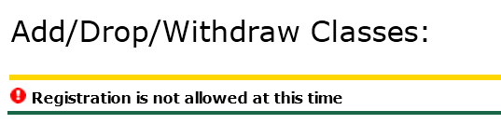

- If no ‘add’ boxes display at the bottom of the registration page, that means the RW code is not valid for any part of term for that term. In the example below, only WD is valid, so no ‘add’ boxes display:
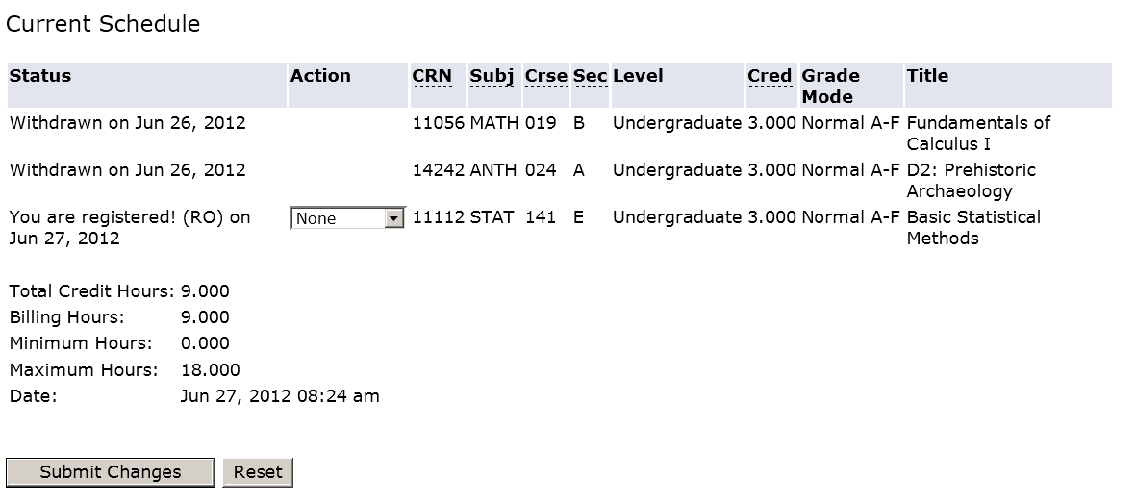
- If the student sees the messages that usually the dean’s offices see when they are doing a WD, it is because all the end dates for DW, RW and WD are the same on SFARSTS. This is not the case for fall/spring, but currently summer is set up this way. If we move to parts of term for summer, this should no longer occur.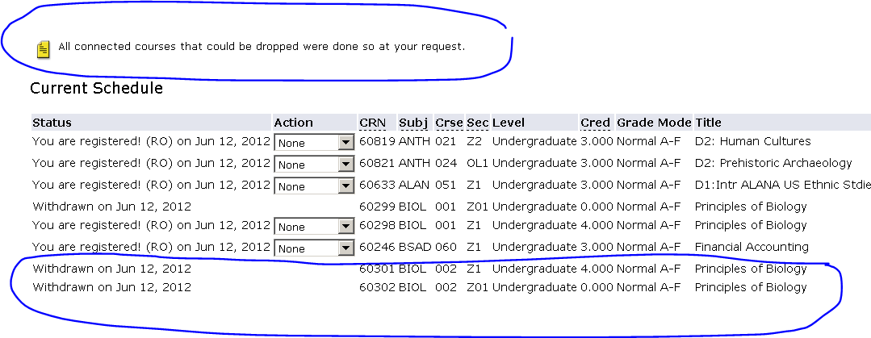
- Dean’s Offices are not able to WD students. They always get the message about it not being the end of the WD period.
  - This occurs if the end date for the WD code for that part of term for the term is > SYSDATE. Dean’s offices cannot WD students until after the system thinks the WD period is over. The end date for WD ‘tells’ the system when the WD period is over.

- If a student has the sfrstcr_link_error flag = ‘Y’, it will be possible for them to WD from only 1 part of a linked course. This flag is set on SFAREGS by either entering ‘All’ when overriding an error or responding ‘Yes’ to a link error. We run a nightly process to find these students and fix them (reset the error flag).

- If a dean’s office tries to do a WD after the term is over, this message will appear. This is because the EL status on SFAESTS date is < SYSDATE.
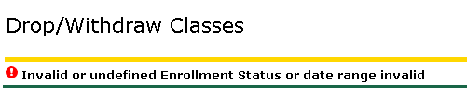

- Unfortunately the message below is not infotext. A programmer must modify bwcklib1.sql if we want it changed:
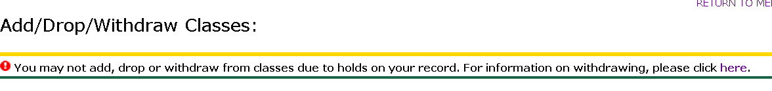
Notes from Warren re nuances:
Nuance 1:
Here's a case where only one (60298) of a pair of linked courses had been WD, and the instructor then does a 'DD' disenrollment for the other (60299) , which wipes out the 'WD'. Since this SHOULD never happen (a single WD, plus a 'DD' after a 'WD'), it is just worth noting for now.
Also worth noting is the method of instructor SSB disenrollments. Unlike the Dean and Student WD, it automatically DDs both sections that are linked -- NO confirmations or warnings. So this method bypasses some of the other rules. We need to be aware to this and I'll note it in the actual program comments.
-- Warren
60298 22 CE 4.00 RE Closed to Registration TEMP N GSTARKS 2012-06-26 08:47:56
24 CE 4.00 RE $ BASE N GSTARKS 2012-06-26 08:48:08
28 CE 4.00 WD Final grade updated to W TEMP N WWW_USER10G 2012-06-26 08:50:16
29 CE 4.00 WD Final grade updated to W BASE N WWW_USER10G 2012-06-26 08:50:16
35 CE .00 DD Final grade updated to NULL TEMP N WWW_USER10G 2012-06-29 14:52:18
36 CE .00 DD Final grade updated to NULL BASE N WWW_USER10G 2012-06-29 14:52:19
39 CE .00 DD Record deleted on 29-JUN-2012 BASE N lhill 2012-06-29 14:52:20
60299 23 CE .00 RE Closed to Registration TEMP N GSTARKS 2012-06-26 08:47:56
25 CE .00 RE $ BASE N GSTARKS 2012-06-26 08:48:08
31 CE .00 RE Linked course required (Lecture). TEMP N WWW_USER10G 2012-06-29 14:52:18
33 CE .00 RE Linked course required (Lecture). TEMP N WWW_USER10G 2012-06-29 14:52:18
34 CE .00 DD $ TEMP N WWW_USER10G 2012-06-29 14:52:18
37 CE .00 DD $ BASE N WWW_USER10G 2012-06-29 14:52:19
38 CE .00 DD Record deleted on 29-JUN-2012 BASE N lhill 2012-06-29 14:52:20

Nuance 2: Regarding output for linked sections on RG2070UP:
Let me again note that the Link ST statuses of WP and WD is normally since the link CRN status in the second row reflects that the WD was completed for it in the line above.
For example,
EE 101 A 10796 RW WP 01/30/2013 02/01/2013 L1 10801 WP
EE 101 A03 10801 RW WP 01/30/2013 02/01/2013 B1 10796 WD

Registration processing responds differently to these holds as follows.
Check Your Registration Status – the message displayed varies for each tier type.
Tier 1: No processing is permitted.
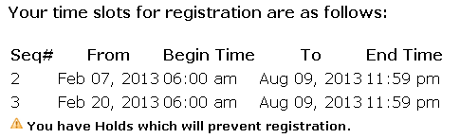
Tier 2: Student may drop or withdraw, but not add.
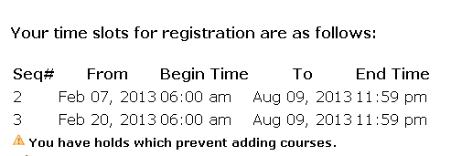
Tier 3 for term < RegTerm: No message is presented because any processing is permitted.
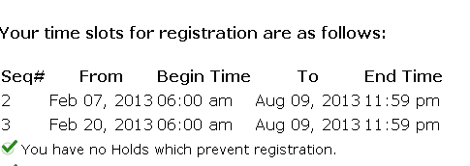
Tier 3 for term >= RegTerm: No processing is permitted.
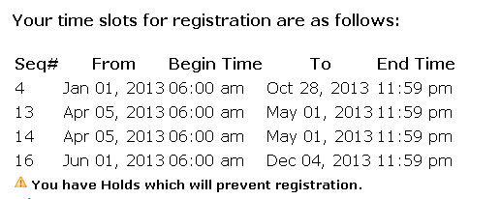

What the student sees when trying to navigate to Add/Drop/Withdraw Classes
Tier 1: No processing is permitted.

Tier 2: Student is presented with ability to drop or withdraw. No add boxes at the bottom of the page. No ability to navigate to Look Up Classes to Add.
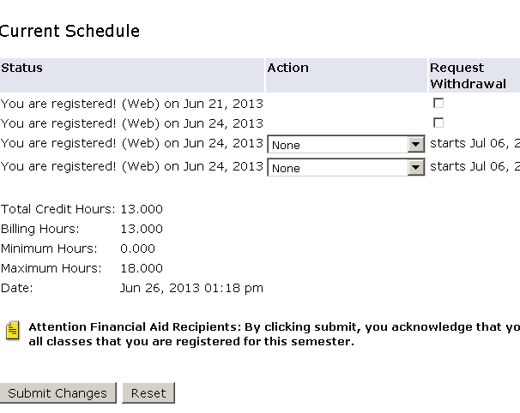

Tier 3 for term < RegTerm: All processing is possible.
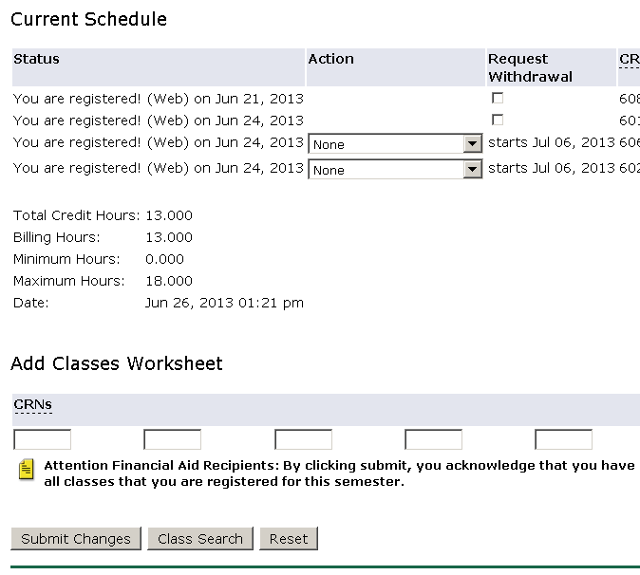
Tier 3 for term >= RegTerm: Same as Tier 1. No processing is permitted.

What the student sees when using Look-up Classes to Register/Add
Tier 1: Student can look at classes but cannot add: SR displays in the column where the add check box would normally be and there are no ‘register’ or ‘add to worksheet’ buttons on the page.
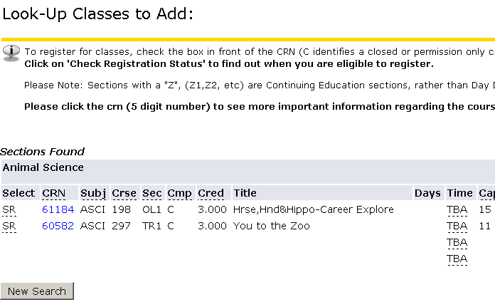
Tier 2: Same as tier 1 because adding is not permitted with Tier 2.

Tier 3 for term < RegTerm: Able to use and add classes, as all processing is permitted. Buttons display at the bottom of the page.
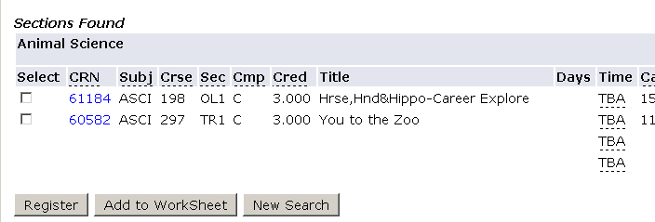
Tier 3 for term > RegTerm: Same as Tier 1.

If a student has multiple holds, the most stringent hold controls the behavior:
- Tier 1, Tier 2 – Tier 1 controls
- Tier 1, Tier 3 – Tier 1 controls
- Tier 2, Tier 3 – Tier 2 controls for term < RegTerm, but Tier 3 controls for term >= RegTerm(because when term >= RegTerm, AA is really Tier 1)
The infotext for the message given when trying to access Look Up Classes to Add is infotext:
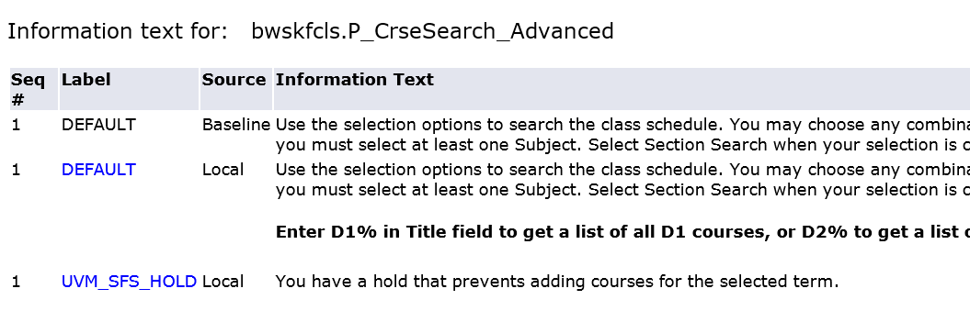
The message delivered when trying to access the Add/Drop/Withdraw page is not infotext. It is hard coded in bwcklib1.sql.
Warren’s documentation is here:
http://giraffe.uvm.edu/ais/rg/ssb_reg_uvm_mods_holds.html
All the source code modifications for this are tagged with:
UVM Mod RG-2013-06-21

