Caitlin O’Connell
Collective and Contested Memory of the of the Ennistymon Workhouse and its Memorialization
Introduction
The Ennistymon Workhouse in County Clare, Ireland is a traumascape as a result of the mass death that occurred at this site during the Irish Famine, or Great Hunger (Corless 2013). The An Gorta Mor Memorial, was erected across the street from the workhouse in 1995 to commemorate the 150th anniversary of the death of approximately one to three million Irish people during the Great Famine and the 20,000 who died at the workhouse (Corless 2013). The Great Hunger lasted from about 1845 to 1850 (An gorta memorial 2015). Workhouses were created in Ireland under the British Poor Law system and were especially utilized during the Great Hunger (Clare County Library 2015). This memorial was the first created in Ireland to honor those who died during the famine and at the workhouse (Corless 2013). It is estimated that during the famine approximately 20,000 Irish people died at the Ennistymon Workhouse, many of them children (Coreless 2013). The monument is erected near a mass graveyard for children who died and were buried without coffins during the famine (Coreless 2013). The Irish Famine is also a contested and political collective memory, providing evidence for a variance in meaning derived from and attributed to memorials, such as the An Gorta Mor Memorial. Additionally, it is a symbol of Irish national unity and collective identity. Today, this commemorative monument serves as a significant tourist destination for travelers in Ireland (Coreless 2013). It continues to inform Irish collective memory through the geographical location of this traumascape and online virtual traumascapes (Kaelber 2010).
Contested Collective Memory and Memory Politics
While many cite the potato blight that spread through Ireland and the United Kingdom during the 1840s as the primary cause for the Great Hunger, Daly’s (1986) research indicates that potato crop failure was not the primary cause of mass starvation (p. 56). Irish tenant farmers were generally required to provide other food production to British estate owners, thus leaving Irish farmers to subsist on the potato. In comparing agriculture statistics, Daly finds that crop production was only 5% less at the start of the famine as compared to five years prior to the famine and food supplies were up 13% from 1841 when there was no famine (Daly 1986, p. 56). In addition, while the potato fungal disease, Phytophthora infestans, spread throughout Ireland and the U.K., other countries did not experience the high degree of death due to starvation (Dworkin 2012). Rather, the mass export of grain and cattle accounted for the lack of food that would have served as alternative food sources for the Irish (Daly 1986). At the height of the famine, in 1847, also referred to as ‘Black 47,’ 4,000 ships carrying £17,000 worth of food travelled to England, the same year that an estimated 500,000 Irish people died of starvation and related illness (Dworkin 2012).
British control of Ireland and Irish resources, including land and food production, is understood in Irish collective memory as the primary agent for the mass death and emigration that occurred during the Great Hunger (Daly 2012, p. 8). This is a contested and political memory, as British collective memory often lists the potato blight and carelessness by the Irish as the primary cause of mass death (Dworkin 2012). Dworkin (2012) describes that the majority of deaths were people who spoke Gaelic and were ethnically Irish. Land owners who remained in Ireland following the famine experienced an increase in the standard of living, as a result of “diminished population pressures and a shift towards more profitable large-scale farming” (Dworkin 2012, p. 7). Yet for a time after the famine, this historical narrative was missing from international public collective memory of the Irish famine. Savelsberg and King (2013) argue that it is most especially the “historical consciousness” of the past that allows its full depiction and understanding in contemporary society. Carrier groups, such as civil rights activists, allow historical memories to be remembered even if the dominant members of international memory politics would rather experience collective amnesia (Savelsberg and King 2013). Irish activists, through mobilization efforts, have brought the Irish experience during the famine to the fore in recent years, particularly with an increase in memorialization in the 1990s (Tsutsui 2009).
The issue of political contested memory still dominates the international discussion of how the famine, the resulting deaths, and sites of memory should be conceptualized in collective memory. Historical records, from the Illustrated London News, (1849-1850) provides evidence of the long standing politicized memory of the famine and the resulting deaths. The weekly news reports describe the eviction of Irish farmers from estate land with the passing of the Poor Laws and the manner in which British estate land owners capitalized on the potato blight as an opportunity for increasing pasture land and ridding themselves of Irish tenants (Illustrated London News 1849). Yet commentary in the Illustrated London News in 1850 contextualizes this suffering within a British ideology, asserting that ultimately the laziness and undeveloped qualities of the Irish were responsible for the unacceptable conditions. This framework is established with supplementary quotes. The English Captain Kennedy in a letter from 1846 published by the British House of Commons calls the Irish “improvident, ignorant… human in habits and intelligence only… [and] half-witted occupiers” (Illustrated London News 1850). This provides evidence that British prejudice regarding the Irish did not occur occasionally, on an individual basis. Rather, these beliefs were held on a widespread societal scale, with government support. This framework of collective forgetting continues to permeate current British popular collective memory, though certainly via the use of contemporary vocabulary and different metaphors. Additionally, it is important to understand that while the ethnic conflict between the British and Irish is frequently cited as a religious battle between Protestantism and Catholicism, this is an inaccuracy that fails to consider the racism, rather than religious identity, that underlies many of the stereotypical assumptions that infiltrate collective memory.
Regarding contemporary contested memory, Peter Gray (2004) provides evidence of British criticism of revisionist memorialization of the famine. In chapter two of The Memory of Catastrophe he provides a platform for engaging with British and Irish collective forgetting and memory. Gray (2004) provides testimony to the mass commemoration that occurred in the 1990s, suggesting that the memorialization was ‘heritage’ related and was used as a tool for providing national and ethnic identity for Ireland and trans-national people of Irish decent (Gray 2004). His criticism of revisionist history, which has come in conflict with popular belief, speaks largely to the still existing tension between the British and Irish ethnic groups. These are tensions that continue to have real implications for Irish land ownership, specifically Northern Ireland, economic development, and international relations. Finally, his dismissal of the Irish historical narrative, which has created a revisionist history for a time period previously recorded and discussed from the dominating British group, is indicative of what Tsutsui (2009) refers to as a denial response to a nation’s dark past.
In American Memories: Atrocities and the Law, Savelsberg and King (2011) explore the impact of legal proceedings on the collective memory of social atrocities in society. Through their research, they establish that laws create memory, impact history, and influence equality and justice in contemporary society. Savelsberg and King (2011) argue that conflicting interest groups influence collective memory and historical accounts. British and Irish historical accounts and collective memory regimes regarding the famine represent conflicting interest groups with disparate historical accounts. Yet in the absence of trials, events are often forgotten. Because the Irish famine was never processed through a judicial system, there is no single collective memory for this time period, with no distinctly defined perpetrators.
Multiple Memories Rather than One Collective Memory
In understanding the collective memory of the Irish Famine, Cormac Ó Grada (2001) provides evidence that there were a multitude of experiences based on class and ethnicity during the famine. Farmers and their dependents were most severely affected by the famine as a result of their loss of livelihood when they were evicted from their land (O Grada 2001). Certainly many Irish people were farmers, often tenant farmers on British occupied estates, and generally poor, so understandably a considerable segment of the Irish population was affected. As the famine progressed, divisions were created between people over access to food and conflict ensued. Although, an Irish Folk Lore survey of the 1930s and 1940s intended to shed light on this time period, it conversely provided barriers in understanding the famine (O Grada 2001). A significant lapse in time, victims’ reluctance to share experiences, the inability of non-victims to listen, and potential selection biases in the survey created difficulty in creating a comprehensive memory of the famine (O Grada 2001). Rather, it enforced the erroneous collective view that all of those living in Ireland shared an identical experience during the famine, while in reality there was a variance in experience based on ethnicity or economic resources (O Grada 2001).
As further evidence of this variance in experience, that is often notably absent in collective memory and its representation, the Illustrated London News stated in 1849, a ‘Protestant’ [English] community occupied “neat white-washed houses and tidy gardens.” Certainly some counties, such as Ulster, were largely unaffected and life went on as usual during the brief years of the famine, while other regions, such as County Clare, experienced dire circumstances and high death rates (O Grada 2001). Additionally, middle and upper class Irish, particularly with certain professions, were not as harshly impacted by the famine, were more likely to have the financial means to be able to emigrate, and less likely to require public relief or to enter a workhouse (O Grada 2001).
Memorialization
In Memorial Mania Doss (2010) describes the contested nature of monuments and memorials. She states that memorials represent one perspective of a historical narrative and often, due to the subjective nature of history, misrepresent or ignore some groups (Doss 2010). As memorials and monuments typically represent the voice and perspective of the most powerful groups in society, sometimes with overt political aims, these representations can be problematic and elicit anger (Doss 2010). Following the famine, there was a considerable absence of Irish commemoration regarding the famine. By the 1990s, memorialization efforts sought to depict the Irish experience, which had been misrepresented and ignored (Doss 2010). Specifically, the An Gorta Mor Memorial acted as a commemorative vehicle for the Irish Famine.
The An Gorta Mor Memorial in County Clare was the first memorial in Ireland that commemorated the Great Famine and aimed to depict the collective memory and consciousness of the famine. It was constructed in 1995 on land owned by the city council due to the advocacy work of the Ancient Order of Hibernians (AOH) and the Clare County Council (Corless 2013). The memorial was dedicated with a commemorative mass and pipe band procession down Lahinch Road toward the monument (Corless 2013). Hundreds of AOH members and the Minister of State attended the event (Corless 2013).Today the actual workhouse has been replaced by a hospital, as the workhouse was demolished in the 1920s (Higginbotham 2015). Now, only part of the crumbling stone dining hall and chapel still remain.
The An Gorta Mor Memorial features two pieces of gray slate, made to look like workhouse doors, on a slate floor surrounded by stones. In front of one door stands the statue of a young boy. Across from the child, the other door features the stone statue head of a tormented mother with her hands clenched in anger (Corless 2013). On one of the doors is a quote.
Gentlemen, there is a little boy named Michael Rice of Lahinch aged about four years. He is an orphan, his father died last year and his mother has expired on last Wednesday night, who is now about being buried without a coffin unless ye make some provisions for such. The child in question is now at the workhouse gate expecting to be admitted, if not he will starve (Coreless 2013).
This note was found in historical papers of the workhouse and was evidently pinned to the shirt of a boy left at the Ennistymon Workhouse on February 25th, 1848 (Corless 2013). The memorial is surrounded by a groomed lawn and an informational board that provides the visitor with contextual information on the famine in Ireland. Additionally, a stone that resembles a grave marker states in English and Gaelic the date the memorial was erected and a dedication to those who died during the Great Hunger. Behind the memorial is a privately owned bed and breakfast.
Symbolic Role of Memorialization
Based on Doss’ (2010) research on memorialization of public affect, the An Gorta Mor memorial can be conceptualized as representing collective ‘grief.’ She describes how political, social, and cultural perspectives inform the significance derived from the past, epitomized in the physical monuments and memorials used to commemorate events (Doss 2010). These “archives of public affect” provide an argument for the subjective nature of history and memory (Doss 2010). Doss (2010) argues that widespread public grief has the potential to mobilize, change, and threaten the established order. Through grief management techniques and representation, this mobilizing emotion can be harnessed and redirected to support or dissuade political aims. These issues touch on matters of cultural heritage, citizenship and membership, historical revision, privilege, power, and injustice (Doss 2010).
The embodied traumascape of the Ennistymon Workhouse provides a location for Irish ceremonies related to the Great Hunger and the memorial is an evocative tribute to the death of those at the workhouse and throughout Ireland. Because it is a tourist destination it is a focusing agent for ritual remembrance of the Great Hunger for those who visit the location. Yet although the visitor is prompted by the memorial and informational signs to ponder the famine, the Ennistymon Workhouse no longer exists. This embodied site as a location for the mass death of 20,000 during the famine is somewhat obscure for the visitor. Rather, research on the virtual traumscapes provides significantly more context. The websites allow people throughout the world to gain accurate historical information on this traumascape and engage with the past.
Virtual Memorialization
In contrast to the embodied traumascape of the Ennistymon Workhouse, virtual traumascapes of the workhouse contain significantly more information and explanation specific to the Ennistymon Workhouse, as well as a platform for discussing how families were affected during this time period. A virtual traumascape is provided by the County Clare Library on their website (Clare County Library 2015). This website provides eleven main pages that detail the history of the Irish Poor Law Act, the Ennistymon Union, workhouse staff, punishments, children at the workhouse, disease, suppliers to the workhouse, outdoor relief, workhouse overcrowding, emigration, and dietary records (Clare County Library 2015). Other pages that link from the main pages provide more detailed information.
One page on the County Clare Library’s website contains a list of deaths in the workhouse from March, 1850 to March, 1852 (Clare 2015). This long and striking list provides the name, age, sex, cause of death, and date of death for each person (Clare 2015). A dietary sheet used at the workhouse in 1850 is available on the website. This lists the food and amount available to the inmates (Clare 2015). The County Clare Library website also provides minutes from Ennistymon Union Meetings from 1839 to 1850. These detailed primary source records provide information on shipments to the workhouse, the health of the Irish at the workhouse, including illnesses and death, shopping lists, changes, and requests (Clare 2015). The medical report in the notes from the Ennistymon Union Meeting from December 1848 to February 1849 states that “the house is in a very unhealthy state at present particularly with respect to fever…There are 142 in infirmary suffering from various diseases” (Clare 2015). These historical documents allow the researcher to engage with the experience of the Irish at the workhouse.
A library forum provides space for library patrons to discuss questions (Clare 2015). One forum called the ‘Clare Past Forum’ provides a venue for dialogue regarding County Clare’s history, including possible discussion of the Ennistymon Workhouse and the Great Hunger (Clare 2015). Particularly active, is the forum devoted to discussing emigration from County Clare following the Great Hunger (Clare 2015). Participants on the forum live in County Clare, as well as internationally and do not have to be County Clare Library patrons (Clare 2015).
A second virtual traumascape provides supplementary information on the physical layout of the workhouse before it was torn down. On a webpage created to provide information on workhouses throughout the U.K. and Ireland, Peter Higginbotham (2015) provides descriptive information and historical visuals. His page states that when it was in operation, beginning in 1842, the Ennistymon Workhouse could accommodate 600 inmates and included an entrance, administrative section, master’s quarters, male and female wings, bake house, wash house, infirmary, ‘idiot’s ward,’ chapel, and dining hall (Higginbotham 2015). During the Great Hunger a hospital was erected (Higginbotham 2015). The webpage also provides an architectural drawing of the workhouse layout. Because the workhouse has been mostly demolished, this is information that would not be available to a visitor at the actual traumascape.
Memories of the Workhouse and its Representation
Although the An Gorta Memorial and websites related to the workhouse provide a starting point for discussions regarding the Ennistymon Workhouse during the Irish Famine, valuable insight can be gained by understanding the actual experiences of inmates in the workhouse. Yet in understanding life inside the workhouse there is less concrete historical information. As Cormac Ó Grada (2001) states there is a conspicuous lack of first hand historical records of these experiences and how decedents have interacted with the workhouse traumascape. The Irish Folklore Commission survey in the 1930s and 1940s provides little information on survivors or descendants of the workhouse. Although survivors of the workhouse were likely poor and unlikely to have emigrated, this gap in historical record may reflect a selection bias in questionnaire or shame and denial of a family’s dark past (O Grada 2001). Receiving public relief or entering a workhouse was indicative of being poor and there was significant stigma surrounding this experience (O Grada 2001).
The information that is available from surviving records describes death rates and conditions inside the workhouse (O Grada and Guinnane 2002). Unfortunately, Ennistymon’s admission books no longer exist but there is evidence that it was overcrowded, did not provide adequate food, and as indicated by the high death rates resulting from contagious diseases, had a “shortage of cloths, staff, beds, and ventilation” (O Grada and Guinnane 2002). There is also information to support that there was corruption and mismanagement of the workhouse, contributing to high death rates (O Grada and Guinnane 2002) County Clare was especially impacted by the famine, so it is likely the conditions were particularly dire due to severe overcrowding and food shortages (O Grada and Guinnane 2002).
A point of particular sadness regarding the workhouse was the high proportion of child deaths (O Grada and Guinnane 2002). Children often entered the workhouse as orphans during the famine or were separated from their parents once in the workhouse. As a result of the conditions, young children were particularly susceptible to marasmus, a non-contagious disease resulting from severe protein malnutrition (O Grada and Guinnane 2002). There is evidence that 7.3% of all deaths in workhouses resulted from marasmus (O Grada and Guinnane 2002). Savelsberg and King (2011) assert that mnemonic bridging and haunting are vehicles through which past memories continue to impact present events. Certainly the historical evidence of conditions for the Irish during this time period provides a platform for collective grief. These collective memories continue to resonate for contemporary Irish identity. As a result of the loss of lives, land, and resources the famine and British occupation, had lasting repercussions that continues to infiltrate Irish national identity. Through memorialization efforts at physical or virtual traumascapes these experiences continue to be remembered, contested, and analyzed.
Conclusion
Today many tourists continue to travel to the An Gorta Mor Memorial and engage in ‘dark tourism’ (Kaelber 2010). Visiting this location is a striking reminder of the loss that occurred for the Irish during the Great Hunger. Situated near a burial site of 20,000 people and across from the remnants of the old workhouse, visitors can visit the place of death of thousands during the famine (Corless 2013). The symbolic statues poignantly depict the sadness from this time period and the visitor sign provides some context. Yet visitors will find a lack of information on the experience of those living in the workhouse (Corless 2013). Additionally, because little of the workhouse’s structure still exists, the visitor will not specifically understand the loss and suffering that occurred on Lahinch Road in the mid-19th century. In contrast to the embodied traumascape, the virtual traumascapes of the Clare County Library and Higginbotham’s webpage provide information not available to the tourist at the embodied traumascape (Higginbotham 2015). Insight from historical research on conditions in workhouses during the famine also provides valuable insight on the Ennistymon Workhouse (O Grada and Guinnane 2002). Additionally, County Clare Library’s online descriptive summaries and primary source historical documents from the workhouse allow individuals in any part of the world to study the Ennistymon Workhouse (2015). Ultimately, the An Gorta Memorial symbolically represents the history, feelings, and memories of Ireland during the famine. It expresses national identity and purpose and provides a platform for continued conflict regarding the contested collective memory of the Irish Famine.
Appendix
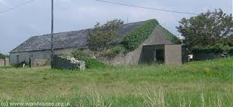
Fig. 1 All that is left of the Ennistymon Workhouse are the crumbling dining hall and chapel.
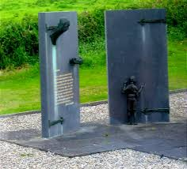
Fig. 2 An Gorta Mor Memorial resembles doors of the workhouse.
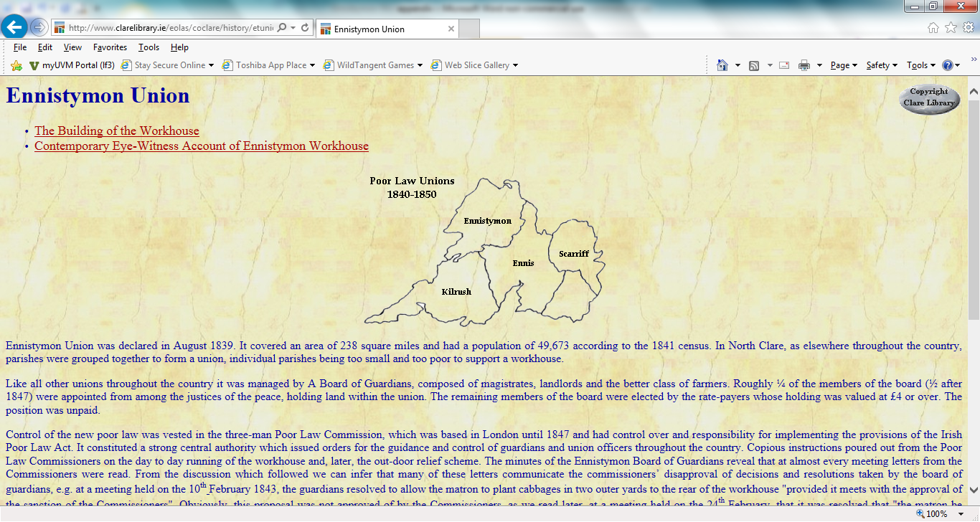
Fig. 3 Clare County Library webpage provides historical information on the Ennistymon Workhouse during the famine.
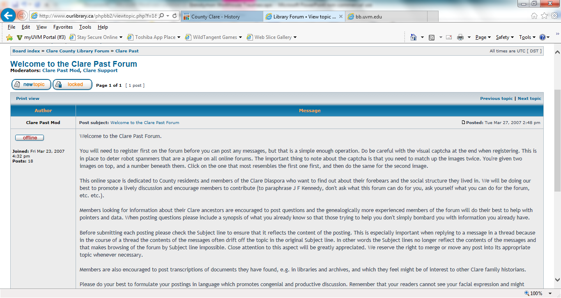
Fig. 4 Clare County Library ‘Past Forum’ exchange questions and information on Ennistymon Workhouse and emigration.
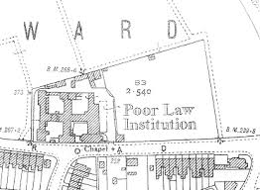
Fig. 5 Higginbotham’s website provides details about the physical structure of the workhouse.

References
Clare County Library (2015). “A Guide to Ennistymon Union.” Retrieved March 19, 2015
(http://www.clarelibrary.ie/eolas/coclare/history/etworkhouse.htm).
Corless, Nicola (2013). Call for Ennistymon famine memorial refurbishment. Clare Champion.
Retrieved March 19, 2015 (clarechampion.ie/call-for-ennistymon-famine-memorial-
Refurbishment)
Daly, Mary E. (1986). The Famine in Ireland. Dundalk, Ireland: Dundalgan Press.
Dworkin, Dennis (2012). Ireland and Britain 1798-1922. Indianapolis: Hackett Publishing Co.
Dyson, Tim and Cormac Ó Gráda. 2002. “The Workhouses and Irish Famine Mortality.”
Pp. 47-63 in Famine Demography: Perspectives from the Past and Present.
New York: Oxford University Press.
Gray, Peter and Kendrick Olver. 2004. “Memory and Commemoration of the Great Irish
Famine.” Pp. 46-60 in The Memory of Catastrophe. Manchester, England:
Manchester University Press.
Higginbotham, Peter (2015). Ennistymon, County Clare. Retrieved March 19, 2015
(http://www.workhouses.org.uk/Ennistymon/)

The Illustrated London News. 1849-1850. “Conditions of Ireland: Illustrations of the Poor
Law.” County Clare: Clare County Library, Retrieved April 10, 2015
( http://www.clarelibrary.ie/eolas/coclare/history/conditions_ofIreland)
Kaelber, Lutz (2010). Virtual traumascapes: The commemoration of Nazi ‘children’s euthanasia’
online and onsite. Digital Icons: Studies in Russian, Eurasian, and Central European
New Media. 4:13-44.
Ó Gráda. 2001. “Famine Trauma and Memory.” Béaloideas.. 69: 121-143.
Savelsberg, Joachim J. and Ryan D. King. 2011. American Memories: Atrocities and the Law.
New York: Russell Sage Foundation.
Tsutsui, Kiyoteru. 2009. “The Trajectory of Perpetrators’ Trauma: Mneumonic politics around
the Asia-Pacific war in Japan. Social Forces. 89, 3: 1389-1422.

