HCOL 195 Geology’s Intersection with Human Health Mineral Identification Exercise

Minerals: **Naturally occurring, typically inorganic materials with an ordered atomic structure**

**ID of minerals based on CHEMISTRY + STRUCTURE**

To “probe” the chemistry and structure of minerals we will utilize how light interacts with minerals

**Polarized Light Microscope (PLM):** Powerful tool for mineralogy – polarizes white light (light vibrates in one plane) and sends it through a thin section (mineral/rock cut and polished to 30 micron thickness). Minerals slow down certain wavelengths of light more than others, and twist the plane of the light – they do this based on differences in their CHEMISTRY and STRUCTURE

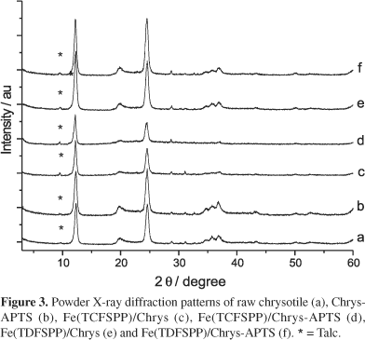**X-Ray Diffraction (XRD)**: Another very powerful tool, utilizes how X-rays (which as they are higher in energy, vibrate over a smaller amplitude) interact with planes of atoms in a mineral, letting us know how far apart atoms are from each other – when done in 3 dimensions, this determines the STRUCTURE

Changing angle of X-ray to mineral determines distance between planes of atoms – generates a diffraction pattern

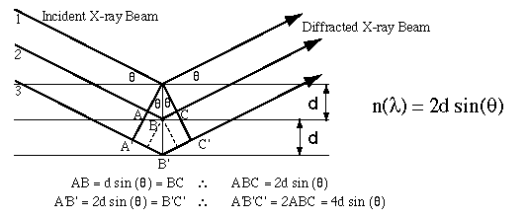

**X-Ray Fluorescence (XRF):** X-rays can also interact with the electrons in each individual atom of a mineral – exciting those electrons, which emit a secondary X-ray at a different wavelength when they relex back to lower energy. That emitted X-ray comes out a a wavelength specific to the element, more X-rays at a specific wavelength mean more atoms of that element in the sample – great way to determine the CHEMISTRY of the mineral.

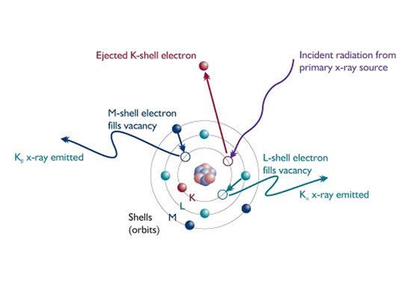

Raman Spectroscopy: This is a spectroscopic technique, using high-energy laser light to probe the bonds in between atoms in minerals. Some of these bonds scatter light in a special way, shifting the wavelength of the light that scatters off the mineral.

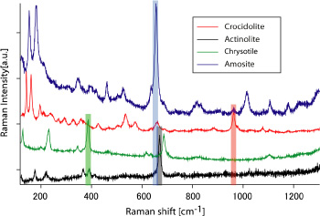

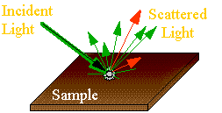

Scanning Electron/ Transmission Electron Microscopy (SEM/TEM): Microscopy that uses high-energy electrons to image very small particles (because the smallest wavelength of visible light is around 300 nanometers, we cannot see things smaller than 300 nm with visible light – these electrons have much smaller wavelengths and can ‘see’ the tiniest of nanoparticles and fibers)!

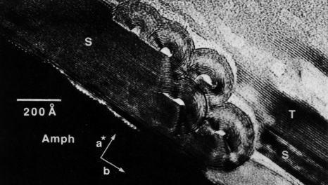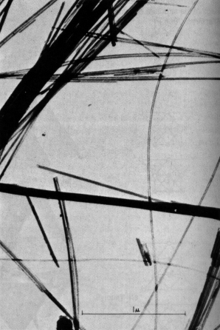

SEM image of fibers

TEM image of fiber end-on, note layers of molecules rolled up like carpet...

Combined Approach: Recall from our initial discussion the iterative process of scientific investigation, testing of materials for the presence of asbestosform minerals and determining how much there is will be a process that will take more than one step or technique!!

Exercise: Look at samples from VAG mine and other asbestos samples using PLM, Raman, and XRF, noting especially what each one does and does not tell you about the mineral. Compare and contrast each method and indicate key properties each is best at describing…

Report: Together with another day’s work (and maybe two) you will prepare a description of samples from the VAG (Vermont Asbestos Group) mine describing them using these different techniques, identifying key minerals (absbestos minerals…), and how you know what they are. For now, keep notes on the techniques associated with these samples