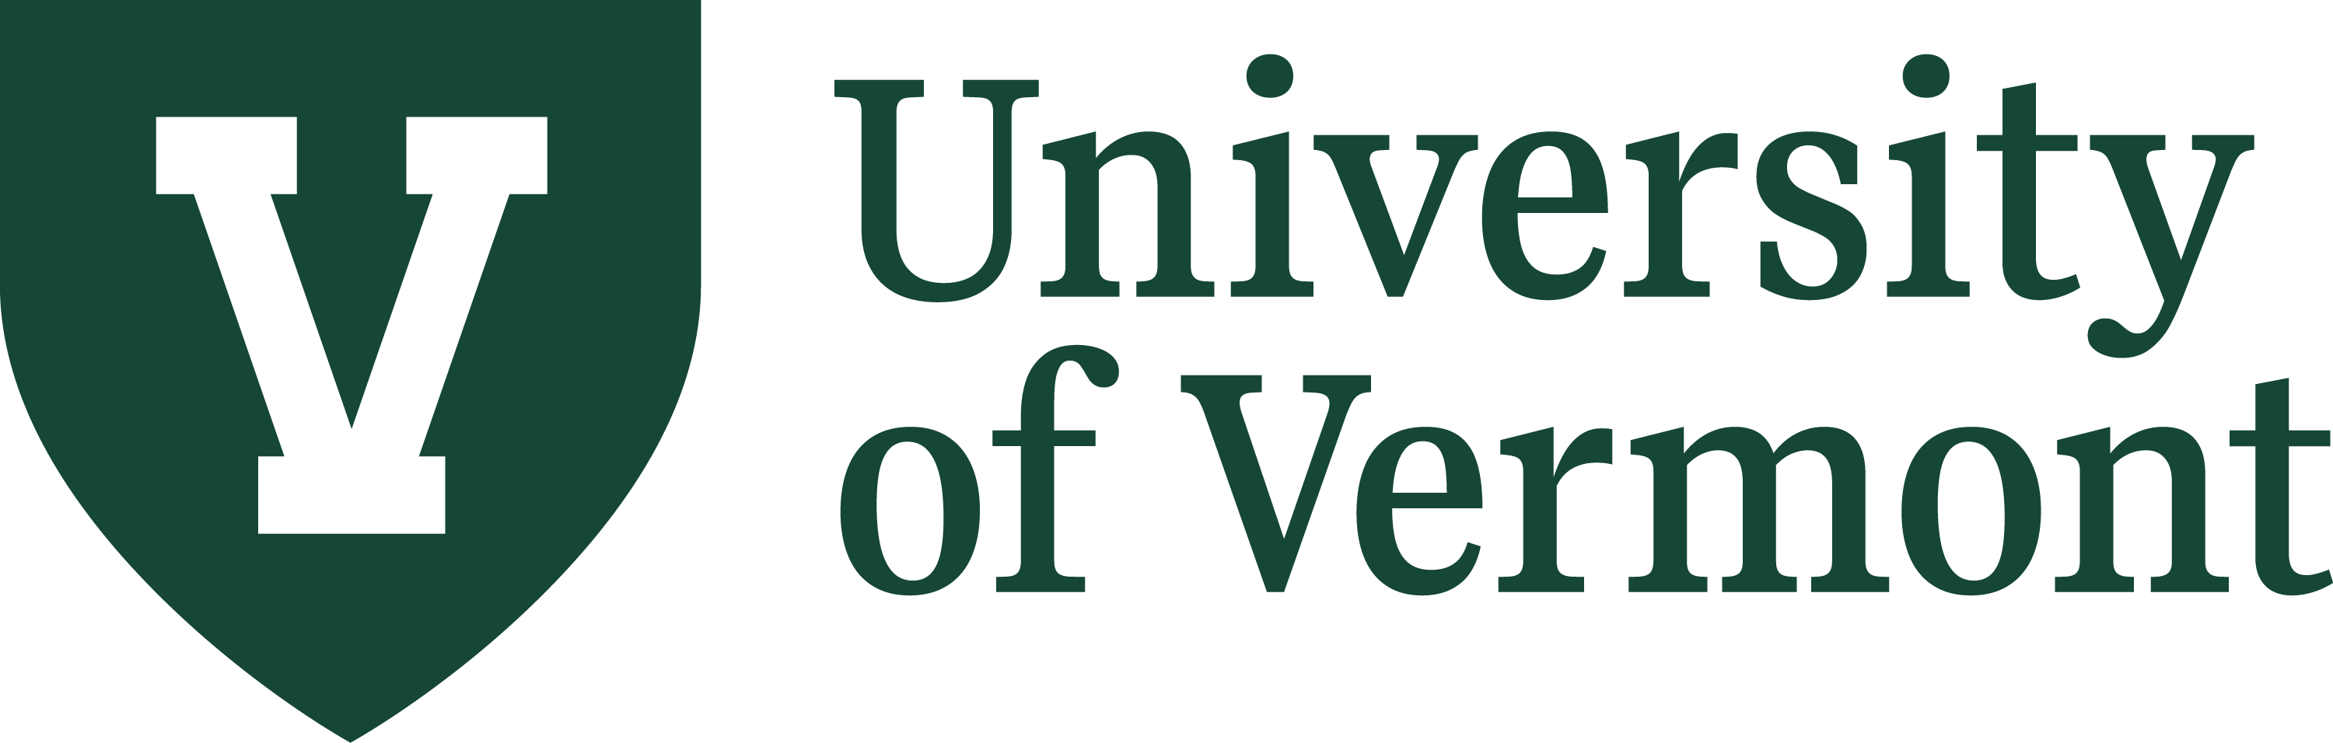

Assessment Plan Template

Office of Institutional Research & Assessment

Updated Spring 2024

Contents
Introduction 3
Program Information 4
Mission Statement: 5
Student Learning Outcomes: 5
Rubrics 7
General Rubric Template 7
Data Source/Course Specific Rubric Template 7
Curriculum Map 7
E1A/E1B Forms 8
E1A Form: 8
E1B Form: 8
Measures 8
Direct Measures 9
Indirect Measures 9
Communication 10

Introduction

The purpose of this document is to assist you in creating a meaningful and sustainable assessment process in your department or program (graduate degree, major, minor, certificate, etc.).

Individual pieces of this Plan (ex: Rubrics, Curriculum Map) can be updated without needing to complete the rest of the Plan as needed. Please make sure to send your complete Plan, or updated pieces of it, to assess@uvm.edu so we can keep our records current.

Don’t hesitate to reach out with any questions that you have or if you need assistance in completing or updating your Plan.

Richard Cohen, Ph.D.
Assessment Coordinator
Office of Institutional Research & Assessment

Program Information

*Program: _______________________________________

Program Assessment Coordinator: _______________________________________

Assessment Committee Members (if applicable): _______________________________________

_______________________________________

Chair: _______________________________________

Department: _______________________________________

College: _______________________________________

Person Completing Report: _______________________________________

*NOTE: Ideally, every Program should have its own Assessment Plan. However, in instances where two or more programs share a significant amount of their Learning Outcomes it is OK to submit a single Assessment Plan for them. However, every effort should be made to include information differentiating between the two Programs in each part of the Plan (Learning Outcomes, Rubrics, Curriculum Map, etc.)

Mission Statement:

In this space, please include the mission statement for your Program. If this Plan covers more than one program, please indicate how the mission statement of each differs from the others.

Student Learning Outcomes:

In this space, please list the learning outcomes for your Program. If this Plan covers more than one program, please list the shared outcomes first and then the remaining outcomes separately.

For assistance in writing Student Learning Outcomes for your Program, please contact Richard Cohen via email or Microsoft Teams.

NOTE: There is no “correct” number of learning outcomes that your Program should have. You should have enough to cover the entirety of student learning but not too many that it becomes impossible to create a sustainable assessment cycle. Although there are 8 spots below, you should not interpret this as the number of learning outcomes you should have and should add/remove spots as needed.

Learning Outcome #1:

Learning Outcome #2:

Learning Outcome #3:

Learning Outcome #4:

Learning Outcome #5:

Learning Outcome #6:

Learning Outcome #7:

Learning Outcome #8:

Rubrics

Two different levels of Rubrics should be created for your Outcomes:

General Rubric Template

This rubric describes student behavior at each level of learning across the curriculum of the Program; it does not contain language to any specific course or activity. A single General Rubric should exist for each of your outcomes.

Data Source/Course Specific Rubric Template

This rubric translates the language of the General Rubric into the language of the specific course or activity that is used to assess the outcome. Each data source for your outcome should have its own Data Source/Course Specific rubric; in other words, if you have two data sources for an outcome, two different Data Source/Course Specific Rubrics should be created, one for each data source.

For new Assessment Plans, rubrics do not need to be created for all learning outcomes. Instead, focus should be on creating rubrics for the outcomes assessed in the first year of the new plan with rubrics for the other outcomes being created either the year before it is assessed, or at the start of the academic year they are assessed.

All Rubrics should be submitted to Assess@uvm.edu. Rubrics can be updated anytime as needed and does not require the submission of an entirely new Assessment Plan.

Curriculum Map

A curriculum map is designed to show where Program Learning Outcomes are learned and assessed (the data sources) in your Program. Please make sure the map indicates which year of your Assessment Cycle each outcome will be assessed, which courses Program Learning Outcomes are taught in (using checkmarks), and which courses outcomes are assessed in (using the abbreviation “DS”).

All Curriculum Maps should be submitted to Assess@uvm.edu. Curriculum Maps can be updated anytime as needed and does not require the submission of an entirely new Assessment Plan.

E1A/E1B Forms

NECHE requires all Programs to have updated E1A or E1B forms on file. These forms can be updated anytime as needed as does not require the submission of an entirely new Assessment Plan. When completed or updated, please submit them to Assess@uvm.edu. These forms can be found at the following links:

E1A Form: This form is required for any Program that does not have an external accreditation.

E1B Form: This form is required for any Program that has an external accreditation.

Measures

Measures are created by Faculty within data sources to assess each learning outcome.

Direct measures typically originate from courses and consist of artifacts of student work. Examples of direct measures include:
- free response questions,
- subset of multiple-choice questions,
- performances or artwork,
- laboratory reports,
- papers.

Indirect measures mostly refer to items that are not artifacts of student work. Indirect measures may ask people to reflect on their perceptions of learning or include parts that go beyond the outcome itself. Examples of indirect measures student include:
- results of student or Faculty surveys,
- focus groups,
- grades,
- completion rates,
- graduation rates,
- employment rates,
- employer surveys.

Please provide a list of measures that you plan on using during your assessment process.

Direct Measures
Measure Name | Outcome(s) Measure is Used With

Indirect Measures
Measure Name | Outcome(s) Measure is Used With

Communication

Briefly discuss how the results of assessment activities will be communicated with your Department, College, and/or the entire campus community. Please make sure to highlight any regular assessment workshops/events/trainings that your Department/College sponsors.

