Table of Contents
(Click entry to jump to page)
Introduction 3
Basic Recruitment Steps in PeopleAdmin 4
Position Management Module 5
Applicant Tracking Module 5
Logging Into PeopleAdmin 6
Basic Navigation 6
Navigation in the Position Management Module 7
Inbox 9
Watch List 9
How to View a List of Positions 10
How to View/Print a Position Description (Staff only) 11
How to Initiate an Action on an Existing Position 12
How to Initiate an Action on a New Position 13
How to View a List of Actions 14
How to Change the Status of an Action 15
How to Modify Your Search Results 16
How to Create a New Staff Posting 19
How to Create a New Faculty Posting 21
Waiver Posting Instructions 23
Staff Waiver Steps 23
Faculty/Academic Administrator/Unclassified Waiver Hire Steps 24
How to View a List of Postings 27
How to Change the Status of a Posting 28
Cancelling a Posting 29
How to View Applicants in a Posting 29
Tips for Downloading Applicant Documents 30
How to Run a Demographics Report on Your Applicant Pool 32
How to Change Applicant Statuses 33
Changing the Status of a Single Applicant 33
Changing Multiple Applicant Statuses at Once 33
Hiring Proposal Instructions 34
Staff Hiring Proposals 34
Faculty/Academic Administrator/Unclassified Hiring Proposals 35
Interview Authorization Steps 36
Appointment Authorization Steps 38
Criminal Conviction Information (“Ban the Box”) 40
Change log 41

Introduction

This guide describes the steps for using the two major modules of the PeopleAdmin system, the Positions Module and the Applicant Tracking Module. Before you can understand those modules, you must first understand the components of each: positions, actions, postings, applicants/applications, and hiring proposals.
(We recommend re-downloading this guide each time you need it, as it will be updated periodically.)

Position Management Module

Applicant Tracking Module
Positions – Have a position number within the position library. They contain all the information about a job: the incumbent, the supervisor, the job duties/essential functions (staff only), the department, the FTE, and more.
Actions – A request by the Department User for permission to do something to a position (including creating a new one). Possible actions are: recruitments, waivers, reclassifications, off-cycle change in duties, off-cycle other, or position description updates. When an action reaches its final status, it updates the position [How to decide which action to choose] [Action workflow]
Postings – Created by Department Users after a recruitment or waiver action has been completed for a position. Information in a posting is pulled from whatever information is currently in the position. Allows the job to be advertised and to collect applicants.
Applicants/Applications – Job seekers who submit an application to a specific posting.
Hiring Proposals – Created within the application of the top candidate by the Department User. If the top candidate accepts the offer, the hiring proposal (1) fills the posting, (2) changes the applicant’s status to “Hired”, and (3) creates an Employee user account in PeopleAdmin who becomes the incumbent in the position.

Basic Recruitment Steps in PeopleAdmin

Below is an outline of the basic steps to use the PeopleAdmin system to conduct a recruitment. Each of these steps are outlined in greater detail throughout this guide.
- Prior to logging in to PeopleAdmin, determine if you will be using/repurposing an existing position or creating a new position (creating a new position number). See Position Number Management Guide for help.
- Initiate your action.
  - If choosing an existing position, go to How to Initiate an Action on an Existing Position.
  - If choosing to create a new position, go to How to Initiate an Action on a New Position.
- If approved, your action will eventually come back to you at the status of “Approved for Posting”.
- Change your action status to “Forward to Applicant Tracking” by following the steps in How to Change the Status of an Action.
- Create your posting the same day that you completed the previous step.
  - How to Create a New Staff Posting.
  - How to Create a New Faculty Posting.
- Review applicants and change applicant statuses as appropriate.
- Change the posting status as appropriate (see Posting Workflow)
- Complete the Hiring Proposal process.

Position Management Module
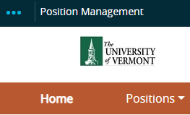
How to Navigate in the Position Management Module
In the Position Management Module, you can:
- View a list of positions or find a specific position
- View and print individual position descriptions (Staff only)
- Initiate actions on existing positions
- Initiate actions on new positions
- View all current and past actions that have been initiated
- Change the status of an action

Applicant Tracking Module
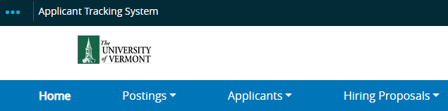
How to Navigate in the Applicant Tracking Module
In the Applicant Tracking Module, you can:
- Create a new posting
- View the list of postings or find a specific posting
- Change the status of a posting
- View the applicants in a posting
- Change the status of applicants
- Create/View/Edit/Complete hiring proposals

Logging Into PeopleAdmin

The URL to log in is www.uvmjobs.com/hr. Click on the yellow link on that page to be brought to a UVM login page where you will use your NetID and password. You must then use multi-factor authentication (MFA) to log in. To set up your MFA, please see the ETS Knowledge Base page.

Basic Navigation

To navigate between the Position Management and Applicant Tracking modules, use the drop-down menu in the upper left corner (it looks like three dots).

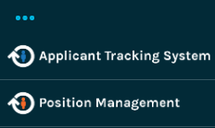

To change your user type, use the drop-down menu in the upper right area.

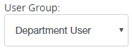

User Types
Department User – Access to create/view positions, actions, postings, applicants, and hiring proposals within the assigned departments.
Dean/Director – Access to approve/view actions and hiring proposals submitted by Department Users. Also, access to approve interview and appointment authorizations (Faculty recruitments only).

Navigation in the Position Management Module
The only drop-down menu you will use in the Position Management Module is the “Positions” menu. It has four choices, below we list the possible uses for each:
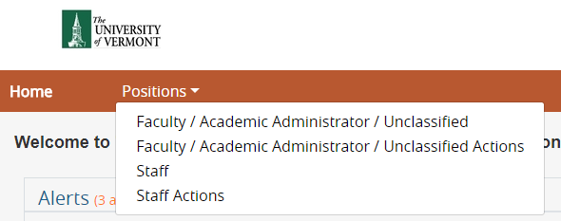
Faculty/Academic Administrator/Unclassified
- View any or all Faculty/Acad Admin/Unclassified positions in the departments you have access to. (Also see: How to View a List of Positions, Modify your search results)
- Start an action on an existing Faculty/Acad Admin/Unclassified position. (Also see: How to Initiate an Action on an Existing Position)
- Start an action on a new Faculty/Acad Admin/Unclassified position - this creates a new position number. (Also see: How to Initiate an Action on a New Position)
Faculty/Academic Administrator/Unclassified Actions
- View any or all actions on Faculty/Acad Admin/Unclassified positions in the departments you have access to. (Also see: How to View a List of Actions, Modify your search results)
- Change the status of an action on a Faculty/Acad Admin/Unclassified position that is in progress. (Also see: How to Change the Status of an Action)
Staff
- View any or all Staff positions in the departments you have access to. (Also see: How to View a List of Positions, Modify your search results)
- Start an action on an existing Staff position. (Also see: How to Initiate an Action on an Existing Position)
- Start an action on a new Staff position - this creates a new position number. (Also see: How to Initiate an Action on a New Position)
Staff Actions
- View any or all actions on Staff positions in the departments you have access to. (Also see: How to View a List of Actions, Modify your search results)
- Change the status of an action on a Staff position that is in progress. (Also see: How to Change the Status of an Action)
Navigation in the Applicant Tracking Module
The most common drop-down menu you will use in the Applicant Tracking Module is the “Posting” drop-down. It has two choices, below we list the possible uses for each:
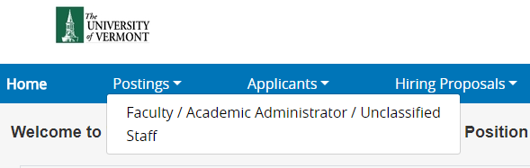
Faculty/Academic Administrator/Unclassified
- View any or all postings on Faculty/Acad Admin/Unclassified positions in the departments you have access to. This may include both old and current recruitments. (Also see: How to View Faculty/Acad Admin/Unclassified Postings, Modify your search results)
- Create a new Faculty/Acad Admin/Unclassified posting on a position. (Also see: How to Create a New Faculty/Academic Admin/Unclassified Posting)
- Change the status of a Faculty/Acad Admin/Unclassified posting. (Also see: How to Change the Status of a Faculty/Acad Admin/Unclassified posting)
- Attach an interview or appointment authorization to a Faculty/Acad Admin/Unclassified posting.
- View any or all applicants to a particular posting on a Faculty/Acad Admin/Unclassified position. (Also see: How to View Applicants)
- Change the status of any or all applicants to a particular Faculty/Acad Admin/Unclassified posting. (Also see: How to Change Applicant Statuses)
- Complete a hiring proposal on the applicant who accepted an offer for a Faculty/Acad Admin/Unclassified posting. (Also see: Hiring Proposal Instructions)
Staff
- View any or all postings on Staff positions in the departments you have access to. This may include both old and current recruitments. (Also see: How to View Staff Postings, Modify your search results)
- Create a new Staff posting on a position. (Also see: How to Create a New Staff Posting)
- Change the status of a Staff posting. (Also see: How to Change the Status of a Staff posting)
- View any or all applicants to a particular posting on a Staff position. (Also see: How to View Applicants)
- Change the status of any or all applicants to a particular Staff posting. (Also see: How to Change Applicant Statuses)
- Start a hiring proposal on the top applicant for a Staff posting to allow for an offer to be made. (Also see: Hiring Proposal Instructions)
- Change the status of a hiring proposal on the top applicant for a Staff posting. (Also see: Hiring Proposal Instructions)

Inbox

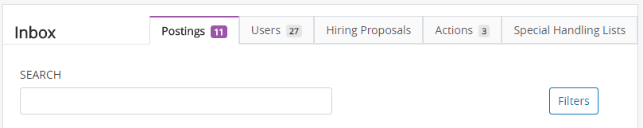
The Inbox displays any postings, actions, or hiring proposals that are under the control of any of your user types. This does not necessarily mean that the posting, action, or hiring proposal needs immediate attention. It is simply a quick way of finding items that you might be currently working on.

Watch List

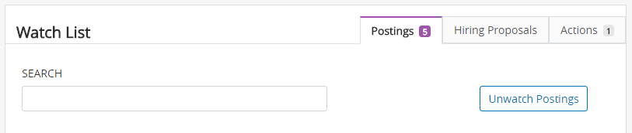
Any time you change the status of a posting, an action, or a hiring proposal, you will be asked if you want to add it to your Watch List. Your Watch List allows you to easily keep track of these items as they move through their respective workflows without having to manually search for them.

How to View a List of Positions
Start by logging into PeopleAdmin as a Department User and navigating to the Position Management module. (How?)
If you are looking for a Faculty/Academic Administrator/Unclassified position:
- Use the “Positions” drop-down and choose “Faculty/Academic Administrator/Unclassified”:
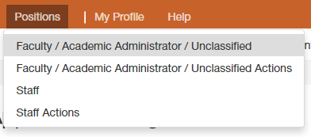
- Modify your search results to find a specific faculty/academic administrator position or to see details about your list of positions.
If you are looking for a Staff position:
- Use the “Positions” drop-down and choose “Staff”:
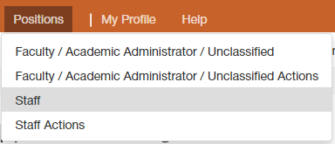
- Modify your search results to find a specific staff position or to see details about your list of positions.

How to View/Print a Position Description (Staff only)
Start by logging into PeopleAdmin as a Department User and navigating to the Position Management Module. (How?) Have the position number handy for the position you are looking up.
- Mouse over the “Positions” drop down at the top and choose “Staff”.
  - If your position list appears blank, you may need to modify your search results.
- Type in the position number into the search field and click “Search”. You should be left with one result in the table at the bottom of the screen.
- In the “Actions” column of the table, mouse over “Actions” in the row with your one search result:
- Choose “View”. This will take you into the position itself. If you are trying to initiate an action on this position, go back to the How to Initiate an Action on an Existing Position steps.
To view and/or print a position description:
- Click on the “Reports” tab:
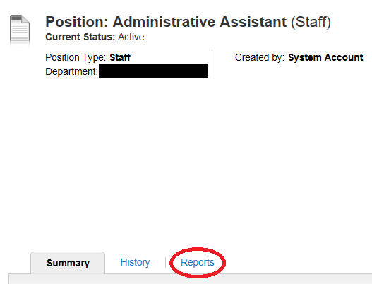
- Click on “Staff Position Description”
  - If the information in the position description report is inaccurate or missing, please contact your HR Rep.
- Use the “Print” function of your web browser to print the PD report if needed.

How to Initiate an Action on an Existing Position
Start by logging into PeopleAdmin as a Department User and navigating to the Position Management Module. (How?) Have the position number handy for the position you are looking up.
- Decide what type of action you need to initiate on the position. (Faculty Action Decision Tree) (Staff Action Decision Tree)
- Navigate into the position that you want to start your action on. (How?)
- On the right hand side, choose the action type you would like to initiate (note: Faculty positions only have options for recruitments or waivers):
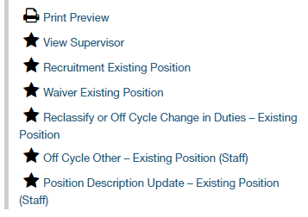
- You will be entered into an edit-mode for your new draft action. Use the “Next” and “Prev” buttons to navigate through each tab and make edits to the position that you would like to request. (Remember, actions are simply requests to do something to a position).
- When you finally get to the “Action Summary” tab, you can review the information in your action.
  - If you need to make additional changes, click any of the “Edit” buttons on the summary tab to enter back into the edit-mode.
- When you are done, use the orange “Take Action on Action” button to change your action status and send it for review/approval.
- Review the Action Workflow to understand where you are sending your action based on the action type that you chose.
  - The solid box on the right hand side of each action workflow in this document is the final action status. The final action status saves all the changes contained in your action to the position.
- Once your action reaches its final action status, you are done unless you are doing a recruitment or waiver action. In those cases, you need to now create the posting.
  - Related: How to Create a Staff Posting
  - Related: How to Create a Faculty/Acad Admin/Unclassified Posting
  - Related: Waiver Posting Steps

How to Initiate an Action on a New Position
Start by logging into PeopleAdmin as a Department User and navigating to the Position Management Module. (How?)
Be aware that starting an action on a new position means a new position number will be created. Consider re-using a vacant position number instead by using the Position Number Management Guide.
- Decide what type of action you need to initiate on the position. (Faculty Action Decision Tree) (Staff Action Decision Tree)
- Navigate to your position list. (Your staff position list if creating a staff position, your Faculty/Acad Admin/Unclassified position list if creating a Faculty/Acad Admin/Unclassified position)
- Click on the orange “Create New Position” button in the upper right area.
- Choose if you are conducting a recruitment or waiver action to fill this new position.
- You will be entered into an edit-mode for your new draft action. Use the “Next” and “Prev” buttons to navigate through each tab and make edits to the position that you would like to request. (Remember, actions are simply requests to do something to a position).
  - On the Proposed Title tab, you can use the “Filter these results” button to choose the position title you want for this position. This will auto-populate some fields on the next tabs you work on:
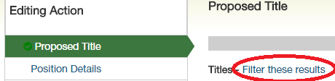
- When you finally get to the “Action Summary” tab, you can review the information in your action.
  - If you need to make additional changes, click any of the “Edit” buttons on the summary tab to enter back into the edit-mode.
- When you are done, use the orange “Take Action on Action” button to change your action status and send it for review/approval.
- Review the Action Workflow to understand where you are sending your action based on the action type that you chose.
- The solid box on the right hand side of each action workflow in this document is the final action status. The final action status saves all the changes contained in your action to the position.
- Once you move the action to its final action status, you will need to create the posting.
  - Related: How to Create a Staff Posting
  - Related: How to Create a Faculty/Acad Admin/Unclassified Posting
  - Related: Waiver Posting Steps

How to View a List of Actions
Start by logging into PeopleAdmin as a Department User and navigating to the Position Management module. (How?)
If you are looking for an Action on a Faculty/Acad Admin/Unclassified position:
- Use the “Positions” drop-down and choose “Faculty/Academic Administrator/Unclassified Actions”:
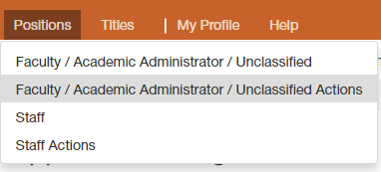
- Modify your search results to find a specific action or to see details about your list of actions.
If you are looking for an Action on a Staff position:
- Use the “Positions” drop-down and choose “Staff Actions”:
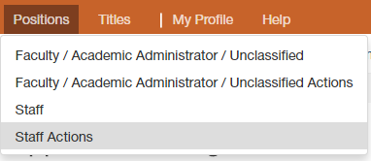
- Modify your search results to find a specific action or to see details about your list of actions.

Tip: You can use the “Saved Searches” drop-down menu and choose “Global – Unfinished Actions” to bring up a default view of all of your actions that are yet to be completed or cancelled.

How to Change the Status of an Action
Start by logging into PeopleAdmin as a Department User and navigating to the Position Management module. (How?)
- View the appropriate list of actions (Faculty/Acad Admin/Unclassified or Staff) and find the specific action you want to change the status of. Modify your search results if necessary.
- In the “Actions” column of the table, mouse over “Actions” in the row of the action:
- Choose “View”. This will take you into the action.
- Determine what the current status of the action is:
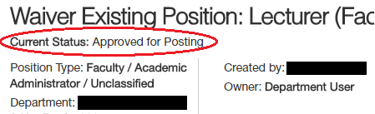
- Review the Action Workflow to determine what status it should be moved to.
- Use the orange “Take Action on Action” to change the action status.
- A confirmation pop-up will appear. You can add a comment which will show up in the History of the action and/or add the action to your Watch List. Click “Submit” to finalize the status change:
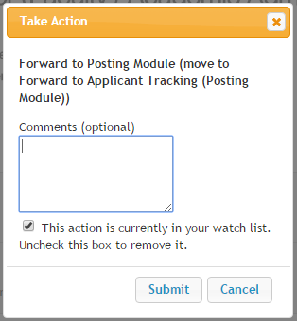
- After submitting, look for a message at the top of the screen which will indicate whether your transition was successful or if you missed some required fields.

How to Modify Your Search Results
Any time you look at a list of positions, actions, postings, or applicants, you are really looking at a search result table. You can:
- Modify this search result to find a specific posting, applicant, position, or action.
- Filter your search results to see a specific group of postings, applicants, positions, or actions.
- Add/Remove columns in your search result to display the data fields that you’d like to see.
- Save any modifications you make so you can quickly do an identical search in the future.
- Export your search data to an Excel spreadsheet.
Finding a Specific Item
- Navigate to the list of whichever item you are looking for:
  - How to View a List of Positions
  - How to View a List of Actions
  - How to View a List of Postings
  - How to View a List of Applicants
- Use the search bar to search by whatever criteria is appropriate (usually position number, action number, posting number, or applicant name):
- If you cannot find what you are looking for, click on the “More Search Options” button next to the search bar.
- Use the fields that open up to check for filters that may be affecting your search result (e.g. Department, Workflow State, Active/Inactive).
  - You can remove filters by selecting every item in that field and then clicking “Search”.
- If you think you may want to use the search you’ve set up again in the future, Save Your Search.
- If you want to export your search table to an Excel spreadsheet, Export your Search Results.
Filtering Your Search Results
- Navigate to the list of whichever group of items you are looking to filter:
  - How to View a List of Positions
  - How to View a List of Actions
  - How to View a List of Postings
  - How to View a List of Applicants
- Click on the “More Search Options” button next to the search bar:
- Use the fields that open up to add/change/remove filters (e.g. Department, Workflow State, Active/Inactive) to shape your search results.
  - After choosing your filters, click “Search” to update your search results.
- If you think you may want to use the search you’ve set up again in the future, Save Your Search.
- If you want to export your search table to an Excel spreadsheet, Export your Search Results.
Changing the Columns of Data in Your Search Results
- Navigate to the list of whichever group of items you are looking to filter:
  - How to View a List of Positions
  - How to View a List of Actions
  - How to View a List of Postings
  - How to View a List of Applicants
- Click on the “More Search Options” button next to the search bar:
- Open the “Add Column” drop-down menu and choose a new column of data to add to your search results.
  - Wait a few seconds for your page to automatically refresh after making your selection. Repeat as often as you’d like until you have the data showing that you want.
- To remove a column, hover your curser over the column title in the search results and click on the x icon:
- Move a column to the left or right by using the < or > icons.
- Sort a column by ascending or descending order using the ʌ or v icons.
- If you think you may want to use the search you’ve set up again in the future, Save Your Search.
- If you want to export your search table to an Excel spreadsheet, Export your Search Results.
Saving Your Search
- Modify Your Search Results so your search table looks the way you want it to.
- Click “Save this Search?” in the upper left area of your search table:
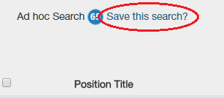
- Check the box if you’d like to make this your default search.
  - A default search means that the next time you come to this list (positions, actions, postings, or applicants), these same search parameters will come up automatically.
- Name the search.
- Click “Save this Search”.
- If you didn’t make it your default, you can recall this search by using the “Saved Searches” drop-down menu located to the left of the search bar:
Exporting Your Search Data
- Modify Your Search Results so your search table contains the data that you want to export.
- Use the orange “Actions” drop-down menu in the upper right area of your search table and choose “Export results”:
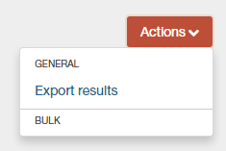

How to Create a New Staff Posting
(Skip to: How to Create a New Faculty/Academic Administrator/Unclassified Posting)
If you were approved for a waiver instead of a recruitment, see Waiver Posting Instructions.
- These instructions assume that your recruitment action was approved (see Basic Recruitment Steps) and you have just changed its status to “Forward to Applicant Tracking”. If neither of these have happened yet, then you should not be creating a posting.
  - You should also write down the “Action Number” and “Position Number” for this action, as you will need them later in the posting creation process. These numbers can be found in the emails you would be receiving as your action progressed through approvals.
- Log into PeopleAdmin as a Department User and navigating to the Applicant Tracking Module. (How?)
- Open the “Postings” drop-down menu and choose “Staff”.
- Click “Create New Posting”.
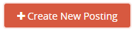
- A pop-up will appear. Click “Create from Position”.
- The next screen will have several search fields. Type your position number into the main search field and click “Search”.
- Your search should produce one result. If you get more than one result, contact HRS (656-3150).
- Use the “Actions” drop-down on the right hand side of the one result and choose “Create From”.
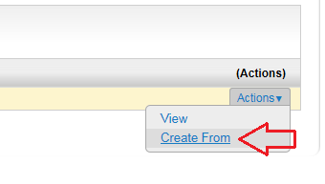
- On the next page, click the orange “Create New Posting” button.
- This will create your draft posting and put you into the edit-mode of your draft posting.
- Navigate to the “Position Details” tab and enter today’s date into the “Job Open Date” field.
  - Please note: all postings must be open for a minimum of seven days, including five business days.
- Enter the action number from the action which you should have just “Forwarded to Applicant Tracking” into the Action Number field.
- If you want your posting to close from new applicants on a specific date, enter that date into the “Job Close Date” field. Please note: all postings must be open for a minimum of seven days, including five business days. If you enter a close date, you cannot close your posting sooner than that date.
- Navigate through the other tabs and make any changes you need to, including creating a Guest User account. (Guest Users can see applicants but not change their statuses. See: Guest User instructions).
- When done, navigate to the “Summary” tab.
- In the upper right corner, click “See how Posting looks to Applicant” and confirm that your posting looks how you expect it to.
- If it does, click the “Back” button on your browser to get back to the Summary tab.
  - If it doesn’t, contact HRS (656-3150).
- Use the “Take Action on Posting” drop-down and choose “Posted”.
- Go to www.uvmjobs.com/postings/search to confirm that your posting appears on the site.

Also see:
- How to View Applicants
- How to Change Applicant Statuses
- How to Change a Posting Status
- Hiring Proposal Instructions
- Waiver Posting Steps

How to Create a New Faculty Posting
(Skip to: How to Create a New Staff Posting)
If you were approved for a waiver instead of a recruitment, see Waiver Posting Instructions.
- These instructions assume that your recruitment action was approved (see Basic Recruitment Steps) and you have just changed its status to “Forward to Applicant Tracking”. If neither of these have happened yet, then you should not be creating a posting.
  - You should also write down the “Action Number” and “Position Number” for this action, as you will need them later in the posting creation process. These numbers can be found in the emails you would be receiving as your action progressed through approvals.
- Start by logging into PeopleAdmin as a Department User and navigating to the Applicant Tracking Module. (How?)
- Open the “Postings” drop-down menu and choose “Faculty/Acad Admin/Unclassified”.
- Click “Create New Posting”.
- A pop-up will appear. Click “Create from Position”.
- The next screen will have several search fields. Type your position number into the main search field and click “Search”.
- Your search should produce one result. If you get more than one result, contact HRS (656-3150).
- Use the “Actions” drop-down on the right hand side of the one result and choose “Create From”.

- On the following page, you can set up Reference Letters for your posting. This will allow you to automatically request reference letters from the candidates of your choosing by changing their applicant statuses to “Request References”. (Also see: How to Change Applicant Statuses)
  - Under the “References” header, choose “Request References” for the Reference Notification drop-down.
  - Keep the Recommendation Workflow drop-down blank.
  - Change Recommendation Document Type to “Reference Letter”.
  - It should end up looking like this:
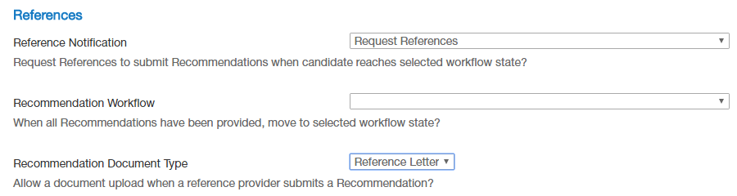
- Once done setting up your reference letter settings, you need to choose an Accepted Application Form. Scroll down to the “Accepted Application Forms” field and choose only ONE application type:
  - The DEFAULT Faculty Application should be used for all Faculty recruitments outside of the College of Medicine (COM).
  - COM Faculty recruitments may choose either application form. The difference is that the “COM ONLY” form does not ask the candidate to enter any reference information into the application (note: this also means the reference letter functionality cannot be used).
- Next, click the orange “Create New Posting” button in the upper right of this page.
- This will create your draft posting and put you into the edit-mode of your draft posting.
- Navigate to the “Position Details” tab and enter today’s date into the “Job Open Date” field.
  - Please note: all postings must be open for a minimum of seven days, including five business days.
- Enter the action number from the action which you should have just “Forwarded to Applicant Tracking” into the Action Number field.
- Skip the Faculty Reference Letters tab.
- Go to the Guest User tab to create a Guest User account. (Guest Users can see applicants but not change their statuses. See: Guest User instructions).
- Skip the Search Committee tab.
- Navigate through the other tabs and make any changes you need to.
- When done, navigate to the “Summary” tab.
- In the upper right corner, click “See how Posting looks to Applicant” and confirm that your posting looks how you expect it to.
- If it does, click the “Back” button on your browser to get back to the Summary tab.
  - If it doesn’t, contact HRS (656-3150).
- Use the “Take Action on Posting” drop-down and choose “Posted”.
- Go to www.uvmjobs.com/postings/search to confirm that your posting appears on the site.
Also see:
- How to View Applicants
- How to Change Applicant Statuses
- How to Change a Posting Status
- Hiring Proposal Instructions
- Waiver Posting Steps

Waiver Posting Instructions

Staff Waiver Steps
(Skip to: Faculty/Acad Admin/Unclassified Waiver steps)
Please note that you must attach a resume or CV of the candidate to the action.
Start by logging into PeopleAdmin as a Department User and navigating to the Applicant Tracking Module. (How?)
- These instructions assume that your waiver action was approved and you have just changed its status to “Forward to Applicant Tracking”. If neither of these have happened yet, then you should not be creating a posting.
  - You should also write down the “Action Number” and “Position Number” for this action, as you will need them later in the posting creation process. These numbers can be found in the emails you would be receiving as your action progressed through approvals.
- Log into PeopleAdmin as a Department User and navigating to the Applicant Tracking Module. (How?)
- Open the “Postings” drop-down menu and choose “Staff”.
- Click “Create New Posting”.
- A pop-up will appear. Click “Create from Position”.
- The next screen will have several search fields. Type your position number into the main search field and click “Search”.
- Your search should produce one result. If you get more than one result, contact HRS (656-3150).
- Use the “Actions” drop-down on the right hand side of the one result and choose “Create From”.
- On the next page, click the orange “Create New Posting” button.
- This will create your draft posting and put you into the edit-mode of your draft posting.
- Navigate to the “Position Details” tab and enter today’s date into the “Job Open Date” field.
- Enter the action number from the action which you should have just “Forwarded to Applicant Tracking” into the Action Number field.
- Navigate to the “Applicant Documents” tab and make sure no documents are required. We don’t need them to attach anything to this application. If you see any documents are being required, contact HRS (656-3150) to fix.
- When done, navigate to the “Summary” tab.
- In the upper right corner, click “See how Posting looks to Applicant” and confirm that your posting looks how you expect it to.
- If it does, click the “Back” button on your browser to get back to the Summary tab.
- Use the “Take Action on Posting” drop-down and choose "Post Internally/Post for Waiver", and submit.
- It will take you back to the summary page. Look underneath the job title for a gray box with a web link in it. This is a secret link to the posting that can be used to apply to it:
- 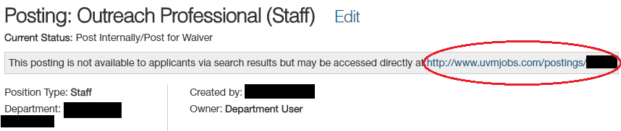
- Send the link to the waiver candidate with instructions to please submit their application to the posting and to let you know when they have done so.
- Once they have applied, go into the posting, find that "Take Action on Posting" button, and choose "Closed". (How?)
- Change their applicant status to "Waiver Candidate". (How?)
- Follow the Hiring Proposal Instructions the same as any other staff hire.

Faculty/Academic Administrator/Unclassified Waiver Hire Steps
(Skip to: Staff Waiver steps)
Please note that you must attach a resume or CV of the candidate to the action.
Start by logging into PeopleAdmin as a Department User and navigating to the Applicant Tracking Module. (How?)
- These instructions assume that your recruitment action was approved and you have just changed its status to “Forward to Applicant Tracking”. If neither of these have happened yet, then you should not be creating a posting.
  - You should also write down the “Action Number” and “Position Number” for this action, as you will need them later in the posting creation process. These numbers can be found in the emails you would be receiving as your action progressed through approvals.
- Start by logging into PeopleAdmin as a Department User and navigating to the Applicant Tracking Module. (How?)
- Open the “Postings” drop-down menu and choose “Faculty/Acad Admin/Unclassified”.
- Click “Create New Posting”.
- A pop-up will appear. Click “Create from Position”.
- The next screen will have several search fields. Type your position number into the main search field and click “Search”.
- Your search should produce one result. If you get more than one result, contact HRS (656-3150).
- Use the “Actions” drop-down on the right hand side of the one result and choose “Create From”.
- On the next page, scroll to the bottom and check the box for “DEFAULT Faculty Application”.
- Click the orange “Create New Posting” button at the top of that page.
- This will create your draft posting and put you into the edit-mode of your draft posting.
- Navigate to the “Position Details” tab and enter today’s date into the “Job Open Date” field.
- Enter the action number from the action which you should have just “Forwarded to Applicant Tracking” into the Action Number field.
- Navigate to the “Applicant Documents” tab and make sure no documents are required. We don’t need them to attach anything to this application. If you see any documents are being required, contact HRS (656-3150) to fix.
- When done, navigate to the “Summary” tab.
- In the upper right corner, click “See how Posting looks to Applicant” and confirm that your posting looks how you expect it to.
- If it does, click the “Back” button on your browser to get back to the Summary tab.
- Use the “Take Action on Posting” drop-down and choose "Post Internally/Post for Waiver", and submit.
- It will take you back to the summary page. Look underneath the job title for a gray box with a web link in it. This is a secret link to the posting that can be used to apply to it:
- Send the link to the waiver candidate with instructions to please submit their application to the posting and to let you know when they have done so.
- Once they have applied, go into the posting, find that "Take Action on Posting" button, and choose "Closed". (How?)
- Change their applicant status to “Criminal Conviction Information” (Why?)(How?)
- Wait for the candidate to go back into their application to provide criminal conviction history information.
- Change their applicant status to "Waiver Candidate". (How?)
- Follow the Hiring Proposal Instructions for Faculty/Acad Admin/Unclassified positions.

How to View a List of Postings
Start by logging into PeopleAdmin as a Department User and navigating to the Applicant Tracking Module. (How?)
If you are looking for a Faculty/Acad Admin/Unclassified posting:
- Use the “Postings” drop-down and choose “Faculty/Academic Administrator/Unclassified”:
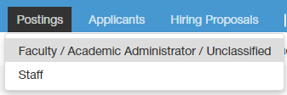
- Modify your search results to find a specific faculty/academic administrator posting or to see details about your list of postings.
If you are looking for a Staff posting:
- Use the “Postings” drop-down and choose “Staff”:
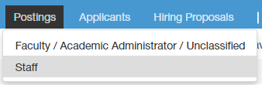
- Modify your search results to find a specific staff posting or to see details about your list of postings.

How to Change the Status of a Posting
Start by logging into PeopleAdmin as a Department User and navigating to the Applicant Tracking Module. (How?)
- View the appropriate list of postings (Faculty/Acad Admin/Unclassified or Staff) and find the specific posting you want to change the status of. Modify your search results if necessary.
- In the “Actions” column of the table, mouse over “Actions” in the row of the posting:
- Choose “View”. This will take you into the posting.
- Determine what the current status of the posting is:
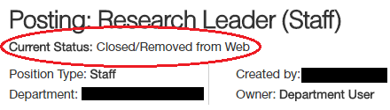
- Review the Posting Workflow to determine what status it should be moved to.
- Use the orange “Take Action on Posting” to change the action status.
- A confirmation pop-up will appear. You can add a comment which will show up in the History of the posting and/or add the posting to your Watch List. Click “Submit” to finalize the status change:
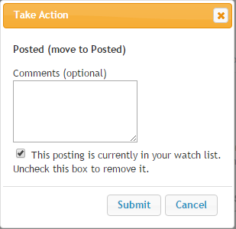
- After submitting, look for a message at the top of the screen which will indicate whether your transition was successful or if you missed some required fields.

Cancelling a Posting
If the decision is made to not fill a position that has been posted, it is critical that we notify the applicants in a timely manner and cancel the posting.
- Identify which applicants have not received any automated email from the system. The only ones who will have received emails are applicants at a status that sends an email immediately. For example, the status of: “Not Interviewed Not Hired – Send Applicant Email”. (How to View Applicants in a Posting.)
- Change the status of all applicants who have not received an automated email to “Position Cancelled”. This will send them an email notifying them of the cancellation. (How to Change Applicant Statuses.)
- **IMPORTANT** - Applicants at a status that would send an email when the posting is filled also need to be changed to “Position Cancelled”!
- Once all applicant statuses are changed, change the status of the posting to “Cancelled”. (How to Change the Status of a Posting.)

How to View Applicants in a Posting
Start by logging into PeopleAdmin as a Department User and navigating to the Applicant Tracking Module. (How?)
- View the appropriate list of postings (Faculty/Acad Admin/Unclassified or Staff) and find the specific posting that has the applicants you want to view. Modify your search results if necessary.
- Click on the “Applicants” tab within the posting:
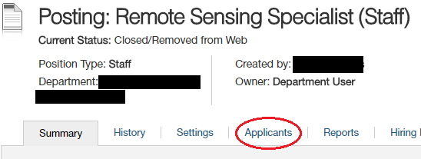
- This will show you the list of applicants to your job posting. Modify your search results if you want to edit the columns of data you can see or if you want to filter which applicants you see.
- Use the “Actions” drop-down menu in the right-most column and click “View Application” in order to view a specific candidate’s application and attachments (cover letter, resume, etc.)
Also see:
- Tips for Downloading Applicant Documents
- How to Run a Demographics Report on Your Applicant Pool
- How to Change Applicant Statuses

Tips for Downloading Applicant Documents
There are two options for downloading applicant documents (application + attachments) in bulk. You can download every applicant document for every applicant into a single, large PDF. Or, you can download one PDF per applicant which contains all of their applicant documents.
Start by logging into PeopleAdmin as a Department User and navigating to the Applicant Tracking Module. (How?)
To Download a Single, Large PDF:
- View your list of applicants. (How?)
- Click the checkboxes on the left hand side of each of the applicants that you want to include.
  - If your applicant list goes onto more than one page, you will need to repeat these steps for every page.
- Use the big, orange “Actions” drop-down menu in the upper right of the applicant list:
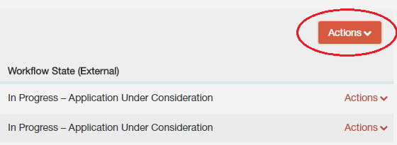
- Choose “Download Applications as PDF”.
- A pop up menu will come up. Choose which documents you’d like to include in your PDF. Click “Submit”.
- It may then take several minutes for your PDF to be created.
  - If your PDF fails to create, try again but with fewer boxes checked. You may need to create multiple PDFs.
To Download One PDF per Applicant:
- View your list of applicants. (How?)
- Click “More Search Options”.
- Use the “Add Column” drop-down menu and choose “Combined Document”. Wait a few seconds for the page to refresh. Each applicant will have a “Generate” link in the new column you have added.
- Click the checkboxes on the left hand side of each of the applicants that you want to include.
  - If your applicant list goes onto more than one page, you will need to repeat these steps for every page.

- Use the big, orange “Actions” drop-down menu in the upper right of the applicant list:
- Choose “Create PDF Document per Applicant”.
- There are two ways to view the PDFs that you have just created.
  - Use the “Add Column” drop-down menu and choose “Combined Document”. Wait a few seconds for the page to refresh. The “Combined Document” column for each applicant you chose will have a link to “View” the PDF.
  - Or, go into each individual application. At the very bottom, under the “PDF Documents” header, you will see a link to “View” the combined document.

How to Run a Demographics Report on Your Applicant Pool
The demographics report allows you to see aggregate data on how your applicants responded to demographics questions. Contact the AAEO office for guidance on how to use this data.
Start by logging into PeopleAdmin as a Department User and navigating to the Applicant Tracking Module. (How?)
- View the appropriate list of postings (Faculty/Acad Admin/Unclassified or Staff) and find the specific posting that you want to run the report on. Modify your search results if necessary.
- Click on the “Reports” tab within the posting:
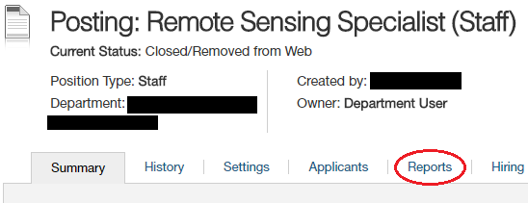
- Choose “Departmental EEO Report”
- A new tab will open in your browser showing the status of your report. The page will refresh automatically when the report is completed.
- Use the “Actions” drop-down on the right to either View Report (in your browser) or Download to Excel.

How to Change Applicant Statuses

Changing the Status of a Single Applicant
(Skip to: Changing Multiple Applicant Statuses at Once)
Start by logging into PeopleAdmin as a Department User and navigating to the Applicant Tracking Module. (How?)
- Go into the application of the applicant whose status you want to change. (How?)
- Determine what status you want to move the applicant to. (See: Applicant Workflow for help)
- Use the “Take Action on Job Application” drop-down menu to choose that status.
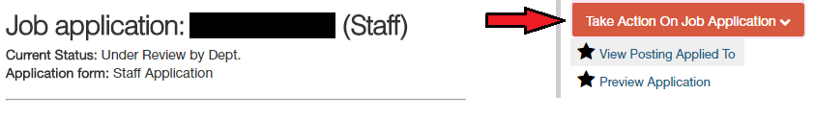
- Give a justification for the status you are changing them to and confirm the status change.

Changing Multiple Applicant Statuses at Once
(Skip to: Changing the Status of a Single Applicant)
Start by logging into PeopleAdmin as a Department User and navigating to the Applicant Tracking Module. (How?)
- Go into the applicant list in your job posting. (How?)
- Determine what status you want to move the applicants to. (See: Applicant Workflow for help)
- Check the boxes on the left of the names of the applicants whose statuses you want to change.
- Use the orange “Actions” drop-down menu and choose “Move in Workflow”:
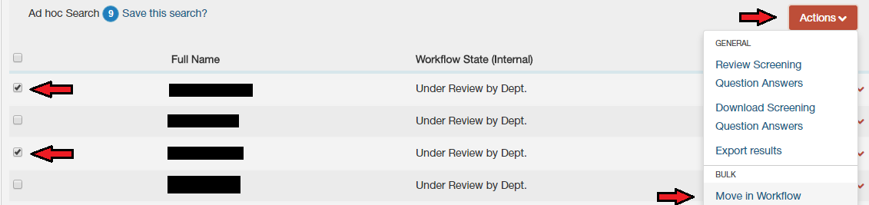
- On the next page, either change all applicant statuses to the same new status using the “Change for all applicants” drop-down menu; or
- Change each applicant status individually using the drop-down menu next to their name.
- Give justifications for the statuses you are changing them to.
- Click “Save Changes”.
- If you have multiple pages of applicants, you will need to repeat these steps for applicants on each page.

Hiring Proposal Instructions

Staff Hiring Proposals
(Skip to: Faculty/Academic Administrator/Unclassified Hiring Proposals)
Also see on the HRS site: Hiring Steps for Staff Positions and the Applicant Workflow & Hiring Proposal Workflow pages for additional context to the following steps.
Staff Hiring Proposals serve three purposes: (1) to get a proposed salary approved, (2) to seat the applicant into the position in PeopleAdmin, (3) to fill your posting.
Start by logging into PeopleAdmin as a Department User and navigating to the Applicant Tracking Module. (How?)
- Once you have identified a top candidate in your applicant pool, change their status to “Recommend for Hire” and the statuses of the other applicants to whichever “Not Hired” status is appropriate (How?)
- Go back into the top candidate’s application. (How?)
- You will see a new button in the upper right to “Start Hiring Proposal”. Click on it.
- The next page shows you a list of positions to choose from, but the position will always already be chosen for you.
- Find and click on the “Select Position” button on this page.
- Complete the required fields. If the person already has an Employee ID from previous employment at UVM, you can enter it into the hiring proposal at this time.
- Navigate to the Summary page of the Hiring Proposal.
- Use the orange “Take Action on Hiring Proposal” drop-down menu to change the status to “Dean/Director for Finalist Review”. (See: Hiring Proposal Workflow)
  - The Dean/Director user will review and move it to HRS for salary review.
- If approved, the Onboarding team will send a draft offer letter to whoever is listed as the Hiring Official and move the status of the Hiring Proposal to “Ready for Offer”.
- Make your official offer to your candidate.
  - If they decline the offer, fill out the “Reason for Offer Declined” field.
  - Change the status of the Hiring Proposal to “Offer Declined” using the orange “Take Action on Hiring Proposal” drop-down menu.
- If they accept the offer, return the signed offer letter, employee information form, and background check forms to the Onboarding team (or to the ABSC if you are their client) so they can begin the ePAR.
  - Your ePAR will be denied if every other candidate in the pool is not moved to an appropriate “Not Hired” or “Alternate” status. Update those statuses as soon as possible. (How?)
- Use the orange “Take Action on Hiring Proposal” drop-down menu to change the status to “Offer Accepted”.
- Once the ePAR is fully processed, the Onboarding team will sign them up for New Employee Orientation and send a welcome email template to the hiring official.
- The Onboarding team will then update the Hiring Proposal to “Hire Complete”.
- Your posting status will automatically bet set to “Filled” and the Applicant’s status will automatically be set to “Hired”.

Faculty/Academic Administrator/Unclassified Hiring Proposals
(Skip to: Staff Hiring Proposals)
Faculty/Acad Admin/Unclassified Hiring Proposals serve two purposes: (1) to seat the applicant into the position in PeopleAdmin, and (2) to fill your posting.
Also see on the HRS site: Applicant Workflow & Hiring Proposal Workflow for additional context to the following steps.
Start by logging into PeopleAdmin as a Department User and navigating to the Applicant Tracking Module. (How?)
- Complete your Appointment Authorization Steps (if you are doing a waiver hire, instead skip to step 5).
- Once your Appointment Authorization has been approved, make your official offer to the top candidate.
  - If they decline, change their applicant status to “Offer Declined”. (How?)
- If they accept the offer, initiate your new hire ePAR to get them into PeopleSoft.
  - While your ePAR is processing, it is a great time to confirm that all other applicant statuses are changed to whichever status is appropriate.
  - If the candidate already has a UVM Employee ID from current/previous employment, skip to the next step without waiting for the ePAR to process.
- Once the ePAR finishes processing, you can start and complete your hiring proposal.
- Go back into the top candidate’s application. (How?)
- You will see a new button in the upper right to “Start Hiring Proposal”. Click on it.
- The next page shows you a list of positions to choose from, but the position will always already be chosen for you.
- Find and click on the “Select Position” button on this page.
- Enter the employee’s PeopleSoft Employee ID and their anticipated start date into the corresponding fields.
- Navigate to the Summary page of the Hiring Proposal.
- Use the orange “Take Action on Hiring Proposal” drop-down menu to change the status to “Offer Accept & Employee ID Entered”.
- Your posting status will automatically bet set to “Filled” and the Applicant’s status will automatically be set to “Hired”.

Interview Authorization Steps
The Provost’s Office requires that a Campus Interview Authorization be approved in order to have candidates come to campus. For information about the content of the Interview Authorization, refer to the Faculty and Department Chair Resources page.
Start by logging into PeopleAdmin as a Department User and navigating to the Applicant Tracking Module. (How?)
First, you need to identify the candidates you want to interview by changing their applicant statuses appropriately:
- Change the status of the applicants who you want to bring on campus to “Criminal Conviction Information”. (Why?) (How to Change Applicant Statuses) (Applicant Status Workflow)
  - Note that this triggers an email to candidates instructing them to go back into their application and update it. Upon completion of these steps, the candidates are automatically moved to the “Recommend for Interview” status.
Next, you want to attach your Interview Authorization Memo, confirm that it has been attached, and send your posting to the Provost’s Office for Interview Authorization approval:
- Navigate to the “Summary” tab of your posting.
- Click the “Edit” button located next to the position title at the top:
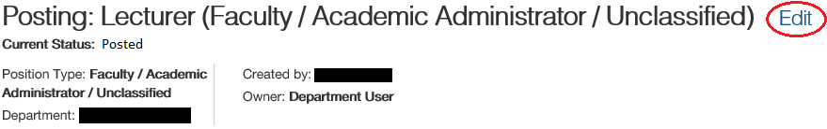
- Navigate to the “Posting Documents” page:
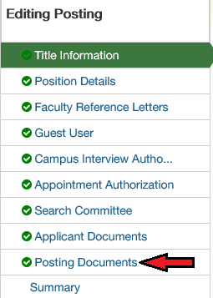
- Find the appropriate “Campus Interview Auth” slot and use the “Actions” drop-down menu on the right to choose “Upload New”.
- Browse your computer for your Interview Authorization and attach and submit it.
- Using the same navigation menu as shown above, go to the “Campus Interview Authorization” page.
- Check the box which indicates that you have attached it. Click “Save”.
- Using the same navigation menu as shown above, go to the “Summary” page.
- If you want to close your posting from receiving new applicants, use the orange “Take Action on Posting” button to change the posting status to “Closed”.
- Whether or not you just closed your posting, use the, use the orange “Take Action on Posting” button to change the posting status to “Dean/Director for Interview Authorization”.
- Your department’s Dean/Director user will review it and move it to the Provost’s Office for approval.
- If all goes well, your posting will come back to you at the status of “Provost Approved for Interview Authorization”.
- You may now conduct your on-campus interviews.

Appointment Authorization Steps
The Provost’s Office requires that an Appointment Authorization be approved in order to make an official offer to a top candidate. For information about the content of the Appointment Authorization, refer to the Faculty and Department Chair Resources page.
Start by logging into PeopleAdmin as a Department User and navigating to the Applicant Tracking Module. (How?)
First, you need to identify the candidates you would be willing to hire by changing their applicant statuses appropriately:
- Change the status of the applicant who is your first choice to “Recommend for Hire”. (How to Change Applicant Statuses)
- Change the status of any candidates who would be alternates to the appropriate “Alternate” status.
- Change the status of any candidates who are definitely not being hired to the appropriate “Not Hired” status.
Next, you want to attach your Appointment Authorization Memo, confirm that it has been attached, and send your posting to the Provost’s Office for Appointment Authorization approval:
- Navigate to the “Summary” tab of your posting.
- Click the “Edit” button located next to the position title at the top:
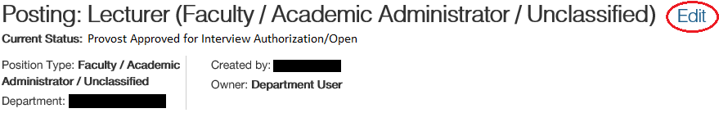
- Navigate to the “Posting Documents” page:
- Find the appropriate “Appointment Auth” slot and use the “Actions” drop-down menu on the right to choose “Upload New”.
- Browse your computer for your Appointment Authorization and attach and submit it.
- Using the same navigation menu as shown above, go to the “Appointment Authorization” page.
- Check the appropriate boxes and click “Save”.
- Using the same navigation menu as shown above, go to the “Summary” page.
- Close your posting if it is not already closed.
  - If your posting is at “Provost Approved for Interview Authorization/Open”, then move it to “Closed”. (How?)
  - If your posting is at “Provost Approved for Interview Authorization/Closed”, then it is already closed and you can go to the next step.
- Once again, use the orange “Take Action on Posting” button to change the posting status to “Dean/Director for Appointment Authorization”.
- Your department’s Dean/Director user will review it and move it to the Provost’s Office for approval.
- If all goes well, your posting will come back to you at the status of “Provost Approved for Appointment Authorization”.
- You may now make your official offer(s).
- Follow the Hiring Proposal Instructions once a candidate accepts the position so that your posting will be Filled.

Criminal Conviction Information (“Ban the Box”)

On July 1, 2017, a new law went into effect in the State of Vermont (commonly known as “Ban the Box”). The law prohibits employers from asking for applicants’ criminal conviction history on the initial job application, even for waiver hires. It is now only okay to ask this question once you have identified applicants for possible interviews.
You now have the option to move applicants to a status called “Criminal Conviction Information.” Doing so will immediately send an email to the applicant giving them clear instructions on how to log back into their application and update the criminal conviction fields. Once they complete the steps, the system will automatically move their status to “Recommend for Interview” and you will then be able to see their response.
Our intention is to have this status be used for all applicants who applied on or after July 1, 2017 whom you are considering for a final round interview. This way, we are not sending these emails to candidates who are not being seriously considered. We recommend that you mention this process to candidates during any initial interview that you conduct so they are not surprised when they receive the email. You do not have to wait for them to complete these steps in order to interview them.
For candidates who applied before July 1, 2017, you simply skip them directly to “Recommend for Interview”. The answer they gave to the criminal conviction question will then become visible to you.
Here are links to the updated Applicant Workflow (PDF) job aid and the updated list of Automated Applicant Emails, which include this new applicant status and the content of the automated email.
As a reminder, an applicant’s criminal conviction history should only be considered with the following in mind: relevance to the duties of the job, the nature and gravity of the offense, the time that has passed since the offense, and any rehabilitation since. HRS is willing to process criminal background checks on any of your potential hires.

Change log

6/9/2024
- Updated the Applicant Workflow (PDF) link.
3/27/2024
- Removed reference to Criminal Conviction Information status in Staff Waiver instructions.
9/19/2023
- Updated the Applicant Workflow (PDF) link.
7/28/2023
- Updated the staff hiring proposal section to reflect the new steps and the involvement of the Onboarding team and updated links to the new hiring proposal workflow.
4/4/2022
- Added clarity to the difference between the two faculty application forms.
7/20/2021
- Updated the Staff Hiring Proposal section on what to do when an offer is declined.
1/6/2021
- Added the “Logging into PeopleAdmin” section.
11/12/19
- Updated language and screenshots to reflect new “Applicant Tracking” and “Position Management” modules (formerly known as “Hires” and “Positions”).
4/25/19
- Added language to the Waiver Hire section to say that a resume or CV must be attached to the waiver action.
- Added language to the Criminal Conviction Information section to indicate that hiring managers do not have to wait for the candidates to complete their steps before an interview may occur.
- Updated the Interview Authorization steps to include the Criminal Conviction Information process.
- Updated the Appointment Authorization steps to include changing the statuses of applicants who are not being hired.
- Added language to hiring proposal steps to include “anticipated start date”.
- Updated links throughout due to new HRS site layout.
7/17/18
- Updated language and screenshot to reflect new “Hires” and “Positions” modules (formerly known as “Applicant Tracking” and “Position Management”).
- Rearranged the order of some of the sections to make more sense for new users.
- Edited language throughout the document to make more sense for new users.
9/25/17
- Updated posting creation steps to include typing in the Action Number of the recruitment.
- Updated posting creation steps to be clear that an action needs to come before a posting and that the action number and position number should be noted for later use.
7/12/17
- Added a section on Criminal Conviction Information.
- Updated waiver hire instructions to reflect the changes to the Criminal Conviction Information section (“Ban the Box”).
4/26/17
- Updated Faculty hiring proposal steps to make them clearer for the Faculty waiver hire process.
11/28/16
- Added a section: “Basic Recruitment Steps in PeopleAdmin”. It outlines the general steps for initiating and completing a recruitment PeopleAdmin.
10/27/16
- Updated ‘How to Create a New Faculty Posting’ with instructions on choosing an application type.
- Updated the Staff hiring proposal instructions to instruct users to complete the hiring proposal if the candidate already has an Employee ID from current/previous employment.

