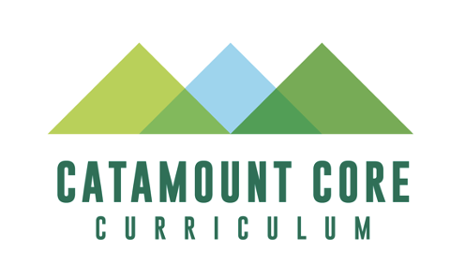
MA: Pure Mathematics Catamount Core Approval Supplemental Information Form

Purpose and Intent: To provide supplemental information relevant to the review of proposed courses for designation as MA and inclusion in UVM’s Catamount Core curriculum. Note: Courses cannot have both an MA and QD designation.

The Submission Process and Approval Criteria, as well as the Rubric that the Catamount Core Curriculum Committee will use to review this proposal, can be found on the following pages of this document.
With a well-developed syllabus, this form should take approximately 15-20 minutes to complete.

To assist students in understanding how courses in each Catamount Core category contribute to UVM’s general education program, please include the following language in a prominent location in your syllabus (e.g. after the course description):

MA: Pure Mathematics
Familiarity with the language and concepts of mathematics fosters a full appreciation of our world, and is an integral component of the Liberal Arts; the phrase “Math is Everywhere” is true only to the extent that one knows where and how to look. The courses fulfilling this requirement help guide students in developing conceptual understanding of mathematics through engagement with the language of mathematics and processes of mathematical operations. In addition to illustrating the universality and beauty of mathematics, these courses will give student practice in constructing and critiquing arguments through mathematics.

Course Information
Course Number:
Course Title:
Name of Faculty Member:
Email Address:

Please indicate if this course presently meets any of the current General Education requirements listed here (check all that apply): | ____D1 ____D2 ____FWIL ____QR ____SU
[v. 2.0, 01/2023]

Submission Process:

The overall purpose of the submission process for all Catamount Core requirements is to maintain the integrity of the general education curriculum at UVM and to ensure that approved courses maintain alignment with the learning outcomes for the corresponding Catamount Core category. A copy of the evaluation rubric used by the review committee is provided at the very end of this form. The review process can result in one of three outcomes:

- Approval (the course will be assigned the requested Catamount Core designation for a 5 year-period)
- Revisions requested (the review committee may ask for changes to be made to the course or for additional information prior to approval)
- Rejection (the course as currently constructed and/or presented in the submission materials does not meet the approval criteria designation)

The committee needs both a syllabus, and detailed information about how a course addresses the MA outcomes in order to complete its review. Information about how the outcomes are addressed can be provided via either a brief narrative or detailed information in the outcomes chart below. You may choose to include both a narrative and the outcomes chart if that is helpful in providing the committee with necessary information:

- A sample course syllabus that includes a list of key readings/textbooks and assignments as well as the required description of the MA category provided above, as well as listing the specific MA outcomes your course meets;
PLUS, either a brief narrative or the completed outcomes chart, or both. Please provide specific examples of course activities and readings in your narrative or learning outcomes rubric, so that it is clear to the review committee how your course meets the course approval criteria:

- A brief narrative (approximately one single-spaced page) that addresses the following:
  - Briefly describe how the course meets the approval criterion below.
  - If not including the outcomes chart below, briefly summarize relevant topics/and learning activities and how and where students’ achievement of the outcomes will be assessed (e.g. research paper; creative work; exam question; presentation).
  - Any other contextual information that can assist the committee in its review.
- The student learning outcomes chart provided below, indicating for each student learning outcome: activities and topics that will support their learning in this area; and the means by which student achievement of each outcome will be assessed (e.g. research paper; creative work; exam question; presentation). Information can be provided in bullet form, but should include substantive information on both topics/activities and assessment.

MA Student Learning Outcomes | Activities/Topics | Assessment
Demonstrate an ability to understand aspects of the world through a mathematical lens.

Give examples related to course materials that show how creativity is central to mathematical thinking.

Be able to demonstrate facility with core mathematical concepts by completing work at the introductory college level or beyond in one area of mathematics.

