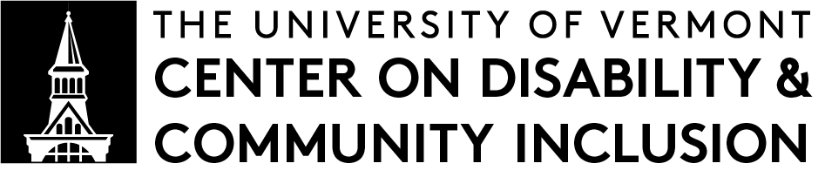 |  | SUMMARY OF CDCI RESEARCH

RISE-VT: Supporting How Restorative Approaches Get Used in Vermont Schools
Summarized by Audrey Homan | Spring 2023

Wood, Valerie F., Halman, L., Wheeler-Sutton, A., Kidde, J., & Castle, N. (2023). Restorative Approaches Implementation for School Equity in Vermont (RISE-VT): Final Report. Submitted to the State of Vermont Agency of Education. Full report available online (.pdf).

You can also listen to an audio version of this summary, read by Valerie F. Wood.

Abstract
Background: RISE-VT stands for Restorative approaches Implementation for School Equity in Vermont. Restorative approaches keep relationships at the center of community behavior, discipline, and goals. Restorative approaches are built on mutual respect, with individuals taking responsibility for their actions. Research shows restorative approaches can work well to create positive school communities. This project worked with schools in Vermont that are already doing restorative approaches to see:
- how they can do them better, and
- how to document and share what they’re doing with other schools and organizations around Vermont.

Methods and Results: The project provided 12 months of support to three Vermont schools and one school district. These four sites were selected because they were already doing restorative approaches and their team was interested in doing more of it. The support consisted of six meetings as a group, team time with coaches trained in restorative approaches, producing a video for each school or district showing how they do restorative approaches, and surveys that measured whether each school or district felt the support was useful. In addition, the project created an online learning module on restorative approaches. The surveys helped the project understand how to do better next time.

Conclusions: The project encountered many challenges throughout the year, including a limited budget, short timeframe, unclear expectations for coaches, and limited inclusion of students. The project and the teams were also impacted by the COVID-19 pandemic. Despite this, the three schools and one school district were able to complete a video showing how each school or district does restorative approaches. The project team also completed an online learning module.

About CDCI Research Summaries:
CDCI shares the research we do so people can understand it.
CDCI provides a plain language summary of each piece of research that we publish. These summaries are meant for: Other researchers, healthcare practitioners, educators, families, and people with disabilities. CDCI encourages you to read and share these research summaries, and ask us questions about them.

Findings
This project found that:
- It’s important for schools to see how “messy” restorative approaches can be. In the videos, teams deliberately shared some of the more difficult aspects of this work in order to encourage other schools to keep at it, even when it gets difficult.
- It’s important that schools have access to coaches that can meet teams where they are at, help them try new things, and move forward.
- It’s also important that coaches have time set aside to talk to one another about how they are supporting their teams. Coaches need support in creating expectations for their work.
- It’s really hard to support schools in starting a new thing while there’s a pandemic going on.
- School staff have a lot of competing priorities, and not enough time and support to get to them all.

Summary
This project was funded by the Vermont Agency of Education, and the work was done through a group called the Vermont Restorative Approaches Collaborative (VTRAC). Researchers from CDCI were part of the project team.

The project took 12 months to complete. First, the project identified four schools or school districts in Vermont who could participate in the study. They were Burlington School District, Proctor Junior/Senior High School, Twinfield Union School, and Wolcott Elementary School. Each school was already doing restorative approaches, and reported to the project that they wanted to and were ready to do more restorative approaches. Schools were then chosen based on being in different parts of Vermont, having different grade levels, and recommendations from VTRAC.

Next, the project team set up six meetings with all the school teams, as well as meetings with coaches who could help them with restorative approaches. These meetings were called a “Community of Practice”. At each meeting, everyone worked to spell out what they wanted from restorative approaches, what they had at their own school to do the work. The teams also connected with one another for inspiration and support. After that, the coaches were available to meet with each school team throughout the year.

At the same time, the project team produced videos of how restorative approaches work at each school, and created an online learning module showing how each school works.

The project faced a lot of challenges in this work based on a global pandemic, school staff having competing priorities, and that that the plan for creating videos for the project originally only covered three schools, not four.

Real-World Implications
As a result of this research project, the research team has five recommendations for other Vermont schools wanting to use restorative approaches:

FOR MORE INFORMATION, CONTACT:

Valerie F. Wood, PhD

CDCI Research Coordinator
Valerie.Wood@uvm.edu
http://go.uvm.edu/cdciresearch
- Schools should look at how restorative approaches match up with other requirements from the Vermont Agency of Education.
- School leaders should make sure staff have enough time and staffing coverage to fully participate.
- School communities should think about how Vermont can provide long-term support for expanding restorative approaches to more schools.
- Schools should complete the online learning module the project made and watch the videos the project created. This is regardless of whether they’re doing restorative approaches or not.
- VTRAC should find a way to get more funding so this project can continue.

Limitations
- The project only had four participating schools or districts. That’s a small sample size.
- Only 3 out of the 4 participating schools or districts included students on their teams, and teams reported that students weren’t really engaged with all the material at meetings.
- Research on restorative approaches indicates that changing a whole system takes multiple years, but this project was only for one year.
- Staff at the schools that participated were stretched really thin and didn’t get enough support to participate fully in this project.
- Not all the schools used all their coaching time.
- It was hard to do all the meetings virtually, rather than in person.
- Students didn’t get to give feedback on what should be in the online learning module, and no one’s sure who’s responsible for improving the module.
- It took a long time for the project team to get permission to make videos in the schools, as well as for the schools to review the videos so they can be publicly shared.

FOR MORE INFORMATION, CONTACT:

Valerie F. Wood, PhD CDCI Research Coordinator. Valerie.Wood@uvm.edu
http://go.uvm.edu/cdciresearch

