[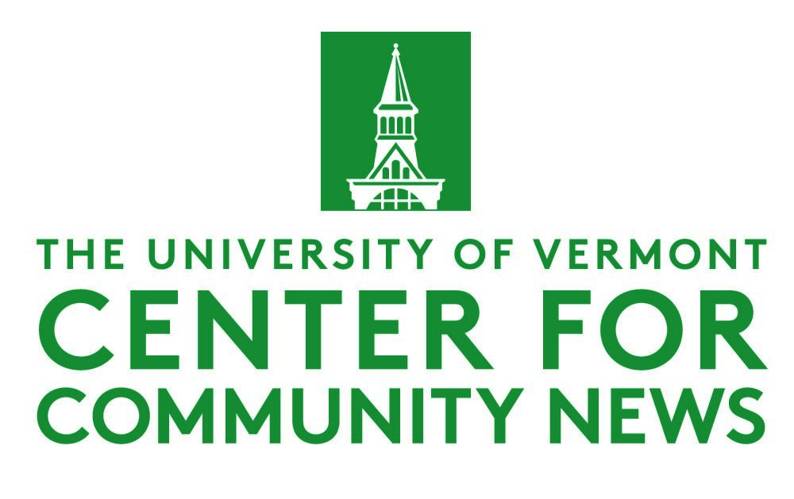](https://www.uvm.edu/ccn)

**CCN Election Assignment Templates**

**Assignment 1: Profiling first-time and/or young voter attitudes on campus**

The Center for Community News’ Election & Democracy Program has created a series of sample templates for faculty to give to students for the Fall 2024 semester. Faculty are welcome to use any and all of these and amend them as they see fit for their classes.

**When to assign this project:** Within the first two weeks of the fall semester

**Why:** Young voters are expected to be pivotal in this election. This assignment is worthy of being published in local papers.

**How:** Students can first submit their report for a grade as a simple, 200 to 400-word vignette, depending on how many people they interview for the assignment. Afterward, you and your students can collaborate on a group project where all their findings are compiled into one feature published in a real newspaper.

Bonus: Students can work together to create a “scorecard” of issues that students on campus appear to care the most about.

For any questions, comments or suggestions, email Elections & Democracy Program Manager Sarah Gamard at [scbgamard@gmail.com](mailto:scbgamard@gmail.com).

### 

### **Assignment: Profiling first-time, young voter attitudes on campus**

Requirements:

* You must conduct ***at least one*** man-on-the-street interview with another student on campus about their election plans, and write a short news story based on that.
* The story must include:
  + Interviewee’s full name, their year (e.g. freshman), and their major
  + A brief summary of their voter attitudes and at least one quote
* Note: You *cannot* interview someone you already know.
* Word length: Minimum 200 words
* Deadline: XXX

QUESTIONS YOU CAN ASK:

* *Do you plan to vote in this election? Why or why not?*
* *Do you know where or how to vote?*
* *What are the three most important issues to you in this election?*
* *Who do you plan to vote for?*
* *Which races are you paying attention to? Are you paying attention to local races or just the presidential race?*

**Tips for faculty:**

* One way to make sure students do these man-on-the-street interviews properly is by using class time to walk around campus and find an interviewee; this may help prevent them from being tempted to just interview a friend or someone in their dorm.