[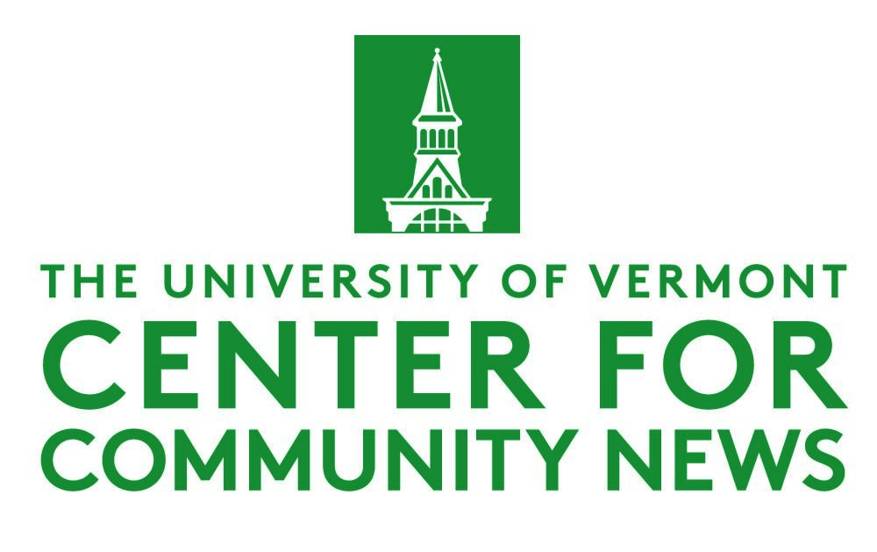](https://www.uvm.edu/ccn)

**Tips for Getting Your Student Work Published   
with Local Media Partners**

**Sept. 10, 2024**

The 120-plus colleges and universities in CCN’s network – [see the map here](https://www.uvm.edu/ccn) – are all regularly seeing their students' work published with local media partners.

In general, local media partners welcome the content *if* they know that a faculty member has reviewed and edited the work first and stands behind it.

In general, any outside publishing of your student work is good for the students to gain more veritable clips and good for local news needs. And will guarantee more people will see it than an internal website.

**FIRST STEPS**

1. Identify potential media partners in your area. The media ecosystem now contains many digital startups and less traditional media platforms in addition to legacy press. See if anyone in your network, or organization already has an existing relationship with the media partner. This will help with the conversation.
2. Start small if this is the first time you have done this. Consider a new start-up, community-level news site, or neighborhood news site as your local media partner. There is always someone who will welcome the content.
3. Start the conversation now, even if the story is weeks away. Ask the partner: Is there anything you should do in the assignment to have a higher chance of getting published, someone the student should talk to, or an angle on the story? By far the best practice is to engage with the partner before delivering the content.
4. Always frame the conversation as the partner gets the final decision. Be respectful of the partner’s deadlines and needs. And make sure you understand them. At the same time, the partner needs to know your first responsibility is the educational experience for the students and sometimes students will not deliver. So look for the stories that are evergreens that compliment what they are doing.
5. Think about multi-media, different story forms – many local media partners need more multi-media stories.
6. Brand your stories somewhere – but otherwise, they are free to the partner “This story was produced by the Community News Service at the University of Vermont.”
7. Your students are reporters and should be thought of as such, so de-emphasize the student part.

**OTHER THINGS TO CONSIDER**

1. Don’t be shy at promoting this work when done – you are helping save democracy!
2. You can ask CCN for help in promoting your work.
3. The best and strongest work can go to the bigger media outlets. Again, in general, the content is free and available to anyone, but if you want to work out a more specific sharing agreement with one partner to start, that is also how some programs do it.
4. Student media is one outlet for your work, but a professional off-campus media platform is generally better. There is no reason not to do both as long as acceptable to both.
5. Think about added ways for media partners to leverage your stories, for example in some cases, broadcast/radio might interview the students who produced the story.

**ADDITIONAL RESOURCES**

CCN hosts drop-in hours. See our events page, every Tuesday and Wednesday at 3 p.m. EST. You can also call or email us.

The Community News Service at UVM makes all our content free to anyone through a re-publish button on the CNS website but also emails out the stories regularly. CNS does have some rules on editing the student reporting content – [click on a story here](https://vtcommunitynews.org/) – then click the republish button to see how CNS does it. Different programs have some version of this.

For information about our Elections & Democracy Initiative, and/or to join our cohort of journalism schools across the country working to fill gaps in local 2024 election coverage, email Program Manager Sarah Gamard at [scbgamard@gmail.com](mailto:scbgamard@gmail.com).