Title: Contributions of winter foraging to the annual growth of thermally dissimilar fish species
Running Title: Winter fish energetics
Authors: ¹Benjamin D. Block*, ¹Jason D. Stockwell, ¹J. Ellen Marsden
Author Addresses:
¹Rubenstein Ecosystem Science Laboratory, University of Vermont, 3 College Street Burlington, VT, USA
*Corresponding Author: Phone: 802-656-0684; Fax: 802-656-0866; Email: ben.block@uvm.edu
Acknowledgments
Special thanks to Amanda Hass and Alisha Secor for their tremendous help with field and laboratory work. I would also like to thank Jacob Crawford, Matt Futia, Allison Hrycik, Dan Delucia, and Undraa Irvin for their assistance. We acknowledge the use of data from Vermont Established Program to Stimulate Competitive Research’s (VT EPSCoR) Basin Resilience to Extreme Events (BREE) award (NSF Award# OIA-1556770). This work was made possible with funds made available to Lake Champlain research by Senator Patrick Leahy through the Great Lakes Fisheries Commission as well as the Explorer’s Club.

Abstract
The seasonal energy dynamics of temperate fishes will likely be affected by climate change, especially during the winter; however, few studies have focused on this season. Fishes may be more active in winter than previously thought, thus, an inquiry into the energetic contributions of winter foraging to the annual growth of fishes is needed given imminent changes in winter conditions. We used stomach content data, total lipid analyses, and bioenergetics modeling to assess the effects of winter foraging on three species in Lake Champlain, Vermont, USA. We compared species in two thermal guilds, the cool-water species yellow perch (Perca flavescens) and two warm-water species, pumpkinseed (Lepomis gibbosus) and bluegill (Lepomis macrochirus). The data suggest that winter energy dynamics likely depend on the thermal preference of individual fish species. Our results indicate that cool-water species can forage in all seasons whereas warm-water species forage only in the open-water seasons. Also, winter foraging provides sufficient energy for overwinter growth in cool-water species but does not in warm-water species. Climate change will affect the seasonal energy dynamics that these species have evolved to tolerate winter conditions in temperate lakes. Thus, climate change may affect individual survival and reproductive success.
Keywords: Fisheries; Under Ice Sampling; Seasonality; Lipids; Bioenergetics Modeling

Introduction
Winter conditions have the potential to affect many aspects of fish ecology, including maternal condition, energy allocation, reproductive success, recruitment, and species coexistence (Farmer et al., 2015; McMeans et al., 2020). Fish are more active in winter than previously thought (Shuter et al., 2012). For example, fish actively forage in low water temperatures and under low light conditions (Eloranta et al., 2013b; Hayden et al., 2013) and some species may consume large proportions of their yearly energy requirements during winter (Eckmann, 2004; Stockwell et al., 2014). Also, fish that forage in winter may have seasonally dissimilar diets (Hayden et al., 2013; Anderson et al., 2016). Winter is, however, logistically challenging for fieldwork in temperate freshwater lakes, and consequently, the winter ecology of freshwater fishes has been understudied (Shuter et al., 2012; Fernandes & McMeans, 2019). We have only touched the tip of the iceberg in terms of understanding the relative importance of winter for fish life history, population dynamics, and overall ecology. For example, additional studies are needed to evaluate the energetic contributions of winter foraging to the annual growth of freshwater fishes to better understand the potential impacts of changing winter ice phenology (Sharma et al., 2019; Woolway & Merchant, 2019).
The degree to which winter conditions affect the foraging behavior, physiology, and energy dynamics of fish may depend on thermal preferences (Shuter et al., 2012) because fish have enzymatic and physiological specializations that allow them to grow and function optimally within a certain temperature range (Magnuson et al., 1979; Hasnain et al., 2010). For example, warm-water fish (preferred temperatures >25°C) are less likely to forage in winter because temperatures are far below their preferred range, whereas cold-water fish (preferred temperatures < 19°C) are more likely to forage in winter (Shuter et al., 2012; McMeans et al., 2015). Winter foraging by cool-water fishes (preferred temperatures 19 - 25°C) is variable (Johnson & Evans, 1991; Shuter et al., 2012), but the conditions under which they forage are unknown. The relationships between thermal preferences and the ability to forage in winter stem largely from lab-based studies but a limited number of in situ studies have tested these relationships (Shuter et al., 2012; Fernandes & McMeans, 2019). Nevertheless, the ability to forage in winter directly affects the seasonal energy dynamics, annual growth, and reproduction of temperate fishes (Byström et al., 2006; Eloranta et al., 2013b).
Lower energy consumption and smaller energy reserves in winter compared to other seasons result in less energy available for growth or reproduction (Giacomini & Shuter, 2013; Ejsmond et al., 2015). However, metabolic costs are lower in winter than in other seasons (Clarke & Johnston, 1999; Barneche & Allen, 2018); if fish actively forage in winter, consumed energy may be more efficiently assimilated to growth, reproduction, or storage compared to other seasons. For example, juvenile lake trout Salvelinus namaycush in Lake Champlain grow in length and sustain their body condition over winter (Wilkins, 2019), and lake whitefish Coregonus clupeaformis in Lake Superior consume 34% of their annual energy consumption and increase lipid content over winter (Stockwell et al., 2014). Most research on winter diets and energy consumption, however, has focused on cold-water species and few studies outside of laboratory experiments have focused on cool-water or warm-water species.
In this study, we tested whether fish from warm- and cool-water thermal guilds differed in how winter foraging contributed to their seasonal energy dynamics and growth. We used pumpkinseed Lepomis gibbosus (Linnaeus) and bluegill L. macrochirus (Rafinesque) (collectively “sunfish”) as representative warm-water species and yellow perch Perca flavescens (Mitchill) as a cool-water species (Hasnain et al., 2010). We hypothesized that yellow perch forage in all seasons whereas sunfish do not forage in the winter, resulting in positive growth in the former and negative growth (mass loss) in the latter over winter. We tested our hypotheses in Lake Champlain using demographic data, stomach content analyses, percent total lipids, and bioenergetics modeling.

Methods

Study system
Lake Champlain is 193 km long and 20 km at its widest point and is situated among New York and Vermont, USA, and Quebec, Canada. Keeler Bay, our study site, is a small (470 ha), relatively shallow (12 m max. depth) embayment on the eastern side of Grand Isle, VT. Shallow areas in the bay contain thick stands of emergent and submerged vegetation and provide habitat for a variety of fish species, including spawning and nursery areas for cool- and warm-water fishes (B. Pientka, VTFWD, pers. comm). Keeler Bay typically has ice cover for four to five months, from December until April.

Sample collection
From September 2018 until October 2019, we collected fish biweekly during the winter and monthly during the open-water seasons. Sampling was conducted throughout Keeler Bay. Experimental gill nets (60-m long, four-panel mesh gill nets of 44.5-, 51-, 70-, and 76-mm stretch length) and fyke nets (1.8 m $×$ 1.0 m, double-throated, 20-mm bar mesh, with a 13.7-m lead set towards shore) were used during the open-water seasons. Nets were set for an average of 2 hrs (3 hrs maximum) to minimize digestion of stomach contents. In winter, fish were angled using ice fishing rods equipped with tungsten jigs (3-4 mm; size 14-16 hooks) and small maggots as bait. In all seasons, fish were immediately put on ice in the field and later stored at -20°C.

Laboratory processing
Fish were thawed in the laboratory, and demographic data were recorded (total length, mass, sex, and gonad mass). Ages of fish were estimated from otoliths using the “crack-and-burn” method. Two investigators independently estimated the age of each fish and together reached a consensus age estimate. If investigators could not reach a consensus, then an additional investigator was asked to independently age the fish. Either a final consensus was made, or the individual fish was excluded from age analyses. Fish excluded from age analysis were still included in stomach content and lipid analyses.
Stomachs were removed and stored in 95% ethanol. Contents were identified and enumerated using an Olympus SZX12 dissecting microscope (Olympus Corporation, Tokyo, Japan) interfaced with a GTCO CalComp digitizer for measurements (Turning Technologies, Inc., Youngstown, Ohio, USA). Prey taxa were sorted into ten categories: Amphipoda (likely Gammaridae), Chironomidae (larvae and pupae), Cladocera, Copepoda, fish, Gastropoda, Isopoda, Ostracoda, Trichoptera, and other invertebrates (crayfish, Bryozoa resting cells, bivalves, damselflies, ephippia, and Hydrachnidia). Prey items labeled “other invertebrates” were relatively rare and appeared in less than 5% of fish collected. In a single fish stomach, the first 20 whole individuals of each prey taxa were measured; any additional individuals were only enumerated. The longest axis of whole invertebrates was measured to the nearest 10 µm and the total length of whole fish was measured to the nearest 1 mm. When only parts of an organism were present, only heads were counted, and length was estimated based on the average length of whole specimens measured in the same sample.
Fish carcasses (not including entire stomachs or otoliths) were ground for total lipid content analysis, following a modified version of the Folch et al. (1957) method, to test for seasonal differences in body lipid content. Total lipid content was reported as the percent of dry mass and was standardized by body mass. Most fish carcasses (n = 600/791 samples) were analyzed for percent total lipid content (PTLC). Samples from 2018 were not analyzed for PTLC. Also, small, young-of-year fish were not included in lipid analyses because the dried samples lacked sufficient mass for replicate analyses.
After stomach and otolith extractions, each thawed fish was homogenized in a NutriBullet Original Blender (600 watts) and a 50-g subsample (or the whole fish if fish < 50 g) was taken from the homogenate. Samples were dried to a constant mass at 65°C for 72 hours in an Isotemp oven (Fisher Scientific, Hampton, NH, USA). Once dry, samples were ground to a powder with a mortar and pestle. Three 1-g subsamples of homogenate from each fish were placed into pre-weighed 50-ml conical centrifuge tubes. We added 20 ml of a 2:1 chloroform:methanol solution to each centrifuge tube. Samples were mixed for 30 seconds using a vortex and centrifuged for 10 minutes at 2,056 RCF [GP Centrifuge GH-3.7 rotor, Beckman Coulter, Brea, CA, USA]. The lipid-containing supernatant was pipetted off and the process was repeated a second time. The resultant lipid-free pellets were then dried for 24 hours at 65°C to ensure any remaining chloroform:methanol solution had evaporated. Samples were weighed again in the centrifuge tubes and tube mass was subtracted from total mass to estimate the final lipid-free dry mass. PTLC was calculated as the percent loss by mass of each subsample after lipid extraction. The values obtained from the three 1-g subsamples were averaged to estimate PTLC for each fish. PTLC estimates with coefficients of variation greater than 60% were not included in data analyses (yellow perch = 10/346 individuals, pumpkinseed = 4/71 individuals, bluegill = 2/176 individuals).
Seasonal variations in condition were estimated using Fulton’s condition factor (K):
$$K=\left(W/{L^{3}}\right)×100$$
where W is the wet mass (g) and L the total length (mm). Seasonal variation in condition within a population represents seasonal changes in the relative robustness or degree of nourishment. Population-level seasonal variations in condition and PTLC were used to assess seasonal energy fluctuations.

Diet metrics
Diet data from individuals collected biweekly and monthly were pooled by season, where season was defined by water temperature and ice cover: autumn 2018 (2018-09-27 to 2018-12-31), winter (2019-01-01 to 2019-04-14), spring (2019-04-15 to 2019-06-15), summer (2019-06-16 to 2019-09-13), and autumn 2019 (2019-09-14 to 2019-10-15). Only fish with identifiable prey items in their stomachs were used in stomach content analyses (i.e., fish with empty stomachs or those with unidentifiable prey taxa were excluded). Wet mass (mg) was estimated for each prey item using length to dry mass and dry mass to wet mass conversion equations derived from literature sources (Table 4). The masses of individual prey items were summed to obtain biomass totals for each prey taxon consumed by each fish. Percent diet compositions by count and biomass for each fish were pooled by season and averaged to obtain seasonal diet composition estimates. Diets were assessed by calculating the percentage of fish with empty stomachs, percentage of occurrence of each prey type in stomachs, and prey-specific abundance and biomass. The average number of diet items and average biomass within a predator species were used to evaluate seasonal differences in prey consumption. Amundsen et al. (1996) plots, made using biomass data, identified seasonal differences in diet composition and feeding strategy in yellow perch and sunfishes.
Stomach content prey diversity was calculated using the Shannon diversity index (H; Shannon & Weaver, 1998):
$$H=-\sum_{i=1}^{s}{p_{i}\ln{p_{i}}}$$
where p_{i} is the proportion of each prey item i in the diet and s is the total number of unique prey taxa in the diet. Each fish, excluding those with empty stomachs and unidentifiable prey, was assigned a prey diversity score and averaged by season to assess seasonal changes in diet diversity.

Data analysis
Species-specific seasonal differences in the number of prey found in their stomachs were analyzed using Welch’s ANOVA and the Kruskal-Wallis H test, depending on data distributions. Subsequent post-hoc tests were conducted to determine pairwise differences in diet content among seasons. Yellow perch prey count data were log_{e}-transformed because residuals were not normally distributed, and a Welch’s ANOVA was then used to determine seasonal differences in prey counts. Pairwise t-tests with a Bonferroni correction were then used to evaluate which seasons differed from each other. Pumpkinseed and bluegill prey count data were analyzed using a Kruskal-Wallis H test because the residuals were not normally distributed, but variances were homogeneous among seasons. Pairwise Wilcoxon Rank Sum Tests with a Bonferroni correction were then used to evaluate which seasons differed from each other. Yellow perch and bluegill biomass data were inversely transformed to obtain homogeneity of variances among seasons; however, the residuals remained non-normally distributed. Pumpkinseed biomass data were not transformed because the residuals were not normally distributed, but variances were homogeneous among seasons. Species-specific seasonal differences in the amount of prey biomass found in stomachs were analyzed using the Kruskal-Wallis H test for each of the three species. Pairwise Wilcoxon Rank Sum Tests with a Bonferroni correction were used to evaluate which seasons differed from each other. All analyses were conducted using the R statistical environment (version 3.5.2; R-Core Team, 2018).
An analysis of similarity (ANOSIM) was used to quantitatively compare diet compositions among sampling dates and seasons (Clarke, 1993). The test statistic R is constrained between the values -1 to 1, where positive numbers suggest more within-season similarity than between-season similarity among sampling dates, and values close to zero represent nearly random groupings among seasons. Negative R values are uncommon but may indicate the need for stratification of the sampling design (Chapman & Underwood, 1999). Therefore, R values closer to 1 would suggest seasonal differences in diet composition while R values close to zero would suggest that diets are similar among seasons. The ANOSIM analyses were conducted using the metaMDS() function in the vegan package (Oksanen et al., 2019).
Schoener’s index of percentage overlap (P_{jk}) was used to assess the similarity of diets between seasons (Schoener, 1970). Species-specific seasonal averages of prey counts and prey biomasses were used to calculate the percent overlap index. We used Schoener’s index to obtain a pairwise comparison matrix that describes in which seasons the diet compositions of a given species were similar. Also, we used Schoener’s index to compare whether diet compositions of pumpkinseed and bluegill were similar within each season. Schoener’s index is calculated as:
$$P_{jk}=\left[\sum_{i=1}^{n}{\left({minimum p}_{ij},p_{ik}\right)}\right]$$
where p_{ij} is the proportion that prey i is of the total prey found in the stomachs in season j, p_{ik} is the proportion that prey i is of the total prey found in the stomachs in season k, and n is the total number of prey categories. Overlap values greater than 0.60 are considered to be biologically significant (Wallace, 1981). The dietOverlap() function in the FSAmisc package was used to calculate Schoener’s index in R (Ogle, 2015).

Bioenergetics modeling
The Wisconsin bioenergetics model was used to estimate daily energy consumption (C) of yellow perch, pumpkinseed, and bluegill. Bioenergetics model simulations were performed using Fish Bioenergetics 4.0 (FB4) (Deslauriers et al., 2017). The model was fit to observed annual growth of age-3 yellow perch, pumpkinseed, and bluegill in Keeler Bay. Sample sizes of other ages were too few to model. A bioenergetics model represents the energy budget of an individual:
$$C=\left(R+A+SDA\right)+\left(F+U\right)+G$$
where C = consumption, R = standard metabolism, A = energy expenditure due to activity, SDA = specific dynamic action (energy required to digest food), F = egestion, U = excretion, and G = growth. Consumed energy is first allocated to metabolism (R + A + SDA), a portion is lost as waste (F + U), and the remainder is allocated to growth (G). All calculations in the model are based on specific rates (i.e., joules per gram of predator per day).
We modeled bioenergetics of yellow perch and bluegill separately using species-specific parameters provided in the FB4 software (Deslauriers et al., 2017). Currently, no model parameters are available for pumpkinseed in FB4. Therefore, the bluegill model parameters were used for pumpkinseed input data. Model simulations ran on a daily time step and began on September 27, 2018 (for pumpkinseed and bluegill) and October 23, 2018 (for yellow perch) and ended on October 15, 2019, for all three species.
Biological inputs for the bioenergetics model included growth, reproduction, diet composition, and predator and prey energy densities. Biological inputs represented average individuals from each species. Values and data derivations of these inputs are detailed in the Appendix, Tables 4 - 8.
Daily lake temperature data were obtained from the Vermont Established Program to Stimulate Competitive Research (EPSCoR) Data Buoy located in Inner St. Albans Bay, Lake Champlain (44° 47’ 37.889” N, 073° 9’ 18.641” W) at an average depth of 3.5 m from September 01 to October 30 in 2018 and June 03 to November 11 in 2019 (Table 7; Zia et al., 2016). Temperature data were collected every hour and were averaged to estimate mean daily temperature. Direct surface temperature measurements, taken using a handheld thermometer in Keeler Bay, were used when VT EPSCoR data were not available. Surface temperature measurements from Keeler Bay were not significantly different than temperature measurements from Inner St. Albans Bay when observations from both locations were available on the same days (Paired t-test, t₈ = 2.31, p = 0.651).
We assumed that fish behaviorally thermoregulated by occupying habitats in which temperatures are within their preferred temperature range when available (Kao et al., 2015). We used the mean optimum growth temperature (OGT) of 25°C for yellow perch and pumpkinseed and a mean OGT of 29°C for bluegill (Hasnain et al., 2010). When water temperatures were lower than the mean OGT, we used the warmest temperature available to approximate the temperature experienced by the modeled fish. In winter, we assumed that the modeled fish occupied 4.0°C.
Daily temperature was modeled as the minimum temperature of ambient water temperature near 3.5 m depth or the mean OGT (Kao et al., 2015):
$T_{exp}\left(t\right)=min⁡[T_{OGT}, T_{amb}$(t)]
where T_{exp}(t) is the temperature (°C) experienced by the modeled fish on day t, T_{OGT} is the mean OGT of the fish, and T_{amb}(t) is the ambient water temperature near 3.5 m depth on day t. For example, when modeling yellow perch, ambient water temperatures were always used except when ambient water temperatures exceeded 25°C, in which case, the OGT of 25°C was used.

Data availability
The datasets generated during the current study will be publicly available in the Dryad data repository (https://datadryad.org). Once publicly available, the datasets will be citable DOI: 0.5061/dryad.kprr4xh24. For private access during this review period, the following temporary link will download all datasets found within the repository: https://datadryad.org/stash/share/lgmTS6VaA59ZcCR_a7rYmLaLwXZ_AIHEfSJC-FIsdqc.

Results
We collected 400 yellow perch (n = 102 autumn, n = 122 winter, n = 99 spring, n = 77 summer), 163 pumpkinseed (n = 71 autumn, n = 34 winter, n = 7 spring, n = 51 summer), and 228 bluegill (n = 48 autumn, n = 124 winter, n = 1 spring, n = 55 summer) from September 2018 until October 2019. The lake level of Lake Champlain rose and flooded the nearshore woodland zone during the spring of 2019 until mid-June, and few sunfish (n = 8) were caught during this time. Sunfish caught in spring were not included in stomach content analyses due to low sample sizes.
Yellow perch, pumpkinseed, and bluegill foraged in every season sampled, although seasonal variation in foraging intensity occurred among individuals and species (Fig. 1, Table 8). The percentage of yellow perch caught with empty stomachs was high in autumn 2018 (39%, total catch (n) = 44) and winter (34%, n = 122), and low in spring (8%, n = 99) and summer (10%, n = 77). Similarly, the percentage of pumpkinseed caught with empty stomachs was highest in winter (76%, n = 34) but below 40% in all other seasons. The percentage of bluegill caught with empty stomachs was highest in winter (51%, n = 124), and low in autumn 2018 (6%, n = 17) and summer (5%, n = 55). Thus, all predator populations foraged more frequently in summer and less frequently in autumn and winter.
The average number of diet items and average biomass per stomach varied by season for each predator species (Table 1). The average number of diet items per yellow perch stomach was significantly different among seasons (Welch’s ANOVA, F_{4, 108.61} = 29.717, p < 0.001), with the highest average number of diet items per stomach in summer (528.4 – zooplankton dominated, SE = 98.51) and lowest in winter (10.5, SE = 1.50). The average number of diet items per stomach in summer was higher than all other seasons (pairwise t-tests, p < 0.005) and the average number of diet items per stomach in winter was less than spring (p < 0.001). The average biomass per yellow perch stomach was also different among seasons (Kruskal-Wallis H Test, H = 30.949, d.f. = 4, p < 0.001), with the highest average biomass in autumn 2018 (1,472.8 mg, SE = 335.44) and lowest in autumn 2019 (91.3 mg, SE = 34.25). The average biomass per stomach in autumn 2019 was lower than all other seasons (pairwise Wilcoxon Rank Sum Tests, p < 0.005). The average biomass per stomach in autumn 2018 was higher than all other seasons (p < 0.005) except summer (p = 0.008). Thus, yellow perch had the highest number of prey and the highest biomass per stomach in summer. Note, on average, few prey were consumed in winter, yet the average diet biomass was large.
The average number of diet items per pumpkinseed stomach was significantly different among seasons (Kruskal-Wallis H Test, H = 8.541, 3 d.f., P = 0.04), with the highest number of diet items in autumn 2018 (17.0, SE = 2.75) and the lowest in winter (4.1, SE = 1.04). The only significant inter-seasonal difference in average diet count per stomach occurred between winter and autumn 2018 (pairwise Wilcoxon Rank Sum Tests, p = 0.005). The average biomass per pumpkinseed stomach was also different among seasons (Kruskal-Wallis H Test, H = 10.404, d.f. = 3, p = 0.015), with the highest average biomass in winter (84.2 mg, SE = 27.32) and lowest in autumn 2019 (6.9 mg, SE = 2.26). The average biomass per stomach in winter was higher than autumn 2018 (pairwise Wilcoxon Rank Sum Tests, p = 0.009) and autumn 2019 (p = 0.005). Thus, pumpkinseed had the fewest number of prey items per stomach, in winter; however, winter prey items had higher biomass than other seasons.
The average number of diet items per bluegill stomach was significantly different among seasons (Kruskal-Wallis H Test, H = 62.860, 3 d.f., P < 0.001), with the highest number of diet items in summer (152.2 - zooplankton dominated, SE = 78.19) and the lowest in winter (9.0, SE = 2.55). The average number of diet items per stomach was lower in winter than all other seasons (pairwise Wilcoxon Rank Sum Tests, P < 0.001). The average biomass per bluegill stomach was also significantly different among seasons (Kruskal-Wallis H Test, H = 12.786, 3 d.f., P = 0.005), with the highest average biomass in summer (80.7 mg, SE = 26.33) and the lowest in winter (24.1 mg, SE = 4.73). The average biomass per stomach in autumn 2018 was different than autumn 2019 (pairwise Wilcoxon Rank Sum Tests, p < 0.001) and winter (p = 0.004). Thus, bluegill had the highest number of prey and highest biomass per stomach in summer and had the fewest number of prey and small biomass in winter.

Diet composition
Diet composition changed seasonally in terms of prey count (DC-C) and biomass (DC-B) for each predator species (Fig. 2 & 3). The species richness and diversity of yellow perch prey was highest in spring (mean Shannon Diversity Score (H) = 0.72, SE = 0.05) and lowest in autumn 2018 (H = 0.11, SE = 0.05) (Fig. 4, Table 8). The DC-C (ANOSIM, R = 0.506, p = 0.001) and DC-B (R = 0.339, p = 0.011) of yellow perch were significantly different among seasons (Fig. 3). The winter diet of yellow perch was dominated by isopods and amphipods, and to a lesser extent, prey fish. Diets were dominated by cladocerans in summer, prey fish in autumn 2018, and chironomids in autumn 2019. Spring diets were diverse and were not dominated by a single prey taxon. Prey fish were clustered in the upper left of the Amundsen plot, which indicates that prey fish are consumed by a few individuals displaying specialization. The majority of prey taxa were low in prey-specific abundance which indicates that yellow perch have a generalist feeding strategy throughout all seasons.
The species richness and diversity of pumpkinseed prey were highest in autumn 2018 (H = 0.95, SE = 0.06) and lowest in winter (H = 0.17, SE = 0.11) (Fig. 4, Table 8), but were not significantly different among seasons. Isopods, and to a lesser extent, chironomids dominated the winter diet of pumpkinseed (Fig. 3). Amphipods were dominant in summer and autumn 2018. Autumn 2019 diets were not dominated by a single prey taxa but rather consisted of a diverse diet. Unlike yellow perch, pumpkinseed shifted from a generalist feeding strategy in autumn to a specialist feeding strategy in winter.
The species richness and diversity of bluegill prey was highest in autumn 2018 (H = 1.26, SE = 0.11) and lowest in winter (H = 0.29, SE = 0.05) (Fig. 4, Table 8). The DC-C (R = 0.593, p = 0.002) and DC-B (R = 0.638, p = 0.001) of bluegill were significantly different among seasons. The dominant prey taxa of bluegill varied seasonally (Fig. 3). Isopods, and to a lesser extent, amphipods and chironomids dominated the diet in winter. Cladocera and Trichoptera were dominant in summer and Amphipoda and Trichoptera in autumn. Similar to pumpkinseed, bluegill displayed a generalist feeding strategy in the open-water seasons but specialized on isopods in winter. Bluegill and pumpkinseed diets were dominated by the same prey taxa in winter and autumn.

Seasonal diet overlap
Species-specific seasonal differences in DC-C and DC-B were determined using Schoener’s percent overlap index. In yellow perch, the DC-C significantly overlapped between spring and summer 2019 (P_{jk} = 0.74, Table 2). DC-B significantly overlapped between winter and spring 2019 (P_{jk} = 0.76), and autumn 2018 and 2019 (P_{jk} = 0.68, Table 2). In pumpkinseed, the DC-C in autumn 2018 significantly overlapped with summer 2019 (P_{jk} = 0.74) and autumn 2019 (P_{jk} = 0.64, Table 2). Summer and autumn 2019 DC-C also significantly overlapped (P_{jk} = 0.70). DC-B significantly overlapped between autumn 2018 and summer 2019 (P_{jk} = 0.84, Table 2). In bluegill, no pairwise diet overlap comparisons were significant (Table 2).
DC-C and DC-B significantly overlapped in almost every season between pumpkinseed and bluegill (Table 3). DC-C of pumpkinseed and bluegill significantly overlapped in autumn 2018 (P_{jk} = 0.80) and 2019 (P_{jk} = 0.63). DC-B of pumpkinseed and bluegill significantly overlapped in autumn 2018 (P_{jk} = 0.82), winter 2019 (P_{jk} = 0.66), and autumn 2019 (P_{jk} = 0.68). These analyses suggest that the two species of genus Lepomis consume similar prey items in three of five seasons studied.

Percent total lipid content, condition, and gonadosomatic index
PTLC and body condition fluctuated seasonally in all three predator species. In yellow perch, PTLC was highest in July and lowest in March, and highly variable in May, likely around the same time that yellow perch were spawning (Fig. 5). Lipids accumulated from May until July and decreased throughout the late summer and autumn. Late autumn values were similar to values obtained in winter. In pumpkinseed, PTLC was lowest in winter and increased in the summer (Fig. 5). The seasonal variation in lipid content in pumpkinseed was similar to the seasonal trend found in yellow perch but lipid content was highest in late summer and autumn. Seasonal and sex-based variation of PTLC occurred in bluegill (Fig. 5). Lipid content was lowest in March and increased through the summer and autumn. The seasonal variation in lipid content in bluegill was not similar to pumpkinseed.
Body condition followed similar seasonal trends as PTLC in each predator species (Fig. 5). In yellow perch, females often had higher condition than males; however, both sexes followed a similar seasonal pattern. Condition increased through the winter and decreased in April and May. In pumpkinseed, condition appeared to increase over the winter and summer and decrease in autumn. In bluegill, condition was stable throughout the winter but increased in summer.
The gonadosomatic index (GSI) varied seasonally for all three predator species and showed differences in the timing of gametogenesis (Fig. 5). Yellow perch began gonad development in early autumn and continued through the winter before spawning in May. Conversely, bluegill did not begin gonad development until after ice-out in April 2019 and spawned sometime after July. There were insufficient pumpkinseed GSI data to observe a trend.

Bioenergetics model simulations
Consumption rates and metabolic rates varied seasonally for each species (Fig. 6). Yellow perch daily consumption rates were 6.0 times higher and metabolic rates were 5.3 times higher in summer than in winter. Consumption rates exceeded metabolic rates for the entire modeled period but the ratio of metabolic costs to energy consumption (M/C) varied seasonally (Fig. 6). M/C had a bimodal distribution with the highest values in February and July. High M/C in February resulted from low consumption rates in winter while high M/C in July resulted from high metabolic rates in summer. The lowest M/C occurred in months with moderate consumption and cool water temperatures. Modeled growth rates were lowest in July which suggests that metabolic costs exceeded energy consumption (Fig. 6). In winter, growth rates were lowest in February but were otherwise positive.
Pumpkinseed daily consumption rates were 10.6 times higher and metabolic rates were 5.7 times higher in August than in February (Fig. 6). Consumption rates exceeded metabolic rates in all months except February, but M/C varied seasonally (Fig. 6). Unlike yellow perch, pumpkinseed M/C had a unimodal distribution; pumpkinseed M/C increased throughout autumn, had the highest values throughout the winter, and gradually decreased in spring. The lowest M/C occurred in months with high consumption and warm water temperatures. Unlike yellow perch, pumpkinseed modeled growth rates were negative throughout the winter.
Bluegill consumption rates were 17.8 times higher and metabolic rates 6.2 times higher in July than in February (Fig. 6). Consumption rates exceeded metabolic rates in all months except January through March 2019, and M/C varied seasonally (Fig. 6). Similar to pumpkinseed, bluegill M/C had a unimodal distribution; bluegill M/C increased in autumn, peaked in the winter, and gradually decreased in spring. The lowest M/C proportions occurred in months with high consumption and warm water temperatures. Similar to pumpkinseed, bluegill modeled growth rates were negative throughout the winter and early spring. In combination, the modeling results suggest that in both sunfish species metabolic costs greatly exceeded energy consumption throughout the winter and energy reserves were depleted to meet metabolic demands (Fig. 6).

Discussion
Here, we empirically show that winter foraging behavior and seasonal energy dynamics are strongly influenced by the thermal preference of individual fish species. Our results support our hypotheses that yellow perch forage in all seasons whereas sunfish do not forage in the winter, resulting in positive growth in the former and negative growth (mass loss) in the latter over winter.
Each of the three fish species studied consumed a large variety of prey types, but the species richness and diversity of the diets declined in winter, especially in sunfish, and diets were often dominated by amphipods, chironomids, and isopods. Yellow perch consumed more prey in winter, in terms of count and biomass, than either of the sunfishes. Yellow perch exhibited a generalist feeding strategy in winter while sunfishes, when they did eat, specialized on only a few taxa. In contrast, the prey diversity of yellow perch in Lake Mendota, Wisconsin decreased from summer to winter (Hasler, 1945). Lake Mendota yellow perch consumed primarily benthic prey in winter, whereas summer diets were more diverse and include pelagic prey. Overwintering zooplankton were consumed by yellow perch and bluegill in our study. Although densities of most zooplankton are often at annual lows during winter, some species overwinter and have high lipid concentrations which may allow for the transfer of high-quality energy to higher trophic levels (Mariash et al., 2017).
Fish are likely to shift their diets as different prey resources and trophic levels become available throughout the year. Seasonal shifts in diet diversity, from surface invertebrates in summer to benthic invertebrates in winter, have been reported in cold-water species such as Arctic charr and brown trout Salmo trutta (Amundsen & Knudsen, 2009). Similarly, Arctic charr in subarctic lakes subsidize their primarily benthivorous diet by consuming zooplankton (Eloranta et al., 2013b). When cisco spawn in Lake Superior, lake whitefish shift their diets from benthic invertebrates to the highly abundant and energetic cisco eggs (Stockwell et al., 2014). Thus, the ability of predators to be generalists and consume whatever prey are available likely ensures continued survival in temporally variable food webs (McMeans et al., 2015).
Whether winter prey taxa are targeted due to their relatively high abundances in winter, their ease of capture, or their high lipid content, remains untested and may be a fruitful avenue of future research. Isopods are likely easy to capture and may explain why they are dominant within the sunfish winter diets. Conversely, yellow perch consumed zooplankton and prey fish in winter and did not appear to preferentially select slow-moving prey solely to conserve energy. Therefore, the winter diet preferences of cool-water fish may be related to prey availability, whereas the winter diet preferences of warm-water fish may be related to the ease of capture and conservation of energy.
Our results show that winter foraging provides sufficient energy for overwinter growth in yellow perch but not in the sunfishes. Yellow perch in temperate lakes likely use assimilated energy for gametogenesis over the winter (Dabrowski et al., 1996). Modeled growth rates and measured lipid levels of yellow perch were at annual lows in winter; however, GSI increased throughout winter and energy gained in winter may be used in gametogenesis. Female walleye Sander vitreus in Lake Erie will forgo spring spawning if sufficient surplus energy reserves are not maintained over winter (Henderson & Nepszy, 1994). Thus, the energy gained and depleted during winter may not only affect individual survival but also future reproductive output and population dynamics (Hurst, 2007; Brodersen et al., 2011).
Unlike yellow perch, the sunfishes ate infrequently in winter, and of those that did eat, winter diets were small in terms of count and biomass. We observed continued depletion of stored energy through the winter. PTLC and body condition of both sunfish species were lowest in winter, and bioenergetics simulations suggest that energetic costs exceeded consumed energy in most winter months. Our results indicate that sunfish likely remain inactive during winter, minimize energetic demands, and feed opportunistically. Intervals of opportunistic feeding may reduce the rate at which stored energy is depleted in winter by occasionally supplementing energy reserves (Johnson & Evans, 1991; Speers-Roesch et al., 2018). Unlike yellow perch which spawn soon after ice-out, sunfish in Vermont do not spawn until June and July and forgo gonad development until ice-out. Warm-water fishes have time between the end of winter and spawning to consume sufficient energy for gonad growth as suggested by the energy consumption rates in our bioenergetics models. Thus, warm-water fishes are likely to merely endure winter and minimize energetic expenditures through prolonged inactivity.
Due to the nature of winter fish work, there were limitations in our modeling and data collection methods. First, prey energy density values used in our models were borrowed from literature sources and do not vary seasonally, an issue that has been raised by authors as a source of error in bioenergetics modeling (Kao et al., 2015; Deslauriers et al., 2017). The use of seasonally variable site-specific values for prey energy densities is ideal, although these data are costly to obtain. Second, angling is a biased sampling method that may inadvertently have targeted more actively feeding individuals. We used angling because it yielded the highest catch rates. We attempted short-term (3-hr) under-ice gillnet sets, as described in Block et al. (2019), but did not catch any fish. Third, we captured relatively few large individuals of any fish species; however, larger individuals are likely to move out of Keeler Bay and into the open lake, and the size range of fish collected in this study is similar to the size range of fish found in other populations throughout Lake Champlain (Pientka, 2017). Therefore, our results are representative of Keeler Bay and not Lake Champlain as a whole. Results would be expected to vary based on lake morphology, ice cover duration, and local temperature regimes.
Winter lake conditions will change due to global climate warming. Mean winter water temperatures have increased globally and will likely continue to increase (Gerten & Adrian, 2000; Sharma et al., 2019). Seasonal ice cover duration will continue to decrease in the coming decades; consequently, lakes will be ice-free more often in winter than in the past and light penetration will be greater during ice-free winters (Sharma et al., 2019; Woolway & Merchant, 2019). Thus, climate change is expected to affect fish directly due to temperature and light effects on consumption and metabolism (Hurst, 2007; Brodersen et al., 2011). Warmer water temperatures will increase metabolic rates in fish; however, whether projected increases in water temperatures would decouple the existing bioenergetic relationships is unclear (Clarke & Johnston, 1999). Increased water temperatures and decreased ice cover have the potential to benefit or harm fish growth, depending on the availability of food (Byström et al., 2006; Brodersen et al., 2011).
In summary, our data show that yellow perch, found in Keeler Bay, foraged and gained sufficient energy for growth in all seasons whereas sunfish foraged in the open-water seasons and had reduced foraging and no growth in the winter. Winter foraging did occur in both the cool-water and warm-water thermal guilds, but the energetic outcomes differed. However, our study was limited to Keeler Bay and only one cool-water species and two warm-water species; therefore, our results may not apply to other members of these thermal guilds in other locations. Cool-water species that spawn in spring likely use energy gained in the winter to develop gonads, while warm-water species merely survive the winter and use previously stored energy to endure. The relationships between winter foraging and seasonal energy dynamics of these fishes will likely be altered due to climate change. Decreased ice cover duration and increases in water temperatures and ambient light will likely disrupt the mechanisms that these species have evolved to tolerate winter conditions in temperate lakes. Thus, changes to the seasonal energy dynamics of fishes would not only affect individual survival but also reproductive success and the transfer of energy through food webs.

References
Amundsen, P. A., H. M. Gabler & F. Staldvik, 1996. A new approach to graphical analysis of feeding strategy from stomach contents data—modification of the Costello (1990) method. Journal of Fish Biology 48:607-614.
Amundsen, P.-A. & R. Knudsen, 2009. Winter ecology of Arctic charr (Salvelinus alpinus) and brown trout (Salmo trutta) in a subarctic lake, Norway. Aquatic Ecology 43:765-775.
Anderson, A. M., E. Mittag, B. Middleton, B. Vondracek & L. C. Ferrington, 2016. Winter diets of brown trout populations in southeastern Minnesota and the significance of winter-emerging invertebrates. Transactions of the American Fisheries Society 145:206-220.
Barneche, D. R. & A. P. Allen, 2018. The energetics of fish growth and how it constrains food-web trophic structure. Ecology Letters 21:836-844.
Benke, A. C., A. D. Huryn, L. A. Smock & J. B. Wallace, 1999. Length-mass relationships for freshwater macroinvertebrates in North America with particular reference to the southeastern United States. Journal of the North American Benthological Society 18:308-343.
Block, B. D., B. A. Denfeld, J. D. Stockwell, G. Flaim, H. P. F. Grossart, L. B. Knoll, D. B. Maier, R. L. North, M. Rautio, J. A. Rusak, S. Sadro, G. A. Weyhenmeyer, A. J. Bramburger, D. K. Branstrator, K. Salonen & S. E. Hampton, 2019. The unique methodological challenges of winter limnology. Limnology and Oceanography: Methods 17:42-57.
Breck, J. E., 2008. Enhancing bioenergetics models to account for dynamic changes in fish body composition and energy density. Transactions of the American Fisheries Society 137:340-356.
Brodersen, J., J. L. Rodriguez-Gil, M. Jonsson, L. A. Hansson, C. Bronmark, P. A. Nilsson, A. Nicolle & O. Berglund, 2011. Temperature and resource availability may interactively affect over-wintering success of juvenile fish in a changing climate. PLoS One 6:e24022.
Byström, P., J. Andersson, A. Kiessling & L. O. Eriksson, 2006. Size and temperature dependent foraging capacities and metabolism: consequences for winter starvation mortality in fish. Oikos 115:43-52.
Chapman, M. & A. Underwood, 1999. Ecological patterns in multivariate assemblages: information and interpretation of negative values in ANOSIM tests. Marine Ecology Progress Series 180:257-265.
Clarke, K. R., 1993. Non-parametric multivariate analyses of changes in community structure. Australian Journal of Ecology 18:117-143.
Clarke, A. & N. M. Johnston, 1999. Scaling of metabolic rate with body mass and temperature in teleost fish. Journal of Animal Ecology 68:893-905.
Cummins, K. W. & J. C. Wuycheck, 1971. Caloric Equivalents for Investigations in Ecological Energetics. Internationale Vereinigung für Theoretische und Angewandte Limnologie: Mitteilungen 18:1-158.
Dabrowski, K., R. Ciereszko, A. Ciereszko, G. Toth, S. Christ, D. El‐Saidy & J. Ottobre, 1996. Reproductive physiology of yellow perch (Perca flavescens): environmental and endocrinological cues. Journal of Applied Ichthyology 12:139-148.
Deslauriers, D., S. R. Chipps, J. E. Breck, J. A. Rice & C. P. Madenjian, 2017. Fish Bioenergetics 4.0: An R-Based Modeling Application. Fisheries 42:586-596.
Downing, J. A. & F. H. Rigler, 1984. A manual on methods for the assessment of secondary productivity. Fresh Waters. Blackwater.
Eckmann, R., 2004. Overwinter changes in mass and lipid content of Perca fluviatilis and Gymnocephalus cernuus. Journal of Fish Biology 65:1498-1511.
Ejsmond, M. J., Ø. Varpe, M. Czarnoleski & J. Kozłowski, 2015. Seasonality in offspring value and trade-offs with growth explain capital breeding. American Naturalist 186:E111-E125.
Eloranta, A. P., H. L. Mariash, M. Rautio & M. Power, 2013b. Lipid-rich zooplankton subsidise the winter diet of benthivorous Arctic charr (Salvelinus alpinus) in a subarctic lake. Freshwater Biology 58:2541-2554.
Farmer, T. M., E. A. Marschall, K. Dabrowski & S. A. Ludsin, 2015. Short winters threaten temperate fish populations. Nature Communications 6:7724.
Fernandes, T. & B. C. McMeans, 2019. Coping with the cold: energy storage strategies for surviving winter in freshwater fish. Ecography 42:1-16.
Folch, J., M. Lees & G. S. Stanley, 1957. A simple method for the isolation and purification of total lipides from animal tissues. Journal of Biological Chemistry 226:497-509.
Gamble, A. E., 2010. Energy flow and ecological connections in the nearshore and offshore areas of Lake Superior. University of Minnesota.
Gerten, D. & R. Adrian, 2000. Climate‐driven changes in spring plankton dynamics and the sensitivity of shallow polymictic lakes to the North Atlantic Oscillation. Limnology and Oceanography 45:1058-1066.
Giacomini, H. C. & B. J. Shuter, 2013. Adaptive responses of energy storage and fish life histories to climatic gradients. Journal of Theoretical Biology 339:100-111.
Hartman, K. J. & S. B. Brandt, 1995. Estimating energy density of fish. Transactions of the American Fisheries Society 124:347-355.
Hasler, A. D., 1945. Observations on the winter perch population of Lake Mendota. Ecology 26:90-94.
Hasnain, S. S., C. K. Minns & B. J. Shuter, 2010. Key ecological temperature metrics for Canadian freshwater fishes. CCRR-17, Ontario Forest Research Institute, Peterborough, ON.
Hayden, B., C. Harrod & K. K. Kahilainen, 2013. The effects of winter ice cover on the trophic ecology of whitefish (Coregonus lavaretus L.) in subarctic lakes. Ecology of Freshwater Fish 22:192-201.
Henderson, B. A. & S. J. Nepszy, 1994. Reproductive tactics of walleye (Stizostedion vitreum) in Lake Erie. Canadian Journal of Fisheries and Aquatic Sciences 51:986-997.
Hewitt, B., L. Lopez, K. Gaibisels, A. Murdoch, S. Higgins, J. Magnuson, A. Paterson, J. Rusak, H. Yao & S. Sharma, 2018. Historical trends, drivers, and future projections of ice phenology in small north temperate lakes in the Laurentian Great Lakes Region. Water 10:70.
Hurst, T. P., 2007. Causes and consequences of winter mortality in fishes. Journal of Fish Biology 71:315-345.
Johnson, T. B. & D. O. Evans, 1991. Behaviour, energetics, and associated mortality of young-of-the-year white perch (Morone americana) and yellow perch (Perca flavescens) under simulated winter conditions. Canadian Journal of Fisheries and Aquatic Sciences 48:672-680.
Kao, Y.-C., C. P. Madenjian, D. B. Bunnell, B. M. Lofgren & M. Perroud, 2015. Potential effects of climate change on the growth of fishes from different thermal guilds in Lakes Michigan and Huron. Journal of Great Lakes Research 41:423-435.
Magnuson, J. J., L. B. Crowder & P. A. Medvick, 1979. Temperature as an ecological resource. American Zoologist 19:331-343.
McMeans, B. C., K. S. McCann, M. M. Guzzo, T. J. Bartley, C. Bieg, P. J. Blanchfield, T. Fernandes, H. C. Giacomini, T. Middel, M. D. Rennie, M. S. Ridgway & B. J. Shuter, 2020. Winter in water: differential responses and the maintenance of biodiversity. Ecology Letters doi:10.1111/ele.13504.
McMeans, B. C., K. S. McCann, M. Humphries, N. Rooney & A. T. Fisk, 2015. Food web structure in temporally-forced ecosystems. Trends in Ecology & Evolution 30:662-672.
Newrkla, P., 1985. Respiration of Cytherissa lacustris (Ostracoda) at different temperatures and its tolerance towards temperature and oxygen concentration. Oecologia 67:250-254.
Ogle, D., 2015. FSAmisc: Miscellaneous functions for simple fisheries stock assessment methods. http://fishr.wordpress.com/, https://github.com/droglenc/FSAmisc, https://github.com/droglenc/FSA.
Oksanen, J., F. G. Blanchet, M. Friendly, R. Kindt, P. Legendre, D. McGlinn, P. R. Minchin, R. B. O'Hara, G. L. Simpson, P. Solymos, M. H. H. Stevens, E. Szoecs & H. Wagner, 2019. vegan: Community Ecology Package. R package version 2.5-6. https://CRAN.R-project.org/package=vegan.
Pientka, B., 2017. Lake Champlain fish community monitoring. Vermont Fish and Wildlife Dept. Annual Report. F-35-R-19, Essex Junction, VT.
Pothoven, S. A. & T. O. Höök, 2015. Feeding ecology of invasive age-0 white perch and native white bass after two decades of co-existence in Saginaw Bay, Lake Huron. Aquatic Invasions 10:347-357.
R-Core Team, 2018. R: A language and environment for statistical computing. R Foundation for Statistical Computing, Vienna, Austria. URL https://www.R-project.org/.
Ross, T. & G. Lima, 1994. Measures of allometric growth: the relationships of shell length, shell height, and volume to ash-free dry weight in the zebra mussel, Dreissena polymorpha Pallas and the quagga mussel, Dreissena bugensis Andrusov.in Proc. The Fourth Inter. Zebra Mussel Conf. Madison, Wisconsin.
Sage, R. D., 1982. Wet and dry-weight estimates of insects and spiders based on length. American Midland Naturalist:407-411.
Schoener, T. W., 1970. Nonsynchronous spatial overlap of lizards in patchy habitats. Ecology 51:408-418.
Shannon, C. E. & W. Weaver, 1998. The mathematical theory of communication. University of Illinois press.
Sharma, S., K. Blagrave, J. J. Magnuson, C. M. O’Reilly, S. Oliver, R. D. Batt, M. R. Magee, D. Straile, G. A. Weyhenmeyer & L. Winslow, 2019. Widespread loss of lake ice around the Northern Hemisphere in a warming world. Nature Climate Change 9:227-231.
Shuter, B., A. Finstad, I. Helland, I. Zweimüller & F. Hölker, 2012. The role of winter phenology in shaping the ecology of freshwater fish and their sensitivities to climate change. Aquatic Sciences 74:637-657.
Speers-Roesch, B., T. Norin & W. R. Driedzic, 2018. The benefit of being still: energy savings during winter dormancy in fish come from inactivity and the cold, not from metabolic rate depression. Proc. Biol. Sci. 285:20181593.
Stockwell, J. D., D. L. Yule, T. R. Hrabik, M. E. Sierszen & E. J. Isaac, 2014. Habitat coupling in a large lake system: Delivery of an energy subsidy by an offshore planktivore to the nearshore zone of Lake Superior. Freshwater Biology 59:1197-1212.
Wallace, R. K., 1981. An assessment of diet-overlap indexes. Transactions of the American Fisheries Society 110:72-76.
Wilkins, P. D., 2019. Spatial and seasonal comparisons of growth of wild and stocked juvenile lake trout in Lake Champlain. Masters thesis. University of Vermont, Burlington, VT.
Woolway, R. I. & C. J. Merchant, 2019. Worldwide alteration of lake mixing regimes in response to climate change. Nature Geoscience 12:271-276.
Zia, A., A. Bomblies, A. Schroth, C. Koliba, P. Isles, Y. Tsai, I. Mohammed, G. Bucini, P. Clemins, S. Turnbull, M. Rodgers, A. Hamed, B. Beckage, J. Winter, C. Adair, G. Galford, D. Rizzo & J. Van Houten, 2016. Coupled impacts of climate and land use change across a river-lake continuum: insights from an integrated assessment model of Lake Champlain’s Missisquoi Basin, 2000-2040. Environmental Research Letters 11.

Tables and figures
Table 1 The average number and average biomass (mg) of prey items per stomach by season for three predator species collected in Keeler Bay, Lake Champlain in 2018-2019. N is the total number of fish of a given species caught in each season and SE is the standard error.

Species | Season | N | Mean # of prey items/stomach | SE | Mean biomass/stomach | SE
Bluegill | Autumn 2018 | 16 | 54.1 | 11.78 | 42.5 | 8.87
Bluegill | Autumn 2019 | 27 | 29.1 | 6.40 | 10.7 | 2.07
Bluegill | Summer 2019 | 52 | 152.2 | 78.19 | 80.7 | 26.33
Bluegill | Winter 2019 | 61 | 9.0 | 2.55 | 24.1 | 4.73
Pumpkinseed | Autumn 2018 | 37 | 17.0 | 2.75 | 18.5 | 4.31
Pumpkinseed | Autumn 2019 | 13 | 12.9 | 5.31 | 6.9 | 2.26
Pumpkinseed | Summer 2019 | 32 | 16.8 | 4.70 | 49.9 | 22.41
Pumpkinseed | Winter 2019 | 8 | 4.1 | 1.04 | 84.2 | 27.32
Yellow perch | Autumn 2018 | 27 | 17.7 | 4.74 | 1,473.0 | 335.44
Yellow perch | Autumn 2019 | 45 | 50.8 | 8.47 | 91.3 | 34.25
Yellow perch | Spring 2019 | 91 | 60.4 | 7.57 | 137.8 | 29.62
Yellow perch | Summer 2019 | 69 | 528.0 | 98.51 | 219.7 | 30.97
Yellow perch | Winter 2019 | 81 | 10.5 | 1.50 | 171.3 | 30.32

Table 2 Schoener’s diet overlap index matrix for yellow perch, pumpkinseed and bluegill based on prey counts and biomass. Fish were collected in Keeler Bay, Lake Champlain in 2018-2019. Values represent inter-seasonal overlap in diet similarity. Values greater than 0.60 represent high overlap (similarity).

 | Autumn 2018 | Winter 2019 | Spring 2019 | Summer 2019 | Autumn 2019
Yellow perch diet overlap based on count
Autumn 2018 | - | 0.40 | 0.31 | 0.15 | 0.13
Winter 2019 | - | - | 0.23 | 0.11 | 0.02
Spring 2019 | - | - | - | 0.74 | 0.15
Summer 2019 | - | - | - | - | 0.04
Autumn 2019 | - | - | - | - | -
Yellow perch diet overlap based on biomass
Autumn 2018 | - | 0.39 | 0.24 | 0.16 | 0.68
Winter 2019 | - | - | 0.76 | 0.2 | 0.41
Spring 2019 | - | - | - | 0.34 | 0.33
Summer 2019 | - | - | - | - | 0.27
Autumn 2019 | - | - | - | - | -
Pumpkinseed diet overlap based on count
Autumn 2018 | - | 0 | NA | 0.74 | 0.64
Winter 2019 | - | - | NA | 0.06 | 0
Spring 2019 | - | - | - | NA | NA
Summer 2019 | - | - | - | - | 0.7
Autumn 2019 | - | - | - | - | -
Pumpkinseed diet overlap based on biomass
Autumn 2018 | - | 0.04 | NA | 0.84 | 0.35
Winter 2019 | - | - | NA | 0.15 | 0.17
Spring 2019 | - | - | - | NA | NA
Summer 2019 | - | - | - | - | 0.46
Autumn 2019 | - | - | - | - | -
Bluegill diet overlap based on count
Autumn 2018 | - | 0.41 | NA | 0.29 | 0.56
Winter 2019 | - | - | NA | 0.34 | 0.38
Spring 2019 | - | - | - | NA | NA
Summer 2019 | - | - | - | - | 0.29
Autumn 2019 | - | - | - | - | -
Bluegill diet overlap based on biomass
Autumn 2018 | - | 0.34 | NA | 0.44 | 0.47
Winter 2019 | - | - | NA | 0.27 | 0.37
Spring 2019 | - | - | - | NA | NA
Summer 2019 | - | - | - | - | 0.53
Autumn 2019 | - | - | - | - | -

Table 3 Schoener’s diet overlap index matrix to compare the seasonal similarity of diets between pumpkinseed and bluegill based on prey counts and biomass. Pumpkinseed and bluegill were collected in Keeler Bay, Lake Champlain in 2018-2019. Values represent inter-seasonal overlap in diet similarity. Values greater than 0.60 represent high overlap (similarity). NA = insufficient data to calculate index.

 | Autumn 2018 | Winter  2019 | Spring  2019 | Summer  2019 | Autumn  2019
Diet overlap based on count
Autumn 2018 | 0.80 | - | - | - | -
Winter 2019 | - | 0.00 | - | - | -
Spring 2019 | - | - | NA | - | -
Summer 2019 | - | - | - | 0.30 | -
Autumn 2019 | - | - | - | - | 0.63
Diet overlap based on biomass
Autumn 2018 | 0.82 | - | - | - | -
Winter 2019 | - | 0.66 | - | - | -
Spring 2019 | - | - | NA | - | -
Summer 2019 | - | - | - | 0.43 | -
Autumn 2019 | - | - | - | - | 0.68

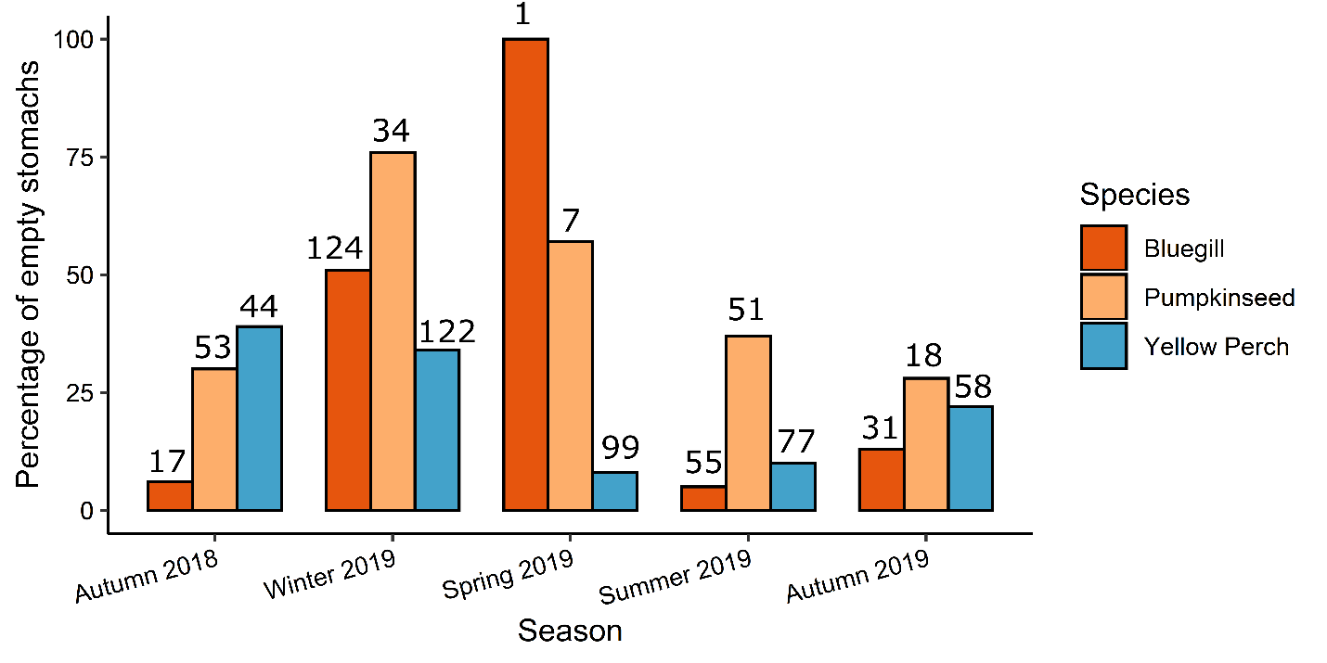
Fig. 1 Percent of fish caught with empty stomachs by season in three fish species collected in Keeler Bay, Lake Champlain in 2018-2019. Values above bars are the number of fish of a given species caught in each season.
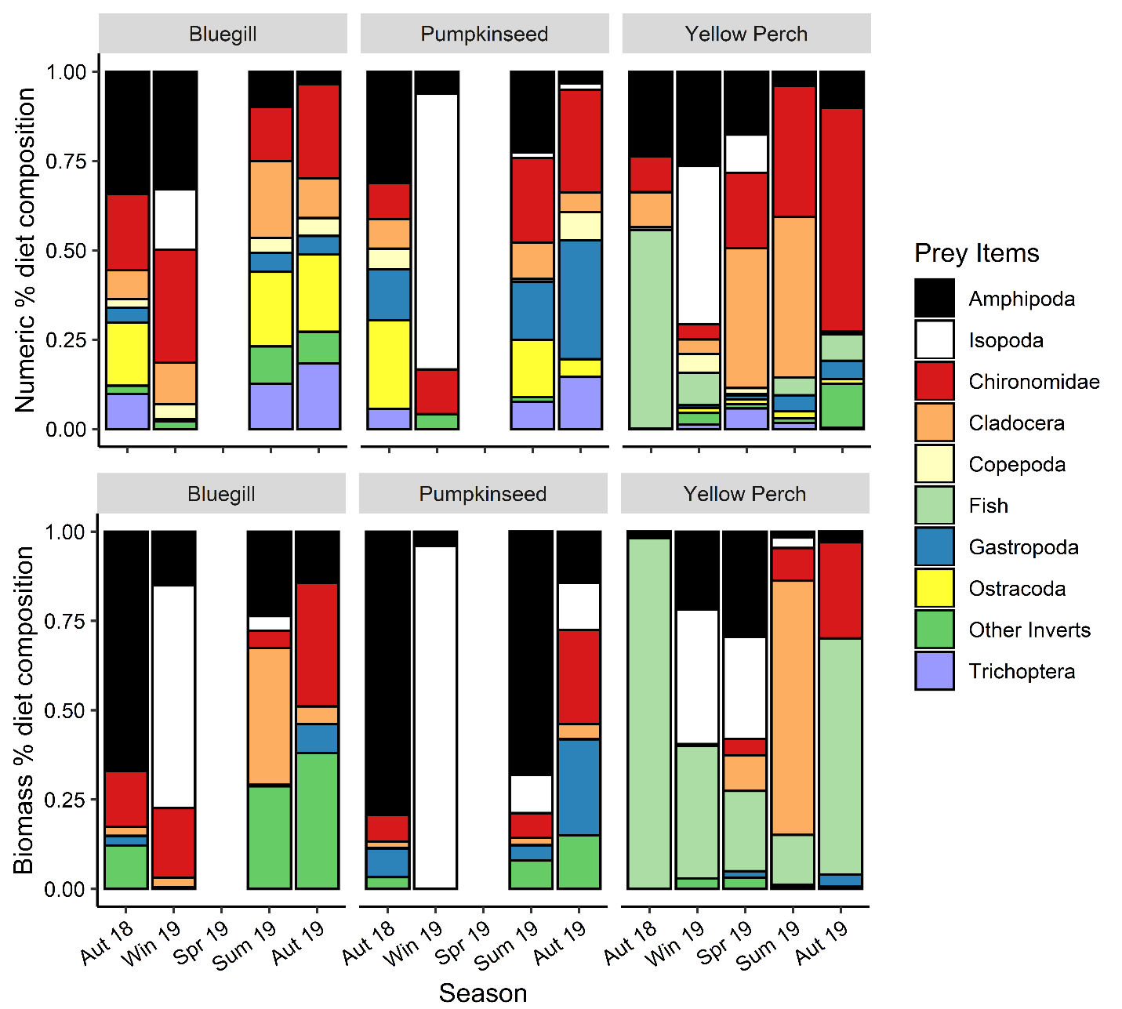
Fig. 2 Percent diet composition by prey count and biomass for three fish species collected in Keeler Bay, Lake Champlain in 2018-2019.
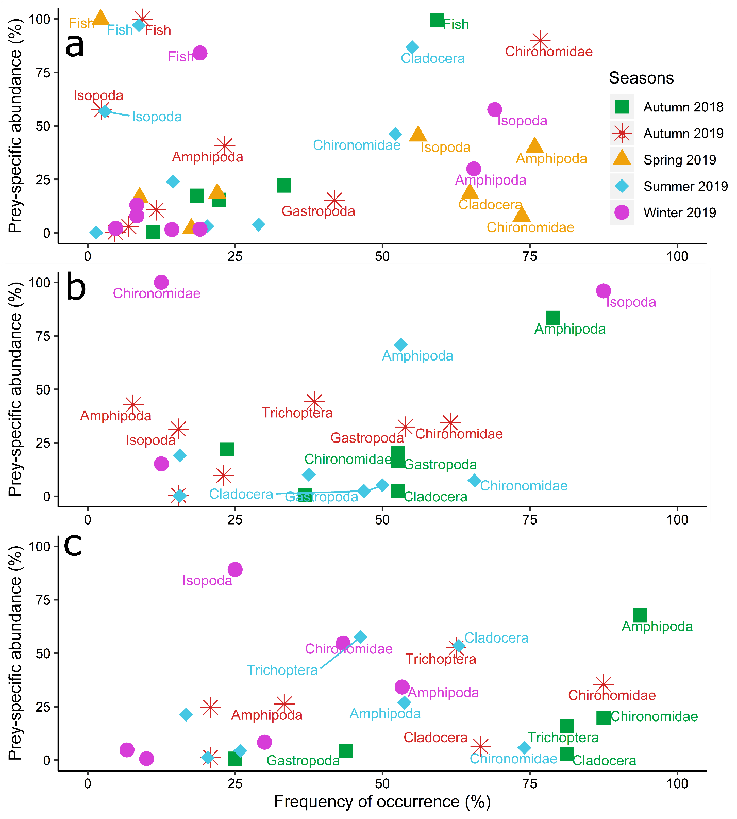
Fig. 3 Seasonal differences in diet composition based on biomass and feeding strategy in yellow perch (A), pumpkinseed (B), and bluegill (C) collected in Keeler Bay, Lake Champlain in 2018-2019. Prey-specific abundance is defined as the percentage of prey taxon biomass which composes total biomass in only those predators in which the actual prey occurs. The frequency of occurrence of a given prey type is defined as the number of stomachs in which that prey occurs (Amundsen et al., 1996).

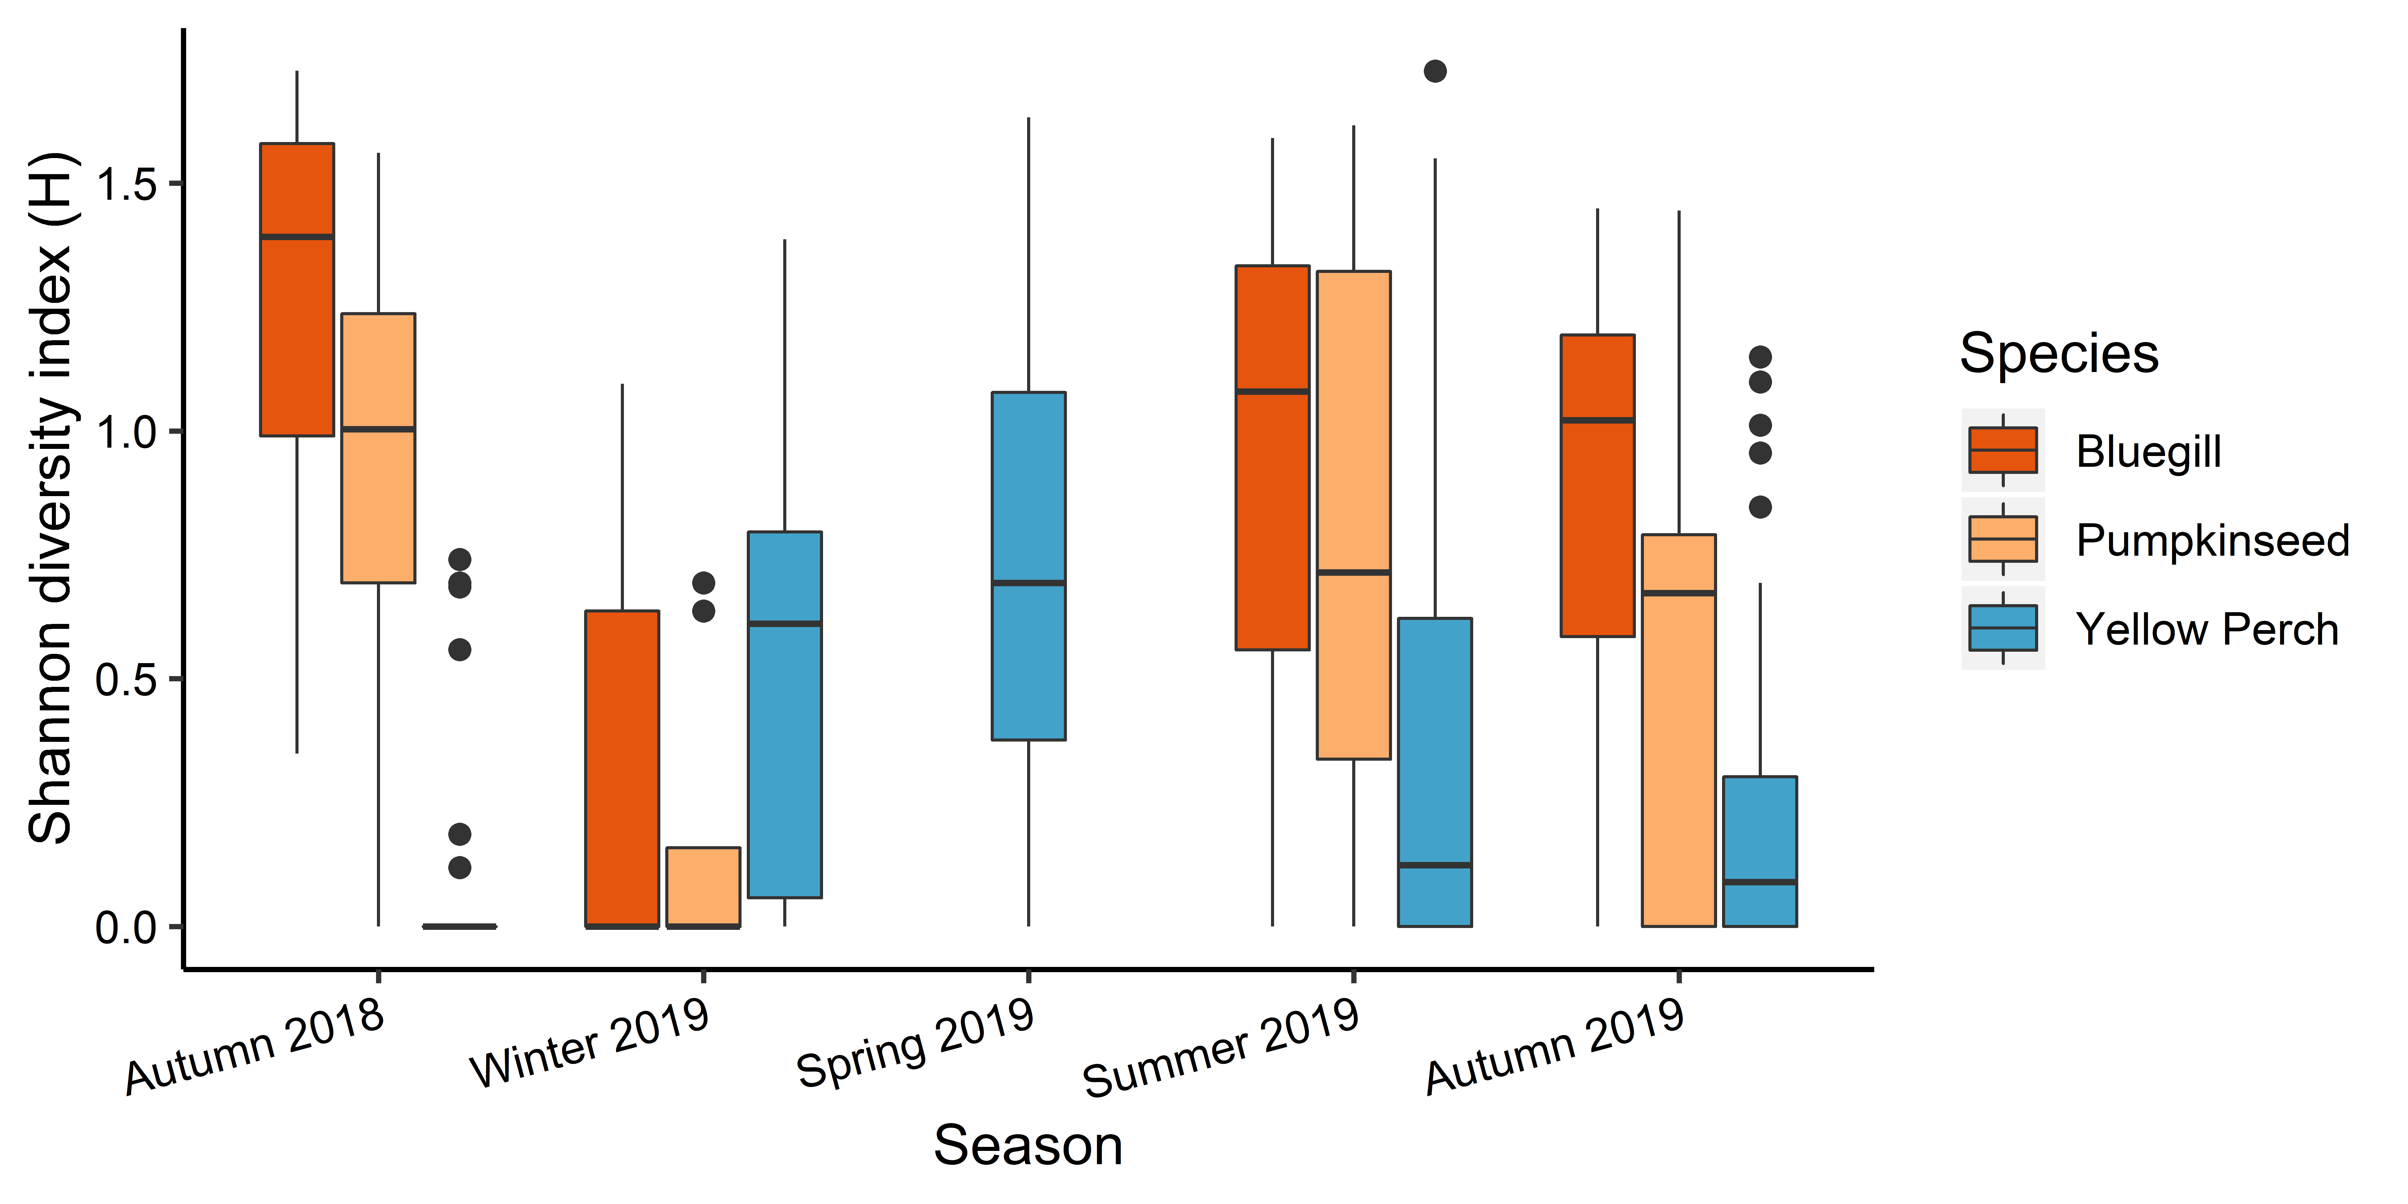
Fig. 4 Seasonal variation in Shannon’s diversity index (H) for three fish species collected in Keeler Bay, Lake Champlain in 2018-2019. Dots represent outliers that are 1.5*interquartile range.

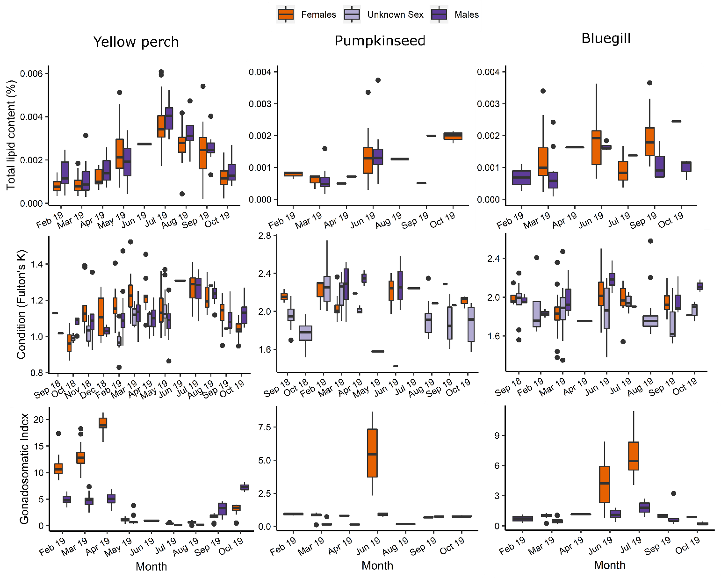
Fig. 5 Percent total lipid content (% of dry mass) per gram of body mass, body condition, and gonadosomatic index by month. Yellow perch, pumpkinseed, and bluegill were collected in Keeler Bay, Lake Champlain in 2019. Dots represent outliers that are 1.5*interquartile range.
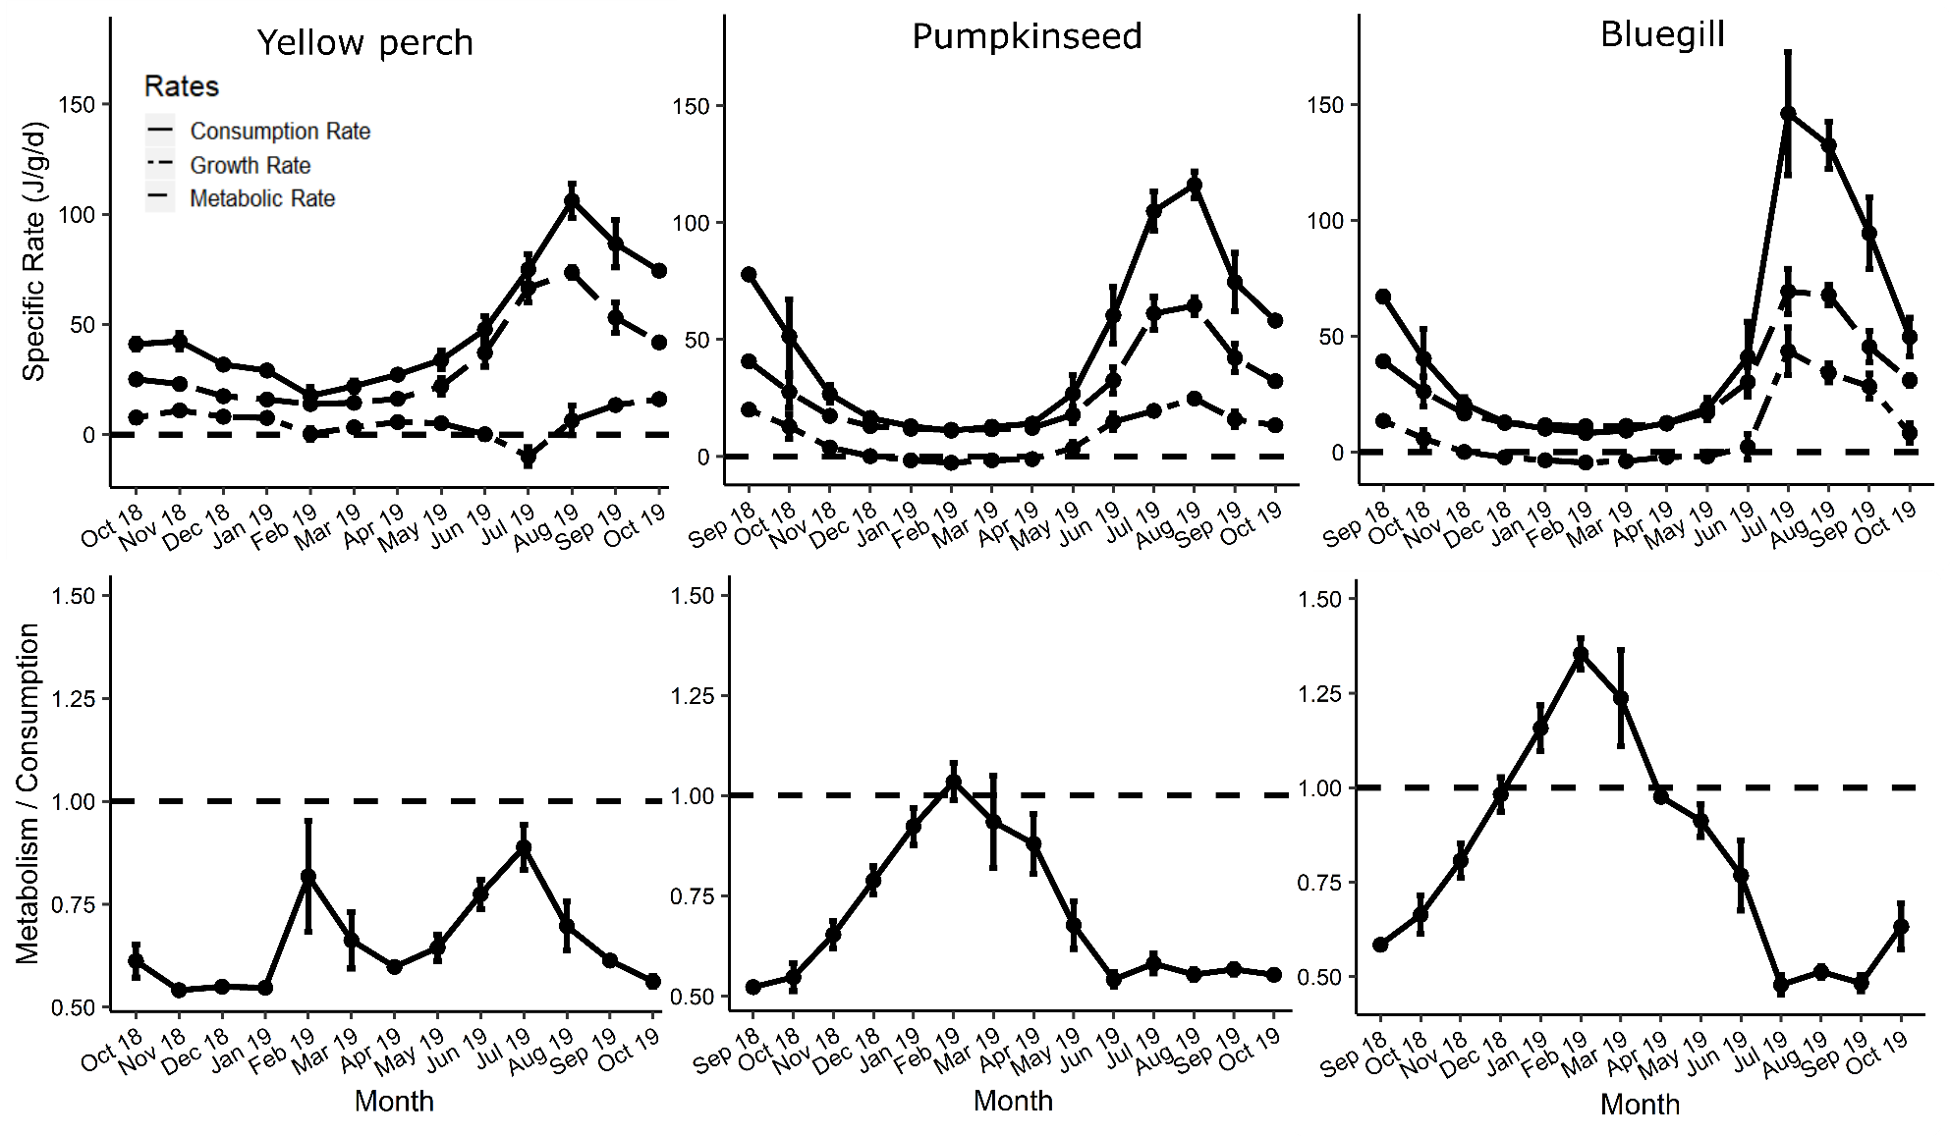
Fig. 6 Bioenergetics model results for yellow perch, pumpkinseed, and bluegill of daily specific rates (joules/gram of fish/day). Top row - monthly averages of daily specific consumption, metabolic, and growth rates. M = R + SDA. Growth rates represent the assimilated energy allocated to both somatic and gonadal growth. Dashed line at y = 0 used to highlight negative rates. Bottom row - monthly averages of M/C. Dashed line at y = 1 indicates when metabolic costs equal energy consumption. Error bars represent the standard deviation surrounding the monthly mean.

Appendix

Bioenergetics model values and derivations

Growth
Yellow perch mass-at-age data were estimated using mean values for age-3 and age-4 fish. The initial mass was the mean mass at age-3 in October 2018 (59.2 g) and the final mass was the mean mass at age-4 in October 2019 (71.9 g). Pumpkinseed and bluegill mass-at-age data were pooled because of a lack of adequate sample sizes. The initial mass was the mean mass at age-3 in September 2018 (62.2 g) and the final mass was the mean mass at age-4 in September 2019 (102.3 g).

Diet proportions
Fish diets were input into the FB4 model as the observed proportion of each prey taxon by wet biomass per day (see Diet metrics section). For each predator species, diet proportions of each individual, excluding fish with an empty stomach, were averaged by sampling date. Diet proportions were maintained for each model-day until the next sampling date when new diet data were available (Deslauriers et al., 2017).

Predator and prey energy densities
Prey energy density values were based on previous studies (Table 5). Seasonal variations in energy densities of common prey taxa have not been published; therefore, we retained constant values across seasons for prey.
The relationship between energy density and the dry-to-wet mass ratio of fishes has been well documented (Hartman & Brandt, 1995); therefore, we measured wet and dry masses of individual fish and estimated energy density as a function of percent dry mass (Table 6). We used a yellow-perch-specific model:
$$ED= -2873+313.1 DM$$
where ED = energy density in J/g wet mass and DM = percent dry mass (Hartman & Brandt, 1995). We also used a Perciform-family model for bluegill and pumpkinseed:
$$ED= -1875+309.5 DM$$
where ED = energy density in J/g wet mass and DM = percent dry mass (Hartman & Brandt, 1995). Using the approach presented here, energy density changed seasonally (Breck, 2008).

Reproduction
Energy stored in gametes is lost when fish spawn. One of the main assumptions of the bioenergetics model is that the gonad energy density is equal to the whole-body energy density of the spawning fish; such an assumption will underestimate the energetic loss in spawning females but overestimate in males (Deslauriers et al., 2017). Spawning day was assigned as April 01, 2019, for yellow perch, June 01, 2019, for pumpkinseed, and July 01, 2019, for bluegill. The maximum gonadosomatic index value measured for each species before spawning was used as the percentage of body mass lost on the spawning day (yellow perch = 21%, pumpkinseed = 9%, and bluegill = 11%).

Appendix Tables
Table 4 Conversions from length to wet mass for taxa found in fish stomachs. L = prey item length in mm. For Amphipoda, Isopoda, Trichoptera, Chironomidae, and Gastropoda, M = dry mass in mg. For Copepoda, Daphnia, Ostracoda, and other Cladocera, M = dry mass in μg. For fish, M = wet mass in g. Dry weights (DW) are converted to wet weights (WW) using a taxa-specific multiplier.

Prey species | Equation | DW to WW | Source for length to dry mass | Source for dry to wet mass
Amphipoda | M = 0.0058L^{3.015} | 7 | Benke et al. 1999 | Gamble, 2010
Chironomidae | M = 0.0059L^{2.099} | 6 | Benke et al. 1999 | Gamble, 2010; Sage, 1982
Cladocera | M = 14.9597L^{2.7955} | 8.33 | Gamble 2010 | Gamble, 2010; Downing & Rigler, 1984
Copepoda | W = 6.03L^{2.744} | 8.33 | Gamble 2010 | Gamble, 2010; Downing & Rigler, 1984
Gastropoda | M = 0.0331L^{2.851} | 5 | Benke et al. 1999 | Gamble, 2010; Ross & Lima, 1994
Isopoda | M = 0.0054L^{2.948} | 6 | Benke et al. 1999 | Gamble, 2010; Sage, 1982
Ostracoda | Log₁₀M = 3.24log₁₀L -3.79 | 8.33 | Newrkla 1985 | Gamble, 2010; Downing & Rigler, 1984
Prey fish | lnM = -12.2167+ 3.0799lnL | N/A |  | Gamble, 2010
Trichoptera | M = 0.0056L^{2.839} | 2.5 | Benke et al. 1999 | Gamble, 2010; Sage, 1982

Table 5 Energetic density in joules per gram wet mass of prey taxa. All data are sourced from Cummins & Wuycheck (1971) except prey fishes, for which the value was sourced from Pothoven & Höök (2015).

Taxon | J/ g WW
Amphipoda | 3908
Chironomidae | 3610
Cladocera | 2523
Copepoda | 2907
Gastropoda | 1799
Isopoda | 2095
Ostracoda | 2854
Prey fish | 4512
Trichoptera | 8366

Table 6 Predator energy density values of yellow perch, pumpkinseed, and bluegill used in bioenergetics simulations. Values were calculated based on the seasonal average percent dry mass of individuals caught in this study and converted to energy density using equations taken from Hartman & Brandt (1995). Day 1 in the simulation is October 23, 2018, for yellow perch and September 27, 2018, for pumpkinseed and bluegill. Day 358 and 384 both represent October 15, 2019.

Yellow Perch |  | Pumpkinseed |  | Bluegill
Day | Energy Density  (J/ g wet) | Day | Energy Density  (J/ g wet) | Day | Energy Density  (J/ g wet)
1 | 5648 | 1 | 6085 | 1 | 6073
10 | 5648 | 12 | 6085 | 143 | 5816
21 | 5648 | 143 | 5912 | 157 | 5816
45 | 5648 | 172 | 5912 | 163 | 5816
102 | 4351 | 175 | 5912 | 165 | 5816
103 | 4351 | 186 | 5912 | 169 | 5816
110 | 4351 | 208 | 5882 | 171 | 5816
117 | 4351 | 266 | 5869 | 186 | 5816
123 | 4351 | 293 | 5869 | 266 | 5922
130 | 4351 | 328 | 5869 | 293 | 5922
143 | 4351 | 358 | 6085 | 328 | 5922
145 | 4351 | 384 | 6085 | 358 | 6073
149 | 4351 |  |  | 384 | 6073
160 | 4351
182 | 4914
198 | 4914
220 | 4914
240 | 6440
267 | 6440
302 | 6440
332 | 5648
358 | 5648

Table 7 Water temperature values used for bioenergetics simulations for each species. Temperature data were obtained from the Vermont Established Program to Stimulate Competitive Research (EPSCoR) Data Buoy located in Inner St. Albans Bay, Lake Champlain (44° 47’ 37.889” N, 073° 9’ 18.641” W) at an average depth of 3.5 m from September 01 to October 30 in 2018 and June 03 to November 11 in 2019. * denotes when direct surface temperature measurements were used when no VT EPSCoR data were available. Water temperatures beneath the ice were modeled as 4.0 °C.

Yellow Perch |  | Pumpkinseed and Bluegill
Day | Temp (°C) | Day | Temp (°C)
1 | 9.44 | 1 | 17.27
10 | 8.54 | 12 | 14.86
21 | 8.48* | 27 | 9.44
45 | 5.01* | 36 | 8.54
102 | 4.00 | 47 | 8.48*
103 | 4.00 | 71 | 5.01*
110 | 4.00 | 128 | 4.00
117 | 4.00 | 129 | 4.00
123 | 4.00 | 136 | 4.00
130 | 4.00 | 143 | 4.00
143 | 4.00 | 149 | 4.00
145 | 4.00 | 156 | 4.00
149 | 4.00 | 169 | 4.00
160 | 4.00 | 171 | 4.00
182 | 4.57* | 175 | 4.00
198 | 5.68* | 186 | 4.00
220 | 11.35* | 208 | 4.57*
240 | 14.30 | 224 | 5.68*
267 | 24.58 | 246 | 11.35*
302 | 24.37 | 266 | 14.30
332 | 17.48 | 293 | 24.58
358 | 14.41 | 328 | 24.37
 |  | 358 | 17.48
 |  | 384 | 14.41

Table 8 Summary of numerical diet composition by season for three predator species collected in Keeler Bay, Lake Champlain in 2018-2019. BG – bluegill, PS – pumpkinseed, YP – yellow perch. N represents the number of fish caught. Prey item values represent the mean numerical percent diet composition and are abbreviated: Amphi = Amphipoda; Chiron = Chironomidae; Clad = Cladocera; Cope = Copepoda; Gastro = Gastropoda; Isop = Isopoda; Ostra = Ostracoda; Tricho = Trichoptera. AvgH represents the average Shannon’s Diversity Index score (H) and seH represents the standard error H.

Species | Season | N | % Empty | Amphi | Chiron | Clad | Cope | Fish | Gastro | Isop | Ostra | Other | Tricho | AvgH | seH
BG | Autumn 2018 | 17 | 6 | 0.34 | 0.21 | 0.08 | 0.02 | 0 | 0.04 | 0 | 0.18 | 0.02 | 0.1 | 1.26 | 0.11
BG | Autumn 2019 | 31 | 13 | 0.04 | 0.26 | 0.11 | 0.05 | 0 | 0.05 | 0 | 0.22 | 0.09 | 0.18 | 0.84 | 0.09
BG | Spring 2019 | 1 | 100 | NA | NA | NA | NA | NA | NA | NA | NA | NA | NA | NA | NA
BG | Summer 2019 | 55 | 5 | 0.09 | 0.15 | 0.22 | 0.04 | 0 | 0.05 | 0.01 | 0.21 | 0.1 | 0.13 | 0.93 | 0.07
BG | Winter 2019 | 124 | 51 | 0.33 | 0.32 | 0.12 | 0.04 | 0 | 0 | 0.17 | 0 | 0.02 | 0 | 0.29 | 0.05
PS | Autumn 2018 | 53 | 30 | 0.31 | 0.1 | 0.08 | 0.06 | 0 | 0.14 | 0 | 0.25 | 0 | 0.06 | 0.95 | 0.06
PS | Autumn 2019 | 18 | 28 | 0.03 | 0.29 | 0.05 | 0.08 | 0 | 0.33 | 0.02 | 0.05 | 0 | 0.15 | 0.57 | 0.13
PS | Spring 2019 | 7 | 57 | 0.09 | 0.85 | 0 | 0 | 0 | 0 | 0.06 | 0 | 0 | 0 | 0.33 | 0.33
PS | Summer 2019 | 51 | 37 | 0.23 | 0.24 | 0.1 | 0.01 | 0 | 0.16 | 0.02 | 0.16 | 0.01 | 0.08 | 0.74 | 0.1
PS | Winter 2019 | 34 | 76 | 0.06 | 0.12 | 0 | 0 | 0 | 0 | 0.77 | 0 | 0.04 | 0 | 0.17 | 0.11
YP | Autumn 2018 | 44 | 39 | 0.24 | 0.1 | 0.1 | 0.01 | 0.56 | 0 | 0 | 0 | 0 | 0 | 0.11 | 0.05
YP | Autumn 2019 | 58 | 22 | 0.1 | 0.63 | 0 | 0.01 | 0.07 | 0.05 | 0 | 0.01 | 0.12 | 0 | 0.23 | 0.05
YP | Spring 2019 | 99 | 8 | 0.18 | 0.21 | 0.39 | 0.02 | 0 | 0.01 | 0.11 | 0.01 | 0.01 | 0.06 | 0.72 | 0.11
YP | Summer 2019 | 77 | 10 | 0.03 | 0.37 | 0.45 | 0 | 0.05 | 0.05 | 0.01 | 0.02 | 0.01 | 0.02 | 0.31 | 0.23
YP | Winter 2019 | 122 | 34 | 0.26 | 0.04 | 0.04 | 0.05 | 0.09 | 0.01 | 0.44 | 0.01 | 0.03 | 0.01 | 0.54 | 0.72

