*For submission to GSA TODAY*

10 October 2018

**Geochemical characterization of the water and watersheds of central Cuba**

Authorship

UVM – Paul, Mae Kate, Julia

Oberlin – Amanda, Monica

Williams – Jay, David, Marika

Cuba - ??

2500 to 3000 words total

**Abstract**

The geochemistry of water and watersheds of tropical regions, many of which are occupied by developing nations, is not well studied. Such studies are important because they can reveal the extent and patterns of rock weathering as well as the impact of human activities. Cuba, the largest Caribbean Island is only 150 km from North America and is underlain by diverse rock types; its landscape has been heavily altered by agriculture for centuries. To quantitatively assess biogeochemistry and the mass transfer from land to sea, a joint Cuban-American team collected water and sediment from 24 rivers (discharge at sampling, 0.002-40 m3 s-1) in central Cuba (basin area 2 to 730 km2; median, 56 km2) in August 2018. Upstream land area was 0 to 98% agricultural (median, 60%) with the remainder mostly forested. At each river, we measured conductivity (130-1380 uS/cm), dissolved oxygen (59-144% saturation), and pH (6.8-8.5). *E coli* were present in all samples; 14 of 24 rivers had levels high enough that the water was unsafe for recreation and drinking. Total dissolved nitrogen was low (0.2 to 1.6 mg/L) and most of it was present as nitrate N (ranging from 0.1 to 1.4 mg/L; median, 0.5). Orthophosphate ranged from below detection limit to 0.6 ppm (median of detectable samples, 1.3 (n = 12)) and chloride ranged from 5-180 mg/L (median, 20). Dissolved inorganic carbon was high and variable (15-93 mg/L, median 43) and possibly sourced from abundant carbonate bedrock. Cation concentrations and annual discharge estimates suggest chemical weathering rates of 42-660 tons km-2 yr-1 (median, 156). Variability in dissolved organic carbon was also high (1.8 to 10 mg/L, median 3.0). We conclude that river water quality in central Cuba is impacted by additions of organic material and *E. coli* related to human activities, most likely agriculture including grazing animals. Dissolved nitrate and phosphate levels are consistent with conservative fertilization. Our data suggest that *E. coli* as well as P and N export could affect coastal ecosystems and coral reefs which are important both ecologically and for tourism.

*Keywords: dissolved load, runoff, nutrients, watershed, weathering*

**Introduction**

The island nation of Cuba, less than 150 kilometers from North America, has seen limited geoscience investigation by American scientists since the United States embargo was made permanent in 1962 (Figure 1). Recent openings in US/Cuba relations have catalyzed scientific interchange and cooperation between American and Cuban scientists (Feder, 2018). Here, we present and interpret extensive new environmental geologic data quantifying the geochemistry of surface waters and drainage basin sediments in central Cuba, the result of a multinational, collaborative field campaign including researchers from the Centro de Estudios Ambientales de Cienfuegos (CEAC), and faculty and students from the University of Vermont, Oberlin College, and Williams College. Our data provide a comprehensive snapshot of the fluid environment in an area of the tropics where only scant data were available previously. Geochemical analyses allow us to address both fundamental geologic questions such as the intensity and pace of weathering in this tropical region and more applied questions related to the quality of surface waters and human impacts on the landscape and riverine geochemical systems.

**Background**

Cuba is the largest island in the Caribbean; its landscape is dominated by a central spine of mountains (up to 1917 m elevation in the east, 500-700 m elsewhere) running parallel to the coasts. The uplands descend into rolling plains and low-lying coastal estuaries. Cuba’s diverse geology reflects its tectonic history at the boundary of the North American and Caribbean plates (Iturralde-Vincent et al., 2016). Central Cuban basement rocks are characterized by rock types that vary from Jurassic to Cretaceous accreted deposits of igneous rocks and clastic and carbonate sediments formed along passive margins, obducted late Cretaceous-late Eocene ophiolite and ophiolitic mélange, and Cretaceous island arc volcano-sedimentary and plutonic rocks underlain by deformed gabbros, basalts, basaltic andesites, and pyroclastic rocks (Iturralde-Vincent et al., 2016). The basement is unconformably overlain by neoautochthonous late Eocene to Recent slightly-deformed sediments (Iturralde-Vincent, 1994).

Agriculture has been practiced in Cuba for centuries. Prior to Spanish settlement in 1510, indigenous peoples cultivated cassava, yuca, and maize, supplementing these food sources by hunting and fishing (Cosculluela, 1946). Spanish colonization brought large-scale sugar agriculture and cattle farming (Zepeda, 2003). Following Cuba’s independence from Spain in 1898, sugar production in Cuba quadrupled under United States’ influence (Whitbeck, 1922). When Cuba became allied with the Soviet Union in 1959, industrialization of the sugar industry to increase yields and exports became a central goal (Peréz-Lopez, 1989). By the 1980s, Cuba boasted the most mechanized agricultural sector in Latin America (Febles-González et al., 2011). Cuba was dependent on imports of food, fossil fuels, machinery, and chemical fertilizers/pesticides to maintain this agricultural system and compensate for decreasing soil quality; the collapse of the Soviet Union in 1991, forced Cuba to adapt agriculturally (Wright, 2012). A conservation-based soil management program featuring minimal tillage, organic soil amendments, and the use of cover crops was implemented on a national scale (Gersper, Rodríguez-Barbosa, and Orlando, 1993).

Surface water quality monitoring to date in Cuba has largely focused on bays and reservoirs. In central Cuba, extensive water chemistry monitoring of the regions four main reservoirs, representing two large river systems and four basins with varied geology, was undertaken between 1986-2005 (Bentacort, Suárez, and Jorge, 2010; Bentacort, Suárez, and Toledo, 2011; Bentacort and Suárez, 2010; Bentacort, Suárez, and Toledo, 2010). The primary control on major ion concentration in all reservoir waters appeared to be the weathering of rocks in the upstream basins; there was no statistically significant variance in water chemistry across dry and rainy seasons in three of the four studied basins (Bentacort, Suárez, and Jorge, 2012). Major ions in solution in these basin waters are: Ca2+ > Na+ > K+ > Mg2+ and (HCO3)− > Cl− > SO2− (Bentacort et al., 2012). Human activities influenced water chemistry, as evidenced by elevated levels of phosphorus in all basins (Bentacort et al., 2012) and elevated levels of nitrogen in some (Bentacort and Suárez, 2010). Elsewhere in the region, water quality and stream health has been investigated using benthic macroinvertebrates as bioindicators (Riveraux et al., 2004). In the San Juan River basin (138 km2), macroinvertebrate bioindicator assessment revealed water quality ranged from “acceptable” to “very critical” quality from its headwaters to its outlet near a major urban area (Naranjo-López et al., 2014).

**Methods**

In August 2018, a US/Cuban field team visited 25 sites in central Cuba, collecting sediment from all sites and water from 24 (Figures 2 and 3A). Field blanks were collected each day using all sampling equipment and deionized water (Milli-Q, 18 MΩ). We measured pH, conductivity, and dissolved oxygen in triplicate at each site using meters. *E. coli* samples were processed in the field using the Aquagenx compartment bag test and incubated for 24 hours (Stauber et al., 2014). Samples collected for major and trace element analysis by ICP-MS at Middlebury College (50 ml) were filtered in the field (0.45 um nylon) and then acidified using 5 drops of 10% nitric acid. Unfiltered, unacidified samples were collected and kept cold. We measured Cl-, NO3-, and HPO43- within 24 hours using LaMotte low-range field kits. Major cations and anions were measured in filtered, unacidified samples using AAS and IC, respectively, at Williams College; alkalinity was determined on unfiltered samples using automated titration. Sediment composition (250-850 μm sand fraction) was determined using an Hitachi XMET Geo8000 portable X-ray fluorescence spectrometer using both soil and mining fundamental parameters methods. Basins upstream of sampled points were extracted from the ASTER GDEM (LP DAAC, 2001). Mean annual precipitation for each basin was determined from WorldClim (Hijmans et al., 2005). Bedrock geology is from the USGS Caribbean layer (French and Schenk, 2004). Land use was determined from the Global Land Cover (GLC) dataset (Chen et al. 2015).

**Results**

Stream waters from central Cuba have widely different chemistries (Figures 3 and 4). All 24 samples we collected were near neutral to slightly alkaline (field pH range, 6.9 – 8.1). Buffering capacity is high with alkalinity (HCO3-) between 65 and 490 mg/L (mean, 256). Dissolved loads (anions + cations) were substantial (TDS = 160 to 2580 mg/L) and positively correlated with field-measured conductivity, which ranged from 130 to 1380 S (R2 = 0.82). On average, cation concentrations were Ca>Na>Mg>Si>K and anion concentrations were HCO3>Cl> SO4> NO3> HPO4 >NO2> Br>F. Na and Cl are well and positively correlated as well as Na and HCO3, F, SO4, NO2, K, Ca, Br, Ti, As, Rb, Sr, Ba, and U (p < 0.05, all positive). These elements are also correlated to one another positively and significantly. In addition, Mg is positively correlated to SiO2, V, Cr, and Ni (p < 0.05). Using basin-specific precipitation estimates and assuming a 20% specific water yield, we estimate chemical denudation rates between 42 and 660 kg km-2 y-1 (median = 157).

*E. coli* bacteria were found in all samples, and most samples (14/23) had enough bacteria to be deemed unsafe according to World Health Organization criteria (http://www.who.int/water_sanitation_health/bathing/srwg1.pdf). Genetic microbial source tracing in two samples (Source Molecular, CU-107, 110) did not identify human-sourced bacteria; rather, the bacteria in sample CU-110 were identified as being of ungulate origin. Dissolved oxygen ranged from 59 to 145% (average 97%).

Dissolved organic carbon and nutrients (N, P, and K) are being exported from each catchment. Dissolved organic carbon averaged 4.02 mg/L (range 1.82 - 9.86). Total dissolved nitrogen averages 0.82 mg/L (range 0.16 - 1.69, lab data only) of which on average 60% is nitrate (range 24-93%). Nitrate values measured in the field and then in the lab several weeks later are well correlated. Dissolved organic carbon/nitrogen ratios also vary widely, from 1.3 to 14.8. Orthophosphate measured in the field and lab are positively correlated but laboratory values are higher on average by ~ 3 (Figure 4).

Sediment samples collected from rivers where waters were sampled also have widely different elemental compositions. Overall Si > Fe > Ca > Al > Mg with all other elements having median values less than 1%. Mg, Si, Ca, and K were detected in both sediment and water samples. We find that Mg and K are weakly correlated between the sediment and water (p < 0.1) but not Ca and Si.

Four of the 24 samples stand out from the rest in a variety of ways. These samples, CU-120, 121, 122 and 132 have the highest Cl-, SO4 and Na concentrations. They plot in a distinct zone of the Piper diagram (Figure X) and have higher Ca, Sr, Ba, Br, Cl and SO4 concentrations than other Cuban samples. These samples are spatially near one another and drain the same rock bedrock unit, but are not the only samples draining that unit. One (CU-122) is mostly wetland (based on Google Earth) while the others are from dominantly agricultural catchments (based on both Google Earth and the GLC land use data).

**Discussion/Interpretation**

Our data provide a comprehensive snapshot of the chemistry of water and sediments moving through rivers in Central Cuba in August 2018 and allow us to infer geochemical weathering processes including the source of solutes, flow paths for water entering rivers, the relationship between bedrock chemistry and water chemistry, and water quality in the region. We then compare Cuban stream water chemistry to measurements made around the world, including the tropics.

*Source of solutes*

High solute concentrations suggest that water in central Cuban rivers is sourced from freshly weathered bedrock surfaces and not deeply weathered regolith. Field observation of bedrock channels at many sampling sites supports this interpretation. The grouping of samples in the Piper diagram (Figure 5), particularly CU-120-122 demonstrated the strong influence of rock type of water chemistry and thus the presence, along groundwater flow paths, of fresh rock that has not been extensively saprolitized.

*Connection between water chemistry and bedrock*

Different rock units separate on the piper diagram (Figure 5), suggesting that the bedrock is a primary control on the chemistry of the water. Four samples (120, 121, 122, 132) have a distinct chemical signature that does not fall on the same mixing lines seen by other samples. These watersheds all drain the same rock unit and are spatially near one another. The high concentration of both cations and anions in these samples, in particular Na and K, suggest that these watersheds may be draining evaporite deposits consistent with their mapping as Marine sediments (REF). The continental rocks, which include metaigneous, plutons, metasedimentary, and volcanic rocks appear to separate into three distinct clusters again suggesting a link between water and rock chemistry.

*Water quality*

Several measured parameters are above the US EPA and WHO limits for drinking water quality for at least one sample site, suggesting there could be health hazards for people using the river as their primary water supply. 14 of 23 samples analyzed for *E. Coli* had water above the WHO limits for drinking and recreational use. The ungulate DNA match is consistent with our field observations that cows were common in and near streams as were horses. The site with ungulate *E. Coli* DNA had a ranch upstream and overall land use was ~15% grassland and ~85% forest. Pigs and chickens were present on the landscape but not adjacent to streams. We hypothesize the area mapped as grassland was primarily in use as pasture, thus leading to the ungulate e coli present in the water.

Some of the contaminants (As, U, Cr) are only present in a few samples, but in these samples, the concentration of these elements exceeds EPA limits. Five samples have detectable As (0.99 – 1.42 mg/L) are all above the 0 mg/L maximum contamination level (MCL) set by the US EPA. Seven samples have U concentrations one to two orders of magnitude above the maximum contaminant level (0.03 mg/L). Three samples have detectable Cr above the 0.1 mg/L MCL.

Other parameters (Mn, Ni, TDS) are of a more widespread concern in central Cuba, with nearly half or more of samples exceeding EPA and/or WHO limits. All 11 samples with detectable Mn have levels well above the EPA health advisory lifetime level of 0.3 mg/L as well as the secondary drinking water standard of 0.05 mg/L and the WHO Health standard of 0.4 mg/L. The levels present are high enough to leave coatings on pans when cooking and to have a taste for some people. Such high levels may be caused by anaerobic conditions increasing solubility of Mn in water. Likewise, 12 samples have detectable Ni well above the EPA health advisory lifetime limit of 0.1 mg/L. Median total dissolved solids in 12-17 samples are above the threshold for taste for some consumers (600 mg/L; 12 samples) as well as the EPA secondary drinking water standard (500 mg/L; 17 samples) and some samples have such high concentrations of dissolved solids that excessive scaling is likely on pipes and household cooking utensils and implements. For two elements (Sr, Ba) all 24 samples have levels well above the EPA lifetime health advisory limits and/or the maximum contaminant level for the element. This suggests that access to clean drinking water without the contaminants is likely a widespread problem throughout central Cuba.

*Comparison to other locations*

The relatively high concentrations of dissolve elements in Cuban river water indicates that chemical weathering rates and solute export rates are high. This inference is supported by comparison with existing data sets. Plotting new Cuban data alongside data compiled by Larsen et al. (2015) indicates that estimated annual solute loads and thus inferred chemical weathering rates are among some of the highest ever measured (Figure 6A). If the limited suspended sediment yield data available for Cuba (REF) are considered along with the estimated chemical weathering rates, then it appears that central Cuba has a very high ratio of chemical to physical weathering, consistent with high rainfall, its warm, tropical climate and the presence of readily weatherable rocks. It maybe that the active tectonic setting of eastern Cuba (REF), with concomitant uplift and rock fracturing, is responsible for the continued supply of fresh, easily weatherable rock, contributing to the extraordinarily high chemical weathering rates.

**Figures**



Figure 1.  Study location map – eventually colorized map of entire island DEM with this little one as location inset.

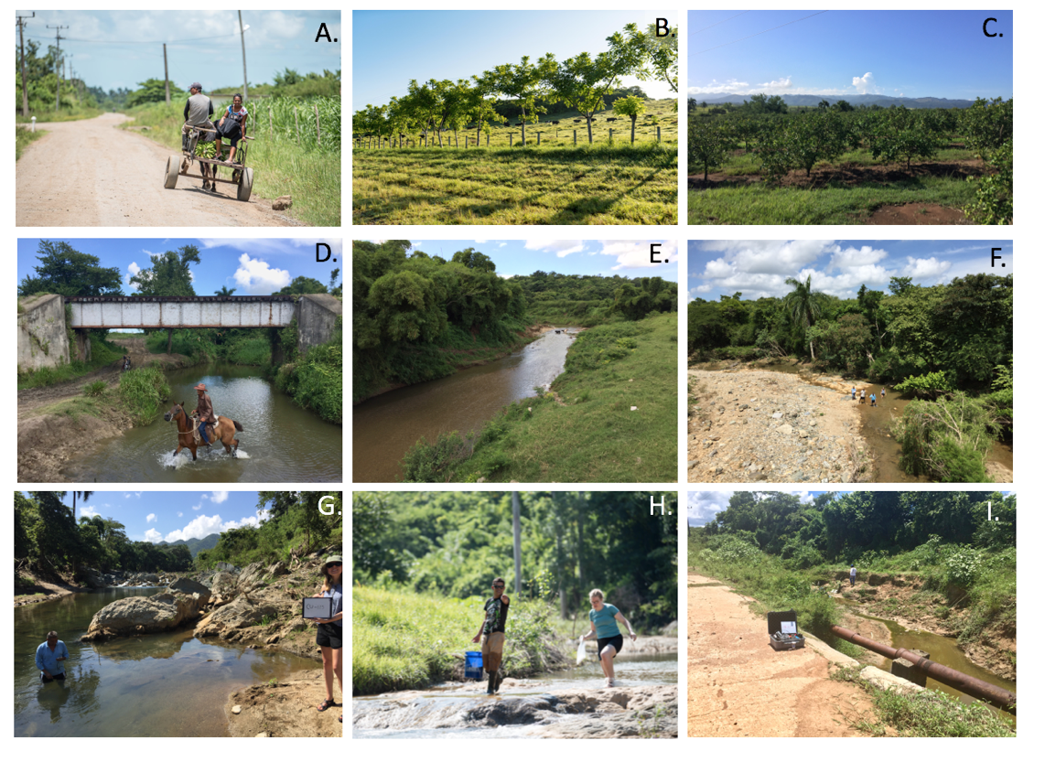

Figure 2.  Common Cuban landscapes and example sample sites. A.  Sugarcane and dirt roads are common on the island. B. Cattle grazing on cleared fields. C. Citrus groves on slopes in southern field area. D. Horses were frequently in streams, CU-132. E. Plane-bed sand and gravel channel with cows in stream, CU-101.  F. Large point bar flooded in Hurricane Alberto showing dynamic range of stream flows over time, downstream of CU-114.  G. Boulder/bedrock channel during in situ conductivity sampling, CU-115.  H. Bedrock channel upstream of CU-114.  I. Low flow sample site in incised channel, CU-122. Locations shown in figure 3.

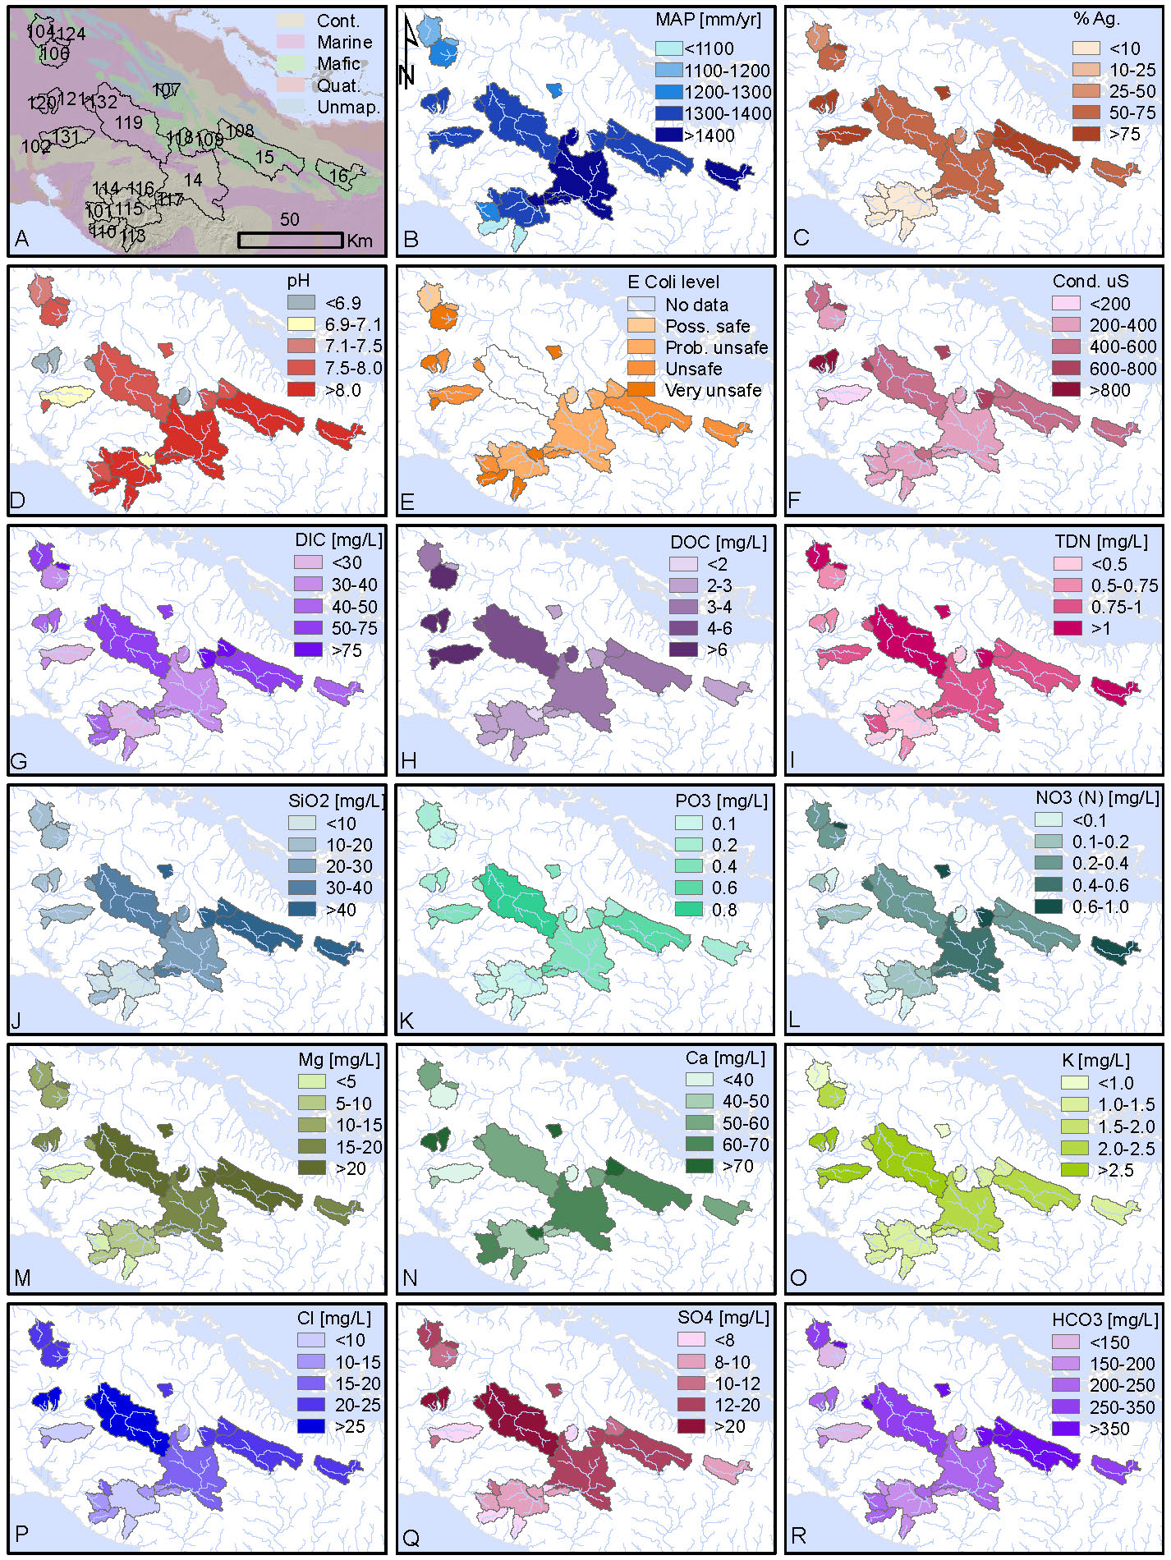

Figure 3. Results of river water geochemical analyses plotted by sampled basins. A. Sampled basins overlain on generalized geological map (French and Schenk, 2004). B. Mean annual precipitation (Hijmans et al., 2005). C. Land used for agriculture (Chen et al., 2015). D-R. Field and laboratory geochemical data for each sampled basin (see supplementary data for values). Italicized letters show locations of photos in figure 2.



Figure 4.  Bar and whiskers of water and sediment geochemical analyses grouped by analyte type and showing in color, the four samples (CU-120, 121, 122, and 132) that are highly conductive. Vertical axes are log scaled. Analytes are on horizonal axes. Central bar is median.

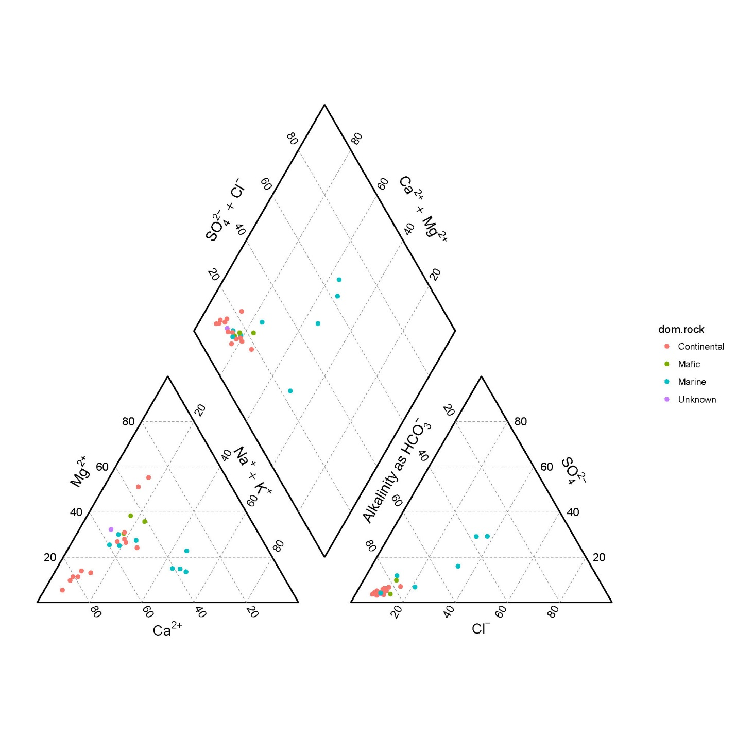Fig 5.  Piper diagram of all data color coded by lithology. Four samples plotting to the right in all three diagrams are CU-120, 121, 122, and 132.





Figure 6. Comparison of Cuban rates of chemical and physical weathering to other values reported globally. A. Bar and whisker plots show chemical weathering rates are among the highest reported in the world. B. Scatter plot with Cuban data.

**References Cited**

Chen, J., Chen, J., Liao, A., Cao, X., Chen, L., Chen, X., He, C., Han, G., Peng, S., Lu, M., Zhang, W., Tong, X., and Mills, J., 2015, Global land cover mapping at 30m resolution: A POK-based operational approach: ISPRS Journal of Photogrammetry and Remote Sensing, v. 103, p. 7-27. DOI: <http://dx.doi.org/10.1016/j.isprsjprs.2014.09.002>

Cosculluela, J. A. (1946). "Prehistoric Cultures of Cuba." American Antiquity 12(1): 10-18.

Febles-González, J. M., A. Tolón-Becerra, X. Lastra-Bravo and X. Acosta-Valdés (2011). "Cuban agricultural policy in the last 25 years. From conventional to organic agriculture." Land Use Policy 28(4): 723-735.

Feder, t. (2018), Physics in Cuba Physics Today, v. 71, n. 3, 10.1063/PT.3.3871

French, C. D., and Schenk, C. J., 2004, Map showing geology, oil, and gas fields, and geologic provinces of the Caribbean Region.

Gersper, P. L., Carmen S. Rodrfguez-Barbosa and L. F. Orlando (1993). "Soil conservation in Cuba: A key to the new model for agriculture." Agriculture and Human Values 10(3): 16–23.

Hijmans, R. J., Cameron, S. E., Parra, J. L., Jones, P. G., and Jarvis, A., 2005, Very high resolution interpolated climate surfaces for global land areas: International journal of climatology, v. 25, no. 15, p. 1965-1978.

Iturralde-Vinent, M. A. (1994). "Cuban Geology: A New Plate-Tectonic Synthesis." Journal of Petroleum Geology 17(1): 39-70.

Iturralde-Vinent, M. A., A. García-Casco, Y. Rojas-Agramonte, J. A. Proenza, J. B. Murphy and R. J. Stern (2016). "The geology of Cuba: A brief overview and synthesis." GSA Today: 4-10.

LP DAAC, 2001, ASTER GDEM, *in* NASA Land Processes Distributed Active Archive Center, ed.: Sioux Falls, South Dakota, USGS/Earth Resources Observation and Science (EROS) Center.

Peréz-Lopez, J. F. (1989). "Sugar and structural change in the Cuban economy." World Development 17(10): 1627-1646.

Stallard, R. F., and J. M. Edmond (1983), Geochemistry of the Amazon 2. The influence of geology and weathering environment on the dissolved load, J. Geophys. Res., 88, 9671–9688.

Stauber C, Miller C, Cantrell B, Kroell K. (2014) Evaluation of the Compartment Bag Test for the Detection of Escherichia coli in Water. *Journal of Microbiological Methods.*

Whitbeck, R. H. (1922). "Geographical Relations in the Development of Cuban Agriculture." American Geographical Society 12(2): 223-240.

Wright, J. (2012). "The Little Studied Success Story of Post-Crisis Food Security in Cuba: Does Lack of International Interest Signify Lack of Political Will?" The International Journal of Cuban Studies 4(2): 130-153.

Zepeda, L. (2003). "Cuban Agriculture: A Green and Red Revolution." Choices: The Magazine of Food, Farm, and Resource Issues.