Are forest managers influenced by peers or pewees?
Experimental evidence on social information and songbird habitat conservation

Hilary Byerly1 and Brendan Fisher1 1University of Vermont
October 30, 2018

Abstract
Working landscapes are important sources of biodiversity and ecosystem services. Voluntary conservation programs ask working lands managers—farmers, ranchers, and forest owners—to manage their resources in ways that maintain or increase these environmental benefits. Insights from behavioral science show that simple changes in messaging that target social preferences can increase pro-environmental behavior. This social information about what others do and think could provide low-cost options for government and nonprofit programs to incentivize land managers to engage in conservation activities. However, few studies have tested whether such behavioral interventions influence land and forest conservation decisions. Using a randomized controlled trial design, we mailed three versions of a solicitation letter for a bird habitat conservation program to 967 Vermont forest managers who produce maple syrup. Maple producers who were offered public recognition for participation were as likely to ask for more information about the program as those who received only a descriptive control message. Those who received information about the participation of their peers (social norms) were 36% less likely to request information than the control. These unexpected results highlight the importance of context in leveraging social influence to change behavior. This research applies insights from human behavioral science to forest management and offers causal evidence on factors that influence participation in voluntary conservation programs that improve wildlife habitat and forest resilience.

Introduction
Working landscapes—croplands, pastures, and managed forests—cover nearly half of the of the planet’s land surface (Foley et al., 2005). Though designated for production, they are essential to biodiversity conservation and ecosystem service delivery (Kremen and Merenlender, 2018). The decisions of farmers, ranchers, and forest managers are super important, often key to conservation success (Hilty and Merenlender, 2003; Pasquini et al., 2010). The challenge is to encourage these land managers to manage for multiple objectives, maintaining environmental benefits and the production of market goods simultaneously. Since many of the environmental benefits and costs of private land management are external to land managers’ decision making, policymakers and program managers seek to influence private land managers to provide more of these public goods (Hanley et al., 2012). Voluntary programs are the primary strategy to engage land managers in conservation and stewardship (ref). They offer financial incentives or educational outreach to attract participation and encourage conservation. It is unclear what drives working land managers to engage with such programs and how their design influences participation (Prokopy et al., 2008; Ferraro and Pattanayak, 2006).
Behavioral science uses field experiments to observe causal relationships between attributes of a decision and behavioral outcomes (ref). The field also shows how simple changes to those attributes can have policy-relevant effects on behavior (ref). Rather than restricting choice or changing financial incentives, researchers and program managers have altered how or when options are presented, by whom, and in what context. These ‘behavioral interventions’ have produced gains in personal health and savings (refs), home energy and water conservation (refs), and a range of other socially beneficial individual behaviors (ref taxes, education). Yet there have been few applications of behavioral science to decisions about land and natural resource management (Byerly et al., 2018). Behavioral strategies are often low-cost and preserve freedom of choice, making them well suited for stretched conservation budgets and property owners resistant to mandates (Ferraro et al., 2017). Applications of behavioral insights to land management decisions may offer new and essential policy options to achieve conservation goals (Reddy et al., 2017).
Here, we address two questions related to the provision of public goods by private land managers. First, what is the effect of a simple change in program messaging on land managers’ conservation decisions? Such causal evidence on non-regulatory, non-price strategies can offer conservation organizations and agencies useful insights. Second, does social information influence land management behavior? By testing behavioral interventions in the context of land management we contribute 1) to the understanding of those strategies (i.e. do they work in a new domain?) and 2) to the applicability of new policy tools to an important social dilemma (i.e. can behavioral insights help address natural resource issues?).
We address these questions through a field experiment that tested whether descriptive social norms and public recognition influenced forest conservation behavior. In partnership with Audubon Vermont and the Vermont Maple Sugar Makers’ Association, we mailed different versions of a solicitation letter for a habitat conservation program to 967 Vermont forest managers who produce maple syrup. We measured differences in requests for more information about the program across the three treatment groups.
Contrary to our expectations, messaging about the participation of peers in the program reduced forest managers’ engagement with the program. This unexpected negative effect demonstrates the sensitivity of behavioral interventions to the context in which they are implemented. Instead of replicating consistently positive effects of descriptive social norms on behavior, we find things to be more complicated. This result provides both a cautionary tale and a call for further research.
This paper proceeds as follows: first, we provide theoretical and empirical justifications for our behavioral interventions and describe the context in which they are tested. Next, we explain the research design and empirical estimation, followed by the results of the field experiment and associated survey responses. Finally, we discuss implications for the landscape and conservation program design, as well as broader insights for behavioral science research for land management.

Background
Economic models of working land managers define them as profit maximizers, systematically evaluating costs and benefits of management decisions to optimize private gains (ref). Behavioral science integrates psychology into the field of economics to explain how decision makers often deviate from these economically ‘rational’ processes. Rather than being strictly self-interested, having a perfect grasp of probability, and always exerting self-control to delay gratification, research in behavioral science shows how humans are ‘boundedly rational’ (Simon, 1955; Kahneman, 2003). This more realistic portrayal of human behavior has traditionally been absent in the design of many environmental programs and policies (Shogren, 2012; Madrian, 2014). Applications of behavioral science to land management decisions are limited (Byerly et al., 2018), with a recent meta-analysis calling for more experimental research, especially partnership with practitioner organizations (Janusch et al., 2018). A more accurate understanding of the factors that influence decision making may improve program effectiveness and, ultimately, conservation outcomes.
Other social science research of land managers has demonstrated a range of nonmonetary factors that influence working land management decisions. Surveys of farmers indicate the importance of social and psychological variables, including autonomy, reputation, empathy, context, among others (Prokopy et al., 2008; Key and Roberts, 2009; Reimer et al., 2014; Howley, 2015; Nebel et al., 2017). While land managers who are environmentally conscious tend to be the most likely to participate in conservation programs (Moon et al., 2012), participation is related to a range of land manager preferences and program characteristics (Matta et al., 2009; Sorice et al., 2013; Dayer et al., 2016). Specifically, social motives are related to adoption of conservation practices among farmers (Atari et al., 2009; Mzoughi, 2011; Karali et al., 2014; ?). These include maintaining positive community relations, being publicly recognized for stewardship, and learning from or keeping up with peers. For example, Kuhfuss et al. (2016) found the stated intentions of farmers were more likely to uphold conservation practices when they learned that other farmers were also maintaining those practices. Those farmers were also more likely to be willing to maintain conservation practices if they had received social recognition for their stewardship. Behavioral science research has found interventions that leverage descriptive social norms and recognition often outperform those that target cost-benefit calculations to encourage pro-social behavior (Kraft-Todd et al., 2015). So we test these two strategies ... (transition).

Descriptive norms
Descriptive social norms indicate how others are behaving. This information signals which behaviors are common in a given situation and can lead people to follow suit (Cialdini et al., 1991). For example, households that received information about their neighbors’ water consumption were more likely to reduce their own water use than households that received only water-saving tips (Ferraro and Price, 2013). Similar applications of descriptive norms have shown to increase curbside recycling (Schultz, 1999), household energy conservation (Allcott, 2011), tax payment rates (Hallsworth et al., 2017), and voter turnout (Gerber et al., 2008). Descriptive norms have shown consistent effects on encouraging pro-environmental behavior (Farrow et al., 2017), even among people who rate normative information as the least motivating behavior-change lever (Nolan et al., 2008).
We have reason to suspect land managers may be influenced by descriptive norms. Social influence is important to the adoption and persistence of conservation activities (Prokopy et al., 2008; Dayer et al., 2017). Studies have shown that information about other land managers’ behavior is related to participation in programs for endangered and invasive species (Sorice et al., 2011; Niemiec et al., 2016), soil conservation (Willy and Holm-Muller, 2013), wildfire mitigation (Fischer and Charnley, 2012), and sustainable land management (Chen et al., 2009; Kuhfuss et al., 2016). None of these studies, however, has measured a causal effect of social norms information on observed landowner behavior. Moreover, if we consider conservation a public goods dilemma, then land managers may be conditional cooperators (ref). A land manager may be more likely to incur costs and contribute to the provision of that public good if she learns that her neighbor is doing his part. We hypothesize that providing such descriptive norms information will increase land conservation behavior.

Recognition
Public recognition makes one’s behavior known to or observable by others. This observability engages reputational concerns, as people are often motivated to maintain a positive image (BÃľnabou and Tirole, 2006; Nowak and Sigmund, 2005). As a behavioral intervention, it has shown to increase charitable donations (Ariely et al., 2009), work performance (Bradler et al., 2016), voter turnout (Bond et al., 2012), and residential energy conservation (ref Yoeli, Schwartz et al. 2013). People are consistently more willing to incur personal costs in time, money, effort for a socially desireable cause when others are informed of their behavior (Kraft-Todd et al., 2015).
Research on the importance of public recognition for land conservation offers conflicting evidence. In some cases, land managers report that recognition is a key motivator of their conservation behavior (Doremus, 2003; Pasquini et al., 2010; Uphoff and Langholz, 1998). Farmers in Nova Scotia reported that being recognized for their stewardship practices was the most important driver for participating in a conservation program (Atari et al., 2009). Others do not report recognition as a compelling reason to engage in conservation Nebel et al. (2017). Importantly, providing recognition for land stewardship is already a strategy used by farm and wildlife conservation initiatives, including state-funded agricultural programs and bird-, pollinator-, and wildlife-friendly habitat programs. Yet, we are not aware of any research that explicitly tests the effect of providing public recognition on engaging land managers in conservation.
It seems possible that providing recognition could influence resource conservation. For land managers who sell products directly, such as small-scale farmers, there may be a business incentive to gain or retain customers through public recognition. The effects of public recognition have been strongest when those contributing to the public good valued their relationship with the observers (Yoeli et al., 2013). There could also be perceived benefits from joining a coordinated stewardship network, such as publicity (Duff et al., 2017).

Forest working landscapes
This section needs a rework to be more general about forest working lands, the biodiversity and ecosystem service challenges they face, and the efforts to engage land managers
«
»
Eighty percent of heavily forested northeastern United States is in private ownership (Thompson et al., 2017). Every year, up to 40 bird species migrate from Central and South America to reproduce in the Northern Forest (Goetz et al., 2014). These species require standing dead trees, fallen snags, and woody debris to build nests, forage for food, and hide from predators (ref). But habitat is declining (ref). And the forest faces other large-scale environmental challenges, such as climate change and invasive pests (Foster et al., 2017). Stewardship actions that promote resilience include increasing diversity in forest structure and species (Seymour and Hunter, 1999). Forests with greater tree species diversity produce higher levels of multiple ecosystem services (Gamfeldt et al., 2013). Such conservation behavior is important to sustaining forest ecosystem services and wildlife habitat at the same time and over the long term.
The northeastern United States also leads the country in maple syrup production (USDA National Agricultural Statistics Service, 2018). While the exact area under management for maple syrup is unknown, the industry is growing in size and technological advances. Maple syrup production and consumption are increasing in the United States, and further expansion will mostly occur on private land (Farrell and Chabot, 2012). Advances in maple production technologies, new market structures, and growth in business size and scale have altered how maple production interacts with the forest ecosystem. Certain forest management practices, such as maple monoculture and understory clearing, are increasingly profitable in the shortrun but reduce wildlife habitat and forest health over the long term (Pierce, 2002; Whitney and Upmeyer, 2004; LeniÃĺre and Houle, 2006). Concern over these impacts has attracted the attention of legislators to understand the effects of large-scale maple production on forest health (Lefebvre et al., 2018). Much like other working landscapes, the impacts of sugaring on biodiversity and ecosystem services are largely a function of management practices (Clark, 2011). As the industry grows and technologies change, their imprint on the landscape is likely to become more pronounced. Engaging sugar makers in forest management that supports wildlife habitat and other ecosystem services will be essential. However, like many private landowners, maple producers are resistant to new regulations that govern the way they manage their lands (Farrell and Chabot, 2012; Becot et al., 2015). Instead, voluntary programs offer financial incentives, education, or non-monetary benefits to encourage forest stewardship.
Targeting social preferences could be an effective means to engage maple producers in forest stewardship. Research on non-industrial private forest owners shows the importance of social networks and norms in management decisions (ref Kittredge, Silver-Huff). Social norms also drive regional differences in maple tapping behavior. For example, West Virginia has more available trees for maple production than Vermont, but no culture of sugaring exists there (Farrell and Chabot, 2012).
In addition to the stated objectives in Section 1, this research addresses gaps in the literature on forest management and maple producers. There is little evidence that connects observed land manager behavior with forest programs and outcomes (Butler et al., 2014). A recent review of studies on non-industrial private timber harvesting found fewer than four percent of XXX studies measure actual harvest behavior as opposed to owners’ attitudes and intentions (Silver et al., 2015). We also add to the scant literature on the social dimensions of maple sugaring. Maple syrup is a $141 million industry across 13 states and growing in extent (USDA National Agricultural Statistics Service, 2018). Very little, however, is known about the behavioral drivers and interests of maple producers (Graham et al., 2007; Snyder et al., 2018). Evidence on how to engage maple producers in ecological forest management could have other benefits.

Experimental and Survey Design

Setting
We collaborated with Audubon Vermont and Vermont Maple Sugar Makers’ Association (VMSMA) to conduct a field experiment on forest habitat conservation. Vermont is the leading producer of maple syrup in the United States, averaging nearly two million gallons annually from an estimated 94500 acres of privately owned forest (USDA NASS, 2018). Something about why their management and conservation practices matter that connects to the previous section.
Audubon Vermont, VMSMA, and Vermont Department of Forests, Parks and Recreation established the Bird-Friendly Maple Project to engage maple producers in habitat conservation. The program invites producers to manage their sugarbush for multiple objectives in exchange for recognition through stickers and website listings. Participants in the Bird-Friendly Maple Project agree to do an inventory of bird habitat in their forest, avoid harvesting trees during nesting season, and have a formal forest management plan that acknowledges bird habitat as a priority. Forest bird habitat requires tree species diversity and a variety of forest structure, especially allowing for dead trees and woody debris. This management also has positive effects on broader forest biodiversity and the delivery of multiple ecosystem services (Gamfeldt et al., 2013; Doerfler et al., 2018). Participants in the Bird-Friendly Maple Project commit to steward their forests in ways that provide all these benefits, but it is not clear what drives decisions to engage in the program. At the start of our study there were 27 producers in the program.
We sent a mailing to VMSMA members to recruit interest in the Bird-Friendly Maple Project. VMSMA is an industry organization that provides education and resources to maple producers and associated businesses across the state. The organization’s members pay annual dues depending on their role in the industry or the size of their operations, as measured by number of taps. These are individuals, households, or businesses whose sugarbushes range in size from less than 1000 to more than 30,000 taps. Similar membership organizations exist in all of the primary maple producing states and tend to have high levels of membership among maple producers.
VMSMA provided their membership list with names, mailing addresses, and size range (in taps). We included only members of the VMSMA that were maple producers, had valid mailing addresses, and were not already part of the Bird-Friendly Maple Project. This resulted in a sample of 967 individuals, families and businesses. This list was merged with maple producers from the USDA Organic INTEGRITY Database. See Appendix B for more information on the data and matching process.
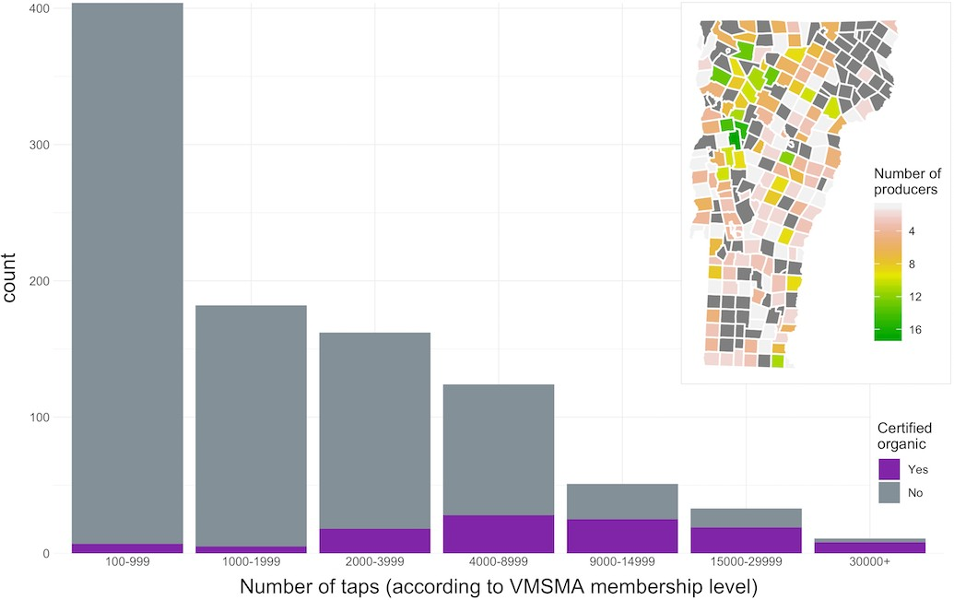
Figure 1 shows what we know about our sample. The majority of producers had less than 1000 taps. Producers were geographically spread across the state. Eleven percent of our sample was USDA certified organic, with proportion increasing with size. We expect VMSMA members to be more informed and engaged than the remaining 500 to 2000 nonmember maple producers in the state (Becot et al., 2015). However, all of the studies of U.S. maple producers that we are aware of used maple industry membership organizations as their samples (Snyder et al., 2018; Kuehn et al., 2017; Becot et al., 2015). As a result, there is little known about the number and demographics of non-member producers.
Figure 1: (a) Size distribution of sample and proportion of producers who are certified organic; (b) Spatial location of producers (mailing addresses) across Vermont.
Previous efforts to recruit producers into the Bird-Friendly Maple Project had only been opportunistic, with no widespread effort to reach a wide audience. We incorporated our tests of social messaging into a mailing to VMSMA members about the program. This strategy mimicked a traditional conservation outreach strategy advertising the ecological benefits of engaging in an environmental program (ref). All mailings were sent first-class in envelopes with VMSMA logos to increase the likelihood of opening.

Experiment
Using a randomized controlled design, we tested social messaging strategies to elicit interest in the Bird-Friendly Maple Project. All producers in our sample received a 6x9” envelope with two cards that had the same layout and basic information about the program (See Appendix A). The larger Promotion card displayed photos of forest-dwelling songbirds under the name of the program. On the back, there was a message requesting the producer to complete the enclosed survey and a brief list of benefits of program participation, all related to forest health and forest birds. The second, smaller Response card listed the name of the program on one side and a five-question survey on the other (see Section 4.3). The final question on the survey asked, “Would you like to receive more information about the Bird-Friendly Maple Project?” with an option to check “YES” or “NO”. Those who checked “YES” also provided an email address or phone number to indicate how they would like to be contacted. This request for information served as our behavioral outcome, a proxy for forest managers’ engagement in a conservation program. Similar designs have been used to experimentally test messaging effects on farmer engagement in conservation practices (Kuhfuss et al., 2016; Wallander et al., 2017), including using a request for information as the dependent variable (Andrews et al., 2013).
The two treatments augmented this version, which acted as our control, by adding brief messaging about descriptive social norms or recognition to the cards (Table 1). The messaging was designed following the justification provided in Section 2. Each of the treatments is additive to the control, providing the exact same information, as well as relatively short phrases in three locations in the mailing (show in figure?). All three versions were designed in collaboration with Audubon Vermont and pre-tested on a small group of university students. They are described in detail below.

Treatment 1: Descriptive norms
Our first treatment indicated the participation of other producers in the Bird-Friendly Maple Project. In addition to the control information, this version included the statements, “Many of your fellow sugar makers are part of (the Bird-Friendly Maple Project)” and “Join dozens of Vermont sugar makers who are part of the program.” These statements were meant to demonstrate that other producers have made the commitment to manage their sugarbush in ways that benefit birds. Informal interviews with producers prior to designing the experiment indicated that other producers are sources of information. This is supported by survey evidence of maple producers (Kuehn et al., 2016; Murphy et al., 2012). Drawing from the theory and evidence on descriptive social norms (more here?), it was expected that producers receiving this messaging would be more likely to request more information about the Bird-Friendly Maple Project than those who received only information about the program.
Table 1: Control and treatment groups

Information
 | Mailing wording | N | taps | organic
Control: | The Bird-Friendly Maple Project | 323 | 135 | 9.9
Treatment 1: Descriptive norms | Many of your fellow sugar makers are part of . . . | 321 | 134 | 12.1
Treatment 2: Recognition | Recognizing the stewardship of sugar makers through . . . | 323 | 135 | 12.1

Join dozens of Vermont sugar makers who are part of the program Earn recognition and visibility for forest stewardship
N, total number of producers who received that version; <1000 taps, number of producers within the total that were designated ‘small’ in block random assignment.

Treatment 2: Recognition
Our second treatment made salient the recognition benefits of participating in the Bird-Friendly Maple Project. This version of the mailing augmented the control with the statements, “Recognizing the stewardship of sugar makers through (the Bird-Friendly Maple Project)” and “Earn recognition and visibility for forest stewardship.” Audubon Vermont advertises these recognition benefits to attract producers to the Bird-Friendly Maple Project (and other habitat conservation programs). We intended to test whether the explicit mention of those benefits would in fact attract more interest in the program than information alone. Since this messaging highlighted how the program makes producers’ behavior observable by others, it was expected to elicit concerns around image and reputation (Ariely et al., 2009). We expected that this treatment would have a positive effect on interest in the Bird-Friendly Maple Project.

Assignment to treatment
Given our sample size, a power analysis indicated we would detect an effect size of 0.1 at α = 0.05 and power of 0.8. In a laboratory experiment, Banerjee et al. (2014) provided information about neighbors’ land conservation behavior and found a standardized effect size of 0.23 on socially efficient land use decisions (Janusch et al., 2018).
Maple producers were assigned to treatment conditions through block randomization on size of operation. Block random assignment uses pre-treatment covariates to segregate subjects into distinct groups and then randomly assign treatments within those groups (Imbens and Rubin, 2015). This technique can increase precision in estimating treatment effects if the grouping variable predicts the outcome. We suspected that producer size would be negatively correlated with our outcome measure for two reasons. First, larger producers are more likely to sell their syrup in bulk (Becot et al., 2015). These producers would be less likely to value the brand reputation and eco-marketing to consumers offered by the Bird-Friendly Maple Project. Second, maple syrup sales are more likely to be the primary source of income for larger producers (Becot et al., 2015). For them, business decisions are likely to be more profit-motivated than for smaller producers who have other income streams and smaller forests to manage.
We stratified the sample into two blocks at a size of 1000 taps. This division was used by Snyder et al. (2018) as the division between ‘small’ and ‘large’ maple operations. The number of subjects in each treatment, block and the proportion that are certified organic can be seen in Table 1.

Survey
While the primary objective of this study was to estimate treatment effects of social information on a conservation behavior, we also used this opportunity to collect information about Vermont maple producers. We included a brief survey to capture more specific information on size (number of taps and number of acres) and tenure (number of years the sugarbush has been in operation).
We also asked subjects about the future of their sugarbush (number of years it is expected to stay in operation) and their primary reason for producing maple syrup. The average age of producers in this region is 61 years old (Kuehn et al., 2017). Land transfer decisions will have a large impact on the forested landscape, so it will be good to know more about how maple producers perceive the future of their forest. The reasons for sugaring listed on the survey include those that were identified in previous surveys of maple producers Snyder et al. (2018); Kuehn et al. (2017). Since these survey will be completed after producers have been treated by the social messaging, it is possible that the treatments will influence responses to the last two subjective questions (future and reason). We will consider this in our analysis.
Lastly, we provided an incentive of the chance to win $50 through a lottery to encourage responses to our mailing. A meta-analysis found that incentives increase response rates to mailed surveys (Edwards et al., 2005). Producers were provided with a postage-paid business reply envelope addressed to the University of Vermont. The data collection process began July 16, 2018. A reminder email was sent from VMSMA one month after the initial mailing. The final responses were received by September 31, 2018.

Results
A total of 177 producers responded to the mailing, which was an 18.3% response rate. This is within the range of similar studies of maple producers and farmers (10 27%) (Becot et al., 2015; Kuehn et al., 2016; Andrews et al., 2013). On average, these producers had 3241 taps over 120 acres (Table 2). The median number of taps was 1300, which matches the size distribution of the total sample (of which 42% had less than 1000 taps). Respondents had been producing maple syrup for an average of 46 years. Analysis of variance (ANOVA) confirmed that there were no statistically significant (p < 0.05) differences between treatments for these variables.
Table 2: Descriptive statistics of respondents

Variable Mean SD Min Max Observations Size
Tenure (years)∗ 46 57 1 300 177
Taps | 3241 | 5360 | 15 | 38000 | 173
Acres | 120 | 190 | 1 | 1250 | 151

SD, standard deviation; Observations vary due to incomplete survey responses. ∗Some respondents answered this question in “generations”, which we multiplied by 28 years (Fenner, 2005).

Across all groups, the majority of those who replied to the survey aloo requested more information (Figure 2). A Fisher’s exact test indicates there is a marginally significant difference in mailing responses between the treatment groups (p = 0.09).
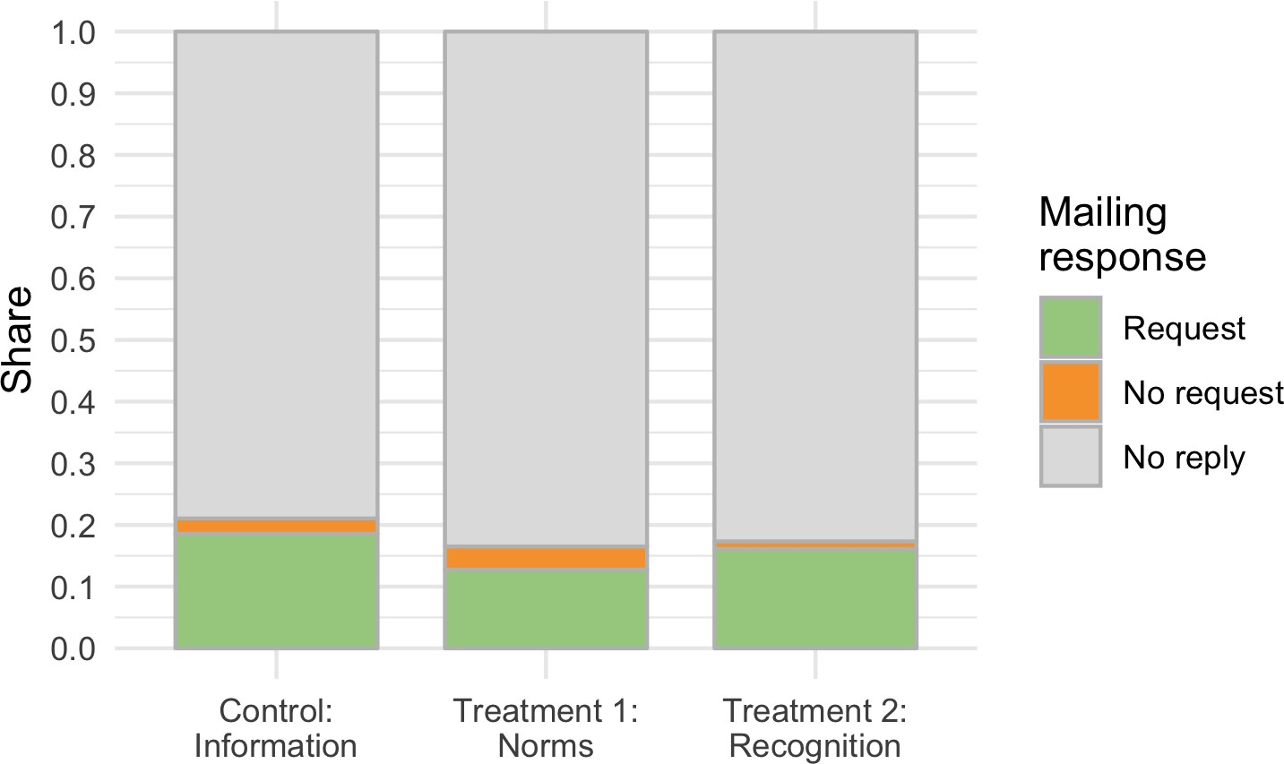

Figure 2: Proportion of responses to the survey across treatment groups.

Our primary outcome of interest was whether the request for information varied across treatment groups (Table 3). We observed requests from producers within each group, however the highest number and proportion came from those in the control (Figure 3). To estimate the average treatment effects on the decision to request more information, we used logistic regression. The outcome variable was equal to one if the producer requested more information about the program or zero, otherwise.
These estimates are show in Model A of Table 4. The coefficients for each treatment show the change in log odds of the outcome for that value compared to the control. We find that when producers were informed about the participation of their peers (Treatment 1), they were significantly less likely to request information about the program than those who received only the control message. Exponentiating the coefficient to get the odds ratio shows that providing descriptive norms information reduced the odds that producers would request more information by 36%. We do not detect an effect of recognition on interest in conservation compared to the control.
We included two covariates in a second model (Model B) to estimate whether size or organic certification explain some of the variation in our outcome. Contrary to our expectation that size would be negatively correlated with the outcome (Section 4.2.3), we fail to detect any effect. This may be attributed to the lack of variation in the size categories (as opposed to more specific continuous size data), or it could be that large producers have more capacity to give attention to this program than their smaller counterparts. Nor do we detect any relationship between organic certification and interest in the conservation program.
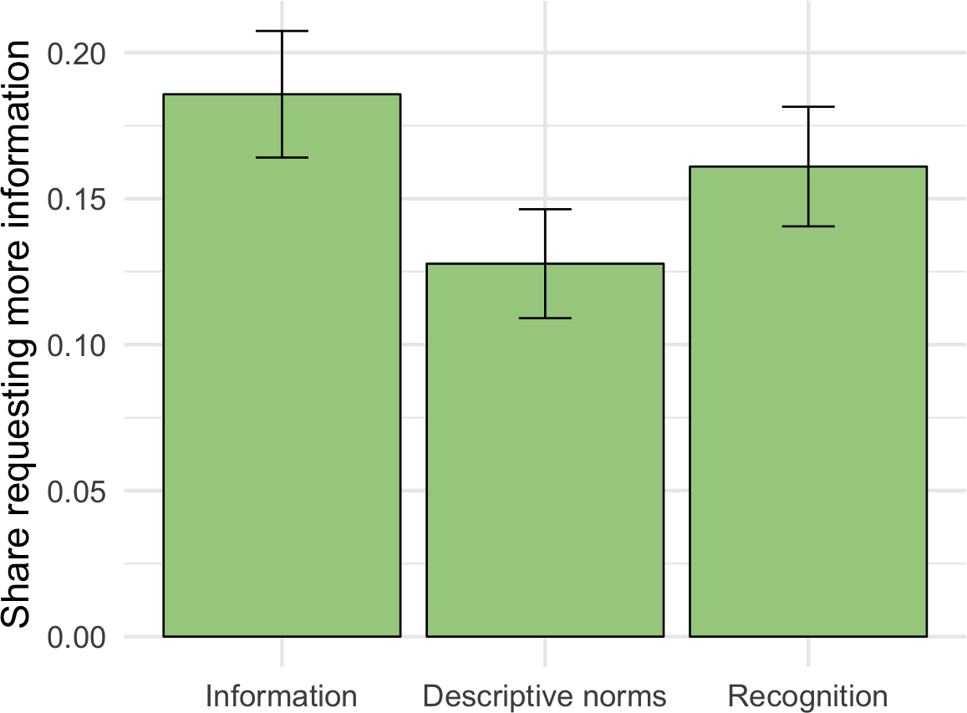

# of % of producers group
Control: 60 18.6
Information (N = 323)
Treatment 1: 41 12.8
Descriptive norms (N = 321)
Treatment 2: 52 16.1
Recognition (N = 323)

Total (N = 967) 153 15.8

Table 3: Summary of requests for more information about the conservation program

Figure 3: Proportions of each group that requested more information. Error bars represent standard error of the mean.

Table 4: Average Treatment Effects: Logistic Regression Models

Model A Model B

Treatment 1: 0.443∗∗ 0.452∗∗ Descriptive norms (0.220) (0.220)
− −
Treatment 2: 0.173 0.181
− −
Recognition (0.208) (0.209)
Small size (<1000 taps) 0.125
(0.186)
Organic certified 0.328
(0.273)
Constant 1.478∗∗∗ 1.566∗∗∗ (0.143) (0.171)
− −
Observations 967 967
Log Likelihood 420.222 419.461
− −
Akaike Inf. Crit. 846.445 848.922
Note: ∗p<0.1; ∗∗p<0.05; ∗∗∗p<0.01

Vermont Maple Producers
Survey responses show that enjoyment and income are the most frequently cited reasons for producing maple syrup (Figure 4). These are consistent with previous studies of maple producers (Snyder et al., 2018; Murphy et al., 2012). Nearly 50% of all respondents indicated they produce syrup for enjoyment, with another 15-20% selecting stewardship or heritage. The high proportion of respondents who selected the non-monetary reasons supports the notion that working lands managers value more than profits, even recognizing that our respondents are not representative of all maple producers.
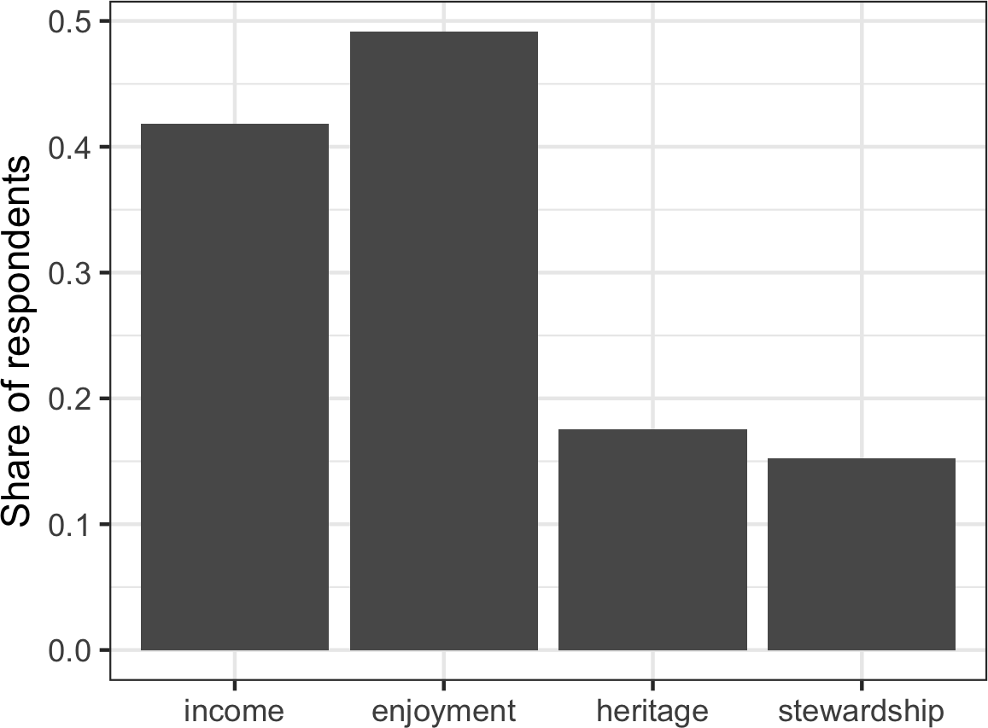

Figure 4: Primary reasons for producing maple syrup among survey respondents. The total share exceeds 1 because some producers selected more than one reason.

Looking at producers’ intentions for their operations, we find that respondents expect their forests to stay in production for an average of 38 years (sd = 37.5). There were 0 responses that indicated they expect or hope their forest to stay in production indefinitely, and 0 who indicated they did not know. Figure 5 shows the distribution of responses by treatment. These differences are not significant (F = 0.11, p = 0.9). Of our respondents, 18% indicated that their sugarbush would no longer be in production in the next 10 years.
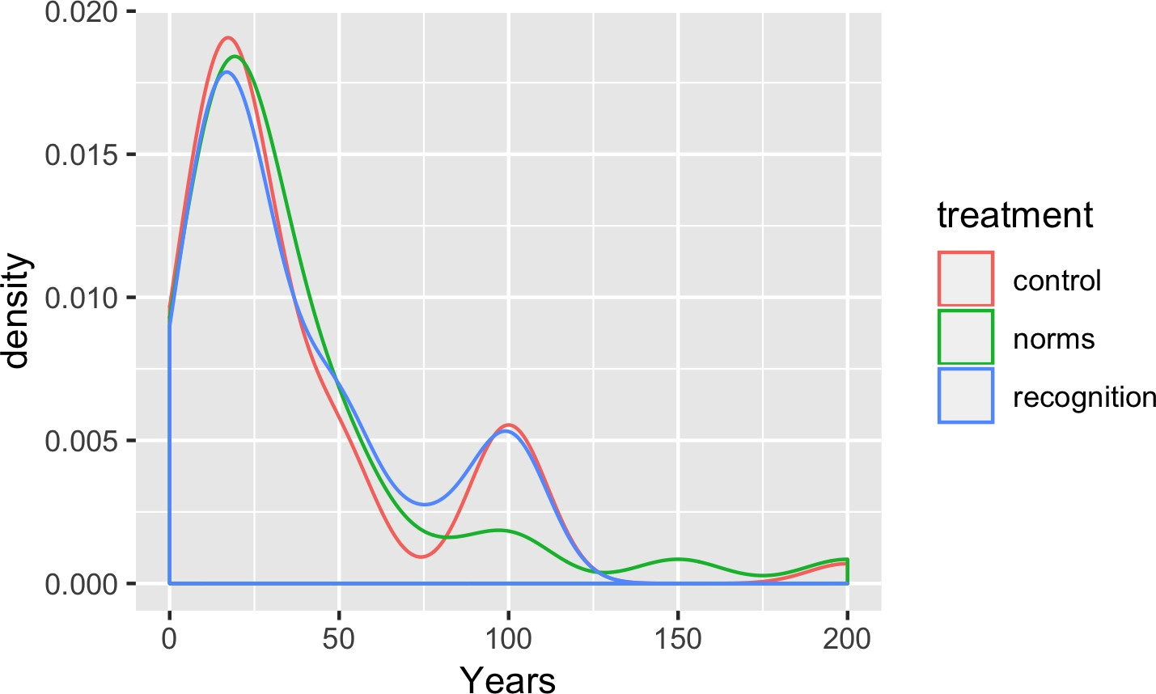

Figure 5: Length of time producers expect their sugarbushes to remain in maple production.

Discussion
Some general thoughts about the results. Revisit the question and why it was important. Explain how design answered the question.
Some interpretation of the descriptive social norms results. Speculate four reasons and support with theory/literature:
- Personal identity conflicted with norm (unique to population). Studies show personal characteristics, such as political affiliations, can moderate the effects of norms and other behavioral interventions (Costa and Kahn, 2013; Trujillo-Barrera et al., 2016). And farmer identity matters in decisions (Howley et al., 2015)
- The norm was not perceived as popular and conflicted with producers’ experience. Evidence that people do not follow a minority norm (Cialdini et al., 2006; Mortensen et al., 2017).
- “Many” implied that lots of others were already part of the program and caused producers to free-ride
- The peer pressure crowded out intrinsic motives (similar to # 1) (Pellerano et al., 2017)
Most likely, the reference group and norm strength matter (Schultz et al., 2018). Also, there are other studies where descriptive norms didn’t work. In their review of behavioral insights for land management, Janusch et al. (2018) found only one field experiment testing descriptive social norms. Wallander et al. (2017) sent mailings to farmers reminding them to enroll their land in the Conservation Reserve Program. Some received additional text in the letter that indicated the participation of other farmers in the program. While the reminder letter itself increased enrollment, the effect was unchanged by the addition of social information. There is some evidence that indicating certain social norms can backfire. John and Blume (2018) found no effect of descriptive norms on tax payment compliance in the United Kingdom, and the treatment actually had a negative effect over the long run. Similarly, Niles et al. (2016) found the absence of support for climate change policies among farmers could be driving subjective norms, suggesting, “If no one else is supporting this, why should I?” (p.291). This highlights the importance of exploring how norms operate across contexts, as results from previous studies may not hold for a different population or behavior.
Some interpretation of the recognition results. Speculate reasons for failing to detect effect:
- Recognition may not cause certain behaviors but instead help maintain them (ref)
- Weak recognition benefits (not handing producers a sign or putting their name in the paper). May not be clearly distinguished from the information control version.

Discuss limitations:
- Not a random sample (VMSMA list): sample average treatment effect, internally valid, perhaps not externally valid.
- Recognition treatment too superficial to produce effect (i.e. only a few extra words that may have been missed). Either not strong enough in the offerings or implied in the control version (indistinguishable).
- Behavioral outcome is cheap. Is checking a box really a conservation behavior? What will the durability and conversion rate be? But it’s hard to measure behavioral outcomes for land management! Unlike changing diets or spending habits, decisions related to land tend to be infrequent, costly, and have lasting effects. In the case of forests, where timber and syrup producers operate on long time scales (Farrell, 2012), it can be difficult to observe effects of policies/programs/experimental interventions. The requisite tree age (30-40 years) and infrastructure investments (tapping tubes, evaporator, etc) imply that managing for syrup production requires a low discount rate and long time horizon in order to out-compete timber management (Farrell, 2012).

Conclusion
What do these results mean for the research questions? Speculate about generalizability to other subjects, contexts, treatments, and outcome measures (e.g. non-maple producing forest owners, farmers...). We need more tests of this stuff because it is being used in real conservation programs, such as Project Cane Changer in Australia. This program uses recognition and social norms to motivate sugar cane farmers to adopt best management practices for the benefit of the Great Barrier Reef. This is what Nyborg (ref) calls for too.
Zoom out to biodiversity and working landscapes and human behavior.

Instruments

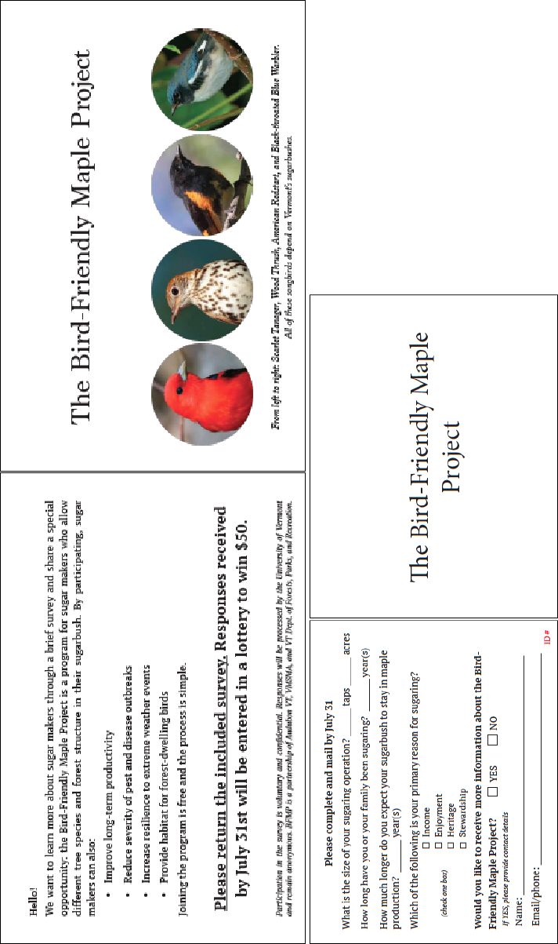

Figure A.1: (a) Promotional card and (b) survey card. These are the Control versions. Additional text in the treatments (see Table 1) was added to the right-hand side of each card, above ‘The Bird-Friendly Maple Project,’ and one more bullet in the list on the Promotional card.

Organic data matching
In order to determine which producers in our sample were certified organic, we used the following process. We accessed the USDA Organic INTEGRITY Database (https://organic. ams.usda.gov/Integrity) and filtered list by State = Vermont AND Certified Products =
maple, yielding 253 results. This list was imported and combined with VMSMA list of producers using the R statistical software. The Organic list had only business names, while the VMSMA list had mostly individual names, so many could not be matched automatically. The combined list was exported to Mircrosoft Excel and sorted by address to look for matching addresses between businesses and individuals. Identical addresses were assigned a unique ID number to indicate they represent the same operation. This produced 96 matches between Organic producers and VMSMA members. Another 10 certified organic producers were found to be current members of the BFMP, so they were dropped from the list. Next, we conducted an internet search for the remaining 147 organic producers. Using the Northeast Organic Farmers Association directory, business websites, and other online directories, we matched another 14 business names with individual names, resulting in a total of 110 organic producers in our sample.

For example, the Vermont Environmental Stewardship Program, New Jersey Department of Environmental Protection’s Environmental Stewardship Program, and National Wildlife Federation’s Certified Wildlife Habitat Program.
Calculated from the USDA-reported 5,670,000 taps in Vermont in 2018 and 60 taps per acre following the density measurements of Farrell (2013)
Addresses were validated by the National Change of Address system.
https://organic.ams.usda.gov/Integrity/
Mapped location based on mailing address, which may differ from location of sugarbush.
Taps: F = 2.51, p = 0.08; Acres: F = 0.59, p = 0.55; Tenure: F = 0.03, p = 0.97.

