For submission to Nature as an Article
November 15, 2015
Using cosmogenic isotopes in marine sediment cores to decipher long-term ice sheet behavior

Paul Bierman, Department of Geology and Rubenstein School of the Environment and Natural Resources, University of Vermont, Burlington, VT 05405, pbierman@uvm.edu, 802 656 4411

Jeremy D. Shakun, Department of Earth and Environmental Sciences, Boston College, Chestnut Hill, MA 02467, jeremy.shakun@bc.edu

Lee B. Corbett, Department of Geology and Rubenstein School of the Environment and Natural Resources, University of Vermont, Burlington, VT 05405, lbcorbett@gmail.com

Dylan Rood, Department of Earth Science and Engineering, Imperial College London, South Kensington Campus, London SW7 2AZ, UK & Scottish Universities Environmental Research Centre (SUERC), East Kilbride G75 0QF, d.rood@imperial.ac.uk

Susan Zimmerman, Center for Accelerator Mass Spectrometry, Lawrence Livermore National Laboratory, Livermore, CA 94550, zimmerman17@llnl.gov

The behavior of ice sheets over millions of years is poorly known because flowing ice usually removes the terrestrial record of earlier glaciations. However, material shed from glaciated continents is preserved offshore in ocean basins providing geologic archives that can be deciphered to understand the history of continents. Here, we use measurements of in situ produced cosmogenic ¹⁰Be and ²⁶Al in quartz isolated from two marine cores offshore of East Greenland to infer the long-term behavior of the central and southeastern sectors of the Greenland Ice Sheet. We find a many-fold decline in decay-corrected ¹⁰Be concentration over the last seven million years; this trend is consistent with deep, progressive but spatially non-uniform erosion by ice of the once slowly eroding, pre-icehouse Greenlandic landscape. ²⁶Al/¹⁰Be ratios indicative of burial show that Greenland was covered by ice for most of the Pleistocene implying that interglacial periods did not cause significant, long-lived reduction in ice sheet extent. Considering isotope ratios and concentrations together suggests times when the ice sheet expanded into areas not previously ice covered. This approach should be useful for reconstructing the long-term behavior of other ice sheets, critical for understanding past and future changes in the cryosphere. [197 words]
Few data constrain the multi-million year behavior of individual ice sheets because repeated ice advances usually over-run, erode, and thus erase the terrestrial record of prior glaciations{Gibbons, 1984 #38}{Nielsen, 2013 #57}{Vanneste, 1995 #81}{De Schepper, 2014 #42}. The few extant terrestrial records of ancient glacial and interglacial periods are rare, isolated, and poorly dated{Funder, 2001 #22}; thus, they cannot provide a continuous, long-term record of ice-sheet behavior{De Schepper, 2014 #42}. Stacked, buried tills near former ice margins, when dated, constrain times of exceptional ice extent{Balco, 2010 #37}, although these till deposits record the extent of only the largest ice sheets.
Most of what is known about long-term ice sheet history comes from marine sediment records interpreted as global or regional proxies for ice volume or glacial activity. For example, stable oxygen isotope measurements of foraminifera isolated from marine sediment track global ice volume and ocean temperature but provide little information about the behavior of each of the world’s major ice sheets individually{Lisiecki, 2005 #36}. Local sea level history also reflects global ice volume but in a complex fashion{Spratt, 2015 #40} because the record is aliased by tectonic and glacial- and hydro-isostatic adjustment of land levels{Clark, 2002 #39}; it too provides little information about individual ice sheets. The most robust inferences about the comings and goings of now-vanished ice sheets are based on the presence and provenance in marine sediment of ice rafted debris (IRD) shed from melting icebergs that originate on glaciated continents {De Schepper, 2014 #42}{Flesche Kleiven, 2002 #43}. IRD records are illustrative of sediment-bearing glacial ice reaching the coast but cannot otherwise constrain ice extent{Dowdeswell, 2001 #44}. Even the longest and oldest ice cores contains less than a million years of ice sheet history{Parrenin, 2007 #41}.
Here, we investigate long term ice sheet behavior using a different proxy, the concentration of in situ produced cosmogenic ²⁶Al and ¹⁰Be in quartz sand isolated from two marine sediment cores collected near east Greenland [FIGURE 1, Location map]. We use these new isotopic records, in conjunction with other extant records, to consider the last 7 million years of Greenland Ice Sheet (GIS) behavior in the context of what is already known from a variety of different approaches.

Millions of years of GIS history
Understanding of early Greenlandic glaciation remains fragmentary and uncertain {FIGURE 2, History of Ice}. The first presence of IRD in marine sediment cores was used to argue that Greenland glaciation began at 7 My{Larsen, 1994 #1} whereas the surface texture of quartz in the same cores suggested that glaciation began at 11 My{Helland, 1997 #45}. IRD from other cores suggests initial glaciation in the high arctic and likely Greenland began as early as 44 My{Eldrett, 2007 #46}{Tripati, 2008 #47}. There is strong marine sedimentological evidence for Pliocene ice (since 7.5 My) in east Greenland{Butt, 2001 #52}{De Schepper, 2014 #42} and IRD data suggest the first large-scale glaciation of Greenland occurred in the latest Pliocene (3.3 My){Flesche Kleiven, 2002 #43}. Multiple IRD records indicate expansive Greenland glaciation by 2.7 My{Flesche Kleiven, 2002 #43}. Several insecurely dated shallow marine deposits including diagnostic fauna and flora indicate periods of warmth in Greenland during the later Pliocene or early Pleistocene, after the initial onset of glaciation{Funder, 2001 #22}{Bennike, 2002 #60}{Feyling-Hanssen, 1983 #61}{Funder, 1984 #62}.
Computer models are consistent with field evidence. They indicate that limited glaciation on Greenland first began around 23 My{DeConto, 2008 #49} and that during warmer parts of the Pliocene, ice was restricted to the highlands of east central Greenland{Dolan, 2015 #51}{Koenig, 2015 #48}{Solgaard, 2011 #53}{Hill, #50}. It appears that lowered atmospheric CO₂ triggers expansion of the GIS but models disagree on whether uplift of East Greenland was important{Solgaard, 2011 #53} {Lunt, 2008 #34}.
A variety of records and models suggest that the GIS, particularly the southern sector, is dynamic, expanding and retreating in response to glacial/interglacial climate forcing{Otto-Bliesner, 2006 #31}{Alley, 2010 #12}{Alley, 2010 #12}. Although meteoric ¹⁰Be data from silt at the base of the GISP 2 ice core (east-central Greenland) suggest near continuous cover there by cold-based, non-erosive ice for millions of years{Bierman, 2014 #54}, other cosmogenic data are more consistent with brief exposure of the GISP site during MIS 11{Nishiizumi, 1996 #55}. Geochemical data suggest that southern Greenland was deglaciated and forested during at least MIS 11 and perhaps MIS 5e{Willerslev, 2007 #56}{de Vernal, 2008. #35}{Reyes, 2014 #77}.

A new approach to understanding ice sheet behavior
The concentration of cosmogenic nuclides provides information about both the near-surface terrestrial residence time and the burial history of material now preserved as marine sediment. Cosmic-rays bombard Earth and cosmogenic nuclides, including ²⁶Al and ¹⁰Be, are produced in situ (in mineral lattices) primarily by neutron interactions in near-surface rock and soil{Lal, 1967 #3}. Cosmogenic isotope production rates and thus nuclide concentrations decrease quickly with depth below the surface as the neutron flux attenuates. Isotope production continues at much lower rates for tens of meters below the surface, caused by the weak interaction of cosmic ray muons{Heisinger, 2002 #6}[FIGURE 3, Isotope concentration and ratio profiles including re-exposure].
Cosmogenic ²⁶Al and ¹⁰Be are typically measured in quartz purified from rock or sediment. Continentally derived quartz typically contains >100,000 atoms g⁻¹ of in-situ produced ¹⁰Be{Portenga, 2011 #2}. On a steadily eroding, ice-free landscape, the concentration of cosmogenic isotopes in rock and sediment can be interpreted as an erosion rate [Bierman, Granger, Brown, Lal]. The measured ratio of cosmogenic ²⁶Al/¹⁰Be provides additional information. Because ²⁶Al (t_{1/2}, 0.70 My) decays more rapidly than ¹⁰Be (t_{1/2}, 1.38 My), burial of material containing these isotopes, by ice on land or under deep ocean waters will, over time, lower both the ²⁶Al/¹⁰Be ratio and the concentration of both isotopes. ²⁶Al and ¹⁰Be are produced at a ratio of ~6.8:1; thus, measured ²⁶Al/¹⁰Be ratios <6.8 are diagnostic of burial. Core age models allow us to decay-correct isotope concentrations in marine sediment to the time of deposition. If decay-corrected ratios are <6.8, they indicate burial by terrestrial ice prior to marine deposition.
Glacial erosion removes the most highly-dosed, near-surface material first before excavating material at depth containing progressively lower cosmogenic isotope concentrations. Only warm-based ice can effectively erode rock and transport sediment to and off the coast{ElverhØI, 1998 #64}; thus, the marine sediment record we present here is strongly biased toward areas of the ice sheet where the basal temperature was at the pressure melting point{Bell, 2014 #66}. Thermal conditions at the base of the GIS are not well known and change over time{Greve, 2005 #67} and space{Petrunin, 2013 #79}{Kaus, 2013 #80}. Warm-based ice is most likely to be found in deep troughs, near the ice margin, and where geothermal heat flux is high{Fyke, 2014 #78}{Petrunin, 2013 #79}. Some models suggests that 20-30% of the pre-industrial GIS was warm-based{Fyke, 2014 #78}whereas others indicate that during the last glacial maximum the GIS may have been up to 50% warm-based{Greve, 2005 #67}.
The marine sediment cores we sampled (ODP918 and 987) were collected off of East Greenland{Butt, 2001 #52}{Larsen, 1994 #1}. Like all marine cores, the specific provenance of the material we analyze is uncertain; however, the East Greenland current [FIGURE 1, Location map] drifts ice from north to south above both coring sites meaning that IRD in the cores is dominantly from East Greenland{Martin, 1999 #70}. Core 987 is 130 km offshore of Scoresby Sund, on the toe of a large subaqueous fan{Butt, 2001 #52}; thus, although some of the sediment may come from the north, most was delivered directly from ice flowing through Scoresby Sund. Core 918 was collected in the Irminger Basin about 120 km offshore. It is likely that the quartz in core 918 is sourced dominantly from southeast to central East Greenland because of the proximity of the core to this area, especially during glacial maxima when the ice sheet approached the continental shelf edge only 40 km away, and because the composition of IRD downcore is similar to modern Greenland IRD and can be traced to terranes along this sector of Greenland {Bridgewater, 1976 #73}{Larsen, 1980 #74}{Linthout, 2000 #72}. While there may be some contribution from gravity flows off the continental shelf, sedimentological evidence (no thick beds, graded beds, erosional bases, distorted sedimentary structures, or reworked microfossil assemblages) suggests that most sand at site 918 comes from ice rafting rather than turbidites{Spezzaferri, 1998 #69}{John, 2002 #68}{Molnia, 1983 #75}{Larsen, 1994 #1}. In core 918, sand is compositionally similar to larger dropstones, another indication of an IRD source {Party, 1994 #71}.

Interpreting the marine record in terms of terrestrial processes and history
To constrain better the interpretation of cosmogenic nuclide measurements in marine sediment, we conducted two experiments. First, we collected sediment samples from Greenlandic rivers, moraines, and river terraces and measured their ¹⁰Be{Nelson, 2014 #58}, and in some cases, ²⁶Al concentrations (Supplementary Data). Then, we conducted sensitivity tests to understand how ice extent, interglacial exposure, and sediment mixing from different sources affect the concentration of ²⁶Al and ¹⁰Be in terrestrial sediment exported from Greenland (Supplementary Data).
Sediment sourced from the ice sheet in eastern, western, and southern Greenland today{Nelson, 2014 #58} and at the end of the last glaciation (accessed via dated terraces){Goehring, 2010 #76}{Nelson, 2014 #58} has very low concentrations of ¹⁰Be, only thousands of atoms per gram. Sediment in streams draining only areas outside the current ice margin has on average several times more ¹⁰Be, reflecting exposure of the land surface to cosmic radiation during the Holocene{Nelson, 2014 #58}. Isotope and mass balance calculations indicate that most sediment now being delivered to the Greenlandic margin originates from the ice sheet and not from deglaciated areas{Nelson, 2014 #58}. The ²⁶Al/¹⁰Be ratio of sediment leaving Greenland today is indistinguishable from the production ratio of 6.8. Sediment in a terrace (sample GLX-08) deposited during deglaciation (~8 ky) has a ²⁶Al/¹⁰Be ratio substantially lower than production (4.54± 0.58; Supplementary Data).
Sensitivity tests show that after the upper several meters of Greenland have been eroded by ice, isotopic concentrations are relatively insensitive to fluctuations in ice sheet extent. This is because the concentration of ¹⁰Be in sediment exported from Greenland is controlled primarily by the extent of sub-ice erosion into the deep, muon-dominated production zone up to tens of meters below the pre-glacial land surface [FIGURE 3, Isotope concentration and ratio profiles including re-exposure]. Short periods (~10-20 ky) of subaerial, interglacial exposure, primarily at the margins of the ice sheet, matter little because they only change the nuclide concentration substantially in the uppermost meter of rock or soil (via shallow neutron spallation reactions) although even short interglacial re-exposure can effectively raise the ²⁶Al/¹⁰Be ratio. During the next ice advance, this material is eroded and mixed with sediment sourced from under the ice.
Conversely, ²⁶Al/¹⁰Be ratios are more dynamic. They rise significantly when small amounts of sediment having a high concentration of nuclides and a different ²⁶Al/¹⁰Be ratio are mixed with sediment having low nuclide concentration. Basal thermal regime is important. Covering a landscape with non-erosive, cold-based ice for 100s of ky lowers the ²⁶Al/¹⁰Be ratio but does not significantly change ¹⁰Be concentration because of the long half-life of ¹⁰Be. In contrast, erosive, warm-based ice, not only lowers ²⁶Al/¹⁰Be ratio by shielding the bed from cosmic ray exposure but lowers nuclide concentration because it excavates overburden incorporating rock that was once deeply shielded from cosmic radiation.

7 million years of ice sheet expansion, contraction, and erosion
Measured ¹⁰Be concentrations in the marine sediment core 918 are low but significantly above blank and thus well measurable, 2100 to 40,000 atoms g⁻¹ (Supplementary Information, Table 1). In core 987, which extends back only to 2.2 My, all samples have uniformly low concentrations of ¹⁰Be, just a few thousand atoms g⁻¹. Decay-corrected concentrations are highest in the oldest sediment (~7 Ma according to the age model) and generally decrease over time (Figures 1 and 4). Inverting the ¹⁰Be data from the oldest sediment sample and assuming that the sediment delivered to the deep ocean as IRD was stripped by glaciers at an elevation near sea-level suggests a landscape-averaged pre-glacial Greenland denudation rate of about 12 m/My, lower than basin-scale erosion rates for polar climates but higher than polar rates of outcrop erosion (Portenga and Bierman, 2011).
By the late Pliocene (~3 My), decay-corrected ¹⁰Be concentrations are more than an order of magnitude lower than at the beginning of the record, reaching a minimum of 12,000 atoms g⁻¹ at 2.7 Ma. This decrease reflects progressive glacial erosion of once-stable Tertiary regolith over some of east Greenland, perhaps by valley glaciers or ice caps. The presence of IRD in core 918 mandates these glaciers extended to the sea and had calving margins. A general increase in the intensity and/or aerial cover of glaciation is supported by rising concentrations of coarse sediment over the length of core 918 (Figure 4a)¹⁰.
At the dawn of the Pleistocene, the decay-corrected ¹⁰Be concentration abruptly increase (Figure 4b). One sample, including sediment deposited at 2.5 Ma, had nearly 150,000 atoms/g of ¹⁰Be when it was deposited, a concentration more similar to Miocene-age sediment than to any Quaternary age material. This ¹⁰Be-rich quartz likely indicates expansion of the ice sheet into previously unglaciated areas of Greenland where stable Tertiary regolith was still present, an interpretation consistent with the abundance of IRD found at site 918 at this time¹⁰. Between 2.5 Ma and 0.8 Ma, the decay-corrected concentration of ¹⁰Be generally declines (Figure 4b)²⁰. The Pleistocene decline in decay-corrected ¹⁰Be concentration is consistent with continued progressive stripping of the preglacial landscape by sub-ice erosion during the Quaternary. As sediment and rock are removed from the landscape under the ice by erosion, material that was deeply shielded in pre-glacial times and thus less dosed by cosmic radiation is incorporated into basal ice and carried offshore before being deposited as IRD.
An abrupt, four-fold drop in decay-corrected ¹⁰Be concentration occurs across the mid-Pleistocene transition at 0.8 Ma (Figure 4b). ¹⁰Be concentrations over the past 0.8 My are similar to those in sediments issuing from the western, southern, and eastern GIS margin today (Nelson et al., 2014) (Figure 4b), except for one brief spike. These data are consistent with the existence of a large, modern-like GIS for at least most of the last million years.
The ¹⁰Be record in core 918 shows parallels with core sedimentology. There is an overall inverse correlation between ¹⁰Be concentration and sand content in the core (Figure 4a), and several previously noted IRD pulses line up with prominent drops in decay-corrected ¹⁰Be concentration, such as near 7, 2.7, 1.8, and 0.9 Ma (St. John and Krissek, 2002). These patterns are consistent with periods of intensified glacial erosion and iceberg calving, reflected by increased coarse sediment, excavating deeper-sourced and thus ¹⁰Be-poorer material.
Although limited to the last 2.4 My by the shorter half-life of ²⁶Al, decay-corrected ²⁶Al/¹⁰Be data from core 918 sediment provide additional information about the exposure history of Greenlandic sediment sources (Figure 5). The lack of correlation between ¹⁰Be concentration and ²⁶Al/¹⁰Be suggests that changes in the ²⁶Al/¹⁰Be ratio are not driven by long periods of continuous surface exposure (which would raise not only the ratio but the ¹⁰Be concentration) but rather by expansion of sediment source areas and erosion of material with different isotope ratios. Such an expansion may reflect changes in basal thermal regime of the ice sheet rather than changes in ice extent; for example, {Petrunin, 2013 #79}suggests that areas of warm (erosive) and cold (non-erosive) bedded ice are closely juxtaposed.
The ratio data do not decline steadily (driven by decay) as would be expected had the source area of sediment been completely and continually covered by ice; rather, between 2.4 and 1.6 My, the measured ²⁶Al/¹⁰Be ratio is mostly consistent with surface exposure, except for lows at 1.9 and 2.2 My. These production-like ²⁶Al/¹⁰Be ratios imply that ice covered the sediment source area for <70% of each glacial cycle because ²⁶Al/¹⁰Be ratios only change significantly when surfaces are buried for several times longer than they are exposed (Fabel and Harbor, 1999; Bierman et al 2015). Most sediment younger than 1.6 My, has ²⁶Al/¹⁰Be ratios ~ 5 consistent with the excavation of sediment largely buried under ice except for a short period around 700 ky when sediment was most likely sourced from a different area that had not been buried by ice for long periods of time after exposure.
The marine record of ¹⁰Be and ²⁶Al concentrations do not show a clear response to major changes in climate such as the extreme interglacials at MIS 5e, 9, or 11. This is consistent with the findings of Nelson et al. (2014) who suggest that most sediment delivered to the current-day Greenlandic margin is derived from under the ice not from deglaciated areas. Although contemporary Greenlandic fluvial sand has a ²⁶Al/¹⁰Be ratio ~7 (likely the result of landscape exposure during the substantial mid-Holocene retreat, Larsen et al., 2015) we see no change in the ²⁶Al/¹⁰Be ratios of marine core sand during MIS 5e, 9, 11; thus, interglacial delivery of coarse (sand sized) sediment off shore must be inconsequential and most of the sand that makes it offshore does so during glacial periods. Carlson et al (2013) detects interglacial periods off southern Greenland geochemically because the records they examine are preserved in fine silt, not sand.
In situ produced ¹⁰Be, derived from continental glacial erosion and preserved in marine sediment, records the development of initial glaciation on Greenland from ~7 to 3 Ma, the first growth of a full GIS at ~2.5 Ma, and a significant change in ice-sheet behavior at 0.8 Ma. The magnitude of the ¹⁰Be signal as well its general consistency with other ice sheet and climate records suggests that our approach could provide a useful new tool for reconstructing other long-term ice-sheet histories, including the Laurentide and Antarctica. Such an approach should also be useful in areas unaffected by glaciation in order to detect differences in terrestrial erosion rates over time in response to changing climate and tectonics. [2955 words]

Methods Summary
We measured in situ-produced cosmogenic nuclides from two marine sediment cores collected off the east coast of Greenland as well as in contemporary sediment (Nelson et al., 2014). At Ocean Drilling Program (ODP) site 918, located in the Irminger basin 110 km southeast of Greenland (63.1°N, 38.6°W, 1800 m depth), we measured ¹⁰Be in 30 samples and ²⁶Al in 22 samples from the top 554 m of the core. Site 918 was previously used to define the onset of Greenland glaciation at roughly 7 Ma based on the earliest occurrence of IRD in the core{Larsen, 1994 #1}; this IRD is included in our oldest sample. We also measured ¹⁰Be in 16 samples from ODP site 987, offshore of Scoresby Sund and 1200 km northeast of site 918 (70.5°N, 17.9°W, 1670 m depth). To compliment existing ¹⁰Be data{Nelson, 2014 #58}, we measured ²⁶Al in 4 samples of contemporary river sediment as well as sediment from a terrace deposited ~ 8 ka (GLX-XX) and another deposited < 1.5 ka (GLX-YY).
Core samples were obtained from the Bremen core repository. We disaggregated and wet-sieved sediments isolating the 0.125 to 0.750 mm grain size fraction and used weak acid ultrasonic leaching (0.5 to 0.25% HF and HNO₃) to slowly dissolve all minerals other than quartz{Kohl, 1992 #8}. We amalgamated quartz from subsamples taken over an interval of core until we had sufficient quartz mass (7.8 to 25.3 g) from which to extract and measure ¹⁰Be reliably. Thus, samples represent the average ¹⁰Be content of quartz present in core sections ranging in length from 0.6 to 91 m (median = 7 m). Age spans for samples range from 0.002 to 3.1 My. Samples were dissolved using HF in the presence of ⁹Be carrier produced from beryl and processed in batches of 12 including 1 or 2 full process blanks. Isotopic measurements were made at Livermore National Laboratory and referenced to standard 07KNSTD3110 (Nishiizumi et al., 2007) assuming a ¹⁰Be/⁹Be ratio of 2850x10⁻¹⁵ (Supplementary Information, Table 1). The average blank ratio (4.6±1.0x10⁻¹⁶, n= 6) was subtracted from measured ratios (Supplementary Information, Table 2). Replicate preparation of sample 918-17 (918-17X) indicates reproducibility within measurement uncertainty (Supplementary Information, Table 1).
To estimate ¹⁰Be concentration at the time of sediment deposition, we decay-corrected{Korschinek, 2010 #5} (¹⁰Be t_{1/2} = 1.387 Myr) measured ¹⁰Be concentrations using the published core age model{John, 2002 #68} using the average age of the sediment in the sampled core interval (Supplementary Information, Table 3). The chronology is anchored to the paleomagnetic timescale over the Pleistocene, but less well constrained by strontium isotope and biostratigraphy in the Pliocene and Miocene. Age model uncertainties can alter the absolute value of decay-corrected ¹⁰Be concentrations and change the timing of some isotopic shifts, but have minimal impact on the overall structure of the record.

References Cited

Supplementary Information is linked to the online version of the paper at www.nature.com/nature.

Acknowledgements
Research supported by NSF ARC-1023191. A. Nelson prepared samples. W. Shakun and M. E. Shakun helped with sediment processing. W. Hale and the Bremen Core Repository facilitated core sampling.

Author contributions
PRB and JDS designed the experiment. JDS oversaw core sampling. PRB oversaw laboratory work and made isotopic analyses along with DR and SZ. PRB, JDS, and LC interpreted the data and wrote the paper.

Figure 1. Map of Greenland showing of cores used in this study (black circles), major ocean currents (white arrows), and locations where we collected contemporary sediment samples (white stars).

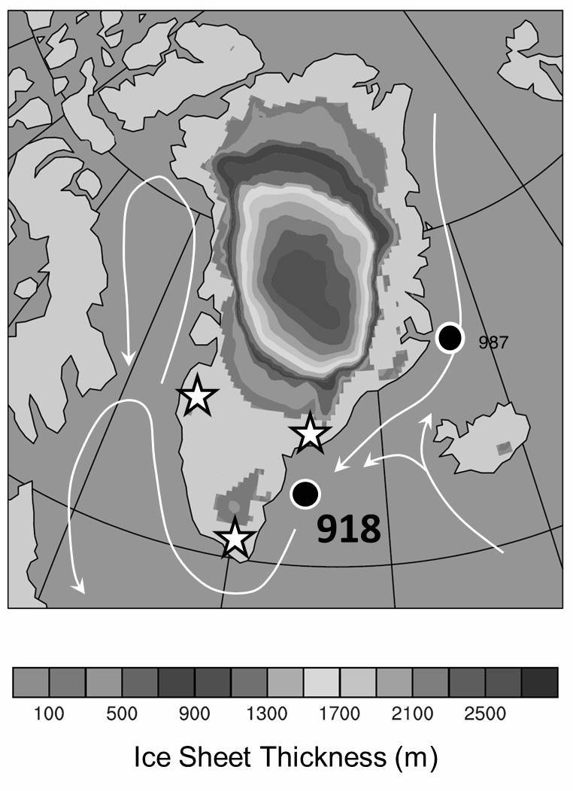
Figure 2. Compilation of findings that constrain the long-term history of the Greenland Ice Sheet. Upper panel, cosmogenic isotopic results from this study. Lower panels, previously published data.

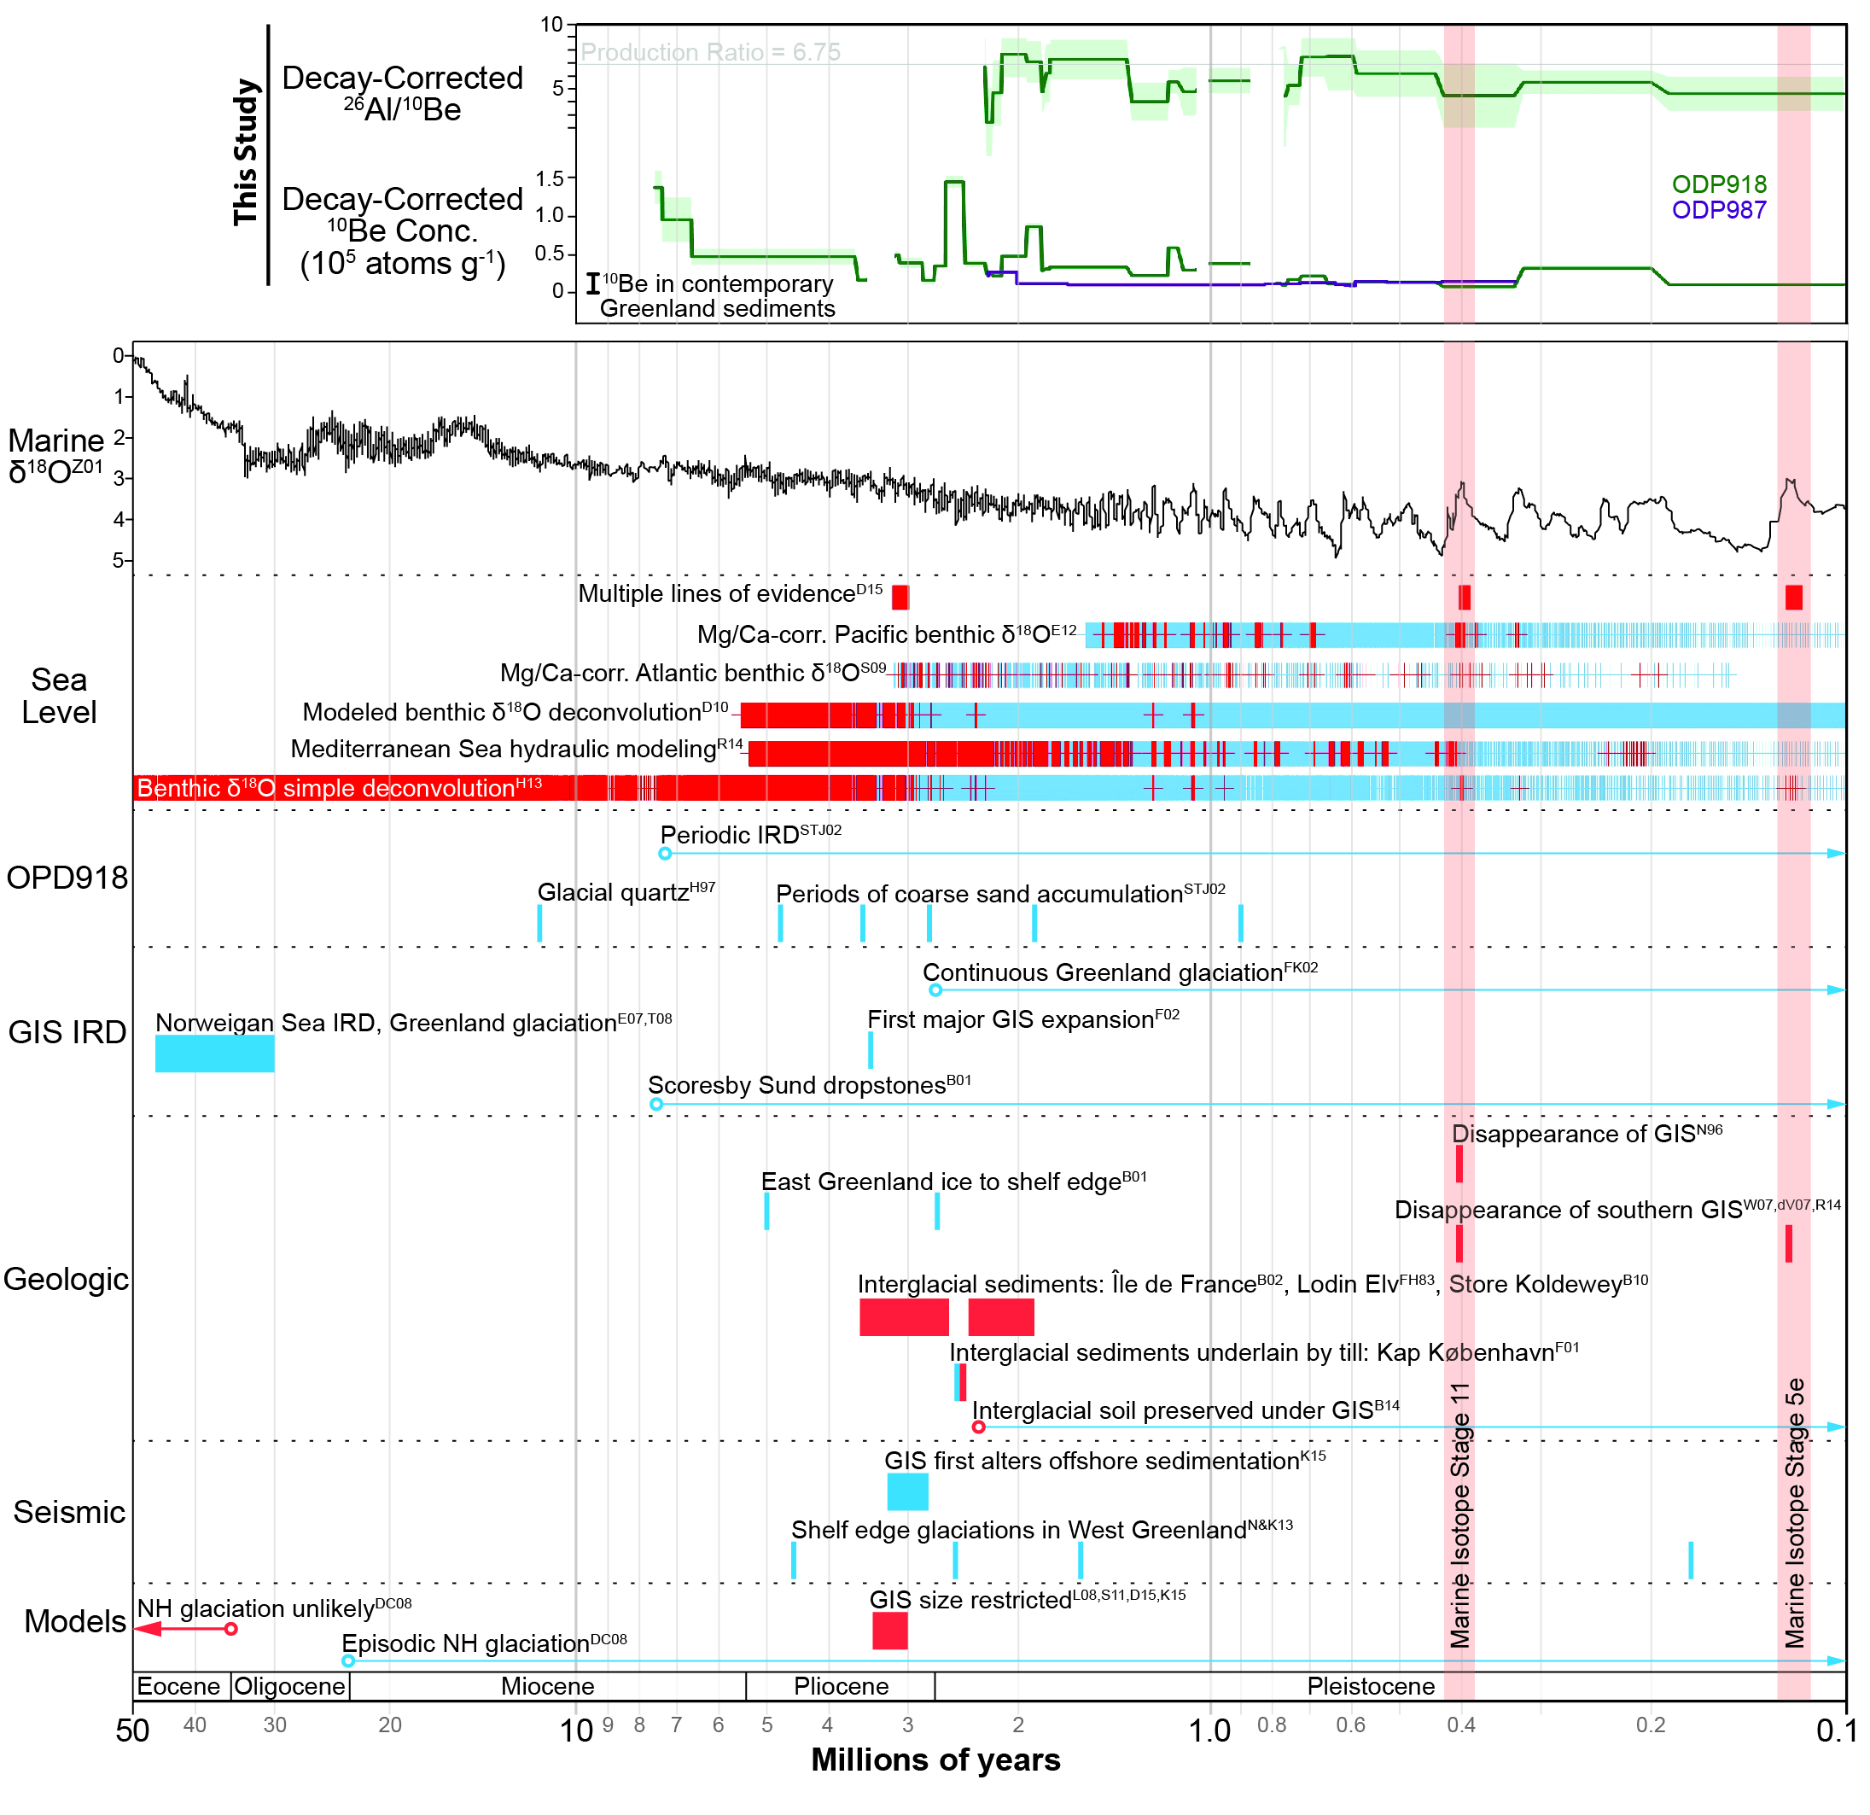
Figure 3. Depth profile of cosmogenic nuclide production in rock.
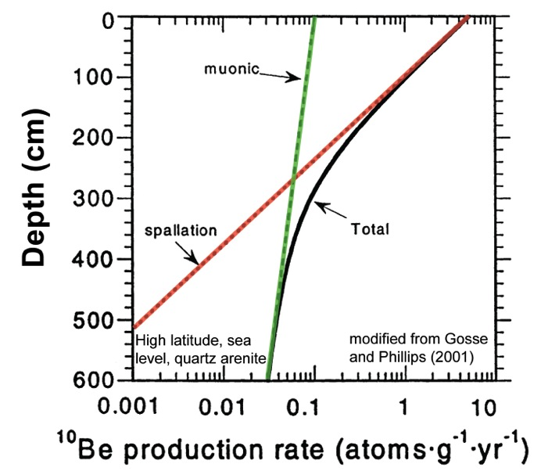

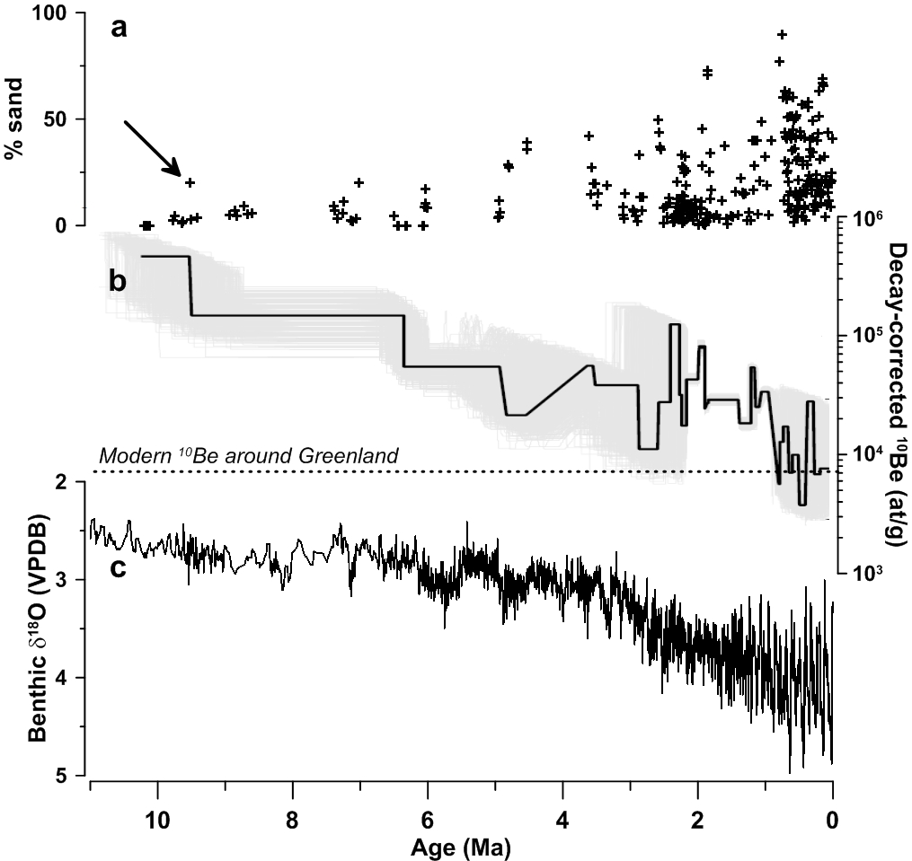
Figure 4. Ten million years of sediment from the SE Greenland coast analyzed for ¹⁰Be content at UVM. a) Sand fraction in samples from which quartz was purified. b) Decay corrected (based on core age model) ¹⁰Be concentration; dashed line is modern sediment from Greenlandic margin (Nelson et al., 2014). Note log scale. c. Global marine stable oxygen isotope record. | Figure 5. Cosmogenic isotopic analyses (²⁶Al/¹⁰Be) from the last 2.4 My in marine core ODP-918 (Larsen et al., 1994) with samples prepared at UVM. Upper panel is ²⁶Al/¹⁰Be decay-corrected ratio based on core age model. Lower panel is decay corrected ¹⁰Be concentrations.

