Ecological Assessment of Backcountry Skiing: Bolton Valley, Vermont

Abstract

The acquisition of this parcel aligns with FPR's current focus on creating effective management strategies for backcountry skiing, a fast growing recreational sport in Vermont. There is little ecological data on the effects of backcountry skiing on wildlife habitat and forest health. The Bolton Backcountry offers an opportunity to study the ecological effects of cutting backcountry ski trails.

Four focal species were used to compare wildlife habitat suitability of the glades and adjacent forest areas. A focal species is one whose requirements for survival are linked to factors important for maintaining healthy ecosystems. The focal species used for the study were black bear (Ursus americanus), Canada warbler (Wilsonia canadensis), black-throated blue warbler (Dendroica caerulescens), and scarlet tanager (Piranga olivacea).

The study was set up with control (forested) plots and treatment (gladed) plots. Results showed that black bear habitat suitability was significantly (p<.05) different between control and treatment plots. Habitat suitability was lower in treatment areas due to the lower diversity of berry-bearing herbaceous plants. This finding aligns with the herbaceous percent cover data that suggests a lower diversity of herbaceous plants in treatment versus control plots. A lack of diversity in the forest vegetation can affect the kind of animals that live there.

Introduction

In the past ten years, a boom in backcountry skiing has pushed FPR toward developing a new management strategy. Backcountry skiing entails accessing skiable terrain by hiking to the area you want to ski. Backcountry skiing is also characterized by skiing in maintained forested areas, colloquially known as tree skiing or glade skiing. Glade skiing is defined for this document as a ski run, maintained in the woods where a skier can make multiple linked turns between trees. Glades are maintained to keep them fun and useable. Maintenance of glades includes removal of the forest understory to prevent skier injury.

Methods

Study Area

The Bolton Backcountry parcel is 1,140 acres covering an elevation gradient from 1000-2800 ft. It is located in Bolton, Vermont and is within 30 miles of Vermont's largest city, Burlington (Figure 2). The parcel is the newest addition to the Mt. Mansfield State Forest, the largest contiguous landholding of FPR. It is approximately 40,000 acres, covers three counties, and includes seven towns. Across the Winooski valley to the south lays the 25,000-acre Camels Hump Management Unit. These two large public land holdings are part of a major north-south wildlife travel corridor in north central Vermont.

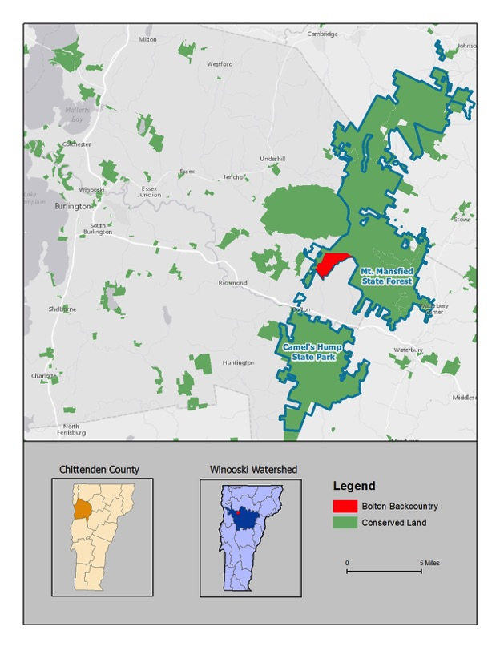
The landscape between Camels Hump Management Unit and Mt. Mansfield State Forest runs through the Winooski Valley. In 2008, a coalition of local conservation advocates, Vermont Land Trust, and the state defined this area as core habitat for wildlife and named it the Chittenden County Uplands. It is considered at high risk for development due to its proximity to Burlington.
Figure 2. The Bolton Backcountry land in context.

Linking core wildlife habitat into wildlife corridors that improve large-scale landscape connectivity is important in the face of a changing climate. The warming temperatures are changing vegetation, which forces migratory animals to move further north to find habitat and food. Bolton Backcountry adds to the landscape level connectivity and provides the needed conserved land base for this moving wildlife population as well as the current wildlife population.

Study Area

Bolton Backcountry in Bolton, Vermont in northwestern Vermont is 1,140 acres spanning 1,800 to 2,800 feet in elevation. The whole parcel is made up of a matrix of northern hardwood forest, montane yellow birch-spruce forest, spruce-fir forest, and a beaver meadow complex. The land is notably rugged with rock outcrops and talus slopes spread throughout the landscape. When these outcrops occur at around 2000 feet they provide suitable conditions for spruce-fir to grow. When viewed from above these outcrops form fingers and tiny islands of coniferous canopy betwixt the deciduous trees. This landscape also holds approximately 60 miles of ski trails and 70 acres of mapped glades. The dense trail network leaves little space untouched by recreationists in winter.

The seventy acres of glades are the focus of this study. There is pressure to expand the glade acreage on the property due to an increased pubic interest in backcountry skiing. The gladed area will be known as the treatment area throughout the document. The 70 acre control area was chosen because of similar forest cover type, soil type, and elevation.

Focal Species

Due to the size of the parcel and the time constraint of the project, four focal species were chosen: black bear, black-throated blue warbler, Canada warbler, and scarlet tanager. The United States Department of Fish and Wildlife (USFWS) has a habitat suitability index established for the black bear (1987). The three bird species habitat suitability needs were created using primary literature.

Black bear, scarlet tanager, black-throated blue warbler, and Canada warbler were chosen as focal species. All of these species are likely to live on the parcel due to size of the forested landscape as well as its cover type and elevation. Focal species is an umbrella term that encapsulates indicator, umbrella, flagship and keystone species (Miller et al. 1999). These species were chosen because of their sensitivity to forest fragmentation and their dependence on diverse forest structure.

Indicator species are sensitive to ecological changes and can be useful for monitoring habitat quality, and can provide an early warning system for the loss of integrity in an ecosystem (Miller et al. 1999). The three birds chosen are dependent on different aspects of forest structure, which makes them viable indicator species for changes created by glade cutting. If a forest lacks the specific requirements that make up their habitat suitability index, the birds are less likely to be there.

Black bear was chosen as a flagship species because they are charismatic and recognizable to the public (Miller et al. 1999). Black bear cover large areas in their seasonal movements, using different parts of a forested system for spring, summer, and fall food as well as winter denning. Black bear are also highly sensitive to habitat fragmentation and alteration because of their dependence on a variety of habitat types throughout the year.

Vegetation Data

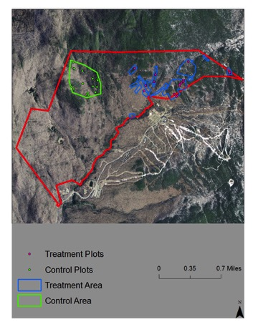
Wildlife habitat suitability models use vegetation data. A modified approach to the United States Forest Service's Field Inventory and Analysis (FIA) approach was used to collect the forest vegetation data. The traditional FIA approach uses a cluster of four 0.25 acre sub-plots to make up one, one-acre plot. I used one FIA sub-plot as my main plot.
Figure 3. A map of the control and treatment areas with random plots.

There were approximately 70 acres of mapped glades on the Bolton Backcountry. The gladed area is referred to as the 'treatment' area throughout this document. It is a treatment area because it is altered from the original forested state (control). A 70 acre control area was defined to match the soil type, elevation, aspect, and natural community type of the treatment area. Once both areas were defined, 15 random points were generated for each 70 acre area. These points were used as plot centers for the vegetation data collection using the FIA protocols (see Appendix A). I collected data on woody species, tree diameter at breast height (dbh), herbaceous species, and percent cover of herbaceous and woody species, downed debris, and canopy closure.

Results

A suite of forest vegetation data was collected in order to assess wildlife habitat suitability. This section walks through the different sets of data collected and outlines the trends present. Further years of data collection in the treatment areas may reveal more about the long-term effects of glading on forest species composition and regeneration.

Trees - Seedlings to Saw Logs

The hypothesis for tree data was that there would be more seedlings and saplings in the control plots than in the treatment area. Seedlings and saplings fall into the 0-6 ft range of the forest understory, which is the area of the forest removed during yearly glade maintenance. It was hypothesized that there would be more pole logs on the control plots since seedlings and saplings are regularly cut out of treatment plots. Finally, it was hypothesized that there would be more saw logs on the treatment plots, since glades are maintained with the intention of keeping large dbh trees. The <1" dbh saplings are lumped into seedlings in this figure because the tree data was broken out into four age classes - seedling, sapling, pole, and saw log - defined by the University of New Hampshire Extension (2010).

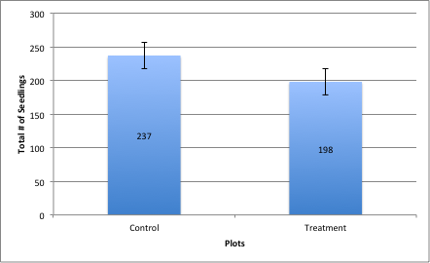
Figure 4. Total Number of Seedlings in Control and Treatment Plots. Seedlings include trees <1" diameter breast height. There are slightly more seedlings in the control area than in the treatment area. This aligns with the hypothesis for this age class.
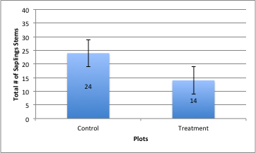
Figure 5. Total Number of Sapling Stems in Control and Treatment Plots. Saplings include trees >1"-4.5" diameter breast height. There are twice as many sapling stems in the control plots compared to the treatment plots. This aligns with the hypothesis for this age class. As mentioned before this age class is cut out by backcountry skiers because these trees interfere with the descent. They are whippy and can hit you in the face and catch your skis, poles, and other equipment.

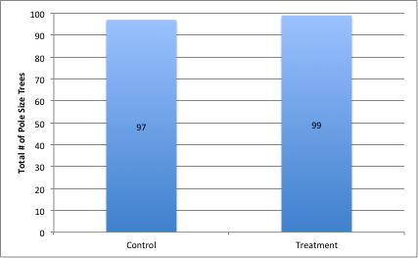
Figure 6. Total Number of Pole Size Trees in Control and Treatment Plots. Pole size trees include trees >4.5"-12" diameter breast height. These results were surprising because it was hypothesized that there would be more pole size in the treatment plots since younger age classes are cut out. There are roughly the same number of pole size trees in control and treatment plots. This finding does support the fact that the forests being compared have a similar composition, which means differences in the younger age classes are likely because of human activity versus natural differences between the forests.

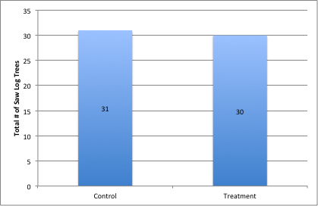
Figure 7. Total Number of Saw Log Trees in Control and Treatment Plots. Saw Log trees include trees >12" diameter breast height. These results align with what was expected. There are roughly the same number of saw log trees in control and treatment plots. This finding supports the fact that the forests being compared have a similar composition, which means differences in the younger age classes are likely because of human activity versus natural differences between the forests.

The trends shown in Figures 5-8 support the idea that there is a difference between the understory (seedling/sapling age class) in control and treatment plots.

Canopy Cover

Canopy cover observed across the study area was very closed. This was confirmed by the data (Figure 9).

Figure 8. Number of Plots in Control and Treatment Plots with x Percent Canopy Cover. This shows that all of the plots have >90% canopy cover. This supports that the two areas are similar.

Downed Woody Debris

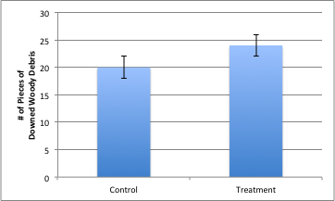
Figure 9. Total Number of Pieces of Downed Woody Debris on control and treatment plots. Downed woody debris is an important part of forest structure. It creates micro climates near the forest floor and as it decomposes releases nutrients back into the soil. Wildlife, invertebrates, and fungi thrive in these pieces of dead wood. There were slightly more recorded on the treatment plots than the control plots. The treatment plot downed woody debris was all much further along in decomposition than the control plots. Some trees had recently fallen while others were barely recognizable. This may be related to the fact that newer downed trees are often cleared from glades to the nearest forest island.

Soil pH

One of the criteria for choosing the control area is that it had the same soil types present as are found in the treatment plots. While in the field soil pH was recorded at each plot.

Figure 10. Number of plots in the study area with x soil pH. Most of the plots had a soil pH around 5. Soil pH can influence what types of vegetation grow in an area, the consistent pH supports that the control and treatment area were similar.

New York Fern Percent Cover

Species and percent cover data was collected at three quadrats on each plot. Species were then recorded at the plot level as well. This data, particularly in relation to herbaceous vegetation, is the most likely to be affected by the seasonal difference in data collection. Data was collected at all treatment plots in early to mid-July, while control plot data was collected from late-July to mid-August. Ferns were observationally larger in August on the whole property. The hypothesis related to ferns is that there would be a higher percent coverage of ferns on the treatment plots. This figure looks particularly at New York Fern because of its ability to shade out other plants and create a carpet of ferns.

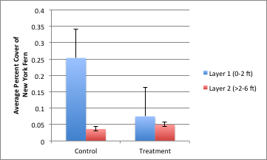
Figure 11. The average percent cover of New York Fern in the first two layers of the forest on control and treatment plots. The trend in data shows that there is a higher percent cover of New York Fern on control plots. As mentioned above, this is likely due to the time of season percent data was collected. Although this does not support the hypothesis, it does show that New York Fern is present on the property.

Vegetation Biodiversity

At every plot all vegetative species present were recorded. There were more species in control plots than treatment plots. Both woody and herbaceous species were counted. Since the woody species were almost the same, the main difference in species is in the herbaceous layer.

Figure 12. The total number of vegetative species on control and treatment plots. There were more species recorded on control than treatment plots. This difference could be important when thinking about the future of the treatment area and what it might look like if it stops being used as a ski run.

Discussion

It is currently unclear what the future forest in the treatment area may look like, due to the lowered herbaceous diversity, the small size of the sapling age class, and the presence of New York fern in the herbaceous layer. A disturbance in this forest will not follow the traditional disturbance successional pattern due to the presence of New York fern in the plots and hay-scented fern on the property. Both of these fern species will take over a newly created opening and suppress the growth of other vegetation (discussed further in management suggestions). Their presence can preclude certain species, thus affecting the species composition of the forest.

INCLUDE INFORMATION ABOUT HSIs here!

Forest Management

The focus of this study was on the effects of backcountry skiing on the site-specific wildlife habitat suitability for bear, black-throated blue warbler, scarlet tanager, and Canada warbler. The management strategies were developed with the focal species needs in mind.

Management Concern 1:

Glade development and maintenance simplifies forest structure:
(1) Loss of vertical forest structure
(2) Presence of ferns in the understory
(3) Loss of diversity in the herbaceous layer

Glading likely produces these results because of yearly maintenance over an extended time scale.

Management Recommendation:

The results of this ecological assessment indiate that Bolton Backcountry should not expand backcountry ski trails or glades; trail density on the parcel is already high. The current trail system needs a lot of maintenance, so spending time and money on that will be better than creating new glades for the long-term ecological health of the parcel. Bolton Backcountry is designated a Backcountry Skiing Management zone, which seems like a good precedent to set. Since the full effects of backcountry skiing are not yet well understood, designating specific areas as management zones will help the users self-regulate and the state focus limited resources where they can do the most good.

Conclusion

Bolton Backcountry offers an opportunity to understand the ecological effects of backcountry skiing. There are trails present on the property that have been glades for forty years and some that were just cut five years ago. The older glades are wide and exemplify the resultant simplified forest structure more acutely than the newer, narrower glades. The trend of glades to grow from narrowly trimmed trails to wide expanses of cleared understory is important to think about as more trails are cut across the state. What will all those newly cut trails look like in forty years?

Another interesting aspect of backcountry skiing is how many popular areas are associated with the alpine ski resort. All the major ski resorts such as Killington, Stowe Mountain, and Jay Peak have backcountry ski trails off the backsides of the mountains. This means that the highest peaks in Vermont are heavily impacted by human use. On one side, there is the traditional alpine ski resort development, while on the other there are trails cutting through the forest. This is of great concern to wildlife populations because it means that a larger portion of their habitat is fragmented. For instance, moose might have been displaced from the spruce/fir habitat on the ski resort side and now reside on the backside of the mountain. The presence of trails on the backside of the mountain means that the moose are under stress from the unpredictable presence of backcountry skiers. Where can the moose move to now? And how does the stress of dislocation and disturbance interact with other potential stressors, such as high winter tick loads?

Bolton Backcountry can be an anchor for education and outreach about these wildlife and forest effects for the backcountry skier community. The state should continue to assimilate information on the effects of backcountry skiing on wildlife and wildlife habitat suitability. Further inventorying, research, and monitoring will facilitate a suite of best management practices that ensure the continued use and future health of the northern forest.

References

Anderson, S. H. and Shugart, H.H. (1974). Habitat selection of breeding birds in an east Tennessee deciduous forest. Ecology, 55, 828-837.

Conway, C. (2010). Canada Warbler (Cardellina canadensis), The Birds of North America Online (A. Poole, Ed.). Ithaca: Cornell Lab of Ornithology. doi:10.2173/bna.421

Daubenmire, R. F. (1959). A canopy coverage method of vegetation analysis. Northwest Science, 33, 43-64.

Degraaf, R. M., Healy, W.M. and Brooks, R.T. (1991). Effects of thinning and deer browsing on breeding birds in New England oak woodlands. Forest Ecology Management, 41, 179-191.

Engelman, H.M. and Nyland, R.D. (2005). Interference to Hardwood Regeneration in Northeastern North America: Assessing and Countering Ferns in Northern Hardwood Forests. Northern Journal of Applied Forestry, 23(3),166-175.

Erdmann, G.G. (1965). Silvics of forest trees of the United States, Agriculture Handbook: Yellow birch. Retrieved from the USFS Silvics Manual, Volume 2.

Goodrich, J.M. and Berger, J. (1994). Winter recreation and hibernating black bears Ursus americanus. Biological Conservation, 67:105-110.

Holmes, R.T., Rodenhouse, N.L. and Sillett, T.S. (2005). Black-throated Blue Warbler (Setophaga caerulescens), The Birds of North America Online (A. Poole, Ed.). Ithaca: Cornell Lab of Ornithology. doi:10.2173/bna.87

Hugie, R.D. (1979). Central and Northeast Canada and United States. In The black bear in modern North American. Boone and Crockett Club. Amwell Press, Clinton, NJ.

Lady Bird Johnson Wildflower Center. (2014). Native Plant Database: Hobblebush. Retrieved from: http://www.wildflower.org/plants/result.php?id_plant=VILA11

Logan, K. T. (1965). Growth of tree seedlings as affected by light intensity: I. White birch, yellow birch, sugar maple, silver maple. Canadian Department of Forestry, Publication 1121. Ottawa, ON.

MacArthur, R. H., & MacArthur, J. W. (1961). On Bird Species Diversity. Ecology, 42(3), 594-598. doi: 10.2307/1932254

Mowbray, T.B. (1999). Scarlet Tanager (Piranga olivacea), The Birds of North America Online (A. Poole, Ed.). Ithaca: Cornell Lab of Ornithology. doi:10.2173/bna.479
New England Ski History. (2014). Bolton Valley, Vermont. Retrieved from: http://www.newenglandskihistory.com/Vermont/boltonvalley.php

Peck, G. K. and James, R.D. (1987). Breeding birds of Ontario Vol. 1. Royal Ontario Mus. Toronto.

Richmond Town Plan. (2012). Richmond Town History. Retrieved from: http://www.richmondvt.gov/about-richmond/history/

Robbins, C. S., Dawson, D.K. and Dowell, B.A. (1989). Habitat area requirements of breeding forest birds of the Middle Atlantic states. Wildlife Monographs, 103, 1-34.

Rogers, L. and Allen, A. (1987). Habitat Suitability Index Models: Black Bear, Upper Great Lakes Region. United States Fish and Wildlife Service. Retrieved from: http://www.nwrc.usgs.gov/wdb/pub/hsi/hsi-144.pdf

Rosenberg, K.V., Rohrbaugh, R.W, Barker, S.E., Lowe, J.D., Hames, R.S and Dhondt, A.A. (1999). A land managers guide to improving habitat for scarlet tanagers and other forest-interior birds. The Cornell Lab of Ornithology.

Rosenberg, K.V., Hames, R.S., Rohrbarugh, R.W., Barker, S., Lowe, J.D. and Dhondt, A.A. (2003). A land manager's guide to improving habitat for forest thrushes. The Cornell Lab of Ornithology.

Stewart, P. and Globig, S. (2011). Vascular Plants and Paleobotany. Apple Academic Press.

Strong, A.M., Rimmer, C.C., McFarland, K.P., and Hagen, K. (2002). Effects of Mountain Resorts on Wildlife. Vermont Law Review, 26, 689.

Tubbs, C and Houston, D.R. (1965). Silvics of forest trees of the United States, Agriculture Handbook: American beech. Retrieved from USFS Silvics Manual, Volume 2.

United States Forest Service. (2014). Forest Inventory and Analysis National Program. Retrieved from: http://fia.fs.fed.us

Vermont Audubon. (2014). Foresters for the Birds. Retrieved from: http://vt.audubon.org

Vermont Fish and Wildlife Department. (2005). Vermont Wildlife Action Plan. Retrieved from: http://www.vtfishandwildlife.com/swg_cwcs_report.cfm

Vermont Fish and Wildlife Department. (2014). Vermont Wildlife Fact Sheet: Black Bear. Retrieved from http://www.vtfishandwildlife.com

Vermont Land Trust. (2014). Bolton Valley. Retrieved from http://vlt.org

Villard, M. A., Trzcinski, M.K. and Merriam, G. (1999). Fragmentation effects on forest birds: relative influence of woodland cover and configuration on landscape occupancy. Conservation Biology, 13, 774-783.

Appendix A

FIA Methods

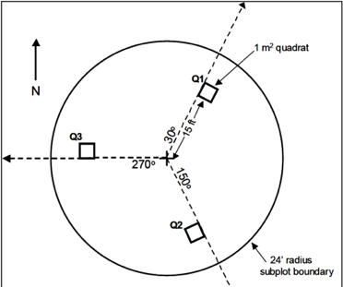
Figure 1. Plot used for data collection. Tree data and percent cover data were collected at plot level, sapling/seedling data at micro plot, vegetation data and percent cover at quadrats, and woody debris and soil along the transects.

Plot:
At each site I collected data in the same order - plot, micro plot, transect, quadrat. At the plot level I used a 24 ft piece of p-cord starting at the N azimuth and walking. I recorded species, dbh, and height of all standing trees >4.5 in. I used a hand held densiometer to estimate canopy cover. Canopy measurements and a picture were taken from plot center facing North, East, South, and West. I used ocular observation to determine percent cover at the plot level (Daubenmire 1959). Four height classes of cover were used: 0-2 ft, >2-6 ft, >6-16 ft., and >16 ft. Percent cover fell into seven categories: 0, 2-5, 6-25, 26-50, 51-75, 76-95, 96-100. For data analysis, these categories were simplified to 0%, 5%, 10%, 38%, 63%, 86%, and 97% (Daubenmire 1959).

Micro plot:
I collected the regeneration data in a 6.8 ft radius micro plot located 90 degrees and 12 ft from the plot center. I identified and measured the dbh of standing trees <4.5-1". Standing trees <1" and seedlings were identified and counted. Seedlings were only counted up to 20.

Transects: I collected downed woody debris (DWD), fine woody debris (FWD), soil duff and litter layer depths on transects. The transects were set up at 30, 150, and 270 degrees and ran from plot center to plot edge. A 24 ft piece of p-cord was used to demarcate transects. I walked from plot center out to record DWD crossing the transect. If DWD crossed the transect, I recorded tree species, dbh, and decay class. I walked along the transect again to count FWD that crossed the transect recording it is as small, medium, or large. Soil pH was taken at the end of the 270 degree transect. I collected soil pH measurements at the end of the 270-degree transect.

Quadrat:
I used a one meter squared quadrat made of PVC to collect herbaceous and shrub layer data on each transect, 15 feet from plot center. It was placed on the right side of the transect with the bottom left corner touching the p-cord. I made a species list of all vegetation in the quadrat. I then repeated the ocular observation technique used at the plot level to collect percent canopy cover data for each species per quadrat.

Species List (this might go in the actual body of work)
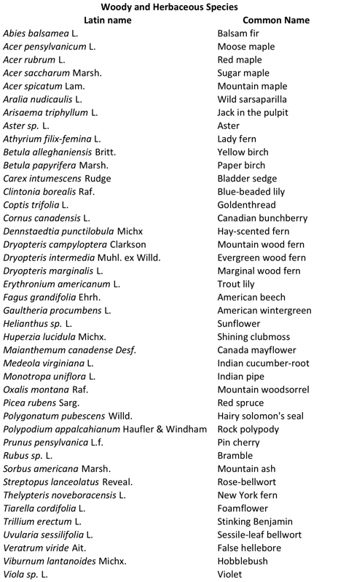

Jon Appleton of Mad River Glen Ski Resort created a forestry management plan in the early 2000s as an attempt to formalize glade cutting with a focus on maintaining forest health and water quality. The United States Forest Service consulted Mad Rive Glen as well about their management techniques, drawing on vegetation islands (mentioned later) to create a plan for glade development in the Rochester Ranger District of Vermont.

Mad River Glen focuses on keeping people happy and on trail as well as strategies to best protect forest health.
The three key rules for laying out trail are:
1) The lines are fun, so people will not leave the trail
(2) Cutting down trees does not create better terrain and might lessen snow held by the total line
(3) Do not cut in spruce/fir forest (starting around 2,200 to 2,500 ft)

When creating new trails, it is important to think about the type of terrain current glade selection covers. Steep terrain is good for powder and challenge, whereas rolling terrain is fun for all abilities. Once the audience is established, trail planning can commence.

Planning should focus on:
Northerly exposures because they hold snow the longest; Rolling terrain because it is fun;
Northern hardwood forests; Stable soil; Fall lines

Unlike hiking trails, ski trails run down the fall line. Potential routes should be scouted during the non-snow months, preferably during "stick season" when the topography of the land is more visible than during mid-summer. Flagging a desired route and visiting it during several seasons allows for revisioning and a full understanding of the issues that may arise from its location. Following the line in winter will give you an idea of what it would be like to ski it.

Glade management should include a focus on retaining structural diversity of the forest. One way to do this involves using vegetation islands. Basic triangular islands have been used at Mad River Glen for about ten years, with anecdotal success. The Green Mountain National Forest's current proposal builds on this idea and includes specific uneven-aged silvicultural practices to promote a structurally diverse forest condition.

Vegetation Islands:
Islands range in size; Include a diversity of species and ages; Include both vertical and horizontal woody structure

Continued contact with the Green Mountain National Forest to find out how the vegetation islands work over time will lend more information for future revision of glade management.

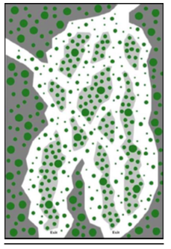
Example of tree-skiing zone layout utilizing a braided line design with retained vegetation islands, courtesy of Green Mountain National Forest.

