Introduction
Humans have become one of the most effective geomorphic agents on the planet, altering 54% of the total land area on earth, 47% of which is through agriculture and forestry (Hooke Article, GSA Today Dec. 2012). By some estimates humans move more earth annually than any other geomorphic process, including mountain building (Hooke, 1994). The result of human induced erosion and sediment redistribution is enormous, and directly impacts humanity’s ability to produce food, source drinking water, and build communities, as well as the health of natural ecosystems (Foley et al., 2005, Fürst et al., In Press).
Characterizing natural background erosion rates is critical to understanding the magnitude and type of impacts humans have on the landscape. My research seeks to use modern sediment associated isotopic methods, up to 23 years of daily sediment yield, and remotely sensed land use data to characterize the natural background rates of erosion, modern erosion rates, and the affect of land-use on erosion. The field are of interest consists of three parent basins ranging from 200 to 2000 km² within the Mekong river system in Yunnan province, SW China (Figure 1). Sediment samples have been collected for up to 25 sub-basins within each of the three parent basins, and will be analyzed for in situ ¹⁰Be, meteoric ¹⁰Be, ¹³⁷Cs, and unsupported ²¹⁰Pb. Beryllium-10 is a rare isotope widely used to determine background erosion rates (in situ) and soil loss rates (meteoric), and cesium-137 and unsupported lead-210 (collectively referred to as short-lived isotopes) have been widely used to assess erosion in the past ~300 years. Opportunistic field sampling of radiocarbon-14 in terraces provide insight into erosion occurring in the time frame between the ¹⁰Be and short-lived isotopes.
Through the use of multiple isotopic systems relevant at a range of temporal scales, daily sediment yield records, and land use, I intend to address four geologically and societally relevant questions: (1) Where is the sediment coming from? (2) How does erosion change from natural pre-human conditions to modern times? (3) What are the primary types of erosion occurring (i.e. what is the source depth of sediment)? (4) How efficiently is sediment exported from upland basins to main-stem trunk streams?
Work Completed to date
Field Work
A total of 78 discrete samples (210 measurements) were collected between May 21, 2013 and June 15, 2013 at field sites throughout Yunnan province, SW China. Samples were collected for in situ and meteoric ¹⁰Be analysis, ¹³⁷Cs, unsupported ²¹⁰Pb, and radiocarbon dating from active channel deposits, terraces, and soil pits (Table 1). Sample sites were selected to represent either an “end-member” land-use, such as primarily forest or primarily agriculture, or as a component of a sediment-networking model that will allow relative sediment contributions from stream branches to be calculated.
Laboratory work
In October 2013 I traveled to Glasgow, Scotland to learn the method for measuring ¹⁰Be with Dylan Rood at the Scottish Universities Environmental Research Centre’s accelerator mass spectrometer facility. 20 of 133 total ¹⁰Be measurements were made as a part of the trip and I will begin data reduction shortly. Measurements have been made using Amanda Schmidt’s germanium detector for 20 of 65 ¹³⁷Cs and unsupported ²¹⁰Pb samples. I will travel to Oberlin in Spring 2014 to learn the laboratory method for counting short-live isotopes.
Presentation of research
In October 2013 I traveled to the annual Geological Society of America meeting in Denver, CO to present my research to-date and the novel approach I intend to take to distinguish modern human associated erosion from natural background erosion. I presented my work in poster form in the special session past, present, and future of geomorphology. (Abstract citation?)
Sample Status
Splits of short-lived isotope samples to be measured by Amanda Schmidt’s laboratory at Oberlin College have been sent to Ohio and all measurements will be complete in early 2014. All in situ ¹⁰Be samples have been reduced to pure quartz and beryllium has been extracted from 30 samples, 20 of which have been measured at the SUERC AMS facility in Glasgow, Scotland. Beryllium will be extracted from the remaining 38 in situ samples by December 20, 2013, and measured by March 2014 at SUERC. The 65 samples to be measured for meteoric ¹⁰Be will be shatterboxed in January 2014 and beryllium extraction completed in February 2014. Measurements will be made at SUREC in March 2014. Radiocarbon samples will be measured at University of California Irvine in winter 2014.
Preliminary data and results
Results for ¹⁰Be and short-lived samples collected in spring 2013 and measured fall 2013 have not yet been reduced for analysis. However, a secondary dataset consisting of ¹³⁷Cs, unsupported ²¹⁰Pb, and meteoric ¹⁰Be measurements made on samples collected as a part of Amanda Schmidt’s dissertation research in 2005 and 2006 have been measured and analyzed. Schmidt’s samples were collected in the Three Rivers Region, adjacent to the north of the field sites visited in 2013, on the Mekong, Salween, and Yangtze rivers.
Meteoric ¹⁰Be concentration and long term in situ ¹⁰Be erosion rates (measured by Schmidt) were used to calculate erosion indices for each basin sampled (Equation 1). Erosion indices describe the ratio of meteoric ¹⁰Be being exported from a basin over the ¹⁰Be delivery rate, and are well suited for assessing long-term soil loss, a topic of considerable interest when using short-lived isotopes, which adhere to sediment grains in the uppermost 20 cm of soil.
Results
88% of erosion indices (n=35) were below 1 (i.e. less meteoric ¹⁰Be is leaving the basin than incident upon it), unsupported ²¹⁰Pb was only present in one sample, and three samples contained ¹³⁷Cs (Figures 3 and 4). The samples containing measureable levels of short-lived isotopes had relatively low concentrations close to the detection limit of the instrument.
Interpretation
The short-lived isotopes and erosion indices appear to tell differing accounts of erosion in the short versus long term. Low erosion indices suggest relatively slow erosion of the landscape in the long-term (10,000-100,000 yr), where meteoric ¹⁰Be is accumulates on the landscape. The absence of short-lived isotopes in almost all samples, and the low values in the few that contain measurable concentrations, indicate that the top 10 to 20 cm of the soil profile that contains the majority ²¹⁰Pb and ¹³⁷Cs has already been eroded within the past 300 years, leaving soil depleted in short-lived isotopes. Based on field observations of land use practices in the region, it is likely that the modern increase in erosion suggested by the short-lived isotope concentrations is the result of human activity on the landscape (Figure 5).
An alternative, and potentially coincident, explanation exists for the differences in erosion indices and short-lived isotopes in the sediment grain size being tracked by our methods. Our meteoric ¹⁰Be and short-lived isotope measurements were done on medium sand size sediment (0.250 - 0.850 mm) to ensure we track the same sediment type as in situ ¹⁰Be. Isotopes adhered to the outside of sediment grains, however, differ fundamentally from in situ ¹⁰Be, in that they may exhibit preference for smaller sediment grains with proportionately more surface area for sorption. Our measurements could be missing large portions of the total meteoric and short-lived inventories if the preference for smaller grains is strong.
Previous studies have found meteoric ¹⁰Be exhibits a mild preference for smaller grains; however, the grain size analysis did not include the smallest grains (Brown, 1988). This experiment has not been published for short-lived isotopes. We have designed a basic but comprehensive grain size experiment that will be conducted in winter 2014 to determine the relative preferences of meteoric ¹⁰Be, ¹³⁷Cs, and ²¹⁰Pb for 0.850 - 0.250, 0.250 – 0.125, 0.125 – 0.063, and <0.063 mm size fractions.
Knowledge of sorption tendencies of sediment adhered isotopes combined with a more complete dataset consisting of samples taken in basins of varying end-member land-uses will allow us to draw more meaningful conclusions from data collected in spring 2013.
Time line for completion of work

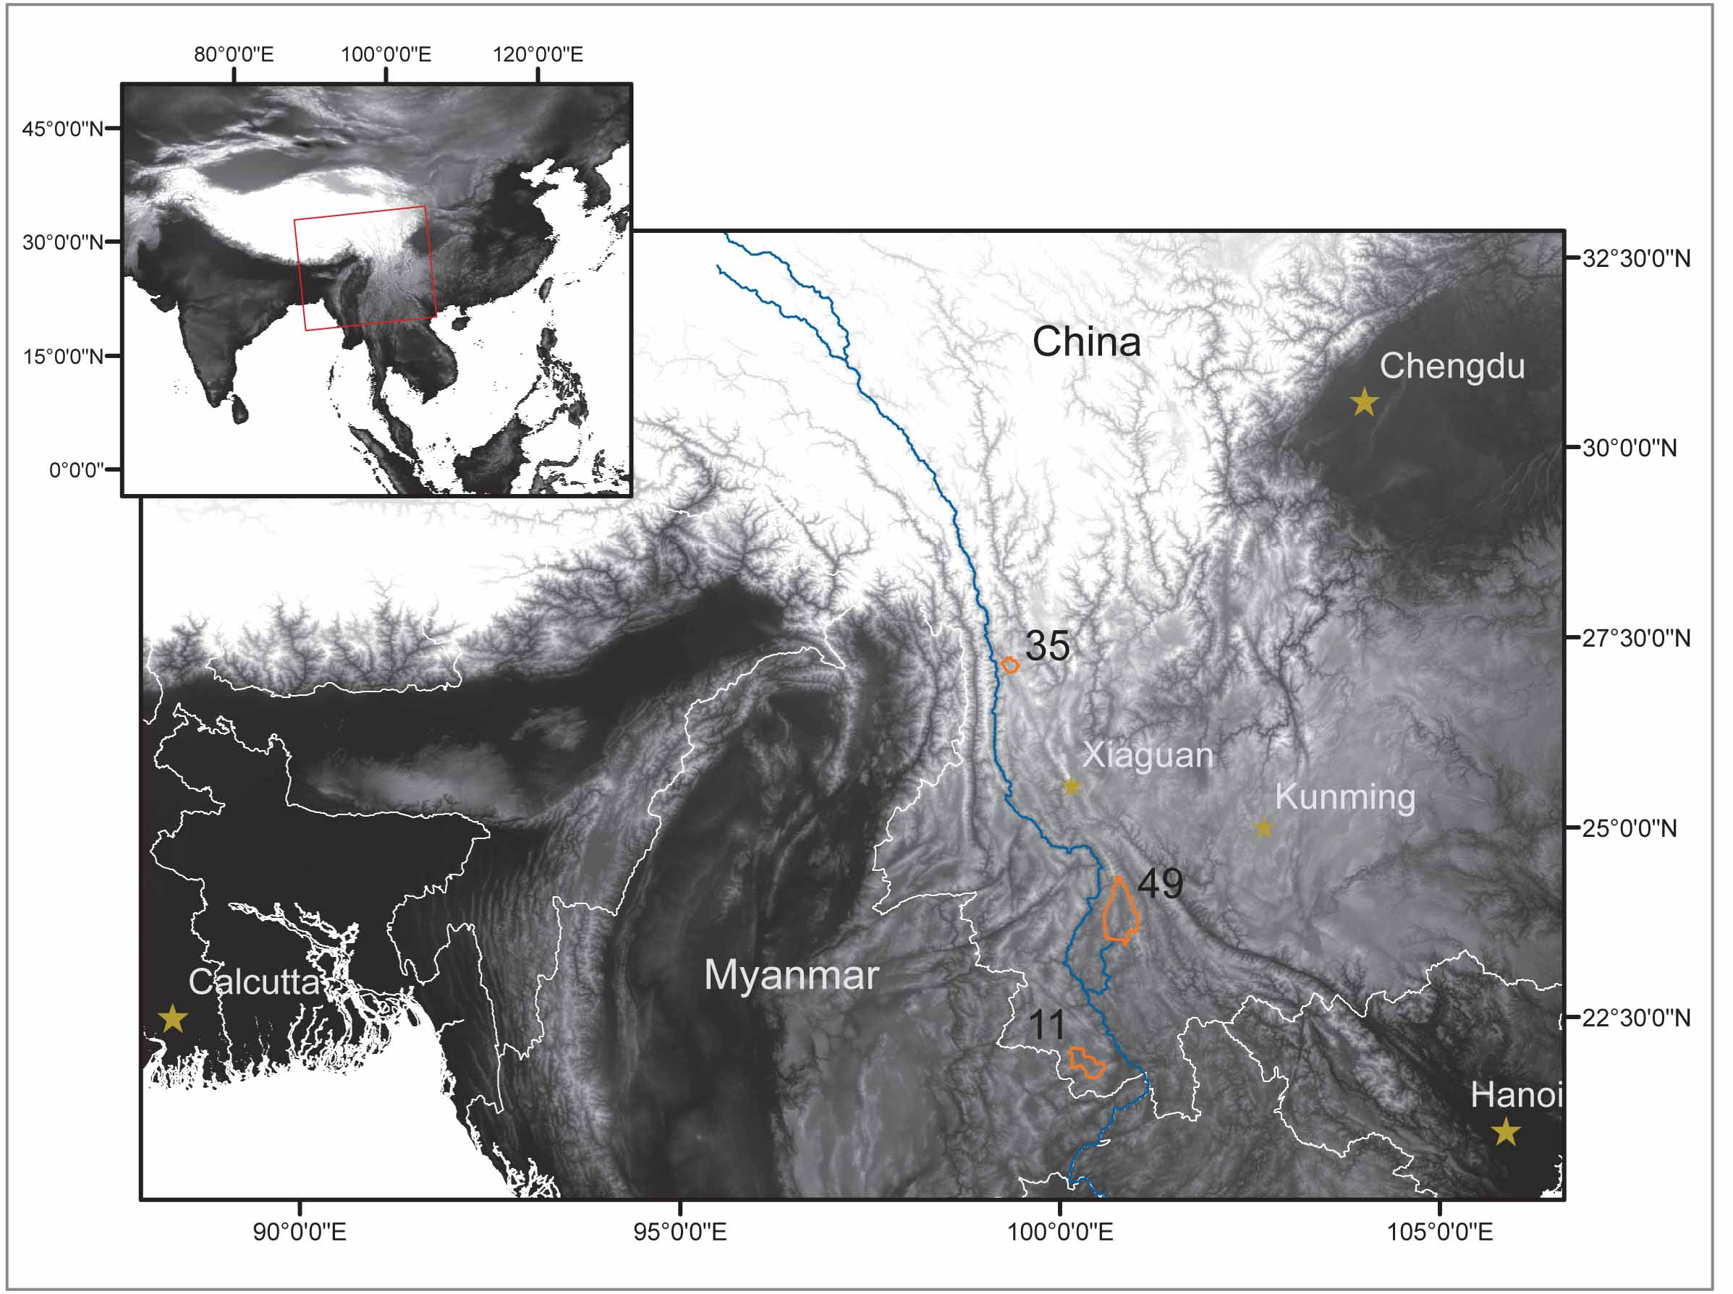
Figure 1. Map of Asia and regional map of study area showing the basins of interest in orange (11, 35, and 49) and the Mekong River in blue.

 | In situ ¹⁰Be | Meteoric ¹⁰Be | ¹³⁷Cs and ²¹⁰Pb | Radiocarbon | Total
Active Channel | 58 | 58 | 58 | 0 | 174
Terrace | 10 | 0 | 0 | 12 | 22
Soil Pit | 0 | 7 | 7 | 0 | 14
Total | 68 | 65 | 65 | 12 | 210
Table 1. Total accounting of analysis and sample type. Values represent measurements to be made, not discrete samples.

$$Erosion Index=\frac{Meteoric \text{10}\text{Be} leaving basin}{Meteoric \text{10}\text{Be} delivery}=\frac{Sed. Yield*\text{10}\text{Be} Conc. in Sed.}{Meteoric \text{10}\text{Be} Delivery *Basin Area }$$

Equation 1. Erosion index is the ratio of the amount of meteoric ¹⁰Be leaving a basin on sediment over the estimated atmospheric delivery. Delivery rate was estimated based on an average latitude of ~29 degrees north using Graly et al., 2011. Sediment yield was calculated using in situ ¹⁰Be erosion rates calculated by Amanda Schmidt (Henck et al., 2011).

For a more detailed description of the properties of each isotope that make it useful for studying erosion please refer to my thesis proposal.

