This plan is best reviewed daily by the student/researcher’s Supervisor, and/or by site personnel at a tailgate meeting before daily field activities commence.

A written Health & Safety Plan for Field Work should be submitted to and approved by your Supervisor, Chair, Dean or Department Head before field work commences or resumes. UVM Environmental Health & Safety (EHS) Lab Safety Coordinators are available to review your draft plan or assist with revising your plan and can offer safety recommendations before submission to upper administrators for approval. Contact safety@uvm.edu for assistance or questions.

Field Work Site Address(es)/Location(s): add line items if needed
List each field work location, specific address, City and State

Site Safety Officer: ____________________________Cell:_________________________

Email: _________________________________ UVM NetID: __________________________

Research Tasks: (check all that apply) Additional Comments:
- Topographic survey (e.g., total station equipment, survey rod, tripod, GPS)
- Unmanned aerial survey or terrestrial lidar survey
- Canoe, kayak or boating operations
- Water sampling
- Soil/Plant management/sampling
- Instrument maintenance (e.g., staff gauge, rain gauge, weir, structural health monitoring sensor)
- Discharge measurements
- Other:
- Other:

Emergency Notifications
Police: Emergency: 911 Non-Emergency: ( ) ____________-_________________

Fire/EMS: Emergency: 911 Non-Emergency: ( ) ____________-_________________

UVM Contact/Advisor:
Name: ____________________________________

Phone: ( ) ____________-_________________

Injuries and Accidents (check all that apply)
- Everyone has been trained to report injuries to the Site Safety Officer listed above.
- Everyone has been trained to report Injury and Accidents to their Supervisor.
- Supervisor is aware of UVM’s Injury and Accident Reporting Procedures: https://www.uvm.edu/riskmanagement/incident-claim-reporting-procedures

Nearest Hospital to the Field Site(s), including Directions
If there are several locations, identify nearest hospital to each field site.

Hospital Name: ________________________________________________________________

Phone: ( ) ____________-_________________

Address: __________________________________________

__________________________________________

(Insert Map and Directions from Site Address to Nearest Hospital)

Level of Risk
Determine the level(s) of risk (high, medium or low) associated with your field site(s) and task(s) to be performed at each site.
Examples:
Low-risk field activities might include trips to places that are easy to access, in close proximity to a main or paved road and are close to medical facilities.
High-risk activities may include traveling long distances to remote areas, working alone in remote area, working long hours with no breaks, working at night, conducting work in areas with little/no cell service, conducting work in areas that are difficult to access on foot. High-risk activities should be avoided when possible.

Individual(s) Risk Factors
Consider your individual risk factors (e.g., physical condition, current acute or chronic medical condition(s), being immunocompromised, allergies or asthma, being pregnant, etc). Describe how you will make adjustments to your field work to accommodate any individual risk factors, if any.
__________________________________________________________________________________
__________________________________________________________________________________

Check that you have reviewed or considered the following:
UVM guidelines and NIOSH guidelines for Field Work Safety have been reviewed. https://www.uvm.edu/riskmanagement/safety-field-work-and-farm-operations and NIOSH Hazards for Outdoor Workers: https://www.cdc.gov/niosh/topics/outdoor/default.html
If soap and running water will not be immediately available in field research location, carry a supply of hand sanitizer with at least 60% alcohol and disinfectant wipes.
A buddy system will be used for safety and communication purposes.
Tools and equipment will be disinfected with soap and water or 70% ethanol after use.
We have reviewed and are following current CDC recommendations re: Covid: https://www.cdc.gov/coronavirus/2019-ncov/your-health/isolation.html
Field workers have been trained to understand UVM COVID-19 guidelines: https://www.uvm.edu/sites/default/files/UVM-Risk-Management-and-Safety/Safety%20Officer%20Meeting/covid_guidelines.pdf
Considerations have been made regarding service areas (e.g. highway rest areas, visitor centers) some may be closed; trail head facilities, availability of porta-lets etc
Any chemicals needed in the field will be transported upright, in secondary containment with a secure lid. Chemicals and samples will be labeled and dated per UVM labeling protocol.

Field Hazards: Risk Reduction Measures
Flora & Fauna Awareness
(Check all that may apply. Add hazards that may be specific to your site in “Other”)

_____ Insect Stings: Bee and/or wasp bites.
- Wear long sleeves and light-colored clothing to lessen chance for a sting
- If stung, run a clean fingernail or gauze from a first aid kit over the sting to draw the stinger out
- Apply ice to reduce swelling
- Monitor for signs of allergic reaction and, if so, seek medical attention immediately
- Individuals with known allergy will carry a prescription epi pen
_____ Venomous Spiders: Black widow
- Avoid wood piles, rock piles, outbuildings – and spider webs in these locations
- If bitten, wash the bite with soap and water, apply a cool compress or ice, and elevate the bite site above the heart, if possible
- Seek immediate medical attention for black widow spider bite
_____ Ticks: Carriers of Lyme disease, Anaplasmosis and (rarely) Powassan virus in the Northeast. (and Rocky Mountain spotted fever in the western US)
- Wear light colored, long pants with pant legs tucked into socks
- Wear gators over lower legs
- Tie back long hair and wear a cap
- Use DEET or insect repellent
- Perform frequent or end-of-day tick checks and shower as soon as you can
- Remove field clothes as soon as you can. Place clothing directly in a hot dryer for a minimum of 6 min on high heat to effectively kill ticks on clothing. If clothing is soiled, wash with water temperature ≥130°F to kill ticks.
- Seek medical attention for confirmed tick bites
_____ Animal Bites: Skunks, foxes, bats, dogs, cats, raccoons, horses, snapping turtles, beers, moose, leeches, other: ____________________________________________________
- Avoid work at dawn & dusk hours
- Seek immediate medical attention for an animal bite that breaks the skin
_____ Poisonous Plants: Poison ivy, Poison oak, Poison/Wild parsnip, other: ___________________
- Cover all exposed skin: wear long sleeves, long pants
- Avoid tall weeds, brush – stay on travelled paths where possible
- Wash exposed skin with soap and water as soon as possible
_____ Other: __________________________________________________________________

River/ Lake / Ocean Awareness
(Check all that may apply and add any additional hazards specific to your site in other)

_____ Canoeing/Boating/Kayaking/Fishing
- Always wear personal flotation device
- Proficiency in swimming required
- Buddy system is best
- Waterproof packs needed for radio or cell phones and supplies
_____ Waders/Boots
- Wear belt with chest waders to minimize waders filling with water
- Use walking stick or river staff to prevent slipping

General Physical Hazards
(Check all that may apply. Add additional hazards specific to your site in “Other”)

_____ Slips/Trips/Falls: Steep Slopes, Rocks, Tree Roots
- Seek immediate medical assistance for suspected sprain or broken bones
- Keep bandaids and bandages in first aid kit for small lacerations, abrasions
_____ Heat Stress
- Know the signs of heat stress.
- Avoid working in field during mid-day or in very hot temperatures
- Wear a large-brimmed hat/cap
- Take regular breaks in shade. Hydrate often!
- Use buddy system. Monitor each other for signs of heat stress
- If a person is affected by heat stress, move them to shade or a cooler location
- Apply cold packs, ice, or cool water compresses and encourage regular intake of cool water
- Seek medical attention
_____ Cold Stress
- Avoid field work during very cold conditions
- Wear layers of loose-fitting clothing and waterproof and insulated boots
- Take regular breaks to warm up indoors or in a car
- Stay hydrated and avoid caffeine or alcohol.
- Use the buddy system and monitor for signs of frost bite or hypothermia
_____ Electrical: (marine batteries, other power sources)
- Minimize the interaction or contact of water with electrical cables
_____ Traffic
- Wear a reflective vest and OSHA-approved hard hat

_____ Construction Sites
- If entering a construction site, report to general contractor or site supervisor and follow prescribed safety guidance

_____ Weather Emergencies: Flash flooding, thunder and lightning
- Download Severe Weather Alert App to phone
- Avoid field work on days where extreme weather is forecast
- If extreme weather occurs unexpectedly, immediately leave a river, lake or body of water; seek shelter in a building, car; move away from hilltops, trees, and utility lines
_____ Other: __________________________________________________________________

Other General Precautions
Personal Protective Equipment (PPE)
PPE will include the following equipment necessary to complete my work safely carry in the field:
_____ Waders
_____ Sunscreen/Sunglasses
_____ Reflective Vest
_____ DEET/ Insect Repellent (to repel ticks)
_____ Sturdy, closed-toe boots or Steel-toed boots
_____ Hard hat
_____Rain gear
_____ Safety Glasses
_____ Baseball cap or other wide brimmed hat
_____ Light colored pants with socks (to see ticks)
_____ Other: __________________________________________________________________
_____ Other: __________________________________________________________________

First Aid Kit (Review location and contents of first aid kit with all site personnel. Do not store or issue medications)
_____ Soap, biodegradable (to wash off wild parsnip oils or insect sting sites)
_____ Tecnu (to remove poison ivy oils from skin)
_____ Band-aids/ Bandages / First Aid Cream
_____ Ace Bandages
_____ Chemical hot packs
_____ Salt (for leach removal)
_____ Tick Remover/tweezers
_____ Other: __________________________________________________________________

Acknowledgment of Risk Form

This form is to be reviewed and signed by anyone conducting field work. The activities may be part of an individual or group research activities or as part of a class/course. A blank copy of this Acknowledgment of Risk Form may also be found in the Quick Links on the Safety for Field Work and Farm Operations website (https://www.uvm.edu/riskmanagement/safety-field-work-and-farm-operations). Please review all the hazards listed on this website when planning your activities.

University of Vermont
Acknowledgment of Risk and Consent for Treatment during Field Labs or Activities

Section 1: To be completed by the class field lab leader or Class Supervisor

Class or Project Name: ______________________________________________________

Field lab leader: _______________________________Cell phone: ______________________________

Address: _____________________________________________________________________________

Field research date(s): _______________________________________________________________________

Equipment/supplies to be provided:
- by participant: _________________________________________________________________
- by field trip leader: _____________________________________________________________

Immunizations required (check with Student Health Center): ____________________________________

____________________________________________________________________________________

Physical activities to be undertaken include: _________________________________________________

____________________________________________________________________________________

Risks inherent in this field trip include bodily injury due to: _____________________________________

Section 2: To be completed by the field worker, researcher, or each field work participant

I acknowledge that there are certain risks inherent in field work, including but not limited to those indicated in Section 1.
I acknowledge that all risks cannot be prevented. I represent that I am physically able, with or without accommodation, to conduct this field work. I am able to use the equipment and/or supplies described above, and have obtained the required immunizations, if any.

Should I require emergency medical treatment as a result of an accident or illness arising while I am conducting field work, I consent to such treatment. I acknowledge that the University of Vermont does not provide health and accident insurance for field work and I agree to be financially responsible for any medical bills incurred as a result of emergency medical treatment. I will notify my Supervisor in writing if I have medical conditions about which emergency medical personnel should be informed.

If a student, I will follow the Code of Student Rights & Responsibilities [insert www.uvm.edu/~uvmppg/ppg/student/studentcode.pdf]. I will not possess or use alcohol or unlawful substances while participating in course work. I will wear a seatbelt at all times during transportation to and from the field site.

____________________________________________
Name (please print)

_____________________________________________ ________________________________
Signature Date

________________________________________ _____________________________
Signature of parent/guardian (if participant is a minor) Date

Section 3: General Information

To request disability accommodations for this field trip, please notify your trip leader or contact the Specialized Student Services Office at least 10 days in advance of the trip by calling (802) 656-7753 (voice); (802) 656-3865 (TTY); or (802) 656-0739 (FAX).

Immunizations may be obtained through the Student Health Center (802) 656-0847 or your primary care physician.

Section 4: Health Insurance Information

Participant’s Name: _________________________________________

Participant’s Health Insurance Company: ___________________________________________

Policy # _____________________________________

Field Team/Participant Roster - Training Documentation
I verify that I have read this Field Safety Plan, understand its contents, and agree to comply with its requirements.
Name/Phone Number | Affiliation | Signature | Date | Emergency Contact/Phone Number

IDENTIFICATIONS: POISON IVY
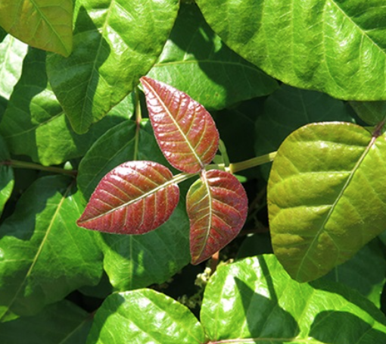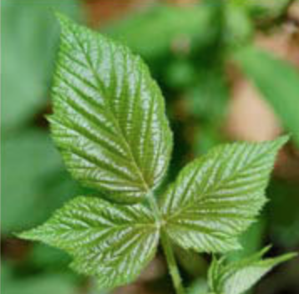
(https://www.pennmedicine.org/updates/blogs/health-and-wellness/2018/july/poison-ivy-sumac-oak)

POISON PARSNIP: SAP WILL BURN SKIN WHEN EXPOSED TO SUNLIGHT
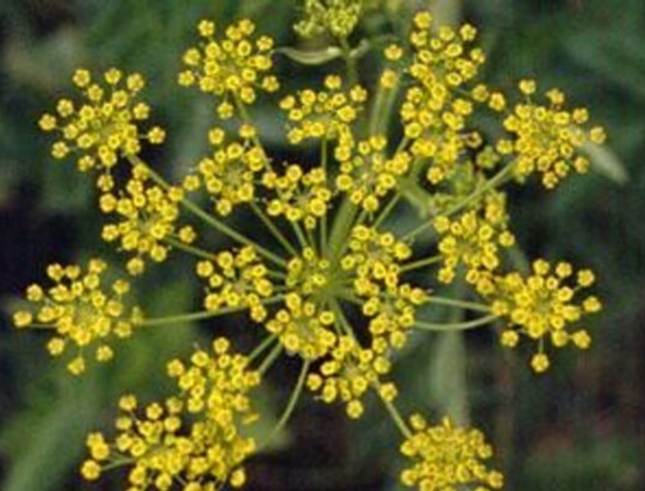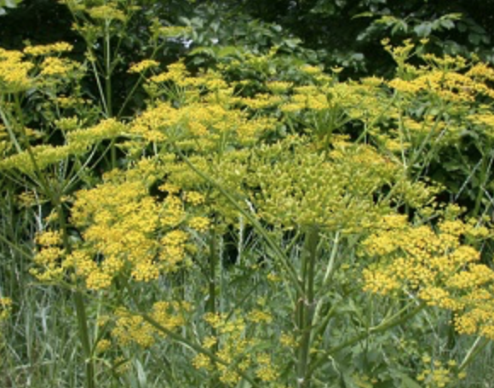
(https://www.burlingtonfreepress.com/story/life/2019/07/11/dangers-wild-poison-parsnip-vermont/1692017001/)
(https://www.dec.ny.gov/animals/105364.html)

COW PARSNIP BURN
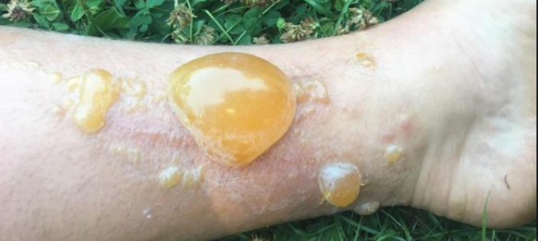
(https://www.usatoday.com/story/news/nation-now/2018/07/19/dangerous-hobo-parsnip-plant-severely-burns-blisters-woman/799636002/)

