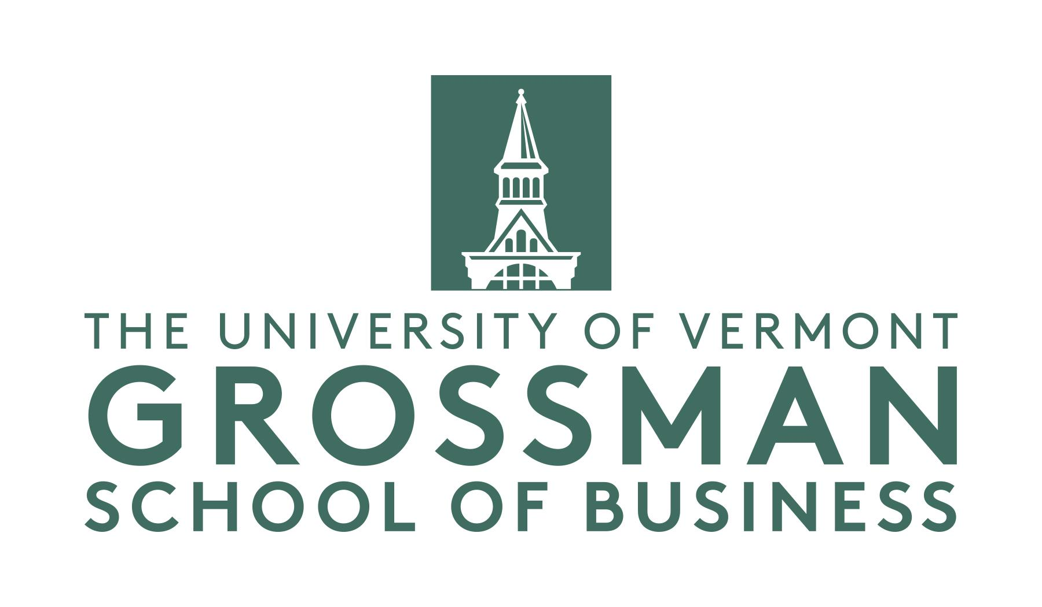
2024 UVM Vermont Legacy & Family Enterprise Awards Application Form

Please return to gsbfba@uvm.edu by July 5th, 2024

Category (Check only ONE box):

☐ 1st Generation Family Enterprise:
Start-up or purchased firm with multiple family members in ownership or operations

☐ Multi-Generational U.S. Based Family Enterprise:
Firm that has completed at least one generational transfer within the family

☐ Multi-Generational Global Family Enterprise:
Firm that has completed at least one generational transfer within the family

☐ Vermont Legacy Enterprise:
Vermont based family business recognized for outstanding and long lasting success
Please note that after evaluating the application, the selection committee may modify the category selected by the applicant if another category is deemed more appropriate.

Section I: Applicant Information

Company name:
Company address:
Company web address:
Name of contact person submitting this application:
Relationship of the contact person with the applicant company:
E-mail address of contact person:
Phone number of contact person:

Section II: About the Company

Number of employees (FT):
Year founded:
Company’s primary industry:
Principal product(s) or service(s):
Number and locations of company’s current operations:
Name(s) of principal owners:
Number of family members currently employed by the company (including board of directors):
Number of generations currently involved in the company:
Number of generations involved since the company was founded:
Generation that currently runs the company:
Name(s) & Graduation year(s) of UVM grads in the family that controls the enterprise:

Section III: Application Questions
Please address the following four topics (400 words or less per topic).
- History of Your Business
- Governance of Your Family and Your Business
What governance structure/s does your family / business use (click all that apply):
☐ Board of Directors
  - Number of Family Members on the Board: Click here to enter text.
  - Number of Total Board Members: Click here to enter text.
☐ Family Foundation / Family Office
☐ Family Council
☐ Formally facilitated regular family meetings
☐ Un-facilitated regular family meetings
How has the control and ownership of your firm been transferred from one generation to the present OR how future continuity is planned

Describe the level of communication within and between generations on matters of governance and succession plans?

- Contributions of Your Business and/or Family to Society
- Innovative business practices or strategies
Provide 2-3 examples of innovative new technologies or business models adopted by your company over the years. Did any of these initiatives help expand the reach of your company to new market segments or customer groups? If so, please elaborate.
- Financial Data: Please provide the following information.
 | 2019 | 2018 | 2017 | 2016
Gross Revenues
Net Profits (before taxes)
% of firm owned by controlling family

Section IV: Additional Information Requested (Optional)
- A company brochure or catalog
- Copies of newspaper or magazine articles about your company
- Business-related and family photographs
Information Accuracy:
I confirm that, to the best of my knowledge and belief, all information provided in this application is true and complete. In addition, all short-listed entries will be required to provide more information and/or meet in an interview with members of the selection committee. If selected as award winners, we are expected to attend the award presentation ceremony in October 2020 at the University of Vermont (Ifshin Hall) in Burlington.

Applicant’s Name (please print):
Applicant’s Signature:
Date:

